Data Storytelling with Python Altair and Generative AI
299 views in the last week
Angelica Lo Duca
- MEAP began July 2023
- This book is in development
- ISBN 9781633437920
- 250 pages (estimated)
- printed in black & white
- Data
placing your order...
Don't refresh or navigate away from the page.

Our eBooks come in DRM-free Kindle, ePub, and PDF formats + liveBook, our enhanced eBook format accessible from any web browser. $29.99 $39.99 you save $10 (25%)
get all Manning content with a subscription

Great data presentations tell a story. Learn how to organize, visualize, and present data using Python, generative AI, and the cutting-edge Altair data analysis toolkit.
After you’ve crunched, sliced, and organized your data behind the scenes, you need to present it in a way that tells a story. With Python’s Altair library and generative AI tools like Copilot and ChatGPT, it’s never been easier to create intuitive data presentations.
In Data Storytelling with Python Altair and Generative AI you’ll discover:
- Using Python Altair for data visualization
- Using Generative AI tools for data storytelling
- The main concepts of data storytelling
- Building data stories with the DIKW pyramid approach
- Transforming raw data into a data story
Data Storytelling with Python Altair and Generative AI teaches you how to turn raw data into effective, insightful data stories. You’ll learn exactly what goes into an effective data story, then combine your Python data skills with the Altair library and AI tools to rapidly create amazing visualizations. Your bosses and decision-makers will love your new presentations—and you’ll love how quick Generative AI makes the whole process!

about the book
Data Storytelling with Python Altair and Generative AI is the fast track to data presentations that inspire your audience and move them to action. Throughout the book, you’ll be guided by the principles of the DIKW (Data, Information, Knowledge, Wisdom) pyramid: a methodology that is the backbone of leading data management systems. Each chapter takes you hands-on with a new interesting data story, from tourist arrivals in Portugal to population growth in the USA. At every stage, you’ll see how tools like Copilot, ChatGPT, and DALL-E rapidly increase your productivity and streamline the visualization process.

table of contents
You can see this entire book for free. Click anywhere in the table of contents to start reading
detailed TOC

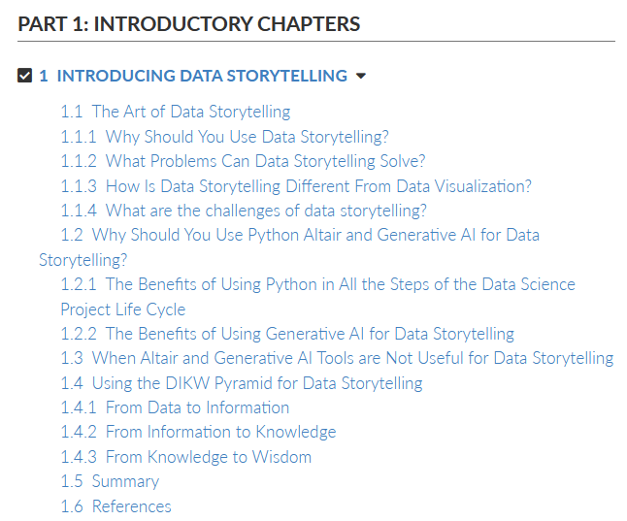

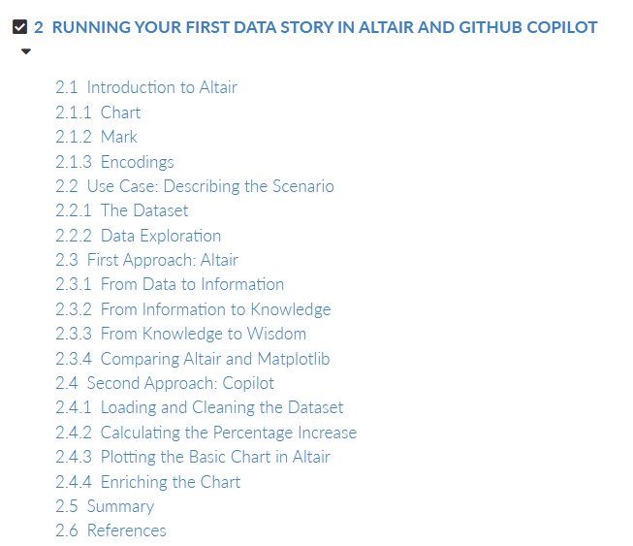

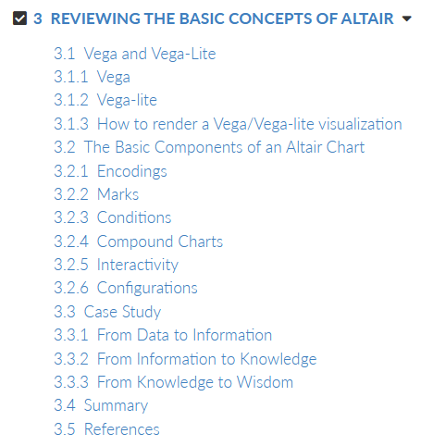



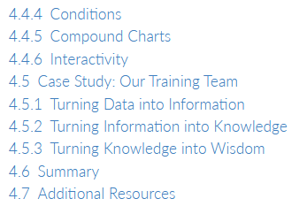

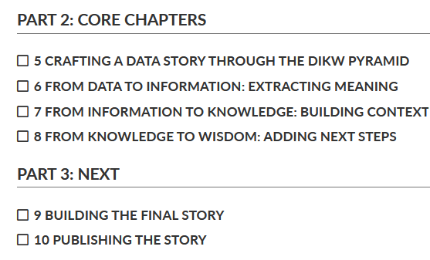

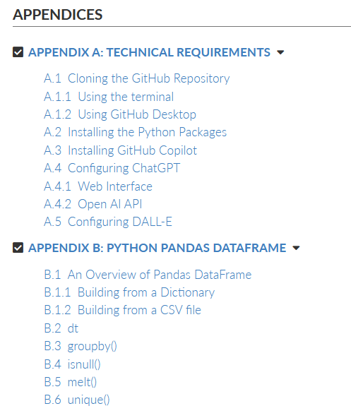

about the reader
For data analysts and data scientists experienced with Python. No previous knowledge of Altair or Generative AI required.

about the author
Angelica Lo Duca is a researcher at the Institute of Informatics and Telematics of the National Research Council, Italy. She is also an external professor of Data Journalism at the University of Pisa. She has published more than 40 scientific papers at national and international conferences and journals.
you might also like

