Data Science with GPT 1P
Please focus on the big picture, not on correcting grammar errors and typos. What you see is a raw manuscript; it has not been copyedited. Code annotations (#A, #B, etc.) are in an intermediate format that will be turned into the usual Manning in-line code annotations during book production.

Please try to be specific with your comments – “Sections 2.4 and 2.6 are too long” is much more valuable than “Some parts of the book are too long”. If you want to make comments additional to our questions, you are more than welcome. Just add them at the bottom of the questionnaire.
Also, please use the code from repository we sent you to run and examine the examples (code from the book might not work). Do not copy the code from the PDF chapters.
gecarter53@gmail.com Switch account

* Indicates required question
Email *
gcarter@acm.org
Your Full Name *
George Edward Carter

1a. What do you do and what is your technical background?

1. First, please tell us a little about yourself.
I’m retired and describe my technical background as follows (in reverse chronological order):
- 8 years as a data analyst in government (health care and business development services) extensively using SQL, SharePoint and Salesforce.
- 8 years in the mortgage industry supporting a financial application using SQL and Java.
- 23 years’ experience as an accountant (CPA) in municipal accounting where spreadsheets were the major tool for accounting analysis.
Also, I attained a Master’s Degrees in both in computer science data analytics, completing complex projects requiring substantial utilization of SQL, Python, R, Tableau, and Excel.

1b. On a scale of 1-10, how would you categorize your expertise in this subject?
3
1c. Did you read the entire review package? If not, which chapters did you read?
I read the assigned chapters – 1 thru 5.
2. Imagine that you’re writing a review for this book on Amazon… (You are reviewing a partial manuscript containing approximately 1/3 of the planned content. If the rest of the book is of similar quality to what you’ve read so far, how would you answer these questions.)

2a. How many stars would you give it?
4
2b. What would you say?
ChapGPT is increasingly becoming popular as a tool in the IT industry; particularly with regards to data science. For many data scientist, this has come along subsequent to our academic training, so we’re left either seek for training opportunities, or train ourselves. There such a glut of information regarding the subject, but few provides a comprehensive, yet concise, resource for the beginner. This text does an excellent of introducing the subject from how it works (without a lot of math and theory), how to setup the application, and enough examples and exercises for a novice to be productive in a short period of time. This is truly a ChatGPT “handbook.”

2c. What would the authors need to change to get 5 stars?
Though chapter 3 and 4 did not go too deep into the theory, I felt some of the concepts could be better understood with more examples and diagrams.

3. Please comment on the manuscript.
3a. Is the writing interesting? Does it hold your attention?

3b. Were there passages that required repeated reading to understand? If so, which ones?
Many sections in chapters 3 and 4 for reason explained in question 2c.

3c. Does the introduction illustrate the different ways to use language models for data analysis well?
Yes. The intro chapter not only gives a good general idea of the benefits of using LLMs, but also stimulants an interest to get started as soon as possible.
3d. Would you prefer having background information on Transformer models and transfer learning at the current position or at the end of the book?
Because I was eager to get hands on experience as soon as possible, getting through those chapters proved a long delay before I could jump in. If had to do all over again, I would have skipped those chapters until the end, unless, reading subsequent told me I needed that knowledge to successfully move forward.
3e. Did the book make a good case for why Chapters 3 and 4 (background on language models and training) are useful?
The content of those chapters explained an understanding of its content would help appreciate the behind processes of LLMs. But concepts presented were a little complex and required slower reading than the other chapters.

3f. Are there any figures \ screenshots which don’t make sense to you or could be captioned \ annotated better to clarify what they are showing?
Figure 3.2
A single example does not seem sufficient to explain the flow from ‘query’ to ‘output.’ Maybe showing the queries vary for all of the words

Figure 3.4 and Figure 3.5
It would help to select one of the attention mechanisms from Figure 3.5, highlight, in red, the corresponding association in Figure 3.4.

Figure 3.7
This could use further clarification, and helped possibly, using an example from Figure 3.7 and tying it to Figures 3.4 and 3.5.
3g. Are the examples good and applicable in real world? Are there enough of them?
The examples were good, but I would have liked to have seem more, representing a diverse of different industries.
3h. What do you think of the overall concept of the book and the approach toward the intended audience?

The book starts from the ‘beginning’ – what is ChatGPT, how it works, how to set it up, and how to use it.
3i. What possibilities do you foresee for using tools like ChatGPT and OpenAI to work with data? Does the author appear to be covering those possibilities? What, if anything, might the author be missing that you feel should be covered?
I feel ChatGPT will be instrumental in creating, improving and/or debugging/troubleshooting SQL queries I use for exploratory data analysis. On a grander scale. it would also be helpful in suggesting project plans for completing various type of data science projects – predictive, exploratory, descriptive and inferential. Though maybe covered in subsequent chapters, I think its important the author mention something about ‘hallucinations’, and discerning reliance on LLM output.

3j. What are your own views on the use of AI language models in working with data? Are you favorable to the idea? Are you skeptical toward the idea? Let us know why or why not, because we are interested in learning our audience's viewpoint on these new technologies.
I believe LLMs are a valuable tool in data analysis, but as a tool, is only beneficial in the hand of a trained data professional. Those mesmerized by all the hype, will be lured in a false sense of security, relying on LLM results which could lead to disastrous or catastrophic consequences. Even as models are continued to be improved, there still needs to be a human “looking over its shoulder.”

3k. Do you recommend any improvements to the Table of Contents?
No, but I would include
- an index (for quick chapter/lookup)
- a glossary (for quick definition lookup)
- a Reference section (URLs, book titles, etc., for further topic exploration)

3l. Does the title of the book match the content? Do you think the title will attract the attention of the readers?
The title indicates a ‘general’ text, not indicating the experience level for which the book is intended. Because everybody is currently writing about this topic the books title does not make it stand out for any reason. Readers may find it by chance.
3m. Are any parts of the manuscript too long, too short or missing?
If chapter 3 could be shorter, a reader’s attention be be easily retained.
3n. Does the book make learning the subject easy?
Yes, the tone of the book with simply code examples makes learning easy.
3o. Did you actually learn to do anything after reading these chapters? What?
Yes, I learned
- the benefits of using LLMs
- how transformers work
- how to setup ChatGPT account
- hoe to use ChatGPT web interface
- how to use ChatGPT api

3p. Did you gain any new techniques, insights or perspectives?
With regards to SQL programming, ChatGPT can serve as a programming ‘partner’ – help developing, reviewing code, improving code, debugging/troubleshooting code.
3q. What have you learned about LLMs and ChatGPT from reading the chapters so far? What would you say your top 3 learnings are, and do you feel that those learnings deliver on the promise of the book?
- ChatGPT has both an online app, that can be accessed directly; and also, an API so users can access its capabilities in Python code
- ChatGPT can suggest queries that the developer did not consider
- Training an LLM can be complex and effect the value of its result in future use

3r. How much value is there in this book compared to free online resources?
All of the topics covered in this book are probably covered in several online resources, but at different experience levels. A person would need to collect several online articles/posts to cover all the experience covered by this single book. This book is a good comprehensive resource that could be supplemented by online resources.

3s. How have the chapters helped your understanding of emerging technologies such as ChatGPT? Do you feel your understanding of AI language models is improved from reading this author's content so far?
Yes, I realize now the importance of how a LLM model is trained, and why its important to consider when choosing and/or configuring a model for use.

3t. Did you have any “aha!” moments while reading this manuscript?
When reading about the various parameters, the user has a lot of control over the accuracy, tone, length, etc., of the results.

4. We often provide examples for two reasons – to help learn the topic and as illustrations of real-world code. Please consider thoroughly running the code. This is a vital part of the manuscript review - we need your opinion on both text and code.

4a. Is the number of examples sufficient? If not, which points should be illustrated by additional examples?

Understanding this would increase the length of the book, but I would like to see more examples demonstrating the results of using various parameters, and combination of parameters.

4b. Did you try out examples described in the book? (If not, where? If none, why?) How many of the source code examples did you run? Were you able to obtain similar results?
I tried all the examples and was successful in getting similar results for all.

4c. Did the code examples help you learn the material?
Yes, doing examples reinforced what I read
4d. Are the examples nicely explained?
Yes, they were easy to follow.
4e. Were there any examples that were helpful in real-world situations?
Being an extensive user of SQL, the SQL examples opened a lot of possibilities for me.

4f. Do the examples use the current and most common version of the technologies covered in the book?
Yes

4g. Are there new versions of the software announced or coming soon that will affect the examples in the book?
ChatGPT-4
Jupyter Notebook 7

5. Wrap up.
5a. How much interest is there in this topic (1-5)?
5
Burning Hot
5b. What other topics would you like to see books published on?
Web scraping (R, Python)
Geospatial analytics (R, Python)
Feature Engineering (R, Python)

5c. Can you name some technology experts (perhaps lesser known) who you think would make good authors?
I don’t know of any.

5d. To help get the word out about our books, we often convert sections of books into articles published on the Web. Which sections in this manuscript would make interesting or useful articles?

1.6 Using language models for data analysis
2.4 Processing tables with GPT
5.4 Making GPT tell us a story

5e. How would you recommend this book to your colleagues? What would you tell them?
“Heard about ChatGPT and LLMs? Need to catch up to speed so you can start using this AI technology as a data professional. Look no further than this book. Sure, you can find the same information online. But why waste your trying assemble all the necessary articles and post to give you a comprehensive understanding. Just pick up this book and immediately raise your data skills to higher levels.”

5f. Occasionally we use quotes in promotional material. May we use a quote from your review with or without your name for these promotions?
Yes
5g. What is your LinkedIn profile?
https://www.linkedin.com/in/gecarter/

5h. What is your Twitter handle?
  - gcarterit

Additional Comments
The author writes with an engaging conversational tone, making striking references to pop culture topics and subjects.
Each chapter’s introductory and conclusion summary makes a smooth transition from chapter subjects.
Author makes good use of existing frameworks to avoid any challenges users may have setting up the applications on their PCs.

“The following experiments use the BertViz tool which you can download at https://
github.com/jessevig/bertviz or, which may be simpler, use the pre-configured
notebook online (you find the link on the corresponding project page).
Where was this link?
I found the notebook from the link in the review instruction email: https://itrummer.github.io/DataScienceWithGPT/
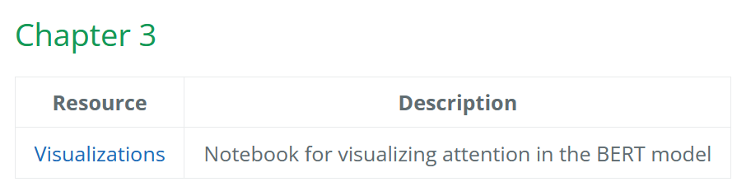
Then clicking on the Visualizations link…
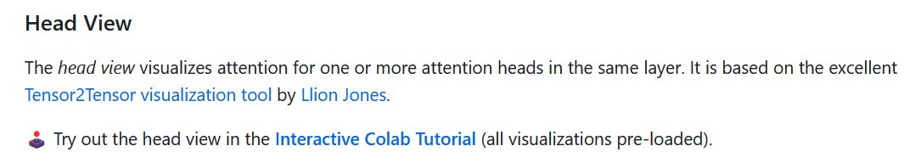
Then clicking on Interactive Colab Tutorial

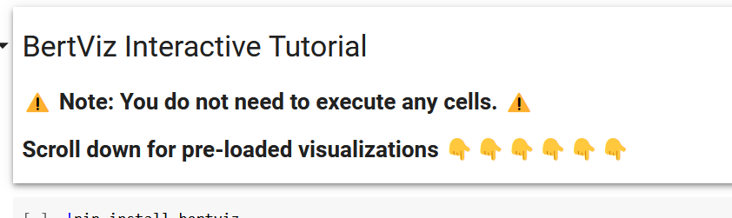

I think the above instructions are misleading and should say something like: You do not need to execute any cells, if you only want to see the pre-loaded visualizations. Otherwise edit and execute the cells to run your own visualizations.

‘Now, consider the “parent” field. What do you notice? It turns out: the value of the
“parent” field for the second model equals the ID of the first model!’
This was not the case for me the second models ID = null

Figure 3.4 shows
the corresponding online notebook. No need to understand each line of code within it but
know that we are visualizing dependencies between two input sentences that you can config-
ure yourself (simply by replacing values for the two variables sentence_a and sentence_b
that you see in the figure). We will use the two sentences “I bought the BananaBook laptop”
and “It’s great!”, inspired by our review example, in the following. BERT can be used to
perform various tasks on this input, e.g., determining whether the review expresses satisfac-
tion or dissatisfaction with the product (we used GPT for that in Chapter 2).”

For me, this required better instruction/direction.

I was able to follow the link: https://
github.com/jessevig/bertviz

