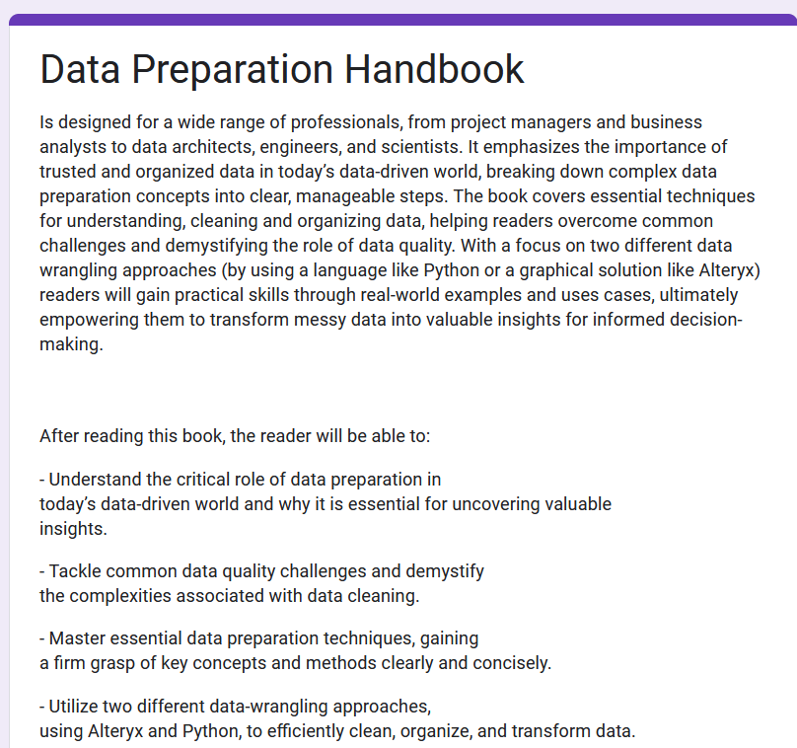

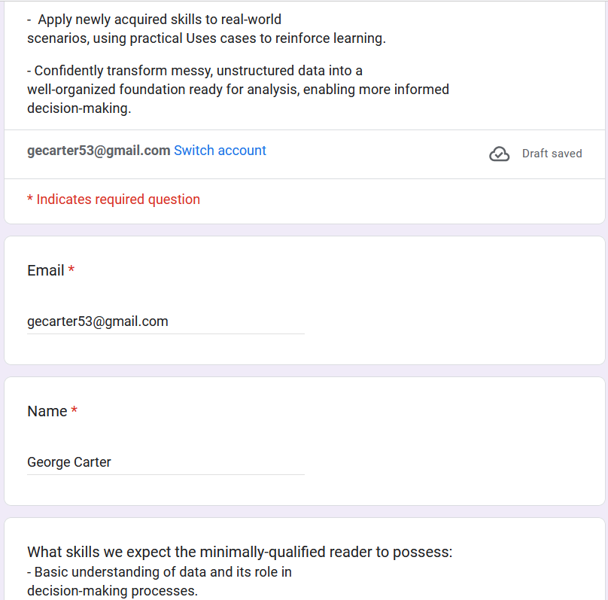
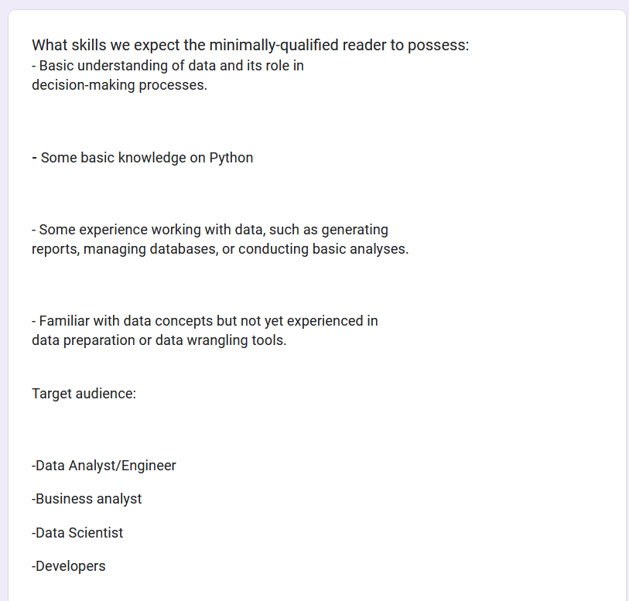
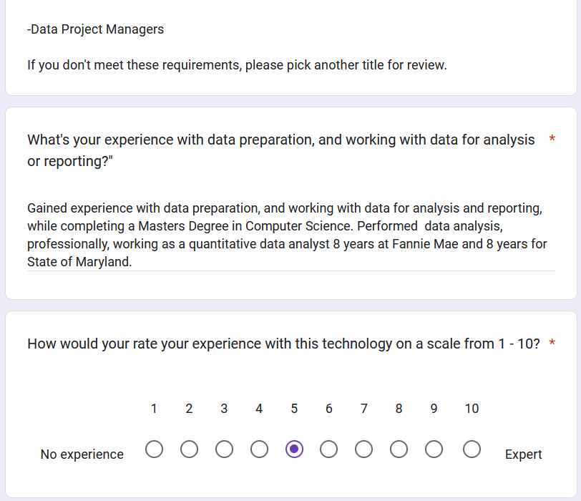

Gained experience with data preparation, and working with data for analysis and reporting, while completing a Masters Degree in Computer Science. Performed data analysis, professionally, working as a quantitative data analyst 8 years at Fannie Mae and 8 years for State of Maryland.




