1. **Features and vision**
   * Inspiration and similar projects
     + <https://www.flexxtrainingsystems.com/>

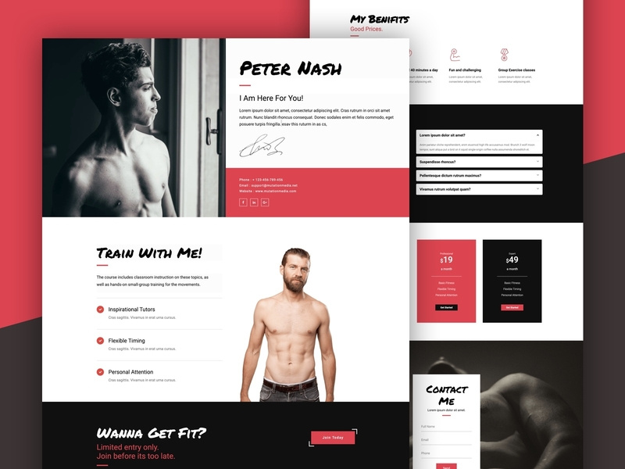

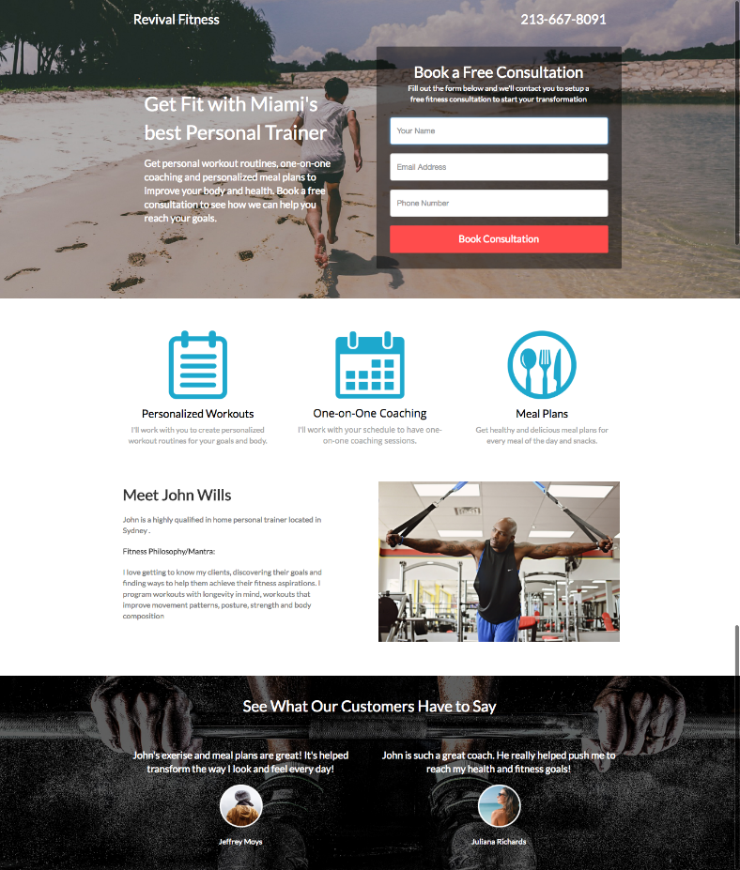

* + Attractive and engaging landing page
    - Pictures, links and graphics for other parts of website
  + Apart from the attractive landing pages it will have other pages
    - Coaching page with details and link to questionnaire.
    - Testimonials with date of when testimonial was given, athlete name and testimonial
    - Initial testimonial page with details then individual pages with, back and next buttons.
    - About page
    - Possible link to big cartel shop.
    - Questionnaire for new clients
    - Client login
  + Administrator software

1. **Sprint 1**
   * Sprint Goal
     + Create and deploy initial site with landing page and testimonials.
   * Stories
     + Create database for testimonials
     + Create UI for landing page
       - Nice opening banner with a diagonal line containing solid color with logo and name
     + Deploy on Heroku
2. **Sprint 2**
   * Sprint Goal
     + Get new athlete questionnaire working for user submission and admin view
     + <https://startbootstrap.com/previews/sb-admin-2/>
   * Stories
     + A user can sign up for coaching if interested by filling out an application
       - The form must have some type of security to prevent form bots
     + A user can log in to dashboard to get a link to his program, and weeks out from next meet
     + An administrator can access an admin page, protected by a username and password
     + A user can skip the coaching application and have access to a minimized version of the client dashboard
     + An administrator can view and accept or deny submitted user coaching applications
     + An administrator can request an update which includes when next meet is, among other questions
     + Keep it simple above else
3. **Feature Backlog**
   * + An administrator can accept a user as a client, taking info from the users application
     + An administrator is notified when a user submits a questionnaire
       - <https://pythonhosted.org/Flask-Mail/>
     + A user is notified after filling an application
     + As a developer I want to import old client data
       - Excel file with a table containing client data
       - What data does administrator need at hand
         * Training program end
         * Next meet
         * Filter data depending on what he needs
     + A user can add a meet he is competing in to his account