ICP

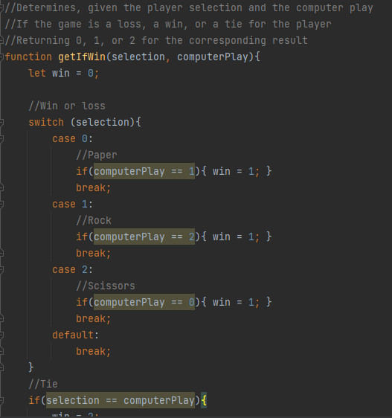

I wanted to make the RPS game to look nice, so I started with it. I used open-source emoji images from OpenMoji for the icons to add some graphical niceties. I had to accomplish the UI in a kinda hacky way by using blank pngs to act as grid elements so that the player choices and the computer response would

I then added a border and made sure the background boxes were sized correctly and the background colors would be changed correctly. Then I implemented the rough logic in JavaScript. I then ran into some bugs, but I was able to get them ironed up and the program code cleaned up quickly with comments.

[Github Link](https://github.com/gcb-umkc/Web_Lesson_3/tree/main/ICP)

RWD

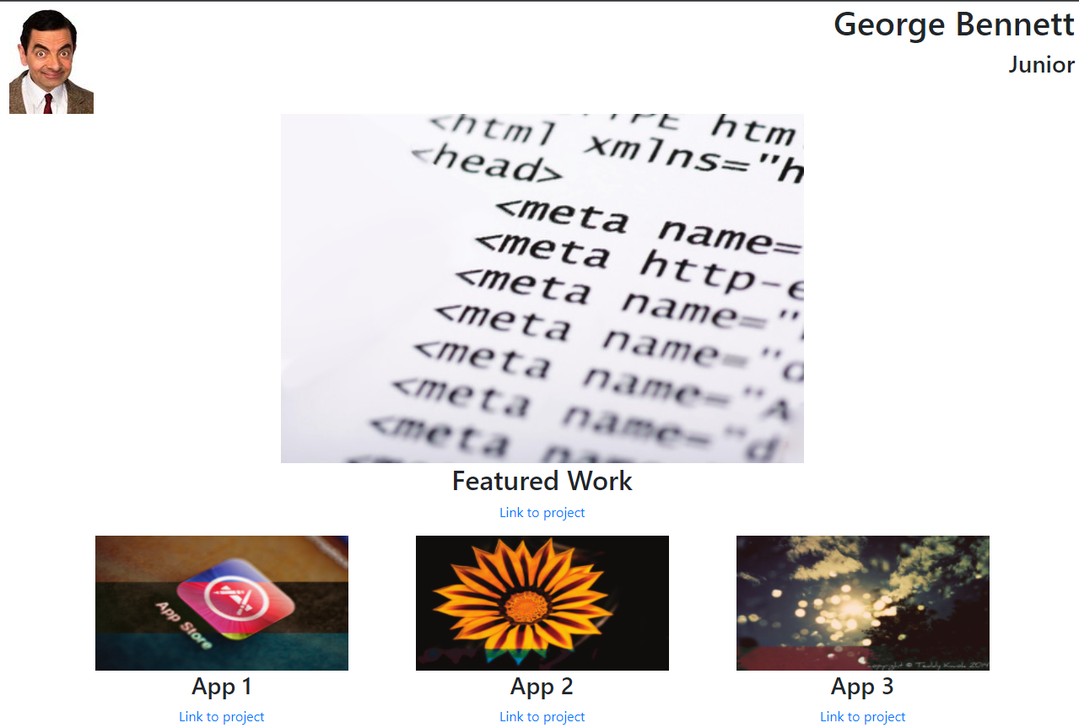

For the example homepage I had to mess around with some of the bootstrap documentation examples. However, the documentation on the Bootstrap website was good. Even though there were some issues with centering the columns properly and fluid sizing of the images, the framework really lightens the load for the formatting you must do compared with native HTML gridding.

[Github Link](https://github.com/gcb-umkc/Web_Lesson_3/tree/main/RWD%20Task)