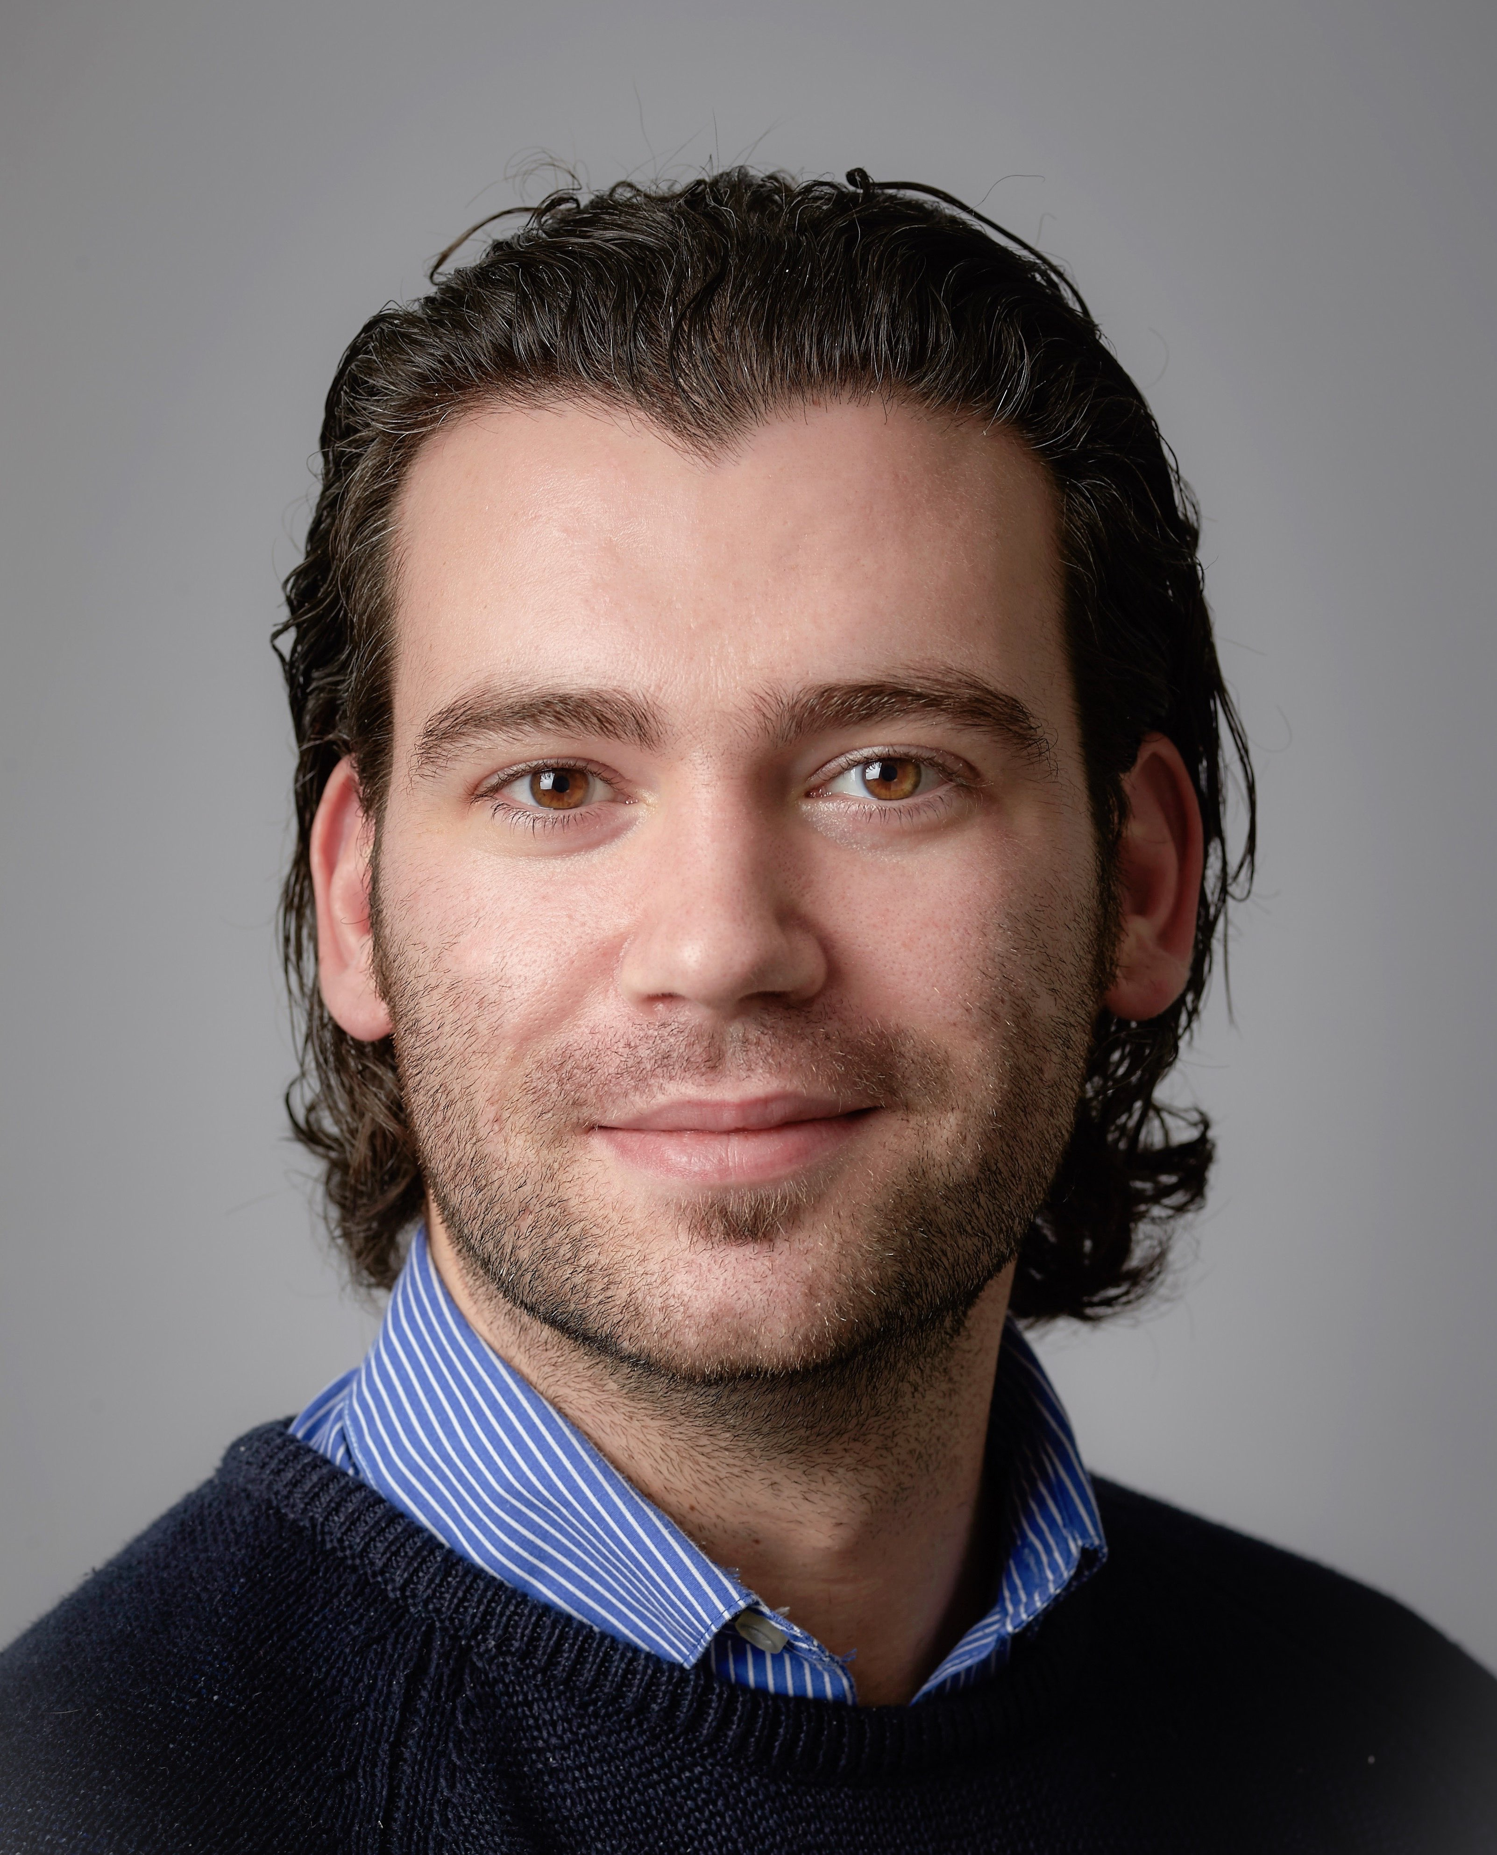

Carlo Bloks

Date of Birth: 04/01/1986

Nationality: NL

Family: Married, 1 daughter

City: Rotterdam

Phone #: +31614873993

Languages: NL / EN / IT

Quick bites:  
(Technical) Product Owner / Product Manager, UX/UI, Analytical, Self-managing, Attention to detail, Conversion & Customer-oriented, Prioritization, Service Design, Sales & Service, Optimization, GTD, Pro-active, Curious.

As a Digital Product Owner/Manager I have a 8+ year track record in leading and managing cross-functional Agile / Scrum teams in various organisations on an international level. I have a thorough understanding of the digital landscape - both technical & commercial - and my curiosity drives me to keep seeking continuously for opportunities that optimize and improve UI / UX and online sales as well as developing the most intuitive digital experiences.

Endorsement:

“Work hard, play hard is the phrase that comes to mind when I think about Carlo. During my time at Allsecur we built and created a new way of working and website. The results were outstanding. Carlo is a proactive, responsible and passionate person with positive attitude and Italian temperament. He is a real team-player who gets things done, and certainly can get my full recommendation.” - Jeroen Millenaar.

Relevant work experience:

2018 - present:

European Digital Product Owner at Allianz Direct (Global Digital Factory in Munich)

Together with the experts in my team we shape the digital landscape of all operating entities within w. We are developing brand new digital experiences with the latest technologies and insights. From the website UX to the brand voice. From all documents to the omnichannel customer communication. From Tracking & Analytics to the Audience Manager and Experience Manager. We implement and optimize the entire Adobe Suite and enable the countries in achieving their goals.

2016 - present:

Digital Product Owner - Website in Rotterdam

For [Allsecur](http://www.allianzdirect.nl) I was responsible for the digital customer experience. We launched a brand new and state-of-the-art website contributing to the best financial year in Allsecur's history.

2015 - 2016:

Various Ad Interim positions as a Digital Product Owner

For Zoover/Weeronline, [Zilveren Kruis](http://www.zk.nl) and [ZieZo.nl](http://ZieZo.nl) I have developed and/or optimized several digital journeys.

2012 - 2016:

Co-founder Dutch Startup ‘Deel Je Passie’

Together with the Award Winning Dutch Digital Agency [Bikkelhart](http://www.bikkelhart.com) we developed an online platform from scratch for the Dutch market where users could learn & teach new skills.

Studies:

Mar 2013 Master Entrepreneurship, MSc / Vrije Universiteit Amsterdam  
Nov 2009 International Business Administration, BSc / Erasmus Universiteit Rotterdam

Skills and Interests:

Github / Jenkins / ELK / Kafka Operatr / Grafana / Sketch / Adobe CC / Magnolia / Adobe Experience Manager / ElastAlert / Adobe Target / Final Cut X / Pixelmator / Blueconic / Node-RED / Zigbee2mqtt / LAKKA / Abstract / Hotjar / MySQL / Omnigraffle / Trello / Invision / Miro / Atomic / Google & Adobe Analytics / Crashlytics / iTunes Connect / Home Automation / YAML / Raspberry Pi / Home Assistant / Workflow Productivity / Slack / Teams / IoT / Jekyll / VSC