IS287: Java Programming II
Midterm (50 points) 2015

For the midterm you will update the Financials project to include a new Financial Operation: Present Value (PV). Present value takes an amount to be received in the future, and ‘discounts’ it according to an interest rate (the time value of money, often assumed to be an inflation rate) for the length of the term. This produces the value of that future amount ‘in today’s dollars.’ The formula for this operation is:

PresentValue = AmountInFuture / ((1 + Rate)^Term)

(remember that the rate must be in the same units as the term; so an annual rate would be divided by 12 if the term is in months)

Thus, the form will now look something like this:
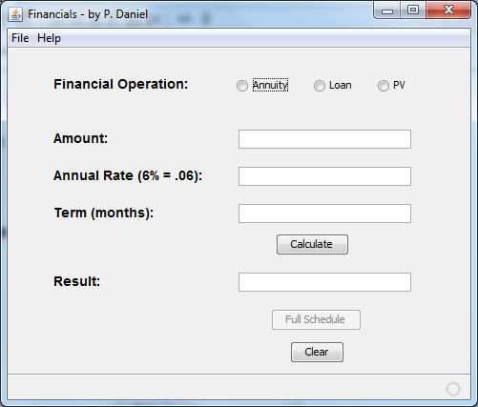

For the Present Value operation the descriptor changes on the form (when PV is selected) are: amount changes to “Future Amount” and result to “Present Value.” You will develop the PV.java class along the same lines as the resturctured Loan.java and Annuity.java from the Financials project. The Schedule for a PV operation is a bit different:

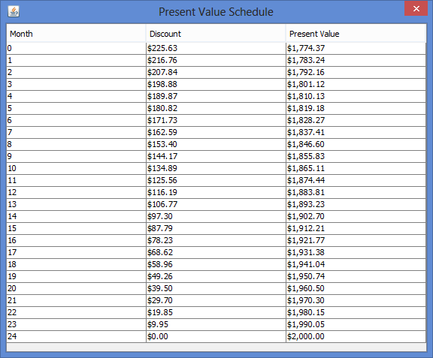

The above example is based on receiving $2000.00 in 24 months, where the annual cost of money is 6%. As you can see from the schedule, the PV concept starts the schedule at month zero (i.e., the current value today), and so will have one extra row vs. the other financial operations. Obviously there are also fewer columns needed than with the other operations.

Polymorphism will still be used on the form side for the PV operation, but we will have to determine the type of Financial object in order to build the proper schedule type (including the extra row). This will be accomplished with the instanceof operator.

Remember that the PV class must conform to the rules of the abstract superclass – meaning all abstract methods must be implemented in the subclass, along with declarations of all descriptors needed for the form and column titles (i.e., the static final values). These all follow the pattern used in the Loan.java and Annuity.java classes.

Call your project FinancialsMidterm, and zip and submit it in the usual way.

