IS287: Java Programming II
Financials (Polymorphism and Abstract Classes 100 points) 2015
In the Forest Park first Java course we developed an application that performed two similar financial operations: calculating the final value of an annuity and calculating a required monthly loan payment. Both operations require an amount, an interest rate, and a term (which we entered in months).

A calculated annuity of $100 a month at 6% (annual rate) over 24 months looked as follows:
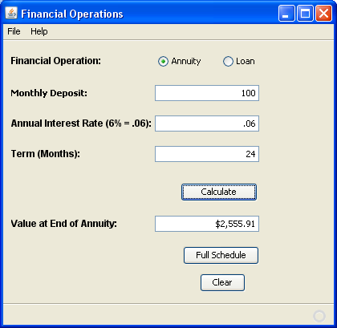

A loan of $5000 at 9% for one year looked like the following (note the change in input labels):
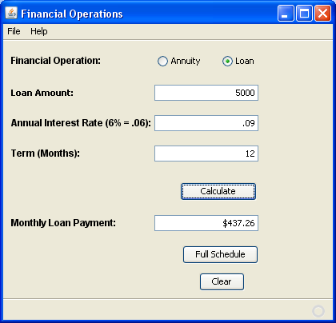

The formula for a simple interest loan calculation was:
__ __
Monthly = |Rate + _______Rate________ | * Principal
Payment | ((1 + Rate) ^ Months) - 1 |
|__ __|

In words: Payment = (Rate + (Rate divided by ((1 plus Rate) to the power of the months) minus 1) all times the principal). Rate must be expressed as a per month value (i.e., annual rate in decimal form, divided by 12). A good website that explains this is: www.1728.com/loanform.htm.

We coded this program in a simple OOP style using two separate, unconnected classes: Annuity.java and Loan.java.

Part A: convert to inheritance model using an abstract superclass and polymorphism
For the first step in this application you will restructure the business objects using an abstract superclass. On the form side you will use polymorphism to simplify the handling of the classes.

The ‘Amount’ and ‘Result’ labels will continue to change depending on which operation is selected, which will require that the subclasses carry “Amount Description” and “Result Description” values (these will be static final values in the class). Recall that the main form changes descriptors as follows:
- Annuity Operation: Amount changes to “Monthly Deposit” and Result to “Final Value of Annuity”
- Loan operation: amount changes to “Loan Amount” and result to “Monthly Payment”

The abstract super class will be called Financial.java and will have the following features:
- Overloaded constructors (one empty, the other receiving Amount, Rate, and Term)
- Regular getter and setter methods for amount, rate, and term (i.e., not abstract methods)
- Abstract methods named getAmountDesc and getResultDesc which will return the appropriate labels for the amount and result lines (as discussed immediately above)
- Abstract method name getResult to return the value to be displayed in the result text field

Then re-design sub classes Anuity.java and Loan.java (samples from Java I are provided with this assignment) to extend Financial and implement the abstract methods required:
- These sub classes use normal inheritance to send starting values (amount, rate, term) to the super class
- Implement the getResult method using the appropriate formula calculation as discussed above

The Annuity.java and Loan.java class files from the previous course are included with this specification to give you a head start on the operation. Note that they include methods for building display schedules that will not be used until Part B.

Part B: add methods to be able to create schedules

In part B you will add logic to produce pop-up schedules for the two financial operations. This will require additional abstract method declarations in the Financials.java superclass, along with implementations for those methods in the sub-classes.

The subclasses will also be designed to contain descriptions for the schedule columns (which vary slightly between the financial operations).

Schedules to be built are shown below:
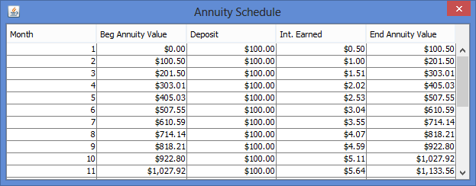

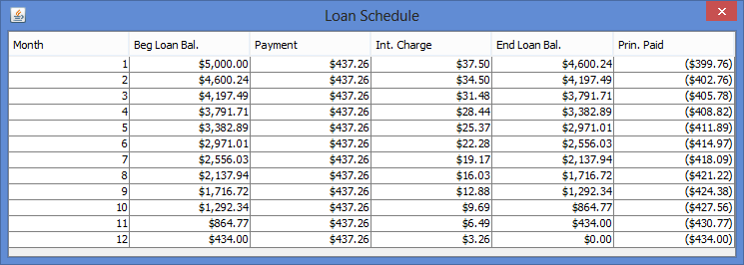

By examining the similarities in the schedules above, we can identify the following additional abstract methods needed in the Financial class (and implemented in each of the sub-classes) in order to build each schedule:
getBegBal(int mo) – to retrieve the beginning balance for the month
getPrinFactor(int mo) – to retrieve the ‘monthly principal’ factor: in an annuity this is
the deposit, in a loan it is the monthly payment.
getIntFactor(int mo) – to retrieve the ‘interest effect’ for the month; in an annuity it is interest earned,
in a loan it is the interest charged
getEndBal(int mo) – to retrieve the ending balance for the month

Further, we will have the sub-classes give us the proper column names, so additional abstract methods will be:
getBegBalDesc() – to get the column label for the beginning balance column
getPrinFactorDesc() – to get the column label for the “PrinFactor” column
getIntFactorDesc() – to get the column label for the “IntFactor” column
getEndBalDesc() – to get the column label for Ending Balance column

The Loan Schedule has one additional column: Principal Paid, which is the difference between the ending balance and the beginning balance. This column, however, should be built by the form, not the loan.java class, and thus will not require any additional abstract methods or implementations. It will, however, require that the form use the “instanceof” operator to determine when the extra column needed.

Call this project FinancialAbstract, and zip it and submit through blackboard in the usual way.

