Art Auction to Benefit PRAIRIE HILL - 11/6

Local artist and PRAIRIE HILL dad Chris Rudasill is donating several pieces of his original artwork to be sold in a silent auction. 100% of the profits will go directly to the further funding of art materials and enrichment opportunities at PRAIRIE HILL.

Silent auction during First Friday
November 6
5–8 p.m.
Lux Center for the Arts, 2601 N 48th St, Lincoln, NE 68504

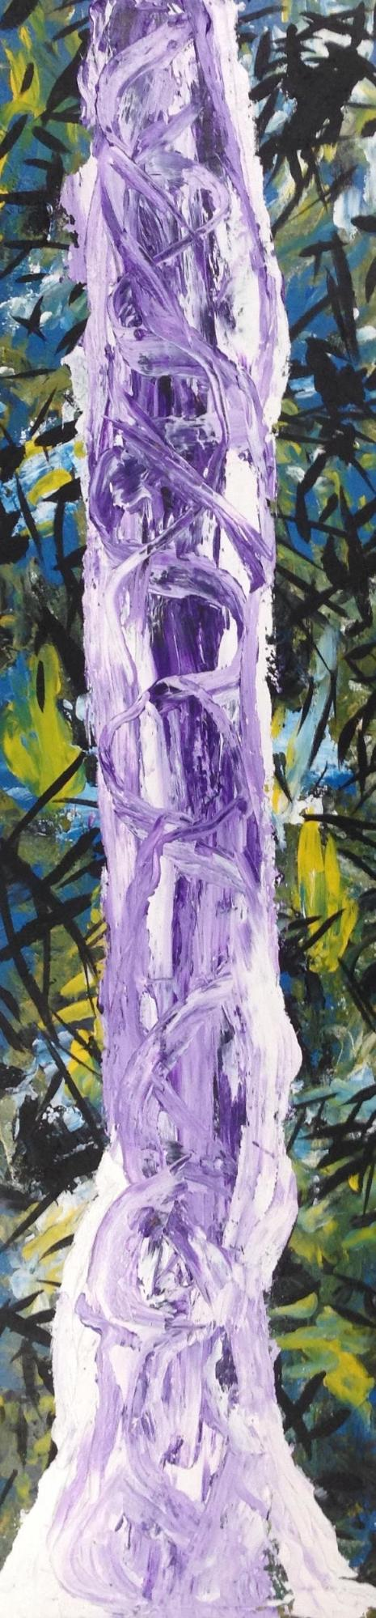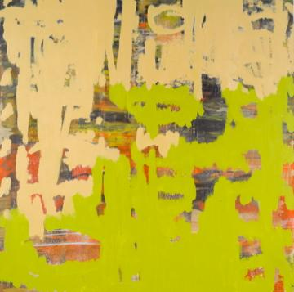

Don’t miss this great opportunity to see and purchase original artwork at accessible prices (some starting bids will be as low as $10) while supporting education through year-round and summer camp programming at PRAIRIE HILL Learning Center.

For more information and images of Chris’s artwork, visit:

chrisrudasill.weebly.com

For more info about PRAIRIE HILL, visit: prairiehill.com

