Install Raspbian (monitor, keyboard, mouse)

* Username: pi (default)
* Password: raspberry (default)

Setup a static IP address (<https://pihw.wordpress.com/guides/direct-network-connection/>)

* sudo ifconfig eth0 169.254.0.2
* hostname -I (check if it worked)
* Saving the new configuration
  + sudo cp /boot/cmdline.txt /boot/cmdline.normal (copy of the original file)
  + sudo nano /boot/cmdline.txt (edit the original file)
  + Add at the end of the long line ip=169.254.0.2 (add a space between the last item and “ip=169.254.0.2”)
  + Crt+x and y (to save and exit)
  + sudo cp /boot/cmdline.txt /boot/cmdline.direct (copy of the new file)
  + sudo reboot (next time the IP address will be automatically set)

Update Raspbian

* sudo apt-get update (fetches the list of available updates)
* sudo apt-get upgrade (strictly upgrades the current packages)
* sudo apt-get dist-upgrade (installs updates, new ones)

TCP vs UDP (<http://pymotw.com/2/socket/udp.html>)

* TCP (ensuring that all of the data is transmitted in the right order)
* UDP (delivery is not guaranteed, faster than TCP, single packet = only hold 65,507 bytes)

PuTTY and WinSCP (<http://www.putty.org/> & <http://winscp.net/eng/download.php>)

* The PuTTY program is to use Linux on another computer using the IP address.
* WinSCP is another good program to transfer files between them.

GitHub (https://github.com/thiagopuga/Project.git)

Setup a remote desktop for Raspberry Pi (<http://www.raspians.com/knowledgebase/?knowledgebase=setting-up-a-remote-desktop-view-the-pi-on-your-windows-pc/>)

* Install Xming on Windows (<http://sourceforge.net/projects/xming/>)
* "C:\Program Files (x86)\Xming\Xming.exe" :0 -clipboard -rootless -screen 0 800x600+100+100@1 (set window size on the shortcut, +100+100 is the window`s position on the screen)
* Install PuTTY on Windows (<http://www.putty.org/>)
  + Run PuTTY.
  + Select SSH as the connection type
  + Enter in your Pi’s IP address as the Host Name
  + The port should be 22 unless you know better
  + In PuTTY`s option tree, select Connection/SSH/X11
  + Check the box labelled Enable X11 forwarding
  + Go back to Session options (in the option tree)
  + If you would like to save these settings, type a name in the Saved Sessions box and click Save
  + Click Open
  + Once you have logged into the Pi type startlxde and you will see the desktop of your Raspberry in the Xming window (the Xming must be running on Windows)

GPS (<https://learn.adafruit.com/adafruit-ultimate-gps-on-the-raspberry-pi?view=all>)

* Connect VIN to +5V (<http://pi4j.com/pins/model-2b-rev1.html>)
* Connect GPS TX (data out from GPS) to Raspberry Pi RX (data into Raspberry Pi)
* Connect GPS PPS (data out from GPS) to Raspberry Pi PCM_CLK (GPIO 1, data into Raspberry Pi)
* Connect GND to Ground
* sudo apt-get install gpsd gpsd-clients python-gps (install GPS Daemon, it uses internet to install)
* sudo nano /boot/cmdline.txt (remove console=ttyAMA0,115200 kgdboc=ttyAMA0,115200 and save)
* sudo nano /etc/inittab (use # to comment out the line T0:23:respawn:/sbin/getty -L ttyAMA0 115200 vt100)
* sudo reboot
* sudo killall gpsd (end gpsd)
* sudo gpsd /dev/ttyAMA0 -F /var/run/gpsd.sock (restart gpsd)
* cgps –s (to test the GPS)

When Putty is used to access the Raspberry on a Windows computer, some of the characters may appear different than it should be (as the command cgps –s). For this, do the following:

* Open PuTTY > Window > Translation
* Change the Remote character set to ISO-8859-1:1998 (Latin-1, West Europe)
* Use Unicode line-drawing points (was already checked)
* PuTTY > Window > Colours > uncheck Allow terminal to use xterm 256-colour mode

GPS auto start

* dpkg-reconfigure gpsd (configure the gpsd boot)

GPS Time UTC

* <https://github.com/thiagopuga/Project/tree/master/GPS> (GitHub)

Reading analog-to-digital

* Use a analog-to-digital converter (ADC)
  + MCP3008 VDD -> 3.3V
  + MCP3008 VREF -> 3.3V
  + MCP3008 AGND -> GND
  + MCP3008 CLK -> SCLK
  + MCP3008 DOUT -> MISO
  + MCP3008 DIN -> MOSI
  + MCP3008 CS -> CE0
  + MCP3008 DGND -> GND
* 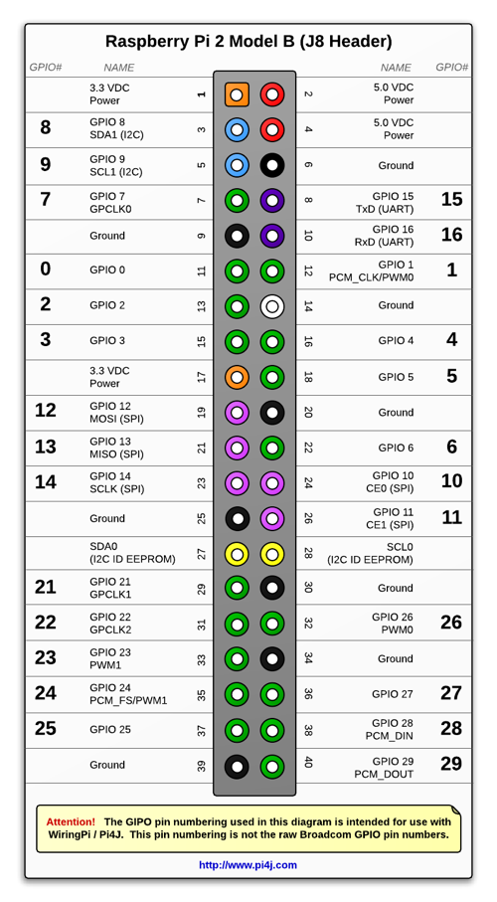<https://github.com/thiagopuga/Project/tree/master/ADC> (GitHub)