Assessing the influence of variable annual sampling effort on official national forest inventory statistics
George C. Gaines III
Bryce Frank
KaDonna Randolph
Jim Westfall
Sep 16, 2026
Abstract
In this study we…

1 Introduction
The USFS Forest Inventory and Analysis (FIA) Program surveys and analyzes the forests of the United States through a nationwide network of permanent sample locations. These plot locations are distributed across all lands with a spatial sampling intensity of about 1 location per 2400 ha according to an unaligned, quasi-systematic equal probability sample design. This design forces desirable spatial dispersion while limiting the potential for alignment of sample locations with periodic population features. Statistical inference on forest population status and change parameters is enabled by measurements of forest vegetation traits made at these locations by field crews.
Historically, FIA sample locations in each state were visited periodically as time, budgets, and workforce capacity allowed. This approach offered logistical flexibility but complicated analysis and reporting timelines. In the early 2000’s the program shifted from periodic to annual inventory protocols calling for approximately equal numbers of plot remeasurements each year on schedules intended to be fixed and consistent within states. Under the annual inventory, each plot location in a state is assigned to one of a set of panels, and all plots assigned to a panel are designated for measurement in the same year. Once the final panel in an inventory cycle is complete, remeasurements at sample locations in the first panel begin the following year. For more information regarding the FIA sample design see (Westfall, Coulston, et al. 2022, chap. 2).
In general, FIA requires that a panel be complete before the associated raw tabular data are pushed to its public-facing databases, and requires a complete inventory cycle within a state to publish official state-scale estimates of forest parameters in fulfillment of Congressional reporting obligations. Unfortunately, in practice, adherence to the annual design described above has proven very challenging or impossible for the FIA Program. Instead, delayed and skipped field measurements cause unintentional lengthening of inventory cycles and/or survey nonresponse (see, e.g., Särndal and Lundström 2005), at rates that vary regionally and over time. The underlying causes of delayed and skipped field measurements are varied, and can be chronic (e.g., denied access to private lands (Westfall, Schroeder, et al. 2022), logistical or administrative challenges in remote regions (Affleck et al. 2026), persistent workforce and budgetary constraints (Conroy 2026)) or result from discrete events (e.g., the COVID19 pandemic). Better understanding of patterns in late and skipped measurements (Conroy 2026), and the investigation of new sampling and estimation techniques to ameliorate the statistical consequences nonresponse (Westfall 2022; Westfall and Patterson 2026), are active research topics.
Of immediate practical concern for FIA and its external partners are the strain on field staff and delays to tabular data publication that result from delayed field measurements. Methods have been proposed to control the measurement delay process by disaggregating FIA’s annual panel structure while still preserving the spatial dispersion of the FIA sample network within field season years. Panel disaggregation enables intentional alignment of workloads with anticipated data acquisition workforce capacity in each field season year through the application of variable annual field sampling effort within individual states.
Though the logistical advantages of variable annual effort (VAE) are profound (i.e., it can help ensure the long-term viability of the inventory in the context of funding and staffing volatility), the statistical consequences of the redistribution of partial panels within inventory cycles, and of extended and variable inventory cycle lengths, are unknown across states and epochs. In particular, a need exists to understand and communicate to stakeholders how adoption of VAE protocols may influence the statistical properties of forest parameter estimates published by FIA in fulfillment of Congressional reporting imperatives.
In this study, we seek to…

2 Data & Methods
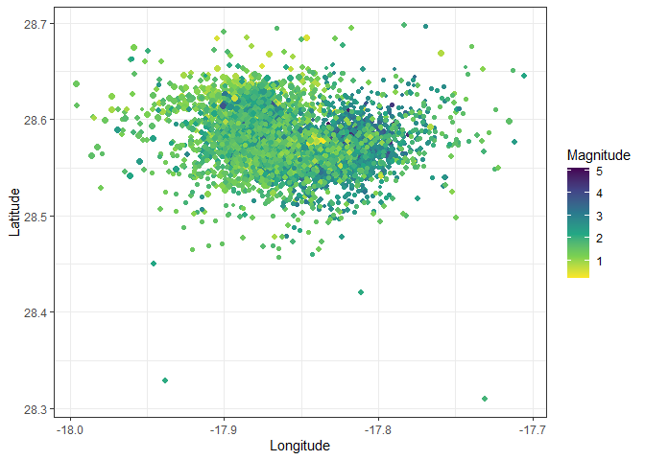
Figure 1: Locations of earthquakes on La Palma since 2017
_{Source: Explore Earthquakes}

3 Conclusion

References
Affleck, David LR, George C Gaines III, Cici Conroy, Gianna Santino, and Andrew J Larson. 2026. “Inventory Measurement Rates Lag in Wilderness Areas Across the Western USA.” Forest Science 72 (1): 95–102.
Conroy, Cici. 2026. Elevated FIA Nonresponse Rates in Wilderness: Investigating Barriers and Potential Solutions.
Särndal, Carl-Erik, and Sixten Lundström. 2005. Estimation in Surveys with Nonresponse. John Wiley & Sons.
Westfall, James A. 2022. “An Estimation Method to Reduce Complete and Partial Nonresponse Bias in Forest Inventory.” European Journal of Forest Research 141 (5): 901–7.
Westfall, James A, John W Coulston, Gretchen G Moisen, and H-E Andersen. 2022. “Sampling and Estimation Documentation for the Enhanced Forest Inventory and Analysis Program: 2022.” Gen. Tech. Rep. NRS-GTR-207. Madison, WI: US Department of Agriculture, Forest Service, Northern Research Station. 129 p. 207: 1–129.
Westfall, James A, and Paul L Patterson. 2026. “Double Ratio Estimation Within a Design-Based Nonresponse Bias Mitigation Strategy.” Forestry: An International Journal of Forest Research 99 (1): cpaf032.
Westfall, James A, Todd A Schroeder, Joseph M McCollum, and Paul L Patterson. 2022. “A Spatial and Temporal Assessment of Nonresponse in the National Forest Inventory of the US.” Environmental Monitoring and Assessment 194 (8): 530.

