Homework 1

Casey Gibson

### Problem 1

$$p(θ)=\frac{1}{21} for θ=0,0.05,0.1,...,1$$

$$Y|θ∼Binom(n,θ)$$

$$P(Y=5|θ=.05)=\left({n \atop 5}\right)θ^{5}(1−θ)^{n−5}=\left({100 \atop 5}\right){.05}^{5}(1−.05)^{100−5}≈.180$$

$$P(Y=5|θ=.5)=\left({n \atop 5}\right)θ^{5}(1−θ)^{n−5}=\left({100 \atop 5}\right){.5}^{5}(1−.5)^{100−5}≈5.94 x {10}^{−23}$$

$$P(θ=.05|Y=5)=\frac{P(Y=5|θ=.05)P(θ=.05)}{P(Y=5)}$$

If we denote $Θ=\{0,1,2..,20\}$ then $θ∈\frac{Θ}{20}$

$$P(Y=5)=\sum_{θ′∈Θ}{P}(Y,θ′)=\sum_{θ′∈Θ}{P}(Y|θ′)P(θ′)=\sum_{i=0}^{20}{P}(Y=5|θ′=\frac{i}{20})P(θ′=\frac{i}{20})$$

$$=\sum_{i=0}^{20}{\left({100 \atop 5}\right)}(\frac{i}{20})^{5}(1−(\frac{i}{20}))^{100−5}\frac{1}{21}≈.0102$$

$$P(θ=.05|Y=5)=\frac{.1800178*\frac{1}{21}}{.0102393}≈.837$$

$$P(θ=.5|Y=5)=\frac{5.93914e^{−23}\frac{1}{21}}{.0102393}≈2.76 x {10}^{−22}$$

### Problem 2

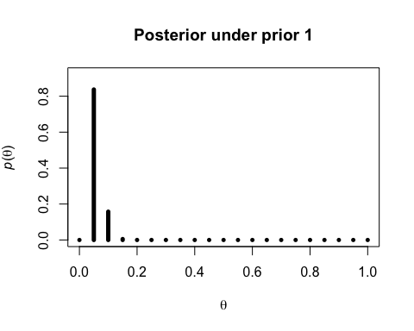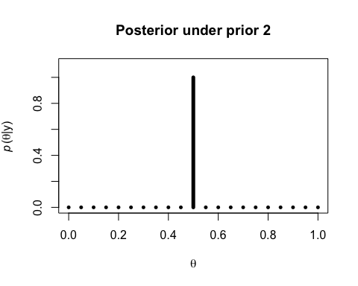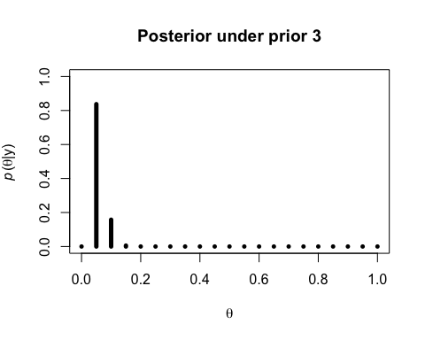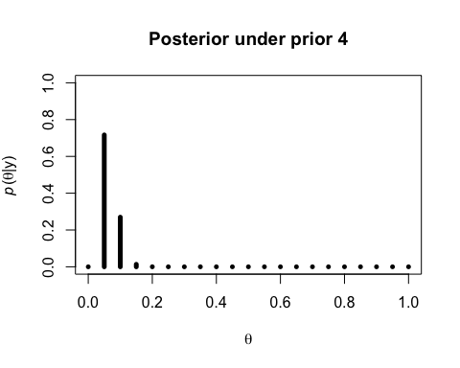

|  |  |  |  |
| --- | --- | --- | --- |
| Expected Value Prior 1 | Expected Value Prior 2 | Expected Value Prior 3 | Expected Value Prior 4 |
| 0.0584 | 0.5 | 0.0584 | 0.0649 |

#### Results

Prior $2$ clearly pulls the posterior towards the right because it forces all $θ′s$ less than $.5$ to have $0$ probability. Prior $3$ yeilds essentially the same results as prior $1$, which makes sense because the likelihood is so skewed towards the range $0,.5$, so excluding $.5,1$ does not change the posterior much. Prior $4$ pushes the posterior slightly upwards, which again makes sense because the prior assigns higher probabilities to higher values of theta, pushing the posterior to the right.

### Problem 3

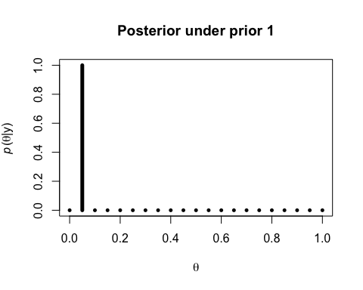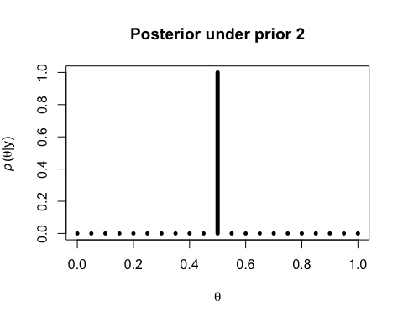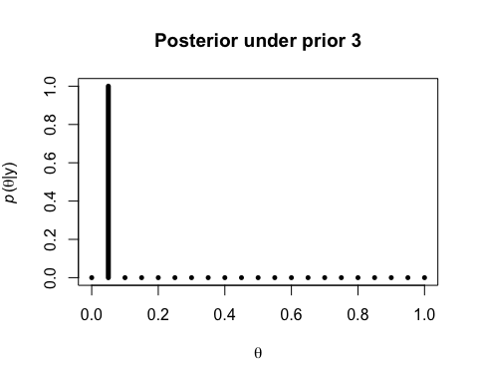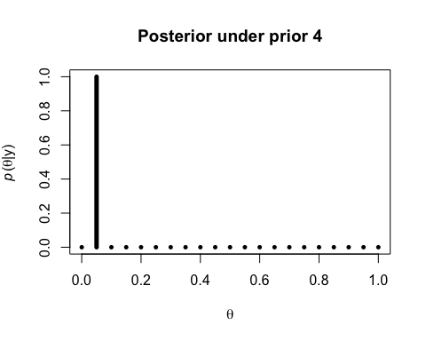

|  |  |  |  |
| --- | --- | --- | --- |
| Expected Value Prior 1 | Expected Value Prior 2 | Expected Value Prior 3 | Expected Value Prior 4 |
| 0.05 | 0.5 | 0.05 | 0.05 |

#### Results

All the priors become much more concentrated around the maximum likelihood estimate of $θ$.

As we get more data the effect of the prior diminishes (which is called "swamping" I think?). This makes more sense, to me at least, if we consider the log posterior.

$$p(θ|y)∝p(y|θ)p(θ)$$

taking logs we see

$$log p(θ|y)∝log p(y|θ)+log p(θ)$$

$$log/p(θ|y)∝log \prod_{i=1}^{n}{L}(θ|y)+log p(θ)$$

where $L(θ|y)$ is the likelihood function.

This becomes

$$log p(θ|y)∝\sum_{i=1}^{n}{l}og L(θ|y)+log p(θ)$$

Now we can clearly see, as $n$ increases the effect of the $log p(θ)$ dimishes since the sum term contributes more than the prior. It is harder for me to see this clearly in the non-log space because we are dealing with multiplication of small numbers.