1.

use chakhidze;

db.createCollection('giorgi')

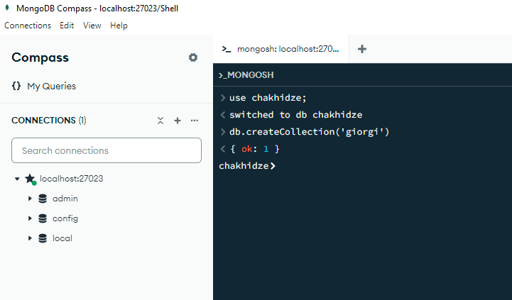

2.

db.giorgi.insertMany([

{

"StudID": 1,

"First_Name": "giorgi",

"Last_Name": "chakhidze",

"CityofRegistration": "Tbilisi",

"Course": {

"CourseID": 101,

"CourseName": "Programming",

"Points": 5

},

"Zip": 0105,

"Address": {

"Street": "Rustaveli",

"HouseNr": 20

}

},

{

"StudID": 2,

"First_Name": "giorgi",

"Last_Name": "chakhvadze",

"CityofRegistration": "Zugdidi",

"Course": {

"CourseID": 102,

"CourseName": "Database Management",

"Points": 6

},

"Zip": 2100,

"Address": {

"Street": "Kostava",

"HouseNr": 15

}

},

{

"StudID": 3,

"First_Name": "giorgi",

"Last_Name": "chikhradze",

"CityofRegistration": "Kutaisi",

"Course": {

"CourseID": 103,

"CourseName": "Mathematics",

"Points": 4

}

},

{

"StudID": 4,

"First_Name": "giorgi",

"Last_Name": "chkhaidze",

"CityofRegistration": "Batumi",

"Course": {

"CourseID": 104,

"CourseName": "Programming",

"Points": 5

}

},

{

"StudID": 5,

"First_Name": "giorgi",

"Last_Name": "chkhartishvili",

"CityofRegistration": "Tbilisi",

"Course": {

"CourseID": 105,

"CourseName": "Database Management",

"Points": 6

}

},

{

"StudID": 6,

"First_Name": "giorgi",

"Last_Name": "chimakadze",

"CityofRegistration": "Zugdidi",

"Course": {

"CourseID": 106,

"CourseName": "Statistics",

"Points": 3

}

},

{

"StudID": 7,

"First_Name": "giorgi",

"Last_Name": "chalamberidze",

"CityofRegistration": "Batumi",

"Course": {

"CourseID": 107,

"CourseName": "Physics",

"Points": 4

},

"Zip": 6010,

"Address": {

"Street": "Chavchavadze",

"HouseNr": 8

}

}

])

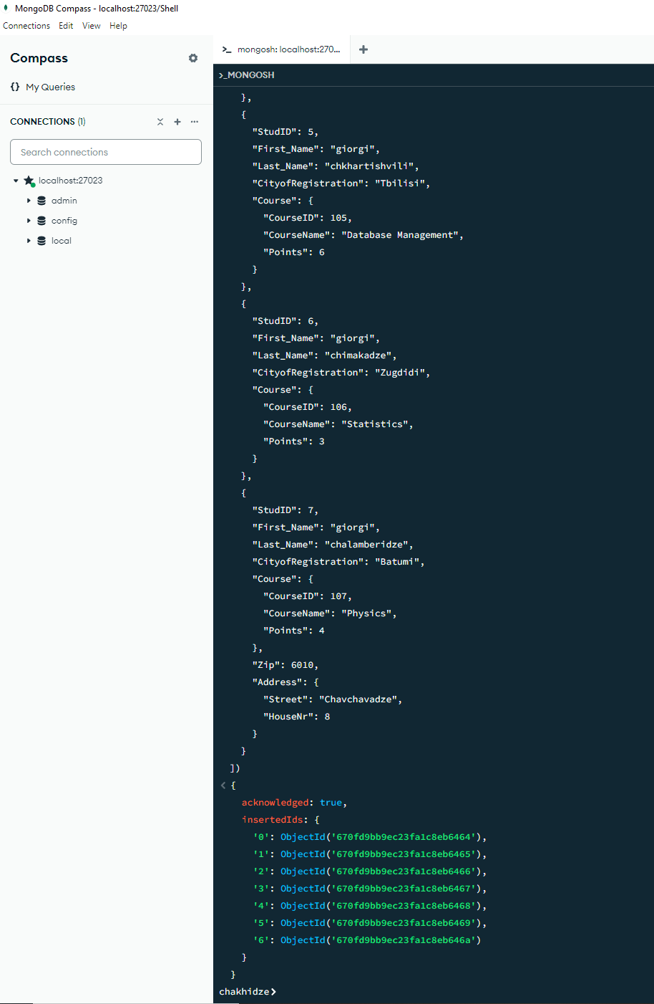

3. db.giorgi.updateMany(

{ "Course.Points": { $gt: 90 } },

{ $set: { "Grade": "A" } }

);

db.giorgi.updateMany(

{ "Course.Points": { $gt: 80, $lte: 90 } },

{ $set: { "Grade": "B" } }

);

db.giorgi.updateMany(

{ "Course.Points": { $gt: 70, $lte: 80 } },

{ $set: { "Grade": "C" } }

);

db.giorgi.updateMany(

{ "Course.Points": { $gt: 60, $lte: 70 } },

{ $set: { "Grade": "D" } }

);

db.giorgi.updateMany(

{ "Course.Points": { $gt: 50, $lte: 60 } },

{ $set: { "Grade": "E" } }

);

db.giorgi.updateMany(

{ "Course.Points": { $gt: 40, $lte: 50 } },

{ $set: { "Grade": "FX" } }

);

db.giorgi.updateMany(

{ "Course.Points": { $lte: 40 } },

{ $set: { "Grade": "F" } }

);

db.giorgi.find()

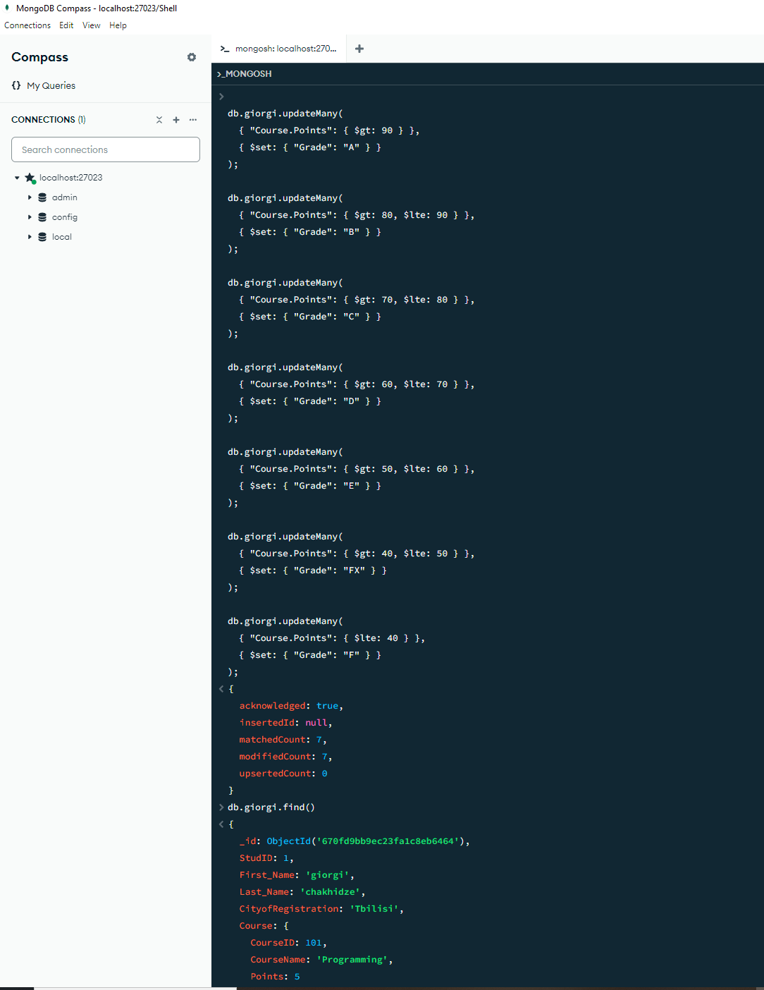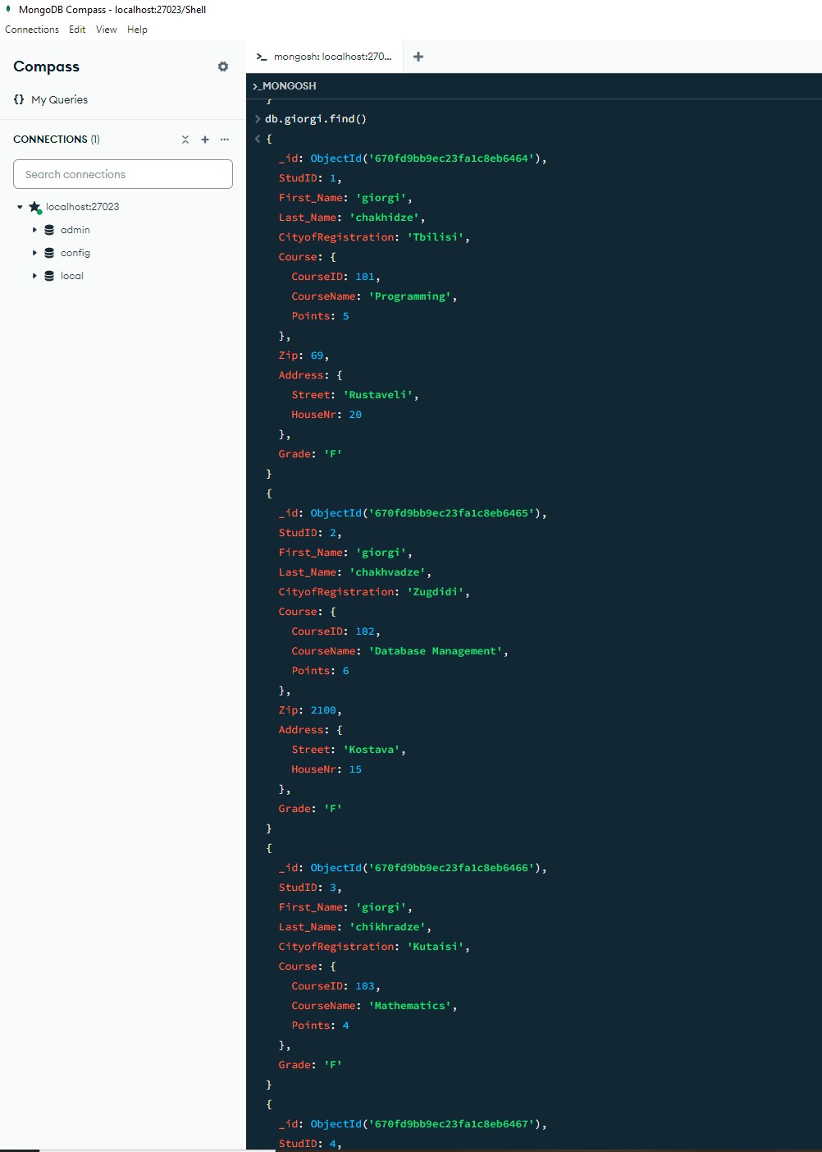

4. db.giorgi.updateMany(

{},

[

{ $set: { "Full_Name": { $concat: ["$First_Name", " ", "$Last_Name"] } } }

]

)

db.giorgi.find({}, { "First_Name": 1, "Last_Name": 1, "Full_Name": 1 }).pretty()

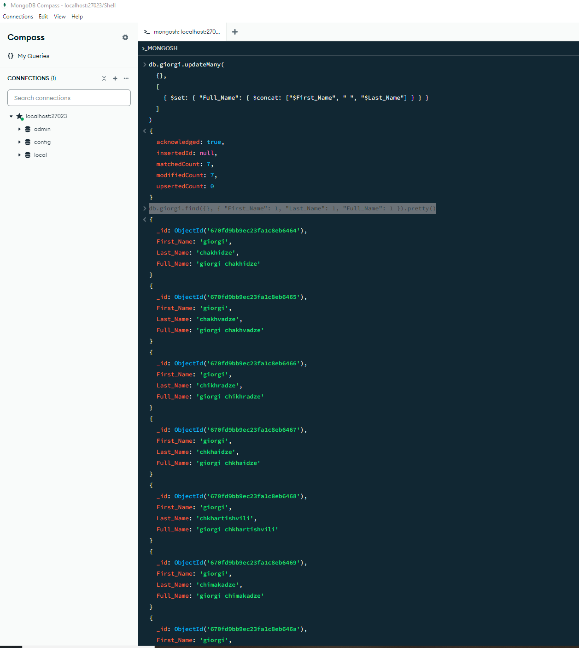

5. db.giorgi.find(

{

"Grade": { $in: ["FX", "F"] },

"CityofRegistration": "Batumi"

}

).pretty()

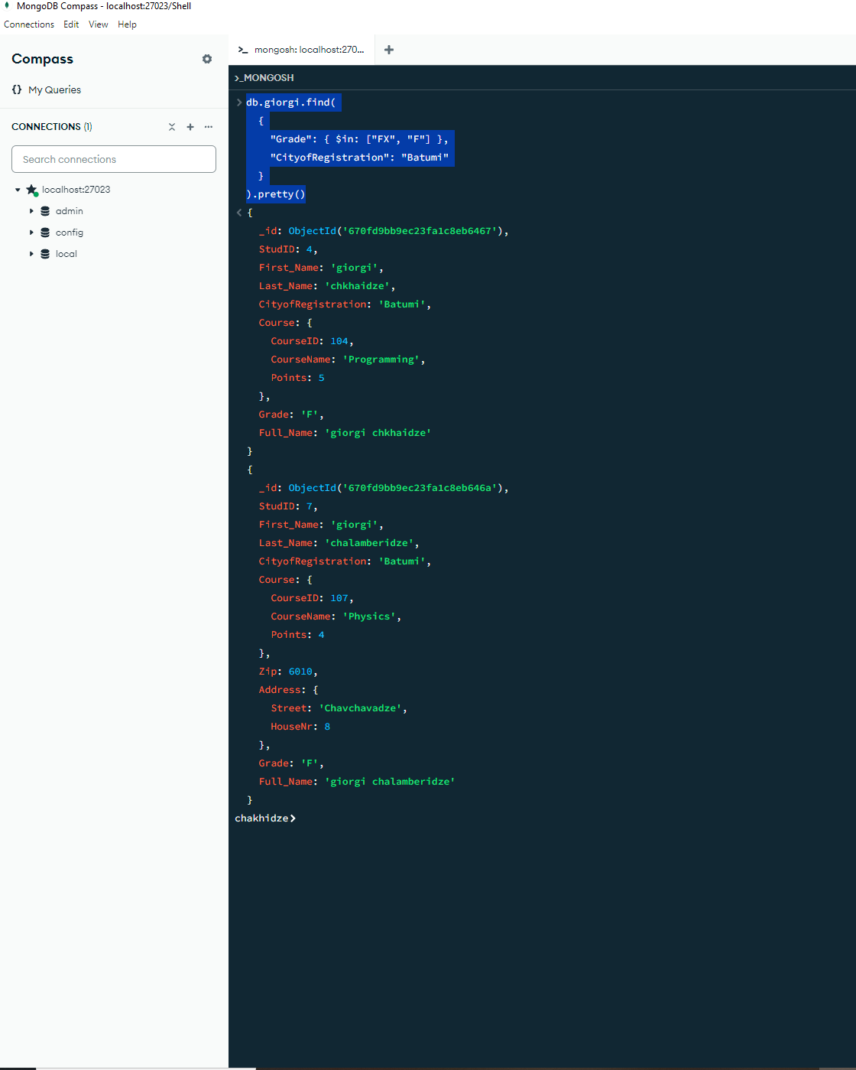

6. db.giorgi.deleteMany(

{

"Course.Points": { $gt: 86 },

"CityofRegistration": "Zugdidi"

}

)

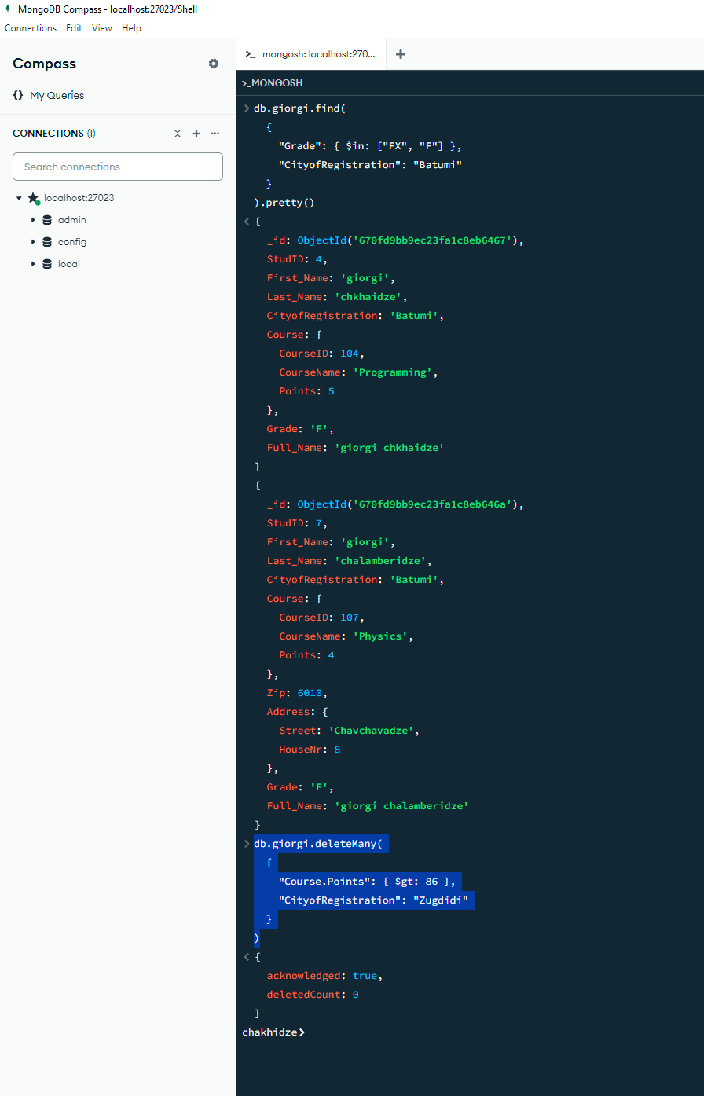

7. db.giorgi.drop()

db.dropDatabase()

