1. db.createCollection("salary")

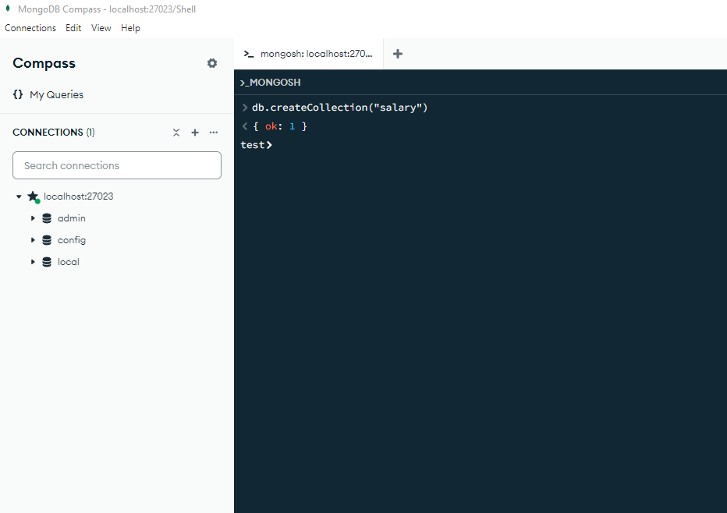

1. db.salary.insertMany([

{

"EmployeeID": "19001001111",

"EmpName": "giorgi chakhidze",

"Department": "Marketing",

"Salary": 5001.00

},

{

"EmployeeID": "19001002222",

"EmpName": "lasha chakhidze",

"Department": "Accounting",

"Salary": 3390.00

},

{

"EmployeeID": "19001003333",

"EmpName": "igori chakhidze",

"Department": "HR",

"Salary": 2850.00

},

{

"EmployeeID": "19001004444",

"EmpName": "merabi chakhidze",

"Department": "Procurement",

"Salary": 3120.00

},

{

"EmployeeID": "19001005555",

"EmpName": "neli chakhidze",

"Department": "Marketing",

"Salary": 1449.00

},

{

"EmployeeID": "19001006666",

"EmpName": "inga chakhidze",

"Department": "Finance",

"Salary": 3650.00

}

])

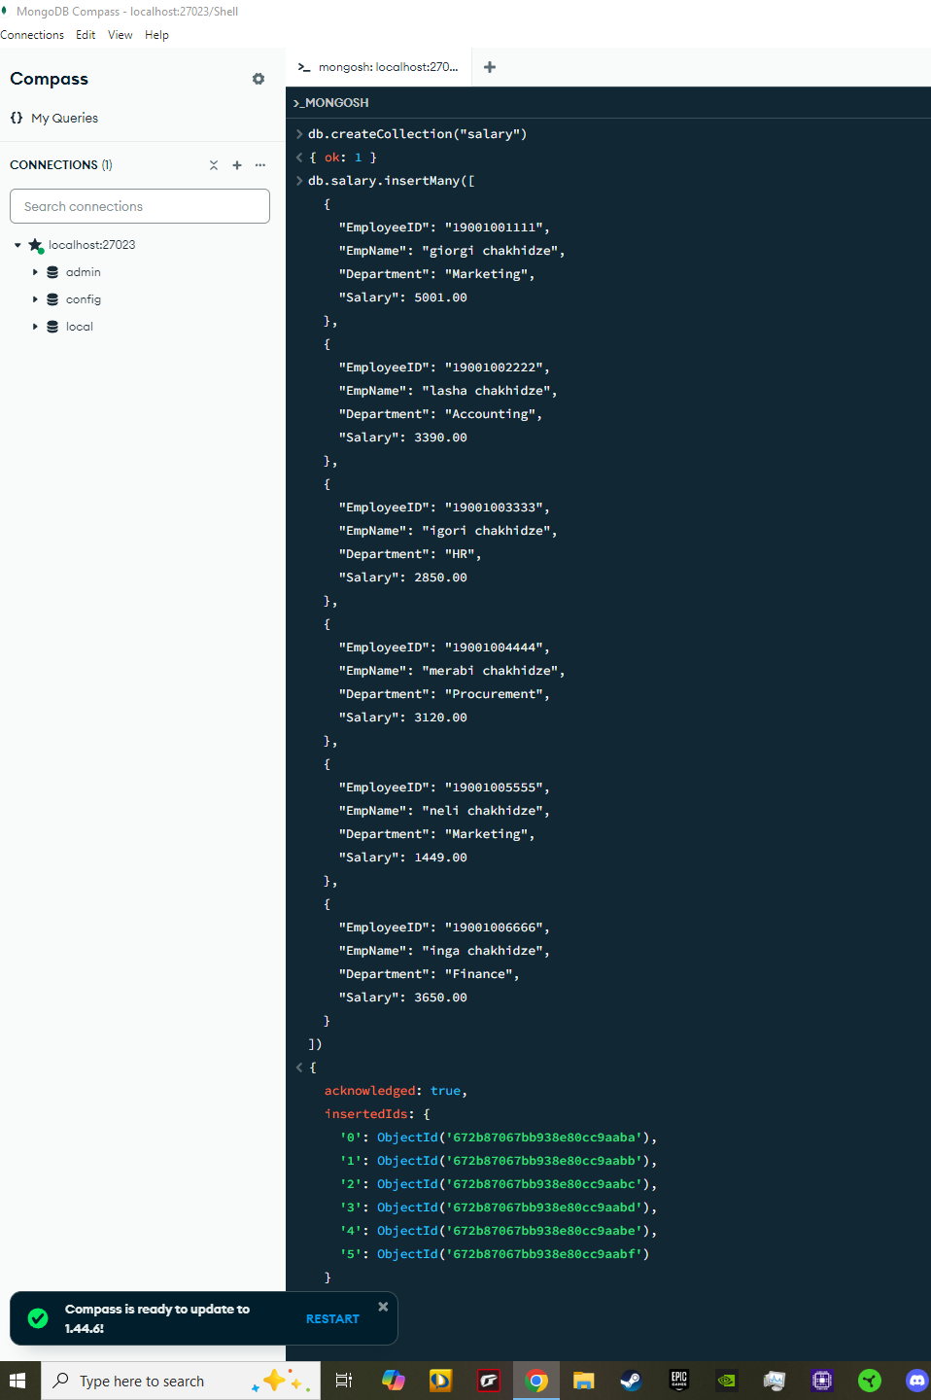

1. db.salary.find(

{

"Department": "Marketing",

$or: [

{ "Salary": { $gt: 5000 } },

{ "Salary": { $lt: 1450 } }

]

}

).pretty()

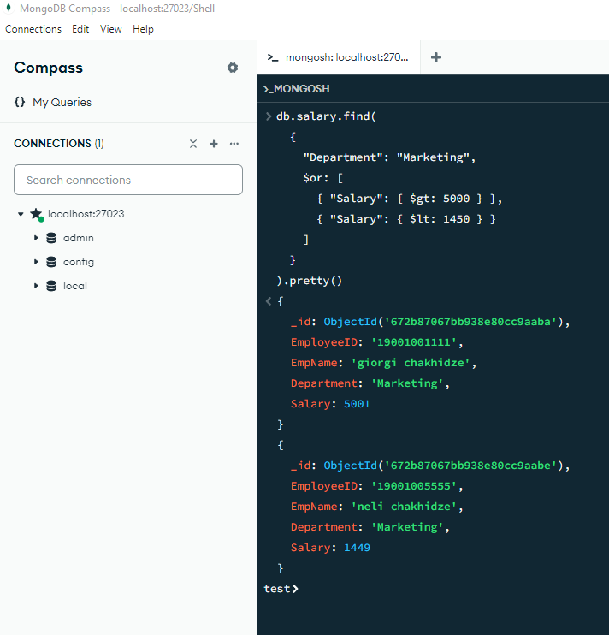

1. db.salary.insertMany([

{

"EmployeeID": "19001001111",

"EmpName": "gio chakhidze",

"Department": "Marketing",

"Salary": 6001.00

}])

db.salary.aggregate([

{

$group: {

_id: "$Department",

totalSalary: { $sum: "$Salary" }

}

},

{

$match: { totalSalary: { $gt: 7000 } }

},

{

$project: {

_id: 0,

Department: "$_id",

totalSalary: 1

}

}

])

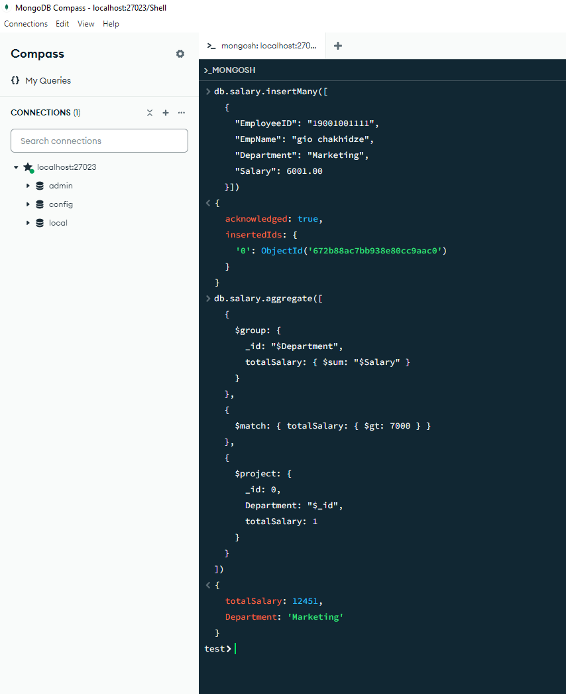

1. db.salary.aggregate([

{

$match: { Department: { $in: ["Marketing", "HR"] } }

},

{

$group: {

_id: "$Department",

avgSalary: { $avg: "$Salary" }

}

},

{

$match: { avgSalary: { $lt: 3000 } }

},

{

$project: {

_id: 0,

Department: "$_id",

avgSalary: 1

}

}

])

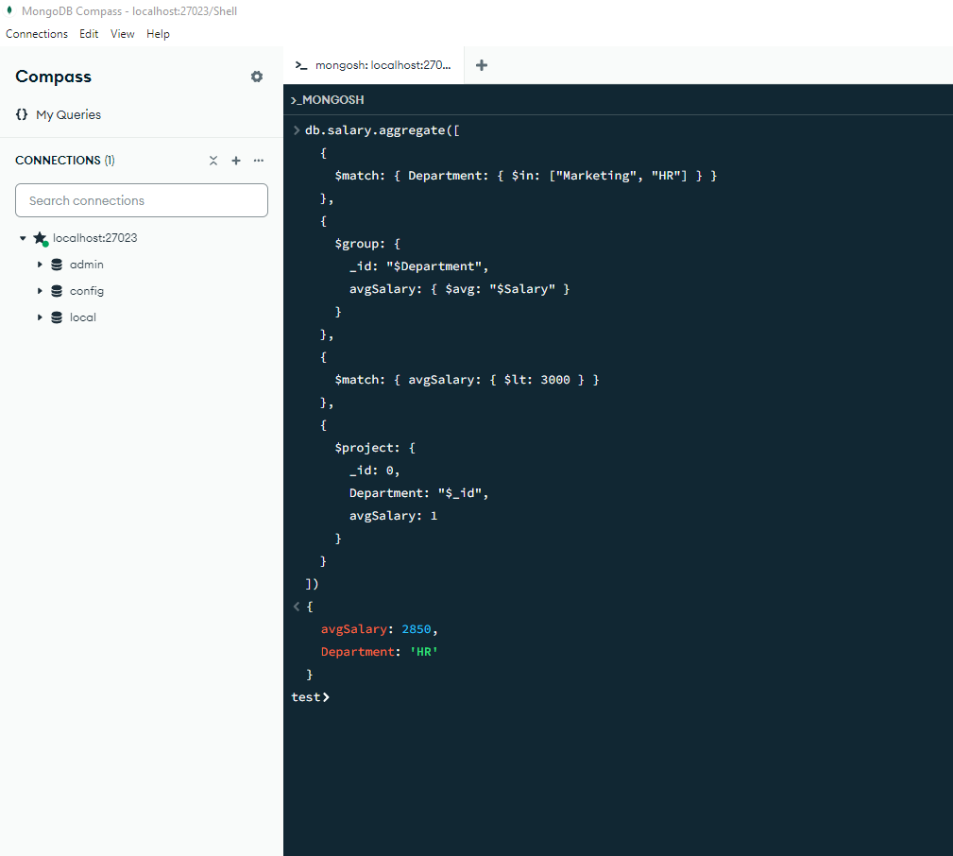

1. db.salary.aggregate([

{

$group: {

_id: "$Department",

Tanamshromlebi: { $sum: 1 }

}

},

{

$project: {

_id: 0,

Departamenti: "$_id",

Tanamshromlebi: 1

}

},

{

$out: "report"

}

])

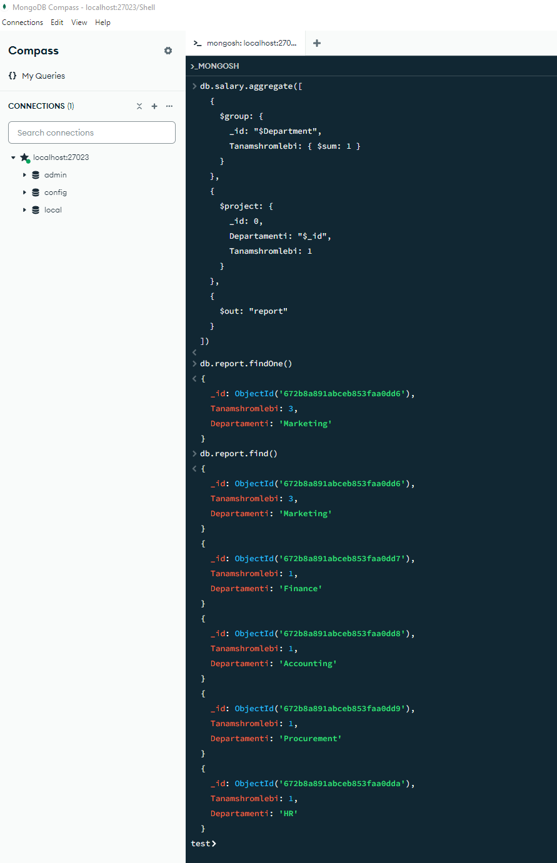

1. db.salary.drop()

