Custom Gauge Image Generator & ICL Optimizer - User Manual

# 1. Prerequisites

Before using this application, ensure you have the following installed on your system:  
- Python 3.8 or later  
- pip (Python package installer)  
  
Required Python libraries:  
- streamlit  
- matplotlib  
- numpy  
- python-docx (optional, only if regenerating this manual via script)  
  
Install them all at once:  
pip install streamlit matplotlib numpy python-docx

# 2. Introduction & App Overview

This tool was built to accelerate GUI development for DWIN HMI displays (https://www.dwin-global.com). It provides live D3.js previews, single or batch gauge exports, and ICL flash-block optimization.

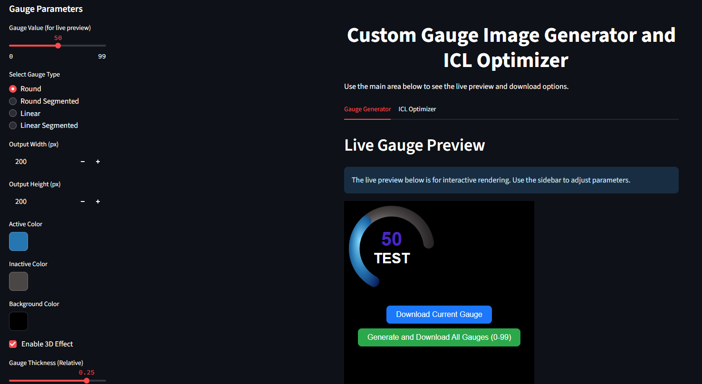Main Interface:

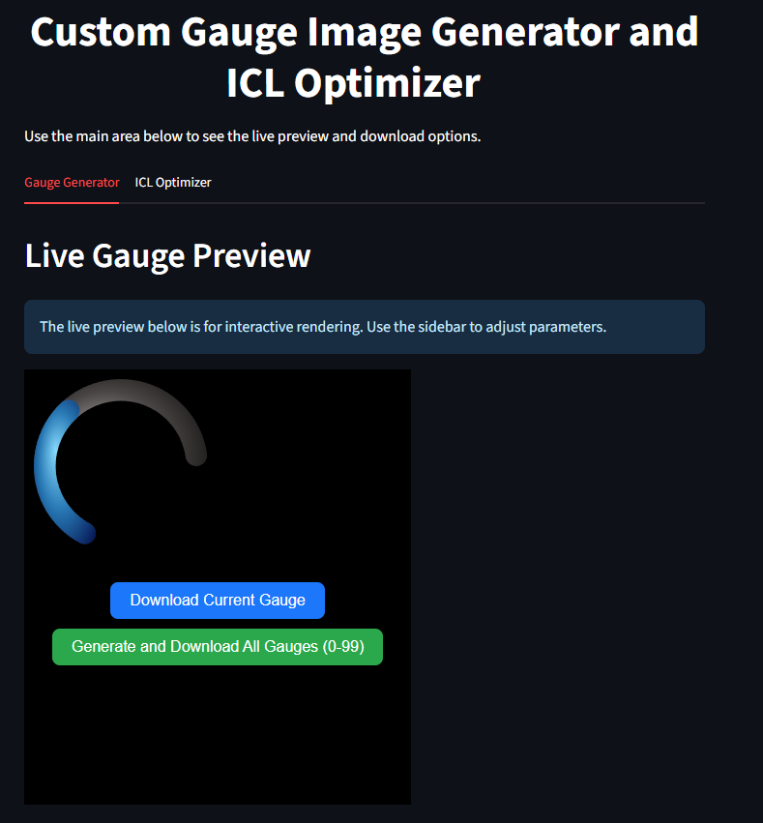

# 3. Gauge Generator Tab

Select the 'Gauge Generator' tab to configure and export gauges.



## 3.1 Live Preview Controls

Use the sidebar controls to adjust your gauge; the preview updates instantly.

Select Gauge Type:

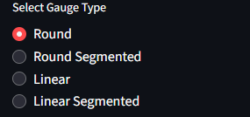

Gauge Value Slider:

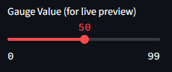

## 3.2 Export Buttons

Download your current gauge or batch-generate all (0–99) PNGs: 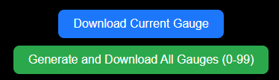

## 3.3 Size Inputs

Set the dimensions for your exported gauge: 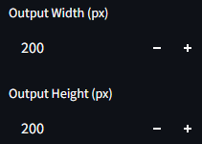

## 3.4 Color Pickers & 3D Effect

Choose active, inactive, and background colors, and toggle 3D effect: 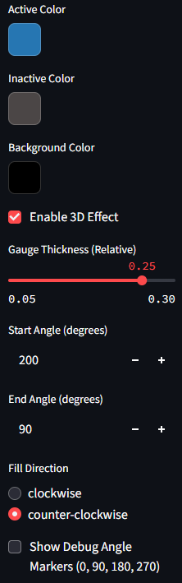

## 3.5 Specific Gauge Settings

Configure thickness, angles, fill direction, tip style, and segmentation: 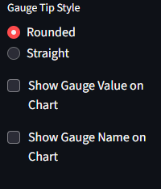

## 3.6 Labels & Gauge Name

Toggle value and name overlays and choose colors:



## 3.7 Live Preview Output

The live preview reflects exactly what will be exported:

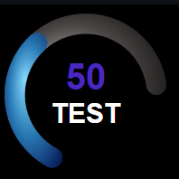

# 4. ICL Optimizer Tab

## 4.1 Upload ICL Files

Drag & drop or browse to upload your .icl modules, then set the block range:

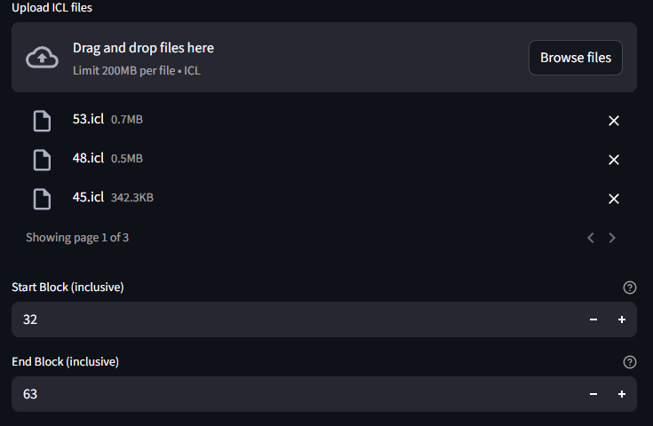

## 4.2 Original Address Allocation Check

Review the original planning: file sizes, blocks used, start/end blocks, and status.

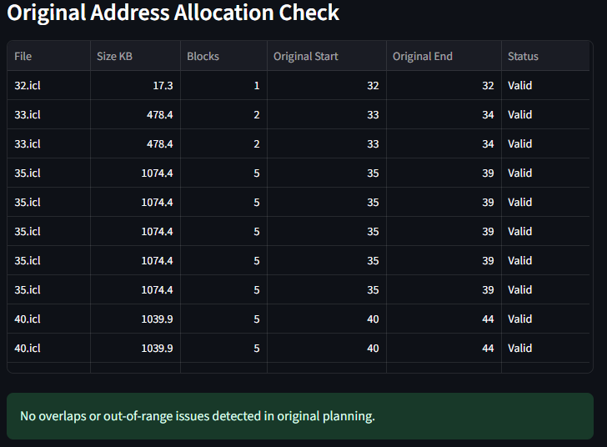

No overlaps or out-of-range issues detected if all statuses are Valid.

## 4.3 Optimized (Non-Overlapping) Packing Proposal

The optimizer reassigns start/end blocks to eliminate any conflicts. New filenames are prefixed.

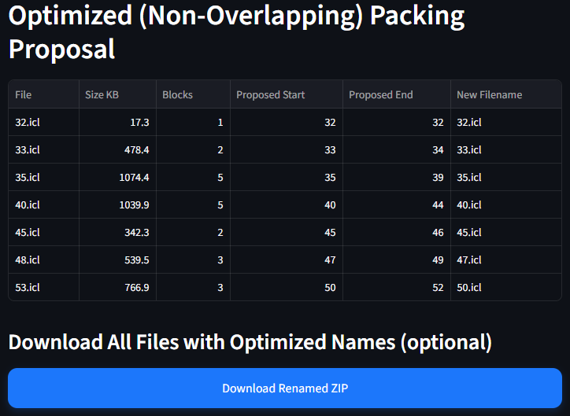

Use 'Download Renamed ZIP' to grab all optimized .icl files.

## 4.4 Block Allocation Map

Visualize memory usage: gray=free, blue=occupied, red=overlap/out-of-range.

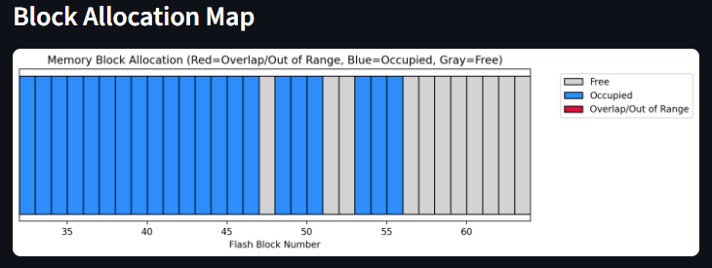

# 5. Tips & Troubleshooting

- Keep 'Show Value/Name' off for linear gauges.  
- For high-res exports (>600px), previews may slow.  
- Ensure .icl filenames match intended start blocks.