**Mathematical model for tolerance/resistance**

**Gilles Charvin**

**05/06/2024**

This document provides several minimalist versions of an ODE model to determine the interplay between resistance and tolerance during the physiological adaptation to hydrogen peroxide. It is originally based on the initial model developed in Goulev et al, and was updated from new hypotheses formulated by Yusuke Himeoka.

**Core model**:

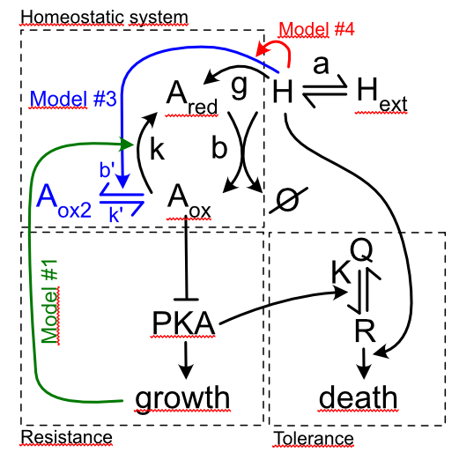

Homeostatic system

All the different versions described below are based on the same assumptions regarding the homeostatic system:

* H2O2 diffuses passively across the cell membrane (rate constant *a*). Sources of H2O2 can be external (*Hext*) or internal (rate constant *e*).
* Internal H2O2 (variable *H*) reacts (with a rate constant *b*) with reduced peroxiredoxins (*Ared*), leading to an oxidized form of the peroxiredoxin (*Aox*). Aox can be reduced (with a rate constant *k*) by NAPDH and NADPH-dependent enzymes.
* Antioxidants are expressed in response to internal hydrogen peroxide (rate constant g).
* Oxidized antioxidants negatively regulate PKA activity, which directly controls cell growth rate (m). Growth is required for antioxidants production and dilutes all the compounds of the system. This is called the “resistance module”.
* Tolerance

According to this core model, one can write the following equations that govern the dynamics of the system :

$\frac{dH}{dt}=e+ a \left(H_{ext}-H\right)-b A_{red}H- μH$ Equation (1)

$\frac{dA}{dt}=g μ H- μ A$ Equation (2)

Additionally, we assume that the redox reactions occurs on a much faster timescale than regulatory events (e.g. antioxidants productions and dilution). Hence we neglect the dilution of H202 in equation (1) and we also assume that antioxidant reactions are at equilibrium at all times :

$A_{red}+H \underset{⇔}{\frac{b}{k}}A_{ox}$

Leading to : ${b A}_{red} H=k A_{ox}$ Equation (3)

Then, since : $A_{red}+A_{ox}=A$

We get: $A_{red}=A \frac{1}{1+\frac{b H}{k} }$ and $A_{ox}=A \frac{\frac{b H}{k}}{1+\frac{b H}{k} }$ Equation (4) and (4b)

This means that the fraction of oxidized antioxidant increases as internal hydrogen peroxide increase.

Resistance module

Last, we assume that the growth rate is controlled by the fraction of oxidized antioxidants, as follows:

$μ=μ_{0} \left(1-\frac{A_{ox}}{A}\right)= \frac{μ_{0}}{1+\frac{b H}{k}}$ Equation (5)

Indicating that the growth rate declines as internal hydrogen peroxide increases.

We then introduce several additional hypotheses to make the model more tractable or to refine the hypotheses.

Tolerance module

We assume that there is a cellular component R that makes the cells sensitive to hydrogen peroxide, yet it can be protected when converted to a Q state, which is immune to peroxides.

The conversion from R to Q is driven by the activation of PKA. When PKA is inhibited, cells favor a protective state.

We assume that the conversion between R and Q is fast with respect to the timescale associated with the homeostatic system. Hence, we note K the equilibrium constant between Q and R. According to equation (5), we assume:

$$K=K_{0} \left(1-\frac{A_{ox}}{A}\right)$$

However, this conversion still requires cell growth, hence, growth arrest prevents any change in the partitioning between the two states. Somehow, this model assumes that tolerance is driven by the initial state of the cells, and protective effects cannot be enabled when the cells freezes.

The death rate is proportional to R and H at all time.

Based on these assumptions, the equilibrium concentration for R ad Q is given by:

$$Q_{eq}=\frac{R_{0}}{K+1}= \frac{R_{0}}{K_{0}\left(1-\frac{A_{ox}}{A}\right)+1}$$

$$R_{eq}=\frac{K R_{0}}{K+1}= \frac{K_{0}\left(1-\frac{A_{ox}}{A}\right)R_{0}}{K_{0}\left(1-\frac{A_{ox}}{A}\right)+1}$$

**Model #1: antioxidant reduction fueled by cell growth**

In this model, we assume that the reaction associated with antioxidant reduction is controlled by growth. Equation (3) becomes:

${b A}_{red} H=k A_{ox} \frac{μ}{μ_{0}}$ (equation 3b)

Then, equation (4) becomes:

$μ=μ_{0} \left(1-\frac{A_{ox}}{A}\right)= \frac{μ_{0}}{1+\frac{b Hμ_{0}}{k μ}}$ (equation 5b)

If we re-arrange equation (4b), we obtain :

$μ=μ_{0} \left(1-\frac{bH}{k}\right)$ (equation 6)

This means that growth is zero if the internal hydrogen peroxide level is beyond a threshold value k/b. This is the exact definition of the Minimum Inhibitory Concentration (or MIC).

Hence combining equation (6) with equation (3b), we get :

$A_{ox}=A\frac{H}{k}$ (equation 7)

Equilibrium in response to steps and ramps

If we use equation (6), (4b) and (7), we can write equation (1) as:

$\frac{dH}{dt}=e+ a \left(H_{ext}-H\right)-b A H (1-\frac{bH}{k})$ (equation 8)

At equilibrium, in the (H, A) hyperspace, the nullclines based on equation (2) and (8) provide:

$A =\frac{\left(e+ a \left(H_{ext}-H\right)\right)}{b H (1-\frac{bH}{k})} and A =g H$ (equation 9 and 10)

The plots below display the nullclines obtained for Hext < b/k and Hext > b/k (here we assume e=0 for sake of simplicity; b=1 and k=0.6).

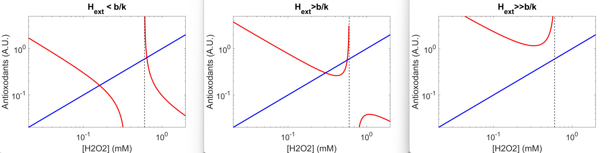

On all these plots, the red curve corresponds to equation 9 and the blue curve to equation 10 at steady-state. The dashed line indicate the asymptote corresponding to H=b/k. On the left and middle plots, there are 2 fixed points (left one is stable, right one is unstable). On the right plot, there is no fixed point, the external H2O2 overwhelms the homeostatic system and the final H2O2 concentration equals Hext.

Stress resistance in step vs ramp

Now, even when there is a stable fixed point, there is limited basin of attraction when switching from 0mM H202 to Hext (step stress pattern). When Hext < 0.6mM, the system converges towards the stable fixed point (adaptation mediated by the homeostatic system, see red and blue curves). Beyond this value, the system diverges away from the fixed point: there is no hydrogen peroxide detoxification (H~Hext at steady state), antioxidant production is limited and arrests due to growth arrest (yellow and magenta curves). The nullclines are indicated as colored dashed lines for each concentration.

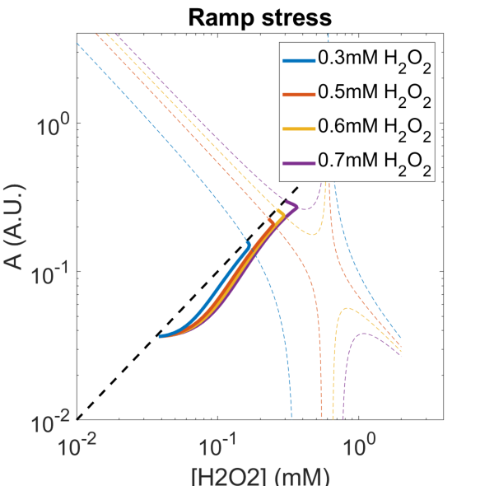

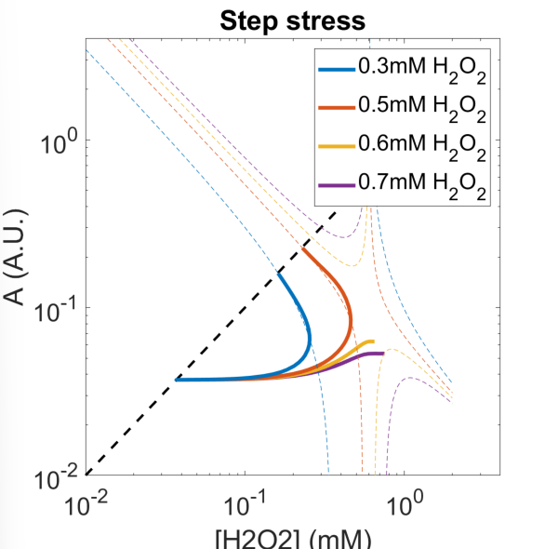

Unlike step stress patterns, slow rising stress ramps (see right panel on the figure) allow the system to converge to the stable fixed point. Hence, this model adequately describes the gain in resistance observed in ramping stress compared to step stress.

In step stress, the sharp transition to arrested growth when increasing H202 level can be observed when looking at the dynamics of the system, as shown in the next figure (left panel). Instead, growth does not arrest under ramping stress (right panel), and the homeostatic system prevents an important increase in internal H2O2 level.

**Step stress** **Ramp stress**

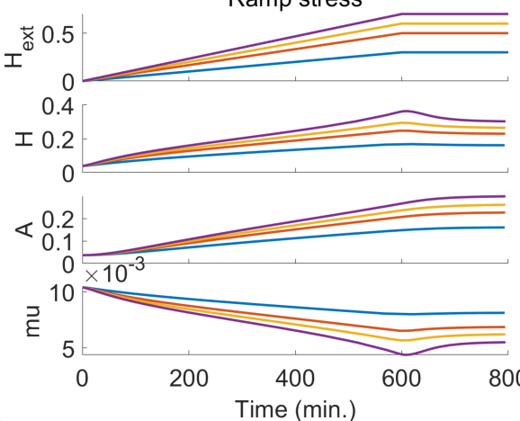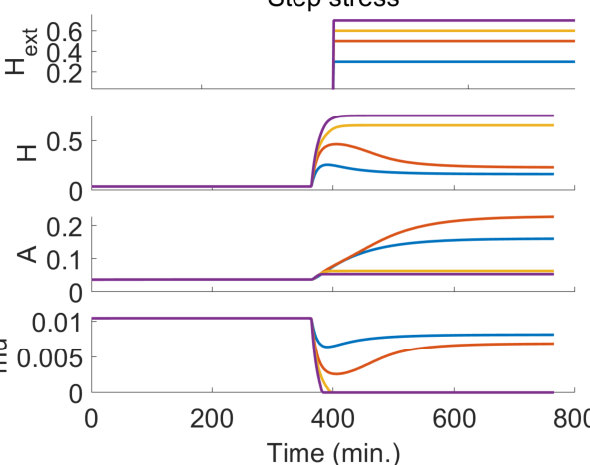

Stress tolerance

According to model #1 assumptions, the steady state for R is given by:

$$R_{eq}=\frac{K R_{0}}{K+1}= \frac{K_{0}\left(1-\frac{A_{ox}}{A}\right)R_{0}}{K_{0}\left(1-\frac{A_{ox}}{A}\right)+1}= \frac{K_{0}\left(1-\frac{bH}{k}\right)R_{0}}{K_{0}\left(1-\frac{bH}{K}\right)+1}$$

The death rate g in the tolerance regime is given by:

${g \sim R}_{eq}H$

Where Req is the level of R before stress exposure (R=Req at all times when growth is arrested) and H is the real-time H concentration. Therefore, in the tolerance regime, is a growing function of H.

Mutants phenotypes

*zwf1D* mutant

In this mutant, the low level of NADPH precludes the efficient recycling of Aox into Ared. This can be modeled as a reduction in k. Reducing k leads to a direct decrease in the MIC, hence reduced resistance as can been on the figure below (using k=0.3mM). The lines in red (resp. blue) represent the mutant (resp. the wt). On the left plot, one can see the shift in the asymptotes towards the left (each set of lines represents an H2O2 concentration: 0.1mM, 0.2mM, 0.3mM). Dashed lines represent the nullclines. On the right panel, the decline in growth rate of the mutant is quite obvious.

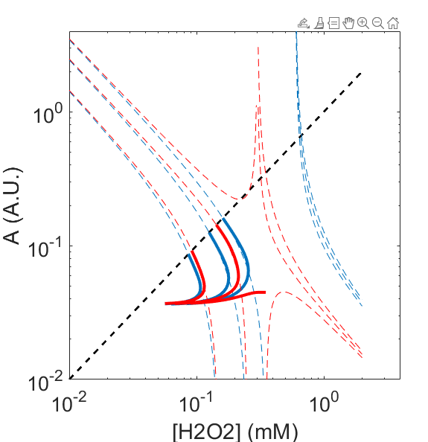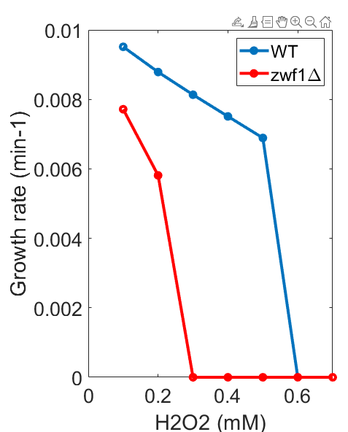

Yet, since the scavenging capacity does not change (b is identical), for small values of H, there is no change in the efficiency of the homeostatic system, in contrast with the experimental data. This can be perceived mathematically by noticing that A= F(H) in equation (9) is only dependent on b but not on k for small H values. It can also be seen on the left panel by noticing that final H (at 0.1mM for instance) is not different in the mutant compared to the WT.

This has a strong implication because it means that the internal redox balance of the mutant is not much perturbed at low H2O2 in the mutant, in contrast to our experimental observations. Since the death rate is greatly dependent on the initial state of the cells (as explained above in the tolerance section), it is very difficult to have the emergence of an increased tolerance, because the partitioning between R and Q depends on the H value before stress exposure. If there is no strong difference in H, then there is no hyper-tolerance.

*pde2D* mutant

A pde2D mutant is such that there is roughly no decline in PKA activity when A is oxidized. In the context of this model, this mutant has an infinite MIC, and this mutant is only limited by its ability to tolerate stress. Since R cannot be converted into Q, R=R0 and the death rate is higher than in the WT, which has a (limited) reduction in R before stress exposure.

*zwf1D* *pde2D* double mutant

This mutant does not experience any PKA inhibition (and thus no particular protection). There is no decline in growth rate with increasing H. The redox balance is slightly impaired compared to a pde2d mutant, hence, overall, tolerance is decreased (but not much, as explained above) compared to WT. Hence this mutant is not particularly well described by the model #1.

*PrxD* mutant

In this case, the scavenging rate b is decreased compared to WT. As expected, H at steady state is larger than in the WT and the homeostatic system is impaired (H202=0.1, 0.2, 0.2mM in the bottom left panel below). However, reducing the scavenging rate also means that the oxidation of A occurs for higher values of H, hence, the MIC of the mutant appears to be slightly higher than WT (see right panel below). Here there might be a confusion since, in theory, a Tsa1delta mutant should be modeled as a complete lack of scavenging. In addition, Aox could actually represent oxidized thioredoxins, which are presumably not oxidized in the a tsa1 delta mutant. Altogether, this discrepancy illustrates the difficulty to really take all the mutants data into account.

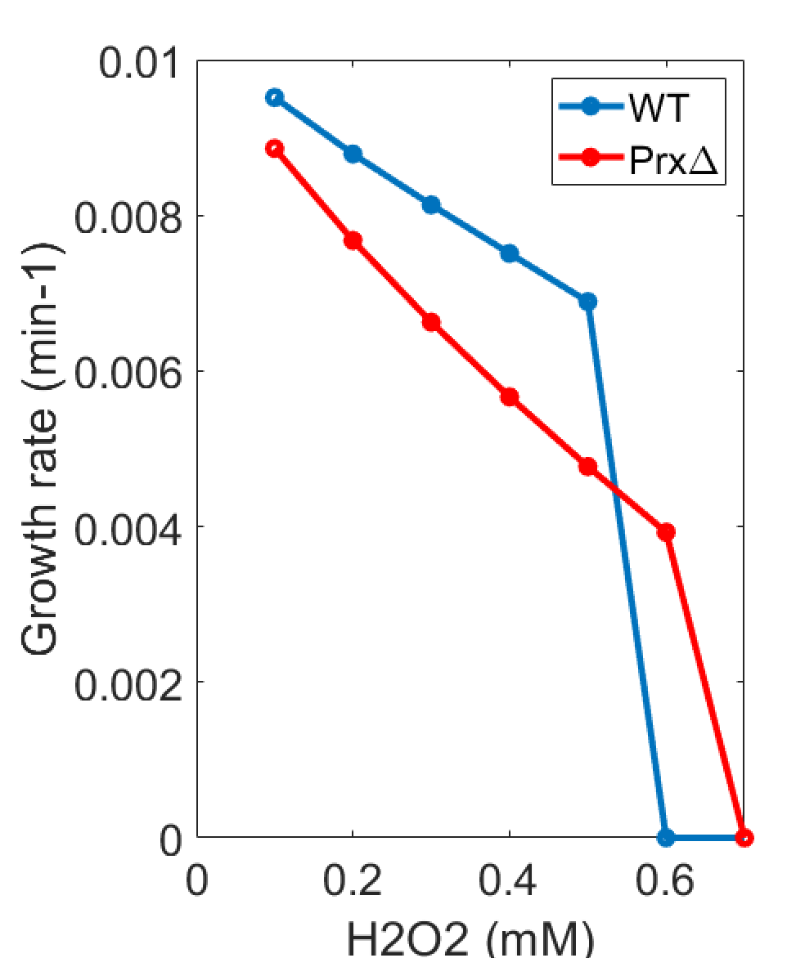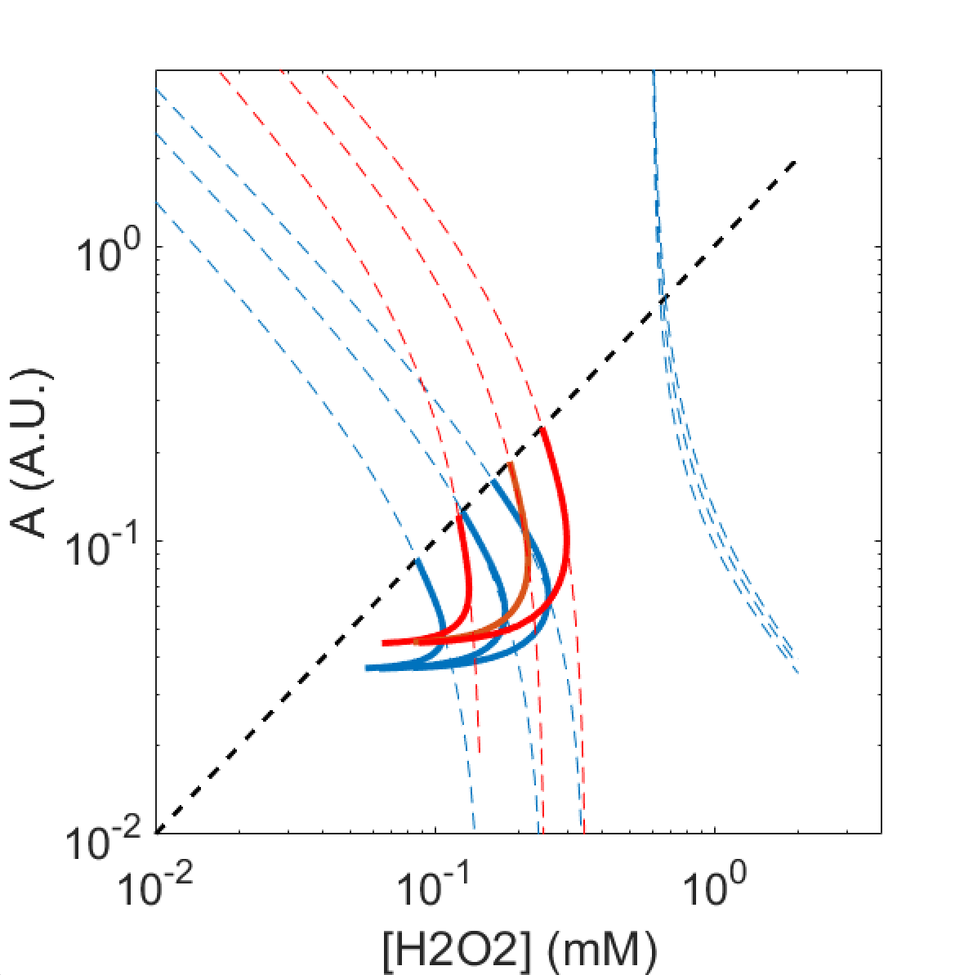

**Model #2: the “base” model**

Model #1 has several issues. Before all, it does not well model the lack of redox balance in the zwf1delta background at low H2O2 concentrations. The assumption that A reduction is fueled by cell growth is not well justified, even though it makes the model more tractable mathematically and introduces a non-linearity in the model that induces a sharp growth arrest.

In this version of the model, we make no particular assumption regarding the recycling of Aox into Ared.

Since : $A_{red}=A \frac{1}{1+\frac{b H}{k} }$ (derived from Equation (4)), equation (1) can be written as :

$$\frac{dH}{dt}=e+ a \left(H_{ext}-H\right)-b \frac{A}{1+\frac{bH}{k}}H$$

Equilibrium in response to steps and ramps

The nullclines that define the steady-state become:

$$A =\frac{\left(e+ a \left(H_{ext}-H\right)\right)\left(1+\frac{bH}{k}\right)}{b H } and A =g H$$

In this case, the nullclines are such that there is one stable state, no matter the value of external H202, as can be seen below (red, resp. blue, lines for the first, resp. second nullcline).

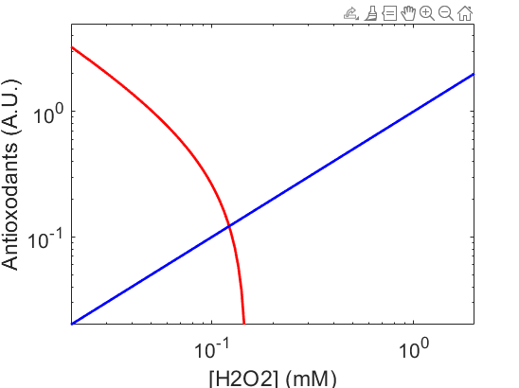

Stress resistance in step vs ramp

Based on equation (5) derived above, the growth rate m depends on H as follows:

$μ=μ_{0} \left(1-\frac{A_{ox}}{A}\right)= \frac{μ_{0}}{1+\frac{b H}{k}}$ (equation 5)

Therefore, in response to a stepping stress, an increase in H induces a transient slowdown in the growth rate (see below). Yet, unlike model #1, there is no irreversible arrest in cell growth and the homeostatic range is not limited, i.e. cells can adapt to an arbitrarily high concentration of H2O2. The reason for this behavior is either that the effect of H on growth rate lacks a storng non-linearity, or because there is a missing feedback of H on antioxidant production.

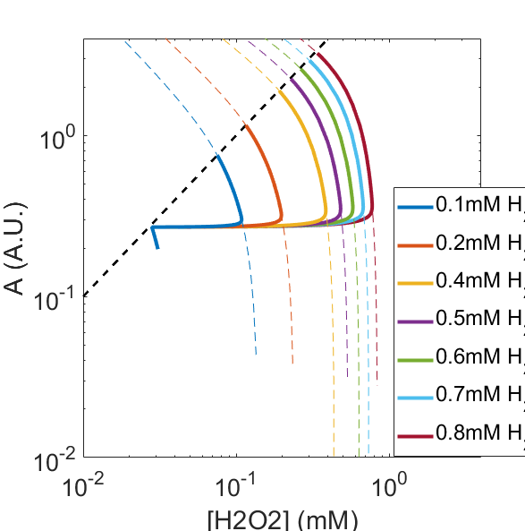

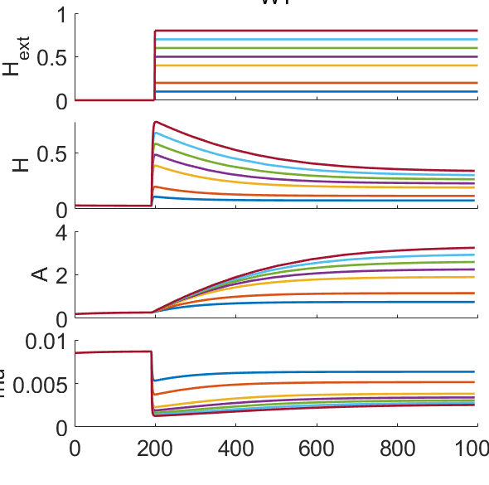

To explore the former hypothesis, in the following, we assume that the oxidation of A has a stronger non-linear dependency on H.

**Model #3: the non-linear model**

Model #3 assumes that Aox, like peroxiredoxins, can be further oxidized as Aox2 by reacting with one more molecule of H2O2 (rate constant b’) and be reduced (rate constant k’). The super-oxidation of peroxiredoxin is a well known feature of peroxiredoxins. It is investigated here as a way to justify the non-linearity in peroxiredoxin oxidation as a function of H. Under these assumptions, the equations that govern the partitioning between, Ared, Aox and Aox2 are:

$$A_{red}+A_{ox}+A_{ox2}=A , b H A_{red}=kA_{ox} , b^{'}H A_{ox}=k^{'}A_{ox2}$$

Hence, Ared writes:

$$A_{red}=\frac{A}{1+\frac{b}{k}H+\frac{bb'}{kk'}H^{2}}$$

This means that both the H2O2 scavenging rate and the reduction in cell growth can follow a quadratic law (provided the linear term is negligible), as follows:

$\frac{dH}{dt}=e+ a \left(H_{ext}-H\right)-b \frac{A}{1+δH^{2}}H$

And :

$$μ=μ_{0} \left(1-\frac{A_{ox}}{A}\right)= \frac{μ_{0}}{1+δH^{2}}$$

Where : $$δ=\frac{bb'}{kk'}$$

Stress resistance in step stress

Although, this model is very similar to the base model, the non-linearity in A oxidation leads to an important decreases in scavenging capacity if H goes beyond a threshold ~1/d. Hence, above this value, the growth rate drops dramatically and so does the antioxidant production rate. Hence the time to reach a steady-state increases a lot beyond this threshold. This indicates that a non-linearity in antioxidant oxidation is key to observe the emergence of sharp resistance limit.

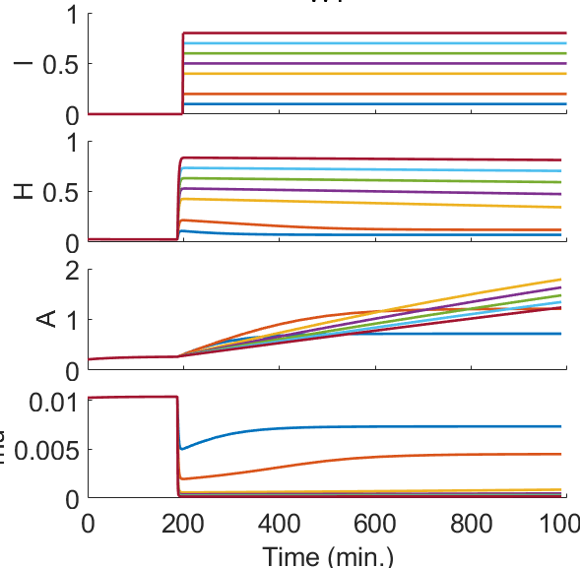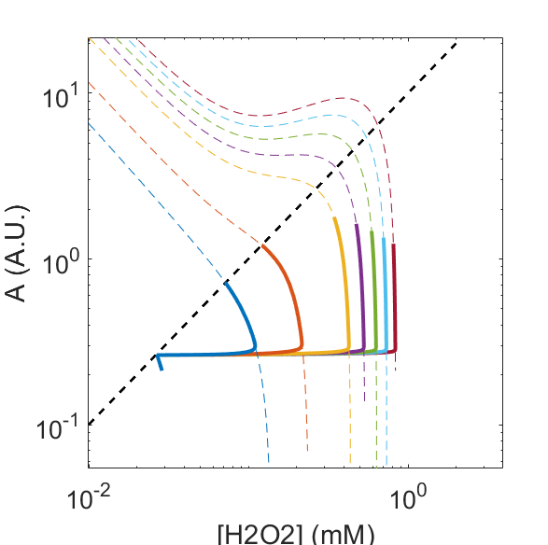

General non-linear model

The shape of the nullclines (above) at high H2O2 concentration also reveal that the system is close to displaying multistability, which could potentially lead to a much sharper resistance limit. To investigate this, in the following, we assume that growth rate depends on H as follows :

$$μ=μ_{0} \left(1-\frac{A_{ox}}{A}\right)= \frac{μ_{0}}{1+δH^{n}}$$

This can be justified that the thiols groups of peroxiredoxins cysteines can be further oxidized as SO3H. The equation of evolution H also becomes:

$$\frac{dH}{dt}=e+ a \left(H_{ext}-H\right)-b \frac{A}{1+δH^{n}}H$$

Below are displayed the nullclines for n=3, with Hext=0.1mM, 0.25mM, and 0.5mM. These nucllines reveal a quite sharp transition from a “low” H stable state to a “high” H stable state as the external H202 concentration increases.

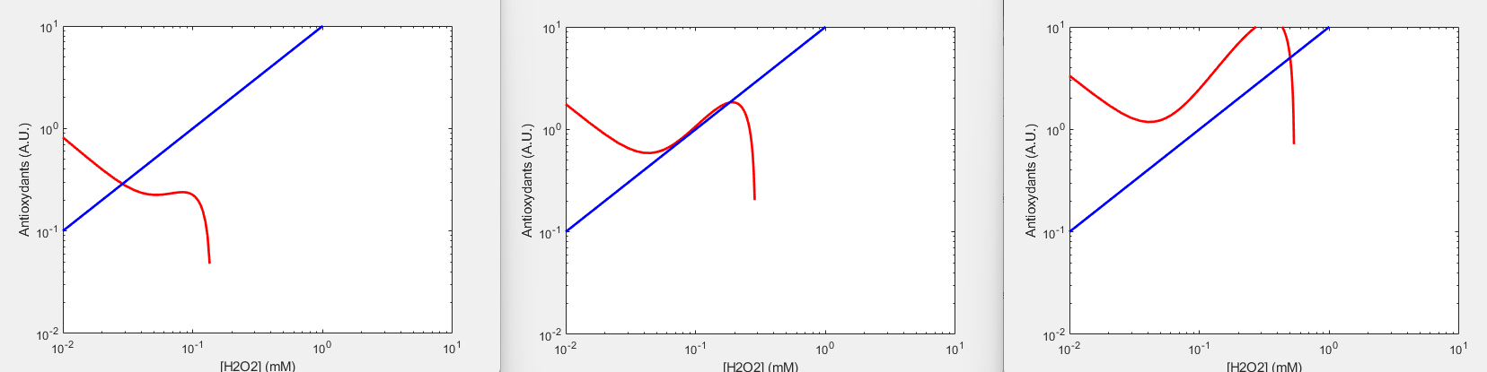

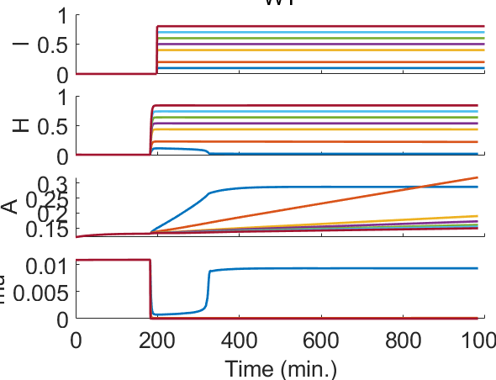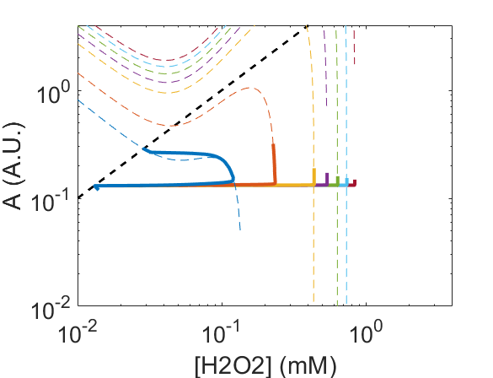If we now consider the dynamics of the system with this set of parameters, we see that, beyond 0.1mM, internal H becomes so high that the system is unable to reach the stable state within the duration of the simulation (see figures below). This behavior is not so different from that observed in model #1 above, even though the stability landscape is quite different.

Adjusting d and b values allows us to get a resistance limit that is closer to that observed experimentally. Yet, the ability of the system to recover long after stress exposure does not really ressemble our experimental observations. The simulation shows that the system is very unstable at intermediate H2O2 concentrations.

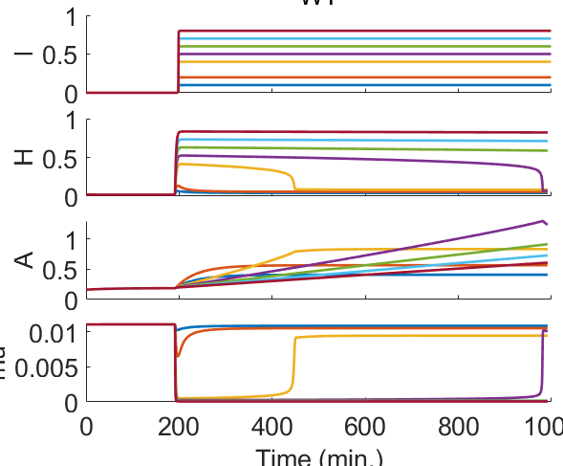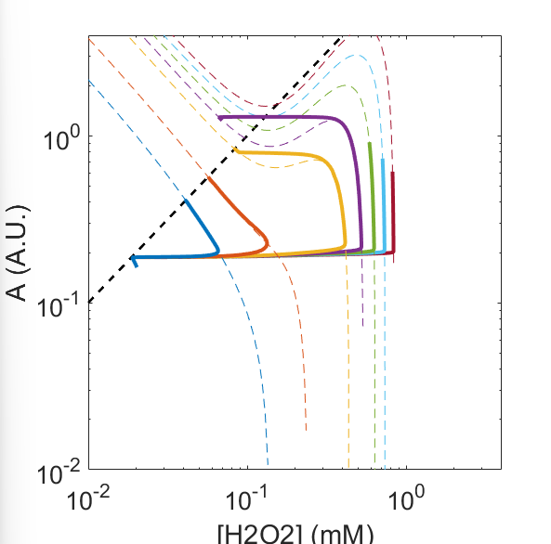

Stress stress versus ramps

As expected, better stress adaptation can be achieved when cells are submitted to ramps compared to step stresses, see figure below. Yet, the geometry of the nullclines indicates that the system is also very unstable at high H2O2 in response to ramping stresses.

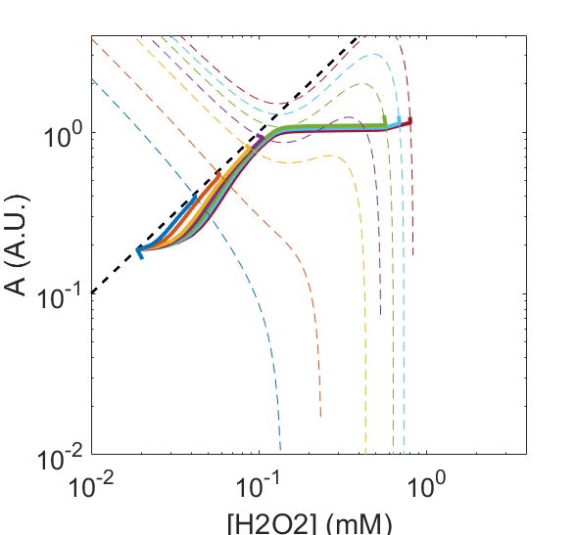

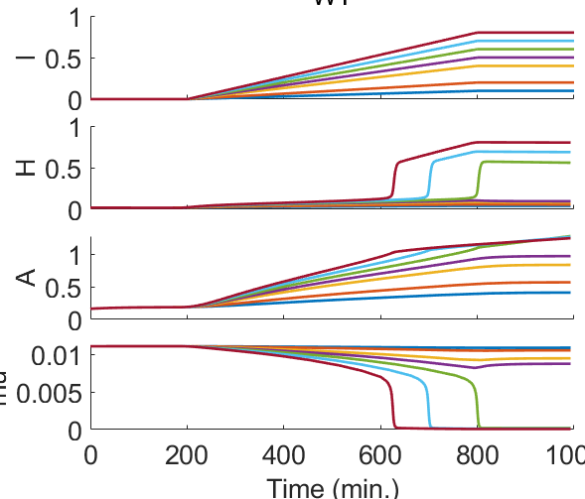

Tolerance

To be done ….

Mutants

*zwf1D* mutant

This mutant can be modeled by decreasing the value of k, leading to an increase in d. This leads in an almost complete growth arrest beyond 0.2mM. Interestingly, antioxidant production is not completely stalled beyond this point. Hence, unlike model #1, there is a slight decoupling between antioxidant production and growth, which makes this model slightly more realistic. Yet, a major issue is that the steady state H concentration is quite similar in the mutant and the WT below the MIC. This discrepancy is also observed in model #1.

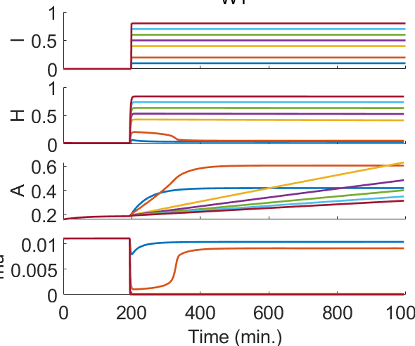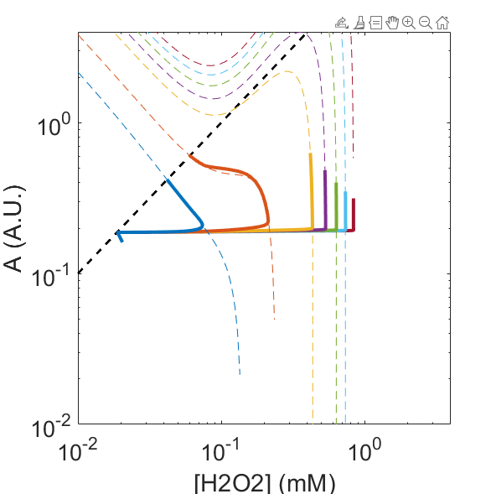

**Model #4: the antioxidant production control model**

The emergence of a resistance limits requires the inactivation of H2O2 scavenging above a certain value H. There are several ways to model this. The main argument used here is that oxidized A slows down the growth rate, and growth is mandatory for antioxidant production, which is key to restore the redox balance.

Several ways have been investigated to take this aspect into account : recycling of A fueled by cell growth (model #1), or non-linear oxidation of A by H (model #3). If no hypothesis is formulated regarding the oxidation of A (i.e. no non-lineraity, model #2), then there is no resistance limit. Nevertheless, even with model #1 and #3, there is a major issue that makes these models unrealistic: Zwf1d mutant and WT do not display a strong difference in internal H at steady state below the MIC. Yet, it is essential to explain why the zwf1d gets a better tolerance than the WT.

Therefore, in model #4, we try to refine the model to comply with experimental observations. The main idea is that the dependency of antioxidant production on H could have a different scaling than the scaling of dilution (or growth) on H.

Equations for this model are as follows :

$$μ=μ_{0} \left(1-\frac{A_{ox}}{A}\right)= \frac{μ_{0}}{1+δH^{2}}$$

$$\frac{dH}{dt}=e+ a \left(H_{ext}-H\right)-b \frac{A}{1+δH^{2}}H$$

$$\frac{dA}{dt}=g \frac{1}{1+δ'H^{n}} H- μ A$$

With n>2.

To be continued….