**ESP32 temperature controller ----- Assembly and function manual**

**Gilles Charvin Feb 2025**

Assembly

1. **Flashing the ESP32 WROOM controller**

Make sure you have an ESP32 board with following pinout :

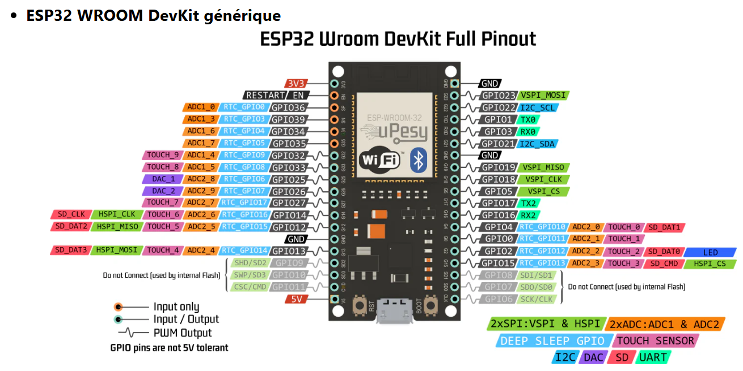

Only the pinouts on the right will be connected to the PCB board.

Connect the micro USB port to a computer. Open the esp32_temperature_controller.ino file in Arduino IDE.

Select the board name ESP32 wroom da module and the COM port to which the board is connected

If the compilation fails, it is likely that you need the following libraries :

Adafruit GFX (core graphics library)

Adafruit SSD1306 (oled display)

Adafruit DHT sensor library (ambient temperature sensor)

PID_v2 by Brett Beauregard (PID controller used for temperature control)

ESP32RotaryEncoder by Matthew Clark

Wen the transfer is don, open Tools🡪Serial Monitor to check the communication between the board and the computer

**Soldering the components on the PCB board**

Installation

Usage