Solutions

1. Increase unit test coverage to reach 60%, achieving more than 60% will only consume your valuable time without extra score.

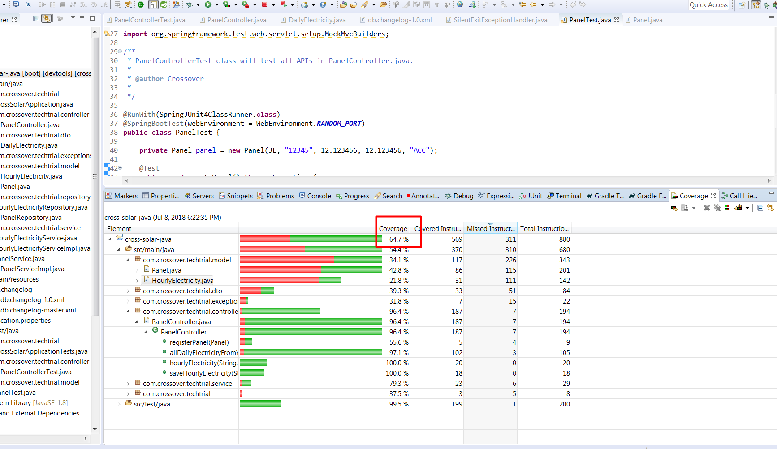

1. Find bugs and fix them, hint: we provided Cross-Solar application in a good structure, so no need to spend your valuable time on structure modifications, just focus on fixing bugs.

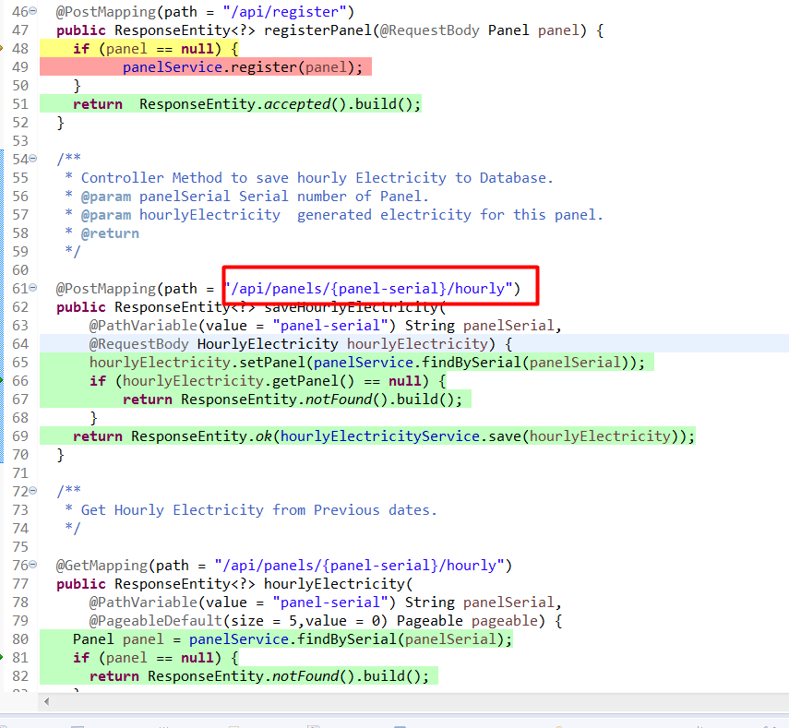

there were errors in the routes of the rest services, which were not real routes like the word "banel" and the local data typeTime in hours per panel

1. Frontend team wants to display panel’s all historical data in a chart, in which each point represents electricity generated by this panel each day [sum, min, max, average] up to the end of previous day, your goal is to implement backend part of this task, API specifications already there in code as agreed with Frontend team, and it is ok to implement this task without any optimization.

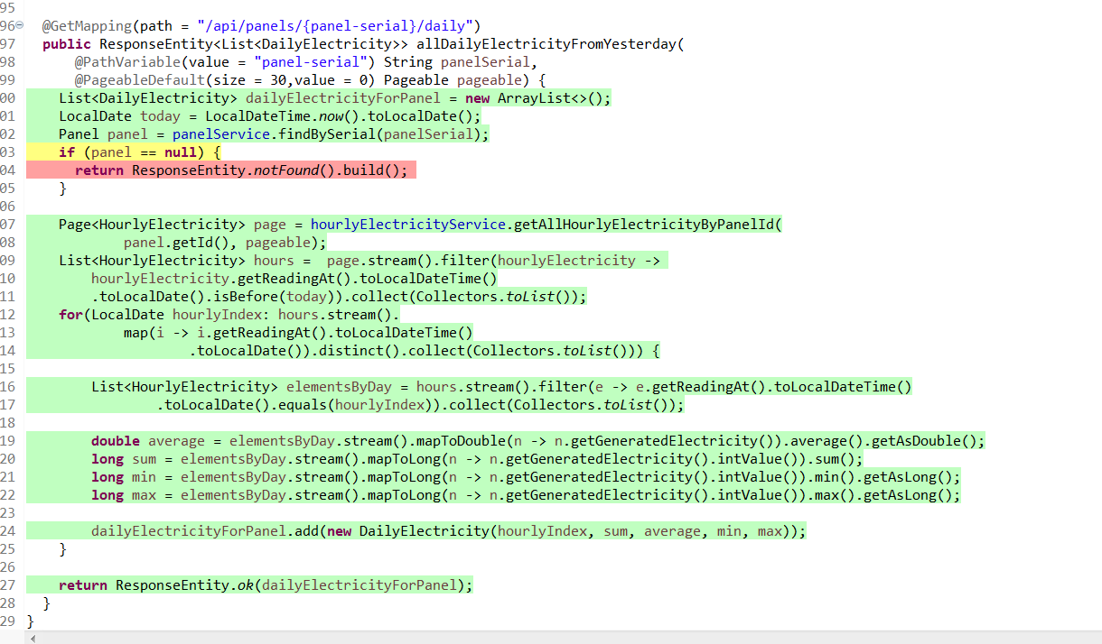

Result returned by the implemented method

[{"date":"2018-01-31","sum":951,"average":158.5,"min":100,"max":310},{"date":"2018-01-08","sum":840,"average":168.0,"min":100,"max":310}]