Trainable sensorimotor mapping in a neuromorphic robot

Jörg Conradt, Technische Universität München
Terrence C. Stewart, University of Waterloo

Abstract

We present a mobile robot with sufficient computing power to simulate ~1 million neurons in real-time. We use this computing power, combined with various on-board sensory and motor systems (including silicon retinae) to implement a novel method for learning sensorimotor competences by example. That is, by temporarily manually controlling the robot, it can gather information about what sensorimotor mapping it should be performing. We show that such a learning-by-example system is well-suited to power efficient neuron-based computation (50 Watts for all 1 million neurons), that it can learn quickly (a few tens of seconds), and that its learning generalizes well to novel situations.

Keywords
Neuromorphic computing; SpiNNaker; Neural engineering; Nengo

Highlights

- We present a mobile omniwheel robot with 2 silicon retinae and 864 ARM processors running neural models of up to 1 million spiking neurons.
- We demonstrate a software tool suite for designing large-scale neural models and installing them into the robot.
- The presented learning algorithm shows how neurons can be used to integrate and filter incoming sensor data, resulting in easy-to-learn parallel sensorimotor mappings.

1. Introduction
- (Jörg and Terry)
- General framing of what we're doing
- Connect it to desired topics of the Special Issue

2. Materials and Methods

2.1. The Robot
- (Jörg)

2.1.1. Robot Sensors
- (Jörg)

2.1.2. Robot Motors
- (Jörg)

2.2. The Integrated SpiNNaker Processors
- (Jörg)

2.3. The Software Tool Suite
While the robot could, in theory, be programmed using standard software methods, standard approaches are not well suited to the massive parallelism available here. Instead, we have integrated the high-level neuron-based modelling software Nengo <http://nengo.ca> with the SpiNNaker packaging system PACMAN. This allows the user to specify a program in terms of vector-based variables and functions on those variables, and the software will automatically develop a neural network model that will approximate those functions, optimized for use on the on-board SpiNNaker chips.

2.3.1 Nengo and the Neural Engineering Framework
The Neural Engineering Framework (NEF; Eliasmith & Anderson, 2003) is a neural compiler; a general method for taking algorithms and converting them into neural networks. It has been used to model motor control (DeWolf & Eliasmith, 2011), working memory (Singh & Eliasmith, 2006), visual attention, action selection (Stewart, Choo, & Eliasmith, 2010), and reinforcement learning (Stewart, Bekolay, & Eliasmith, 2012). Combining these, it was used to create the first biologically realistic brain simulation capable of performing multiple tasks (Eliasmith et al., 2012).
There are three core principles underlying the NEF: representation, transformation, and dynamics. For representation, the NEF takes the point of view that the activity of a group of neurons is best understood as an encoding of some underlying variable x. That is, for each neuron within a group, there is some function a(x) which maps x onto neural activity a. Importantly, x can be a vector, but generally a vector of smaller dimensionality than the number of neurons in the group. This means that the neurons form a redundant and distributed representation of x. In general, every neuron will have some particular value for which that neuron responds the most strongly. We denote this vector as e_{i} (the encoder for the i^{th} neuron), and stipulate that the input any neuron receives when representing x is proportional to the dot product of e_{i} and x.
The second principle of the NEF is the transformation of information. That is, if one group of neurons represents x, we may want to connect those neurons to another group representing y such that y=f(x). This means that the first group of neurons should cause the appropriate firing in the second group of neurons to achieve this mapping. While this could be achieved by traditional neural network learning methods, the representation principle provides a shortcut. In particular, if we perform a least-squares optimization to find a set of decoding weights d_{i} such that 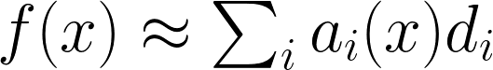, then it can be shown that the optimal neural connection weight from neuron i to neuron j to compute y=f(x) is simply 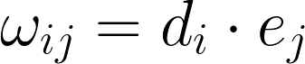. This allows us to quickly build neural models to approximate desired functions. The accuracy can improve without bound by increasing the number of neurons, although it is most accurate for functions that can be well-approximated by low-degree Legendre polynomials.
The final principle of the NEF, dynamics, allows us to build recurrent neural networks. These networks then compute differential equations of the form 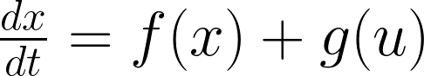 or, after a change of variables, 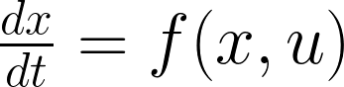. The idea here is to note that when the transformation principle is used to form a connection between two groups of neurons to compute the function y=f(x), the synaptic transmission between neurons introduces a temporal filter. In particular, in the vast majority of models of spiking neurons, when a single neuron fires, this causes current to flow into the receiving neurons over a period of time. This post-synaptic current (or post-synaptic potential) is generally modelled as 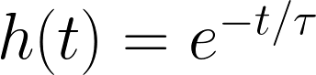 for t>0, and with τ being the synaptic time constant. This acts as a first-order low-pass filter on f(x(t)), meaning that as the activity in the first group of neurons changes over time to represent x(t), the value actually represented in the second group of neurons over time will be f(x(t))*h(t). Crucially, this allows us to predict what will happen if we use the NEF transformation principle to create a neural connection from a group of neurons back to itself. The result (via a Laplace transform) is that if the connection is optimized to compute f(x), the resulting recurrent connection will end up computing 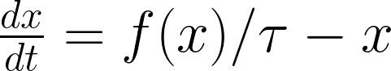. This is an analytic method for finding recurrent connection weights that will produce some desired behaviour. It has been used to create a wide variety of systems (Eliasmith, 2005), including controlled oscillators (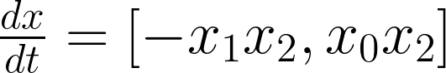), memories (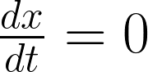), chaotic attractors such as the Lorenz attractor, and Kalman filters (Dethier et al, 2011).
The NEF principles allow for the creation of complex neural models that represent vectors and compute functions on those vectors, including differential equations governing their dynamics over time. This makes it possible to design neural models in terms of a high-level algorithm, rather than relying on low-level training systems, as is traditional in neural networks. Of course, the NEF can be combined with traditional learning algorithms as well. However, since this is a non-standard way of constructing neural networks, considerable development has gone in to Nengo <http://nengo.ca>, an open-source software tool for constructing and simulating NEF-based neural models (Stewart, Tripp, & Eliasmith, 2009; Bekolay et al., 2014).
Importantly, Nengo allows a programmer to not only define the representations and functions the neurons should compute, but it also allows for the specification of neuron-level parameters. This means that Nengo can be used to find synaptic connection weights for the neurons that are simulated on the SpiNNaker processors on-board the robot. Furthermore, we have integrated into Nengo custom commands to deal with the sensors and motors on-board the robot.

2.3.2 PACMAN
Once Nengo has generated the desired neural network, it must be installed on the SpiNNaker processors onboard the robot. To do this, we must not only transfer the details of the network to SpiNNaker, but we also need to determine which of the ARM cores will be implementing which neurons. This becomes a routing problem, as neurons that are connected logically (i.e. which have synaptic connections between them) should also be nearby physically (i.e. on nearby cores or chips). While any chip on the robot can communicate with any other chip, optimizing the physical layout significantly improves the communications bandwidth.
In addition, PACMAN takes care of placing neurons near any sensory or motor system onto SpiNNaker ARM processors that are near the relevant I/O ports on the board itself. This means that, for example, spikes coming from the DVS cameras do not have to be routed through multiple layers of chips before arriving at their relevant destinations.

3. Theory
The robot with its on-board hardware is ideal for developing embodied neuron-based robot control systems. While any neural model could be evaluated with it, we focus here on the particular task of learning by example. That is, there are two phases to the algorithm. First, a person manually controls the movements of the robot. While this is happening, the robot observes and records its sensorimotor state. Second, a neural model is generated that attempts to perform the same sensorimotor mapping as was recorded in the first phase. This model exploits the massive parallelism of the onboard processing hardware to find an ideal control system, matching the original behaviour.
To build this neural model, we first need to make decisions about the sensory information available to the robot to perform this mapping. The algorithm described here is highly agnostic to sensory modalities, and we demonstrate its use of simple bump sensors, complex vision sensors, and even virtual sensors built from remembering previous motor actions. This data must be pre-processed, and we show how this pre-processing can be done with the on-board neurons. Finally (and crucially), we show that this processed sensory state can be efficiently and accurately mapped to desired motor actions via a simple neural network.

3.1 Sensory Data
As noted above, the robot hardware provides a variety of sensors. While it is, of course, possible to write custom ARM code to process this sensory data, one of the advantages of integrating with Nengo is that we can quickly define neural networks that can manipulate this data. Given the techniques discussed in section 2.3.1, we can quickly implement feed-forward functions like y=f(x) (if it can be well-approximated by low-degree Legendre polynomials) and by building recurrent neural networks we can implement functions of the form .
This allows us to build neural networks that pre-process sensory inputs, rather than developing custom code. For the particular task considered here, we look at three different types of sensors: simple binary bump sensors, complex spiking DVS cameras, and a virtual sensor that keeps track of recent motor movements.

3.1.1 Bump Sensors
The robot platform is equipped with a ring of six collision detection switches. The state of these switches can be used to stimulate neurons on the SpiNNaker board. That is, if that state of the six switches is a six-dimensional vector, we can use Nengo to define a group of neurons that will be stimulated to represent that vector. Furthermore, we can perform transformations on that vector. For example, rather than representing the six dimensions independently (so that a front collision would be [1,0,0,0,0,0] while a rear collision would be [0,0,0,1,0,0]), we can transform this into a body-centered two-dimensional coordinate frame (such that a front collision would be [1,0] and a rear collision would be [-1,0]). To go from the six-dimensional space to the two-dimensional, we tell Nengo to optimize the neurons to multiply by the desired 6x2 transformation matrix. The code for this is as follows:

If we run this model on the robot and press the collision sensors, the neural activity of the 100 neurons will change depending on the state of the collision sensors. This neural activity can then be decoded (via the NEF) to show how well the neurons are doing at representing this information. This is shown in the left side of Figure [X].
However, for most useful control strategies, we want more than a simple indication of whether there is a collision happening right now. Rather, we may want a neural representation that has some amount of history to the representation. For example, we may want a low-pass filtered version of the bump sensor (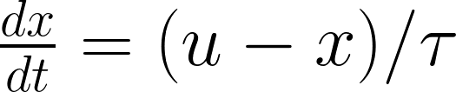). This is expressed in Nengo as a recurrent connection from the neurons back to themselves, and the results are shown on the right side of Figure [X].
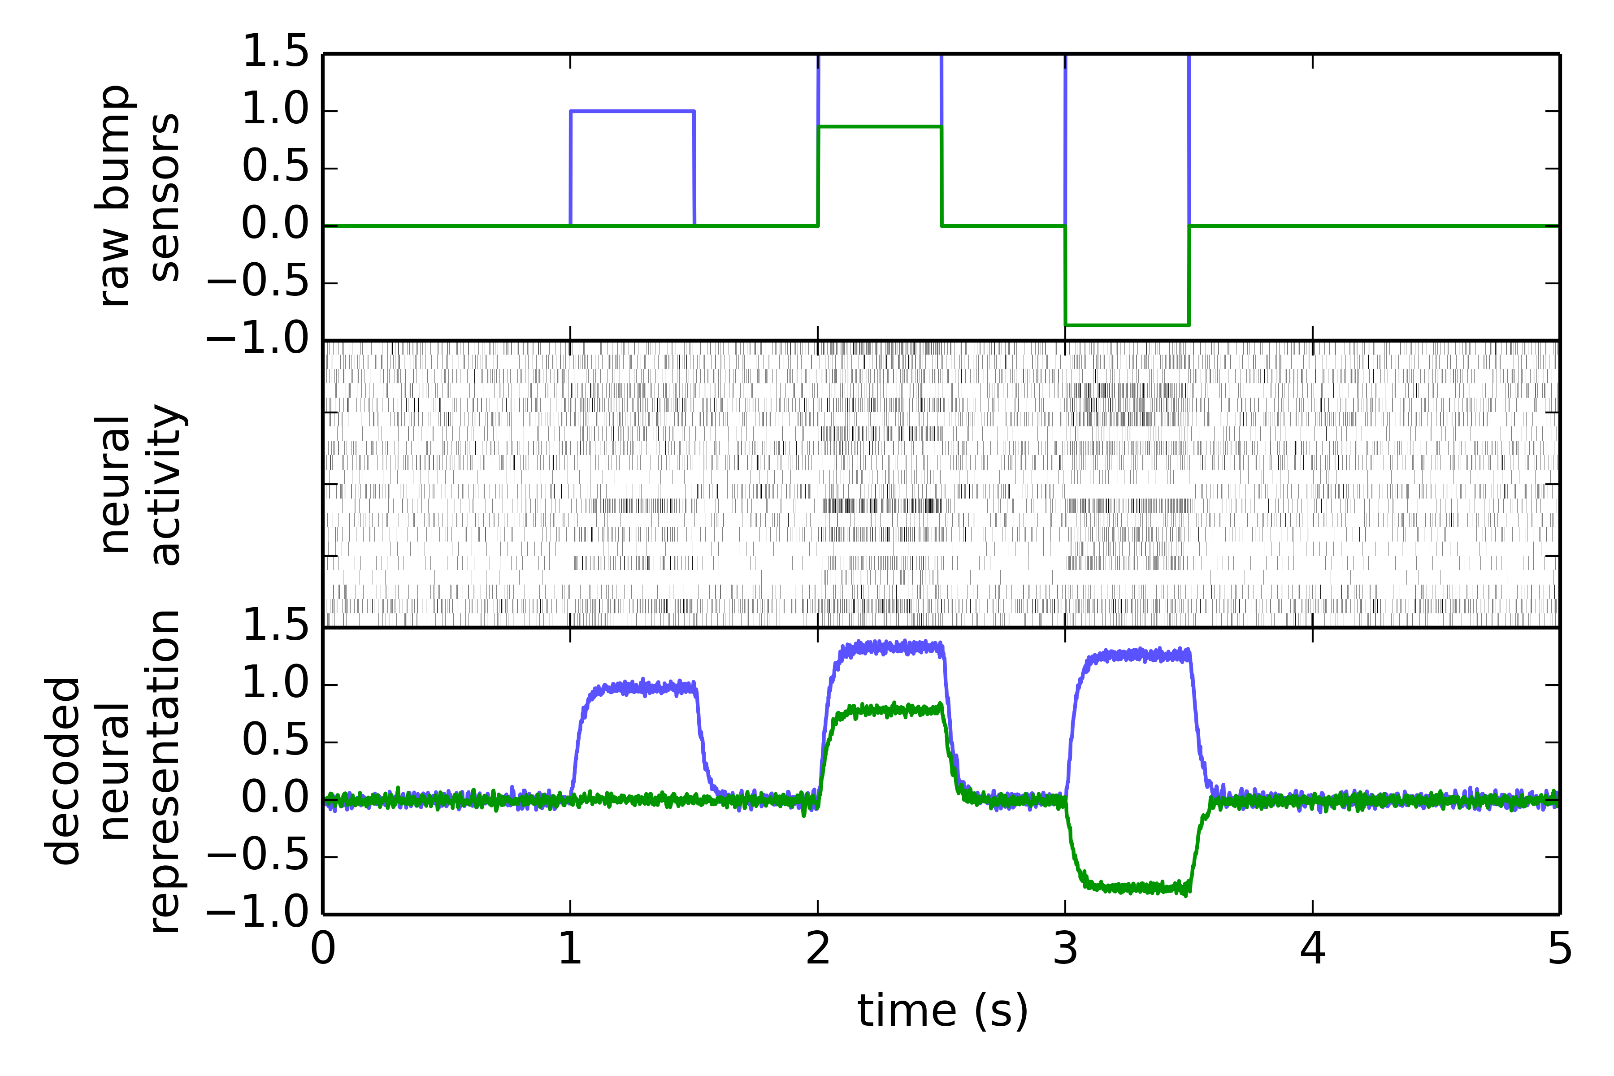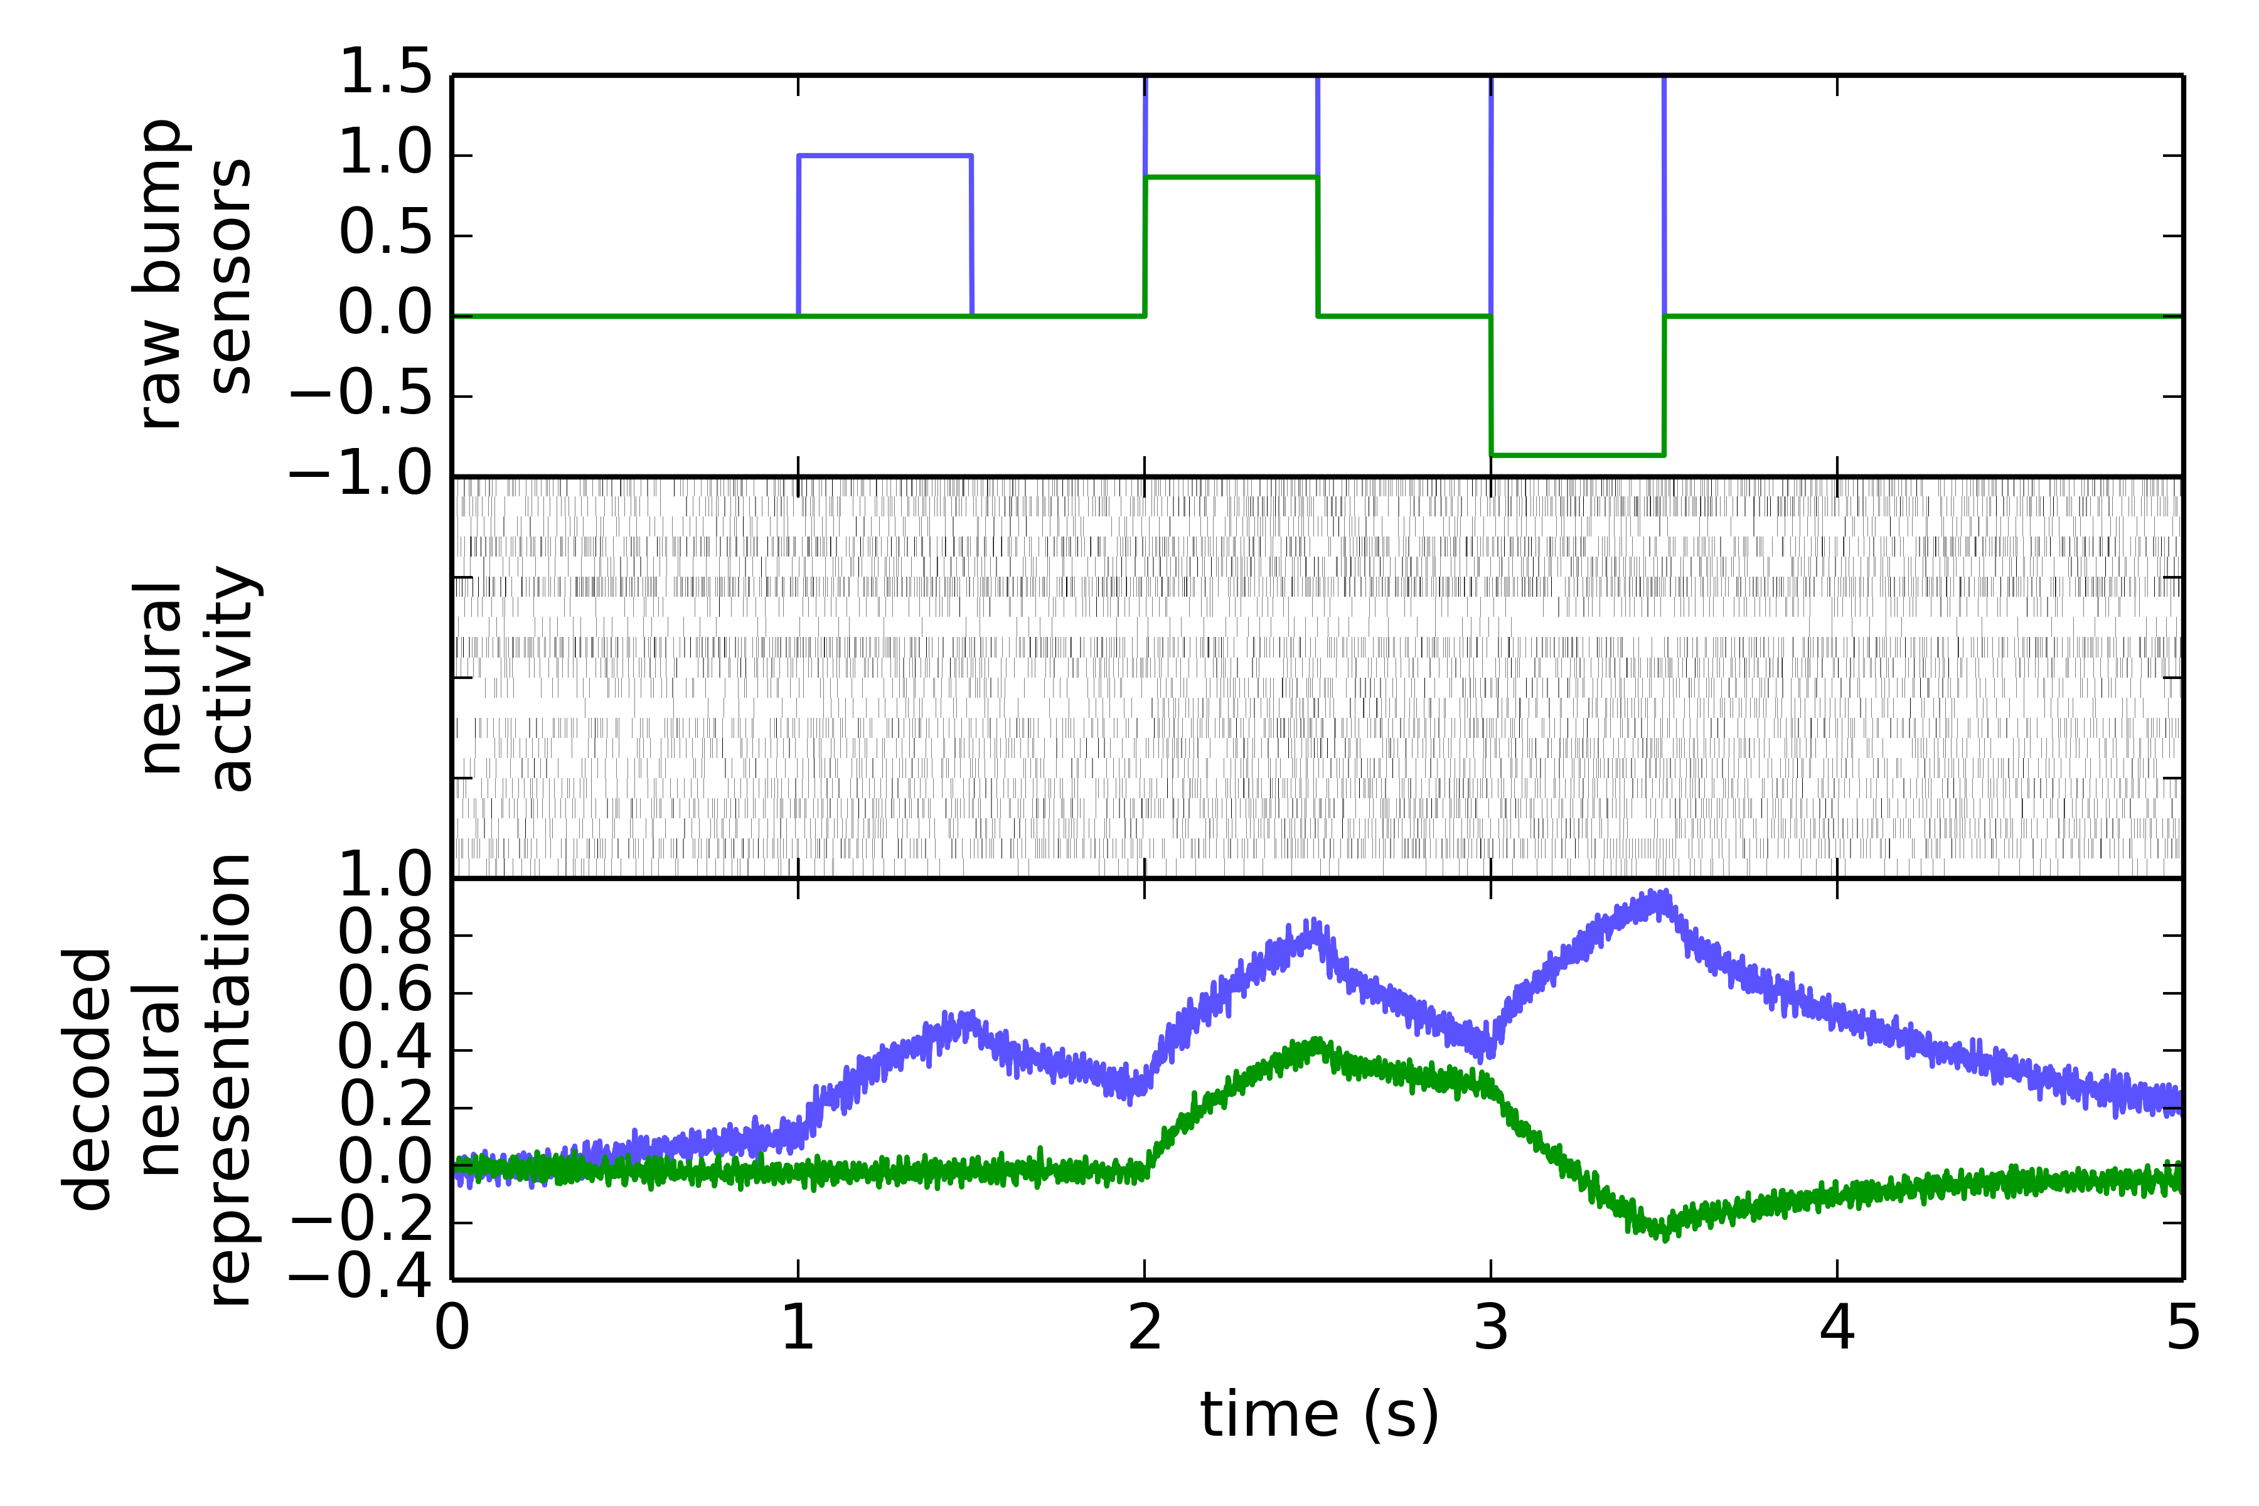
Figure [X]. Two neural models for representing the state of the bump sensors. The top row shows the actual state of the bump sensors, in body-centric coordinates. Blue is the forward/backward axis and green is left/right. Three collisions are shown: one directly in front, one at the front-left, and one at the front-right. The middle row is the resulting neuron activity. The bottom row is the decoded neural activity. This indicates what information is encoded in the spiking neurons. On the left is the simple model which just encodes the current state of the collision sensors. On the right are neurons optimized by Nengo to compute a low-pass filter on the state.

3.1.2 Vision Sensors
The same methodology we used for the collision sensors can be used for more complex sensors, such as the two on-board DVS cameras. Here, rather than having a 6-dimensional vector (one for each collision sensor), each camera provides a 32,768-dimensional vector (128 by 128 pixels, and each pixel has a separate dimension for whether it is getting brighter or getting darker. Given this input data, any image-based algorithm could be used for further processing it, and many modern visual recognition algorithms are easily expresible in Nengo. For example, recent NEF modelling has used Deep Belief Networks to perform symbol recognition (e.g. Eliasmith et al., 2012).
For the purposes of this paper, we use an extremely simple algorithm: computing the centroid of movement. With DVS cameras, this simply becomes a linear transform weighting the activity of an element in that 32,768-dimensional vector by its horizontal or vertical position. This collapses the overall visual activity into a two-dimensional value, as seen in Figure [X+1].
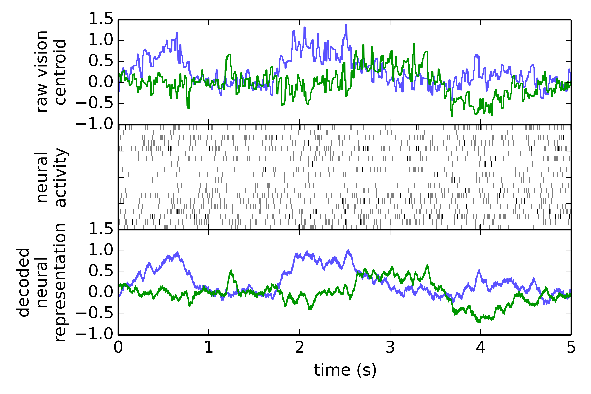
Figure [X+1]. Neural encoding of the centroid of movement from a DVS camera. The blue line is the x-coordinate of the centroid, and the green line is the y-coordinate. The raw data is given in the top line, stimulating the SpiNNaker neurons (middle line). The bottom line shows the information that can be extracted out of the neural activity via the NEF, indicating the accuracy of the neural representation.

3.1.3 Virtual Movement Sensors
As a final type of sensor, we note that many control algorithms may wish to take into account recent movements. That is, a short-term memory indicating the robot has been turning for some period of time, or moving backward for some period of time might be useful when deciding what to do next. One simple way of representing this would be to have neurons represent another low-pass filter, but this time on the recent movement commands sent to the robot's wheels. In this case, we again use a two-dimensional representation, with the first dimension being the velocity forward/backward, and the second dimension being the rotation velocity. This component is built in Nengo using the same techniques as the previous two, and its behaviour is seen in Figure [X+2].
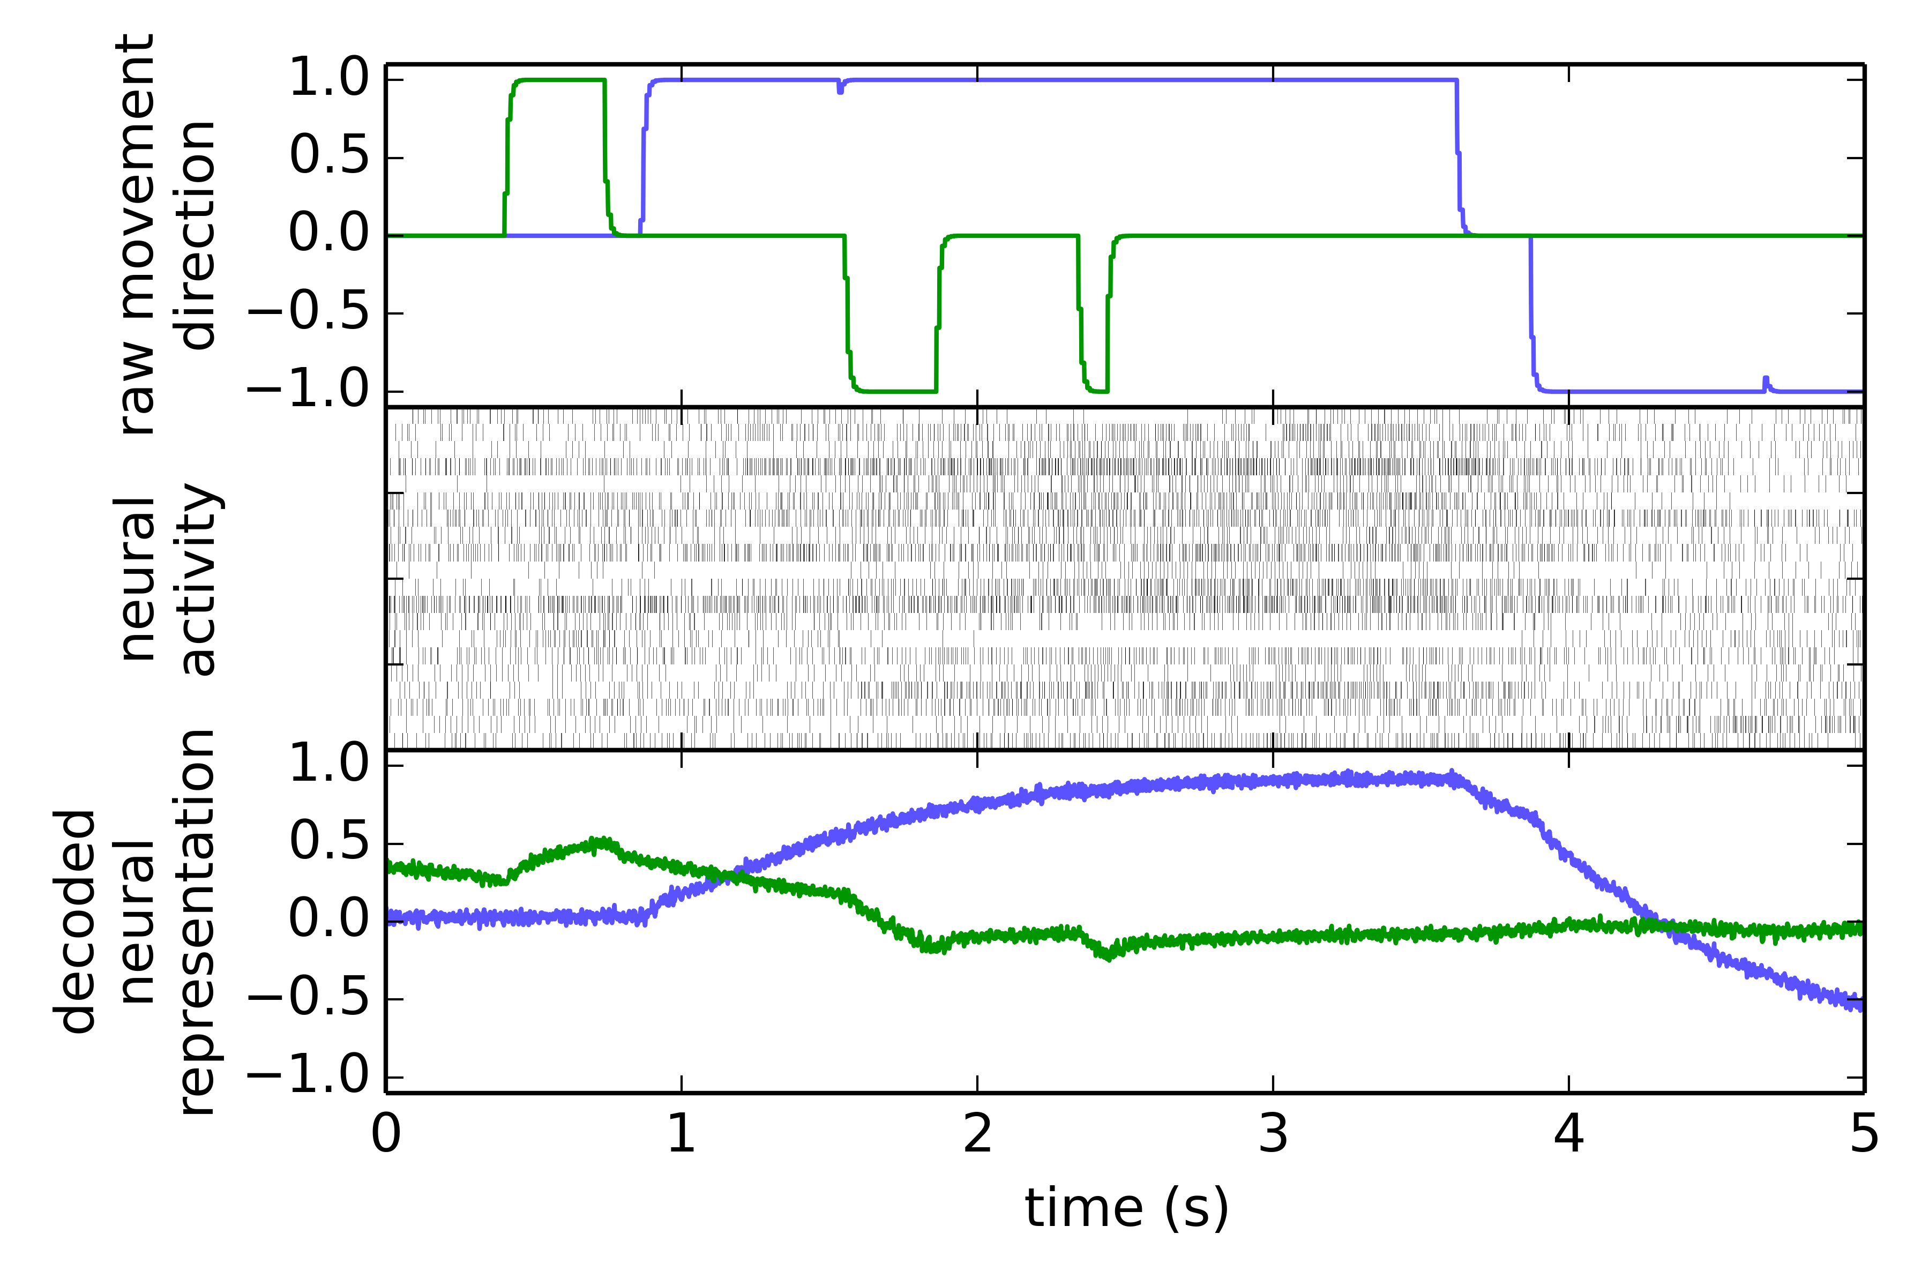
Figure [X+2]. Neurons representing recent movement. The top shows the actual movement commands sent to the robot (blue for forward/backward and green for left/right). The neural activity representing a low-pass filtered version of those commands is shown in the middle. The decoded value represented by those neurons is shown at the bottom.

3.2 Combining Sensory Information
In the previous sections, three different groups of neurons were configured to encode processed versions of three different sensory modalities. We can also use Nengo to combine these separate representations into one. That is, if the state of the bump sensors is s_{b}, the vision system is s_{v}, and the movement system is s_{m} (with each of these being two-dimensional, as shown above), then we can define a combine state variable s=<s_{b}, s_{v}, s_{m}>. To compute the optimal neural connections from each of the original sensors to the one combined state variable, we do the following:
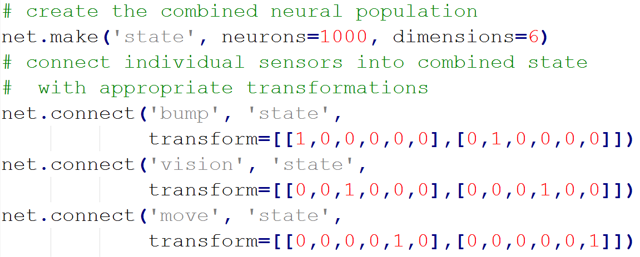
The result is a group of 1000 neurons implementing a distributed representation of the combined processed state information. Now that all of that information is in one place, we can create synaptic connections that will take this sensory information and determine the desired motor action.

3.3 Computing Sensorimotor Mapping
The entire purpose of this model is to learn what motor actions m to perform, given the current sensory state s. In section 3.1, we took the raw sensory data and converted it into values likely to be useful for this mapping. In section 3.2 we brought all of these values together to be stored in one large group of neurons. To complete this model, we need to form synaptic connections between the neurons representing the combined value s and the neurons controlling the robot's motor actions m.
In the previous sections, we made use of the fact that Nengo will find synaptic connections that optimally approximate any given function y=f(x). Here, however, we don't actually have such a function m=f(s). Instead, we define this function by example. That is, we drive the robot around manually, recording m and s as we go. These recorded values are then used as the function for Nengo to approximate.
Figure [X+3] shows that this approach can work. The driving signal provided by the user manually driving the robot is shown at the top. This is what we want the neurons to approximate. However, the only information provided to the system is the processed and combined sensory state data. Using Nengo and the NEF, we can take this neural activity and decode out an approximation of the desired motor command. As can be seen, for this example the approximation is fairly good.
In this particular example, the person manually driving the robot bumped into an obstacle, backed up, and then turned to the right. The motor training data shows these movements, with the blue line being forward/backward and the green line left/right. Learning the simple mapping from a bump sensor being pressed to backing up is not difficult. However, note that this system is able to learn to back up for a certain period of time and then turn. That is, it continues to back up even after the bump sensor is no longer pressed. As will be shown in the next section, this capability is due to the choices made in performing the neural processing of the sensor values to build this state representation.

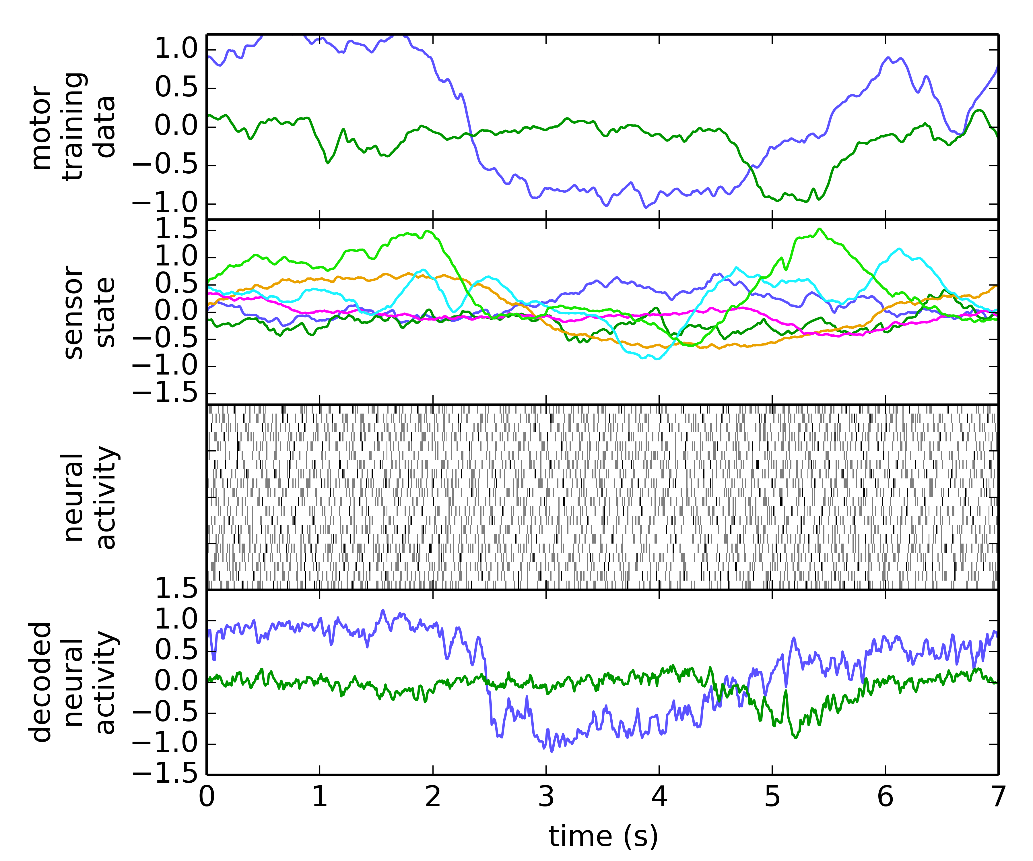
Figure [X+3]. The learned sensorimotor mapping. The sensor state data is encoded in the neural activity. This can be decoded using the NEF to approximate the desired motor control signal (top).

4. Results

4.1 Task Learning: Collision Response
We start by demonstrating that the model is capable of learning a simple task by example. We drive the robot manually for 55 seconds, and we frequently have the robot collide with solid objects. When it does so, we back the robot up and turn away from the obstacle. After training, the resulting network should learn to perform the same task.
The behaviour of the model over sixty seconds is shown in Figure [X+4]. The motor training data shows the model moving forward and backward (blue line) and turning left and right (green line). In this case, it is alternating between collisions on the right (for which it backs up and turns left) and collisions on the left (for which it backs up and turns right). The sensory data is encoded in the neural network, and the bottom row shows that this network is capable of correctly matching this behaviour. Importantly, it is able to determine which way to turn, even though that information is no longer available in the raw sensory input (since the collision sensor is no longer active).

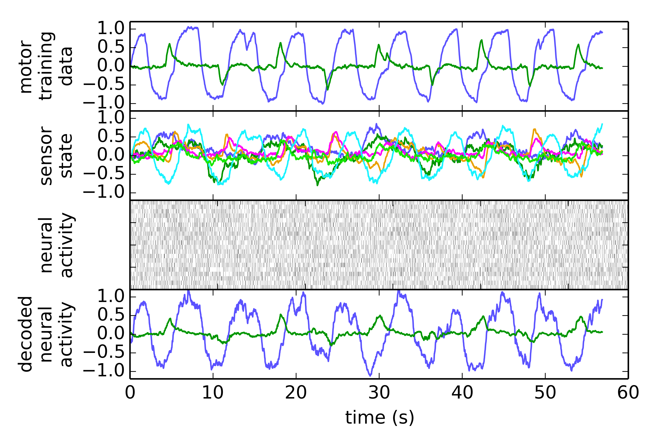
Figure [X+4]. Learning to respond differently to collisions on the right and on the left. The neural network (third row) is able to generate an approximation (bottom row) of the desired motor commands (top row), given only the processed sensory input (second row).
To determine how the model performs this task, we can examine its performance as we vary the number of neurons representing the combined sensory state, and what information is a part of that state. This is shown in Figure [X+5]. The first feature to note is that the error (the difference between the trained movements and the movements produced by the on-board neural network) decreases as the number of neurons increases.
Interestingly, there is a significant advantage if the sensory state includes the visual stimulus, even though this was not an explicitly planned part of the behaviour. That is, the robot is able to exploit features of the visual stimulus to improve its performance on the task, even though the actual desired behaviour (turning away from collisions) did not explicitly consider the visual stimulus. By merging different sensory modalities together into one large neural network, these complex and unexpected sensorimotor contingencies can be automatically detected and exploited.
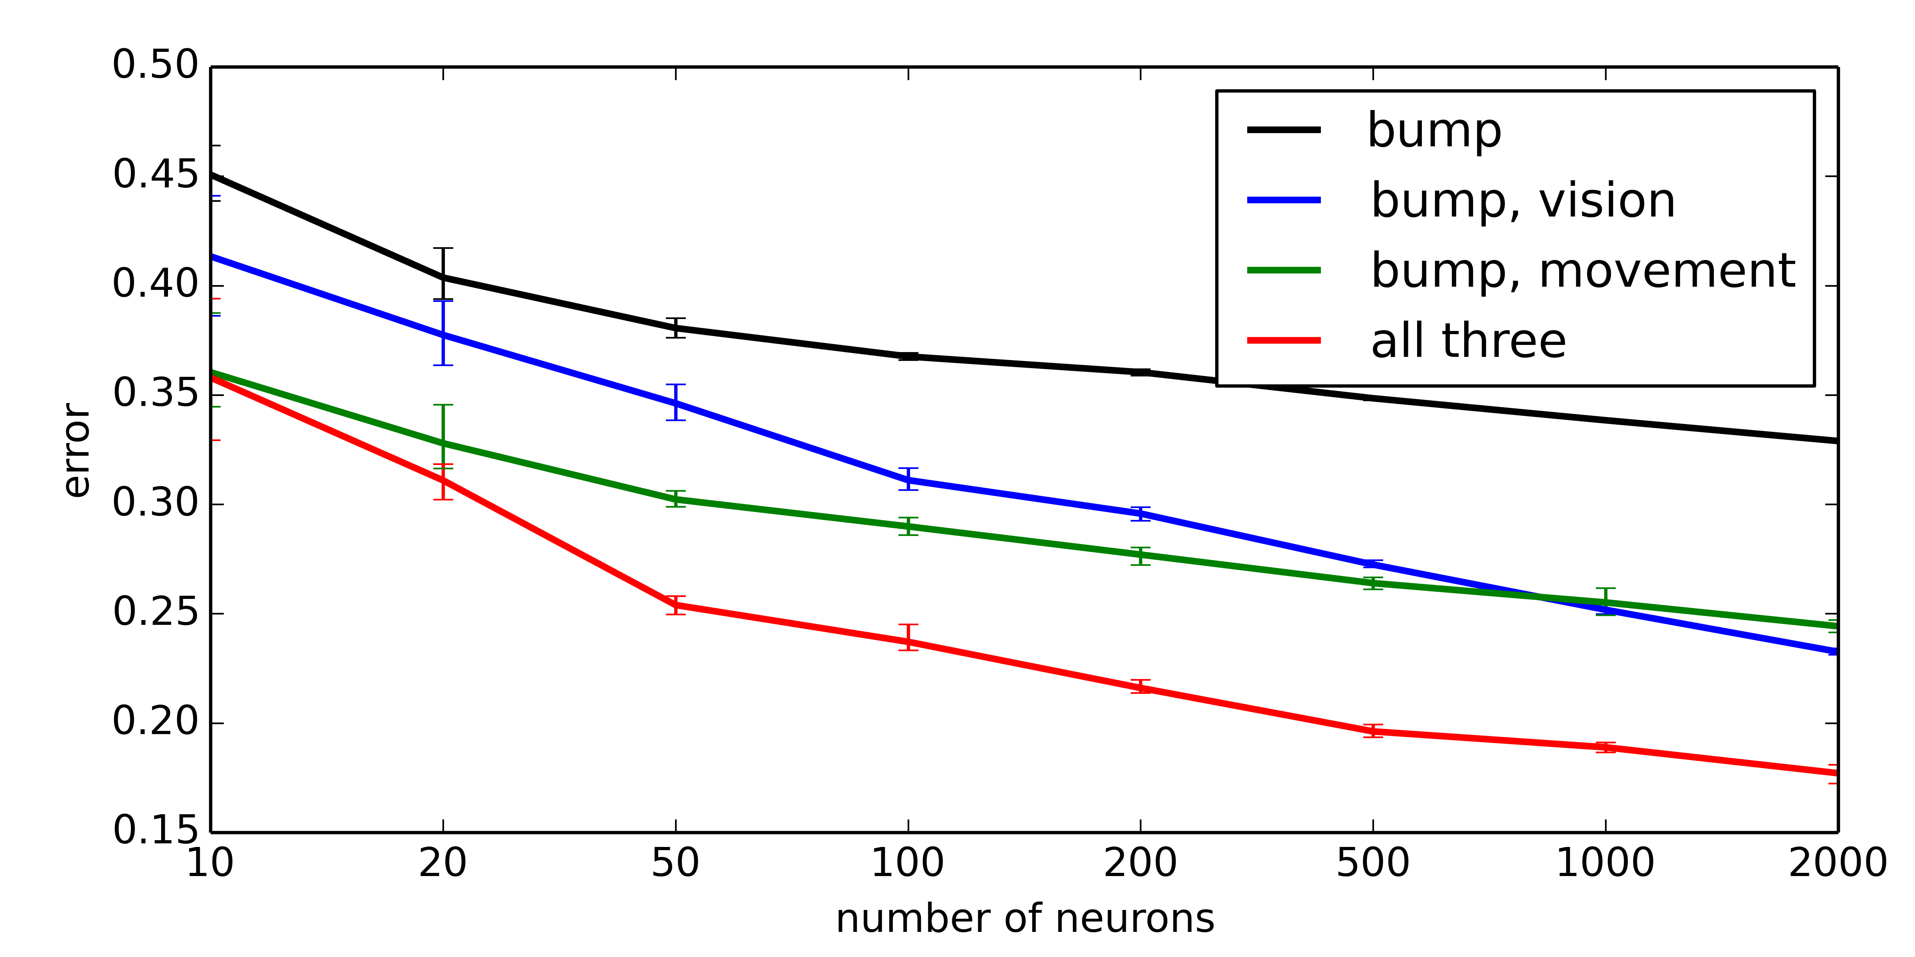
Figure [X+5]. Learned accuracy for turning away from a collision for varying numbers of neurons and varying the contents of the combined sensory state.

4.2 Task Learning: Visual Identification
For the second task, we consider navigating based on visual features. Importantly, we use exactly the same network and training system. The only change is the desired behaviour. Here, we give the robot two highly distinct visual stimuli, and drive the robot to turn left for one of them and to turn right for the other. The neural network must learn this pattern based on the sensory state, even given the extremely reduced visual information provided (only the centroid of movement is included in the combined sensory state).
As can be seen in Figure [X+6], the model can learn this task as well. Interestingly, for this task the movement information appears to be redundant; the model performs slightly better without that aspect of the combined sensory representation. Including information that is not useful for the desired transformation does waste neurons. However, it also makes the system more flexible, as evidenced by this same system's ability to learn the previous task (Figure [X+5]).
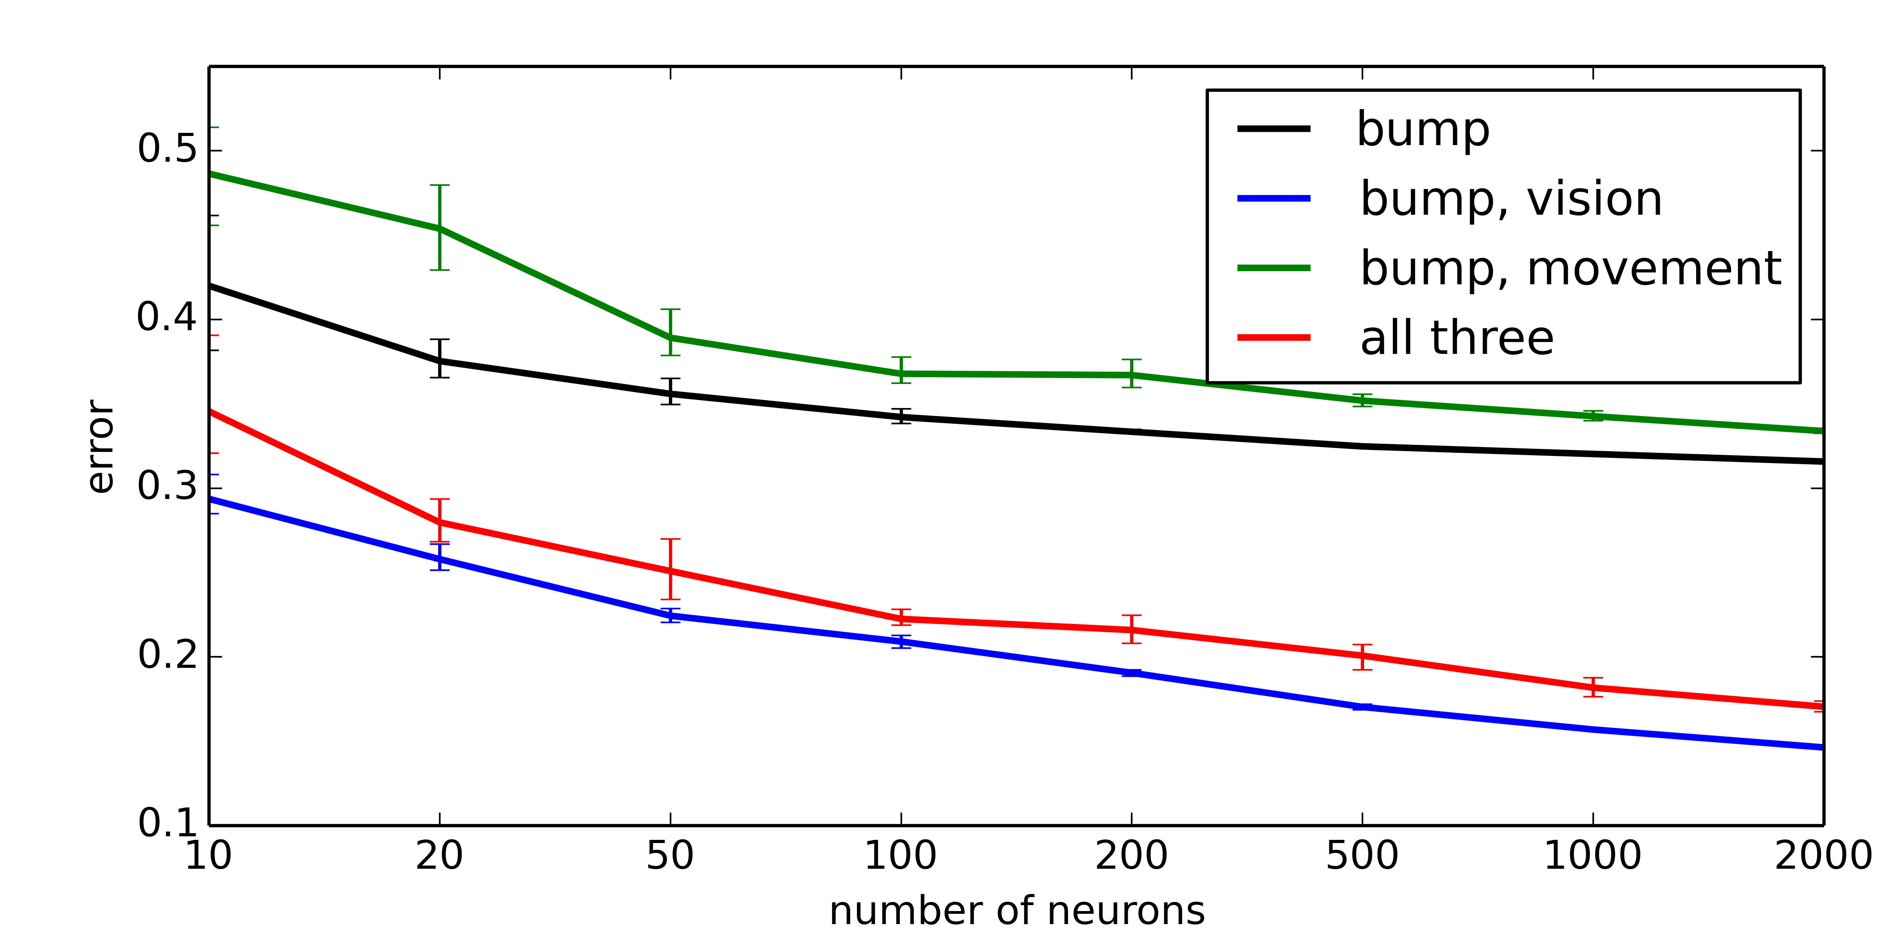
Figure [X+6]. Learned accuracy for visual identification for varying numbers of neurons and varying the contents of the combined sensory state.

4.3 Generalization
As with any learning system, a key question is whether the neural network is over-fitting to the training data. The ability to accurately duplicate the motor commands provided by the user does not necessarily mean that it will be able to accurately create relevant motor commands in novel situations.
To test this, we follow the standard approach of training the model on a subset of the data, and then evaluating its performance. This is shown for both of the tasks in Figure [X+7]. Impressively, the neural network generalizes extremely well. Even when only trained on 15 seconds of data, the collision response system performs just as well as if it was trained on the full data set (as it was for Figure [X+5]). Similarly, the visual identification task only requires 25 seconds of training data.
It is worth noting that, looking at Figure [X+4], the first 15 seconds of training only provides the network with one example of backing up and turning left, and one example of backing up and turning right. In other words, this model is successfully generalizing given only a single example of the desired behaviour. Indeed, it is able to get all the information it needs from that one example, and further examples do not improve performance.
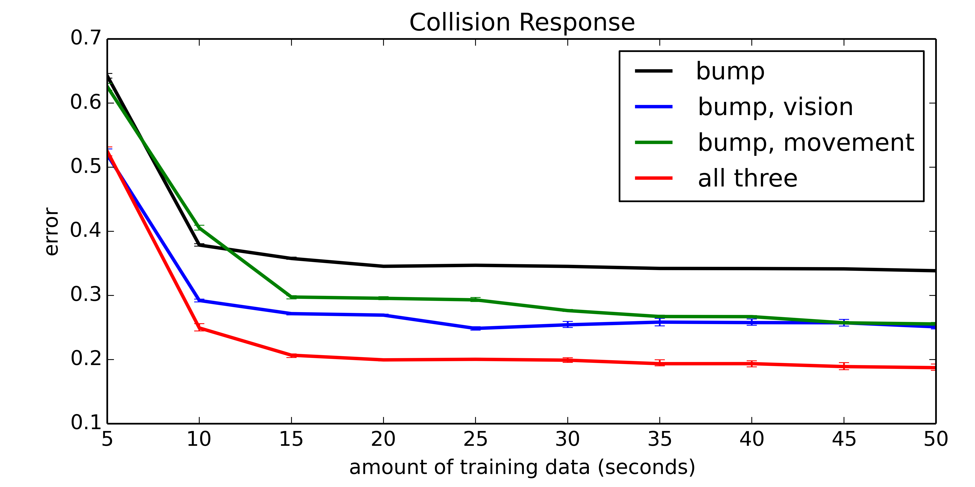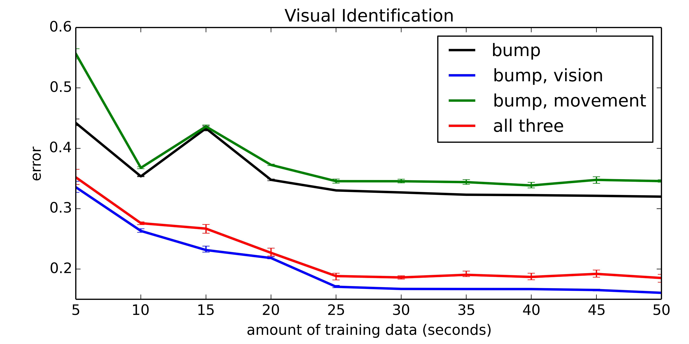
Figure [X+7]. Generalization of performance on both tasks. The neural networks consist of 1000 neurons and are trained on only the first part of the training data.

5. Discussion
- (Jörg and Terry)
- What does this let us do?
- Power efficiency
- Types of generalization
- Classes of algorithms that would also be available via NEF

6. Conclusions
- (Jörg and Terry)

References

Trevor Bekolay, James Bergstra, Eric Hunsberger, Travis DeWolf, Terrence C Stewart, Daniel Rasmussen, Xuan Choo, Aaron Russell Voelker, and Chris Eliasmith. Nengo: a python tool for building large-scale functional brain models. Frontiers in Neuroinformatics, 2014.

Travis DeWolf and Chris Eliasmith. The neural optimal control hierarchy for motor control. The Journal of Neural Engineering, 8:21, 11/2011 2011.

Chris Eliasmith and Charles H. Anderson. Neural engineering: Computation, representation, and dynamics in neurobiological systems. MIT Press, Cambridge, MA, 2003.

Chris Eliasmith, Terrence C. Stewart, Xuan Choo, Trevor Bekolay, Travis DeWolf, Yichuan Tang, and Daniel Rasmussen. A large-scale model of the functioning brain. Science, 338:1202-1205, 2012.

Julie Dethier, Paul Nuyujukian, Chris Eliasmith, Terrence C. Stewart, Shauki A. Elassaad, Krishna Shenoy, Kwabena Boahen. A Brain-Machine Interface Operating with a Real-Time Spiking Neural Network Control Algorithm (Neural Information Processing Systems (NIPS) 24, 2011)

Ray Singh and Chris Eliasmith. Higher-dimensional neurons explain the tuning and dynamics of working memory cells. Journal of Neuroscience, 26:3667-3678, 2006.

Terrence C. Stewart, Trevor Bekolay, and Chris Eliasmith. Learning to select actions with spiking neurons in the basal ganglia. Frontiers in Decision Neuroscience, 2012.

Terrence C. Stewart, Xuan Choo, Chris Eliasmith. Dynamic Behaviour of a Spiking Model of Action Selection in the Basal Ganglia (10th International Conference on Cognitive Modeling, 2010)

Terrence C. Stewart, Bryan Tripp, and Chris Eliasmith. Python scripting in the nengo simulator. Frontiers in Neuroinformatics, 2009.

Vitae

(100-word bios)

