Photoshop Cheat Sheet!

Getting Started:
- Click on the EYE icon.
- File → NEW, then click OK

Tools:

FILE MENU TOOLS
- Click on File → NEW to open new documents
- Click on File → OPEN to open previously saved documents
- Click on File → SAVE to save a document
- Click on File → IMPORT to load pictures

EDIT MENU TOOLS
- Click on Edit → UNDO to undo the last change made (after a change in undone,
this changes to REDO the change that was just undone)
- Click on Edit → STEP BACKWARD to undo multiple changes
- Click on Edit → COPY to copy a selected image
- Click on Edit → PASTE to paste the copied image

SELECT MENU TOOLS
- Click on Select → ALL to select everything at once

VIEW MENU TOOLS
- Click on View → ZOOM IN to zoom in on the image
- Click on View → ZOOM OUT to zoom out on the image

Fun Features:
Change Images using:
- Fresco
- Unsharp Mask
- Neon Glow
- Tiles
- Emboss
- Flip Horizontal
- Rotate
You can also join two pictures together by cutting and pasting from the Edit menu!

Layers:
- To add a layer, go to Layer → NEW
- You can only apply a filter to one layer at a time.
- To select a layer to work in you can right click with your mouse button and it will show you all the layers at that point, select a layer you wish to edit.
- Don’t like layers? Go to Layer → MERGE VISIBLE.
MORE TOOLS
To select a tool, click on it with the mouse. The cursor will then take on the shape of the selected tool. Right clicking on tools with triangles in the bottom corner will give more options for the tool. When then tool is selected, a bar will show up on the top of the screen with different options for how to use the tool.

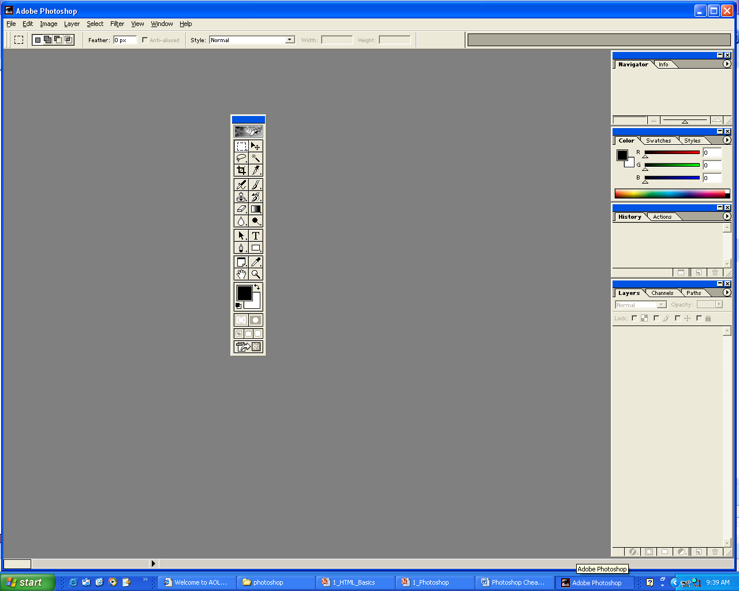  MARQUEE: Makes elliptical, rectangular, single row and single column selections. | MOVE: Moves your selections.
LASSO: Makes freehand and straight edged selections. | MAGIC WAND: Selects similarly colored areas.
CROP: Trims the image so that you can cut out the part of the image you want. | 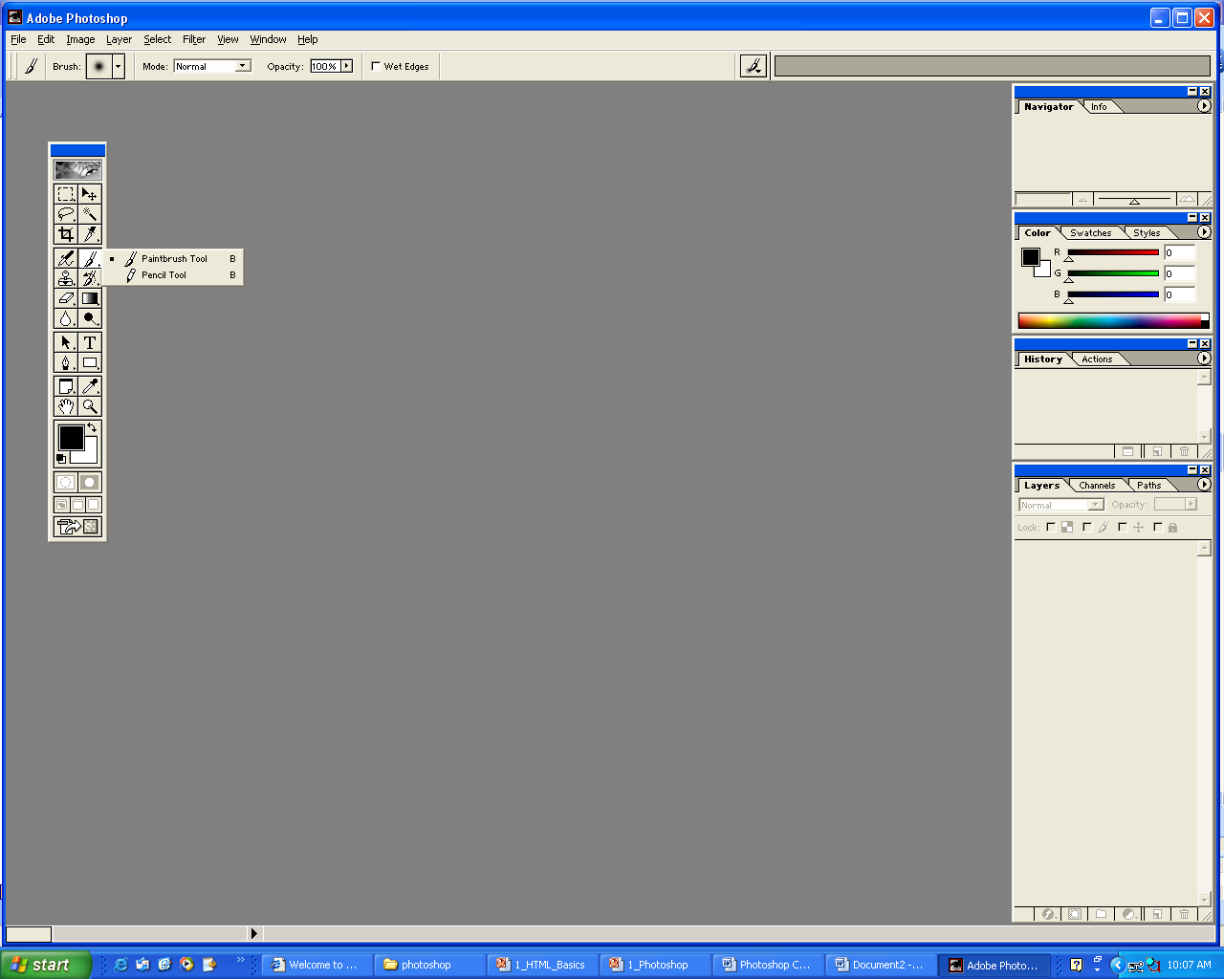  PENCIL: Paints hard edge strokes..
AIRBURSH: Paints soft edge strokes. | PAINTBRUSH: Paints brush strokes.
ERASER: Erases parts of an image to a previously saved state. | 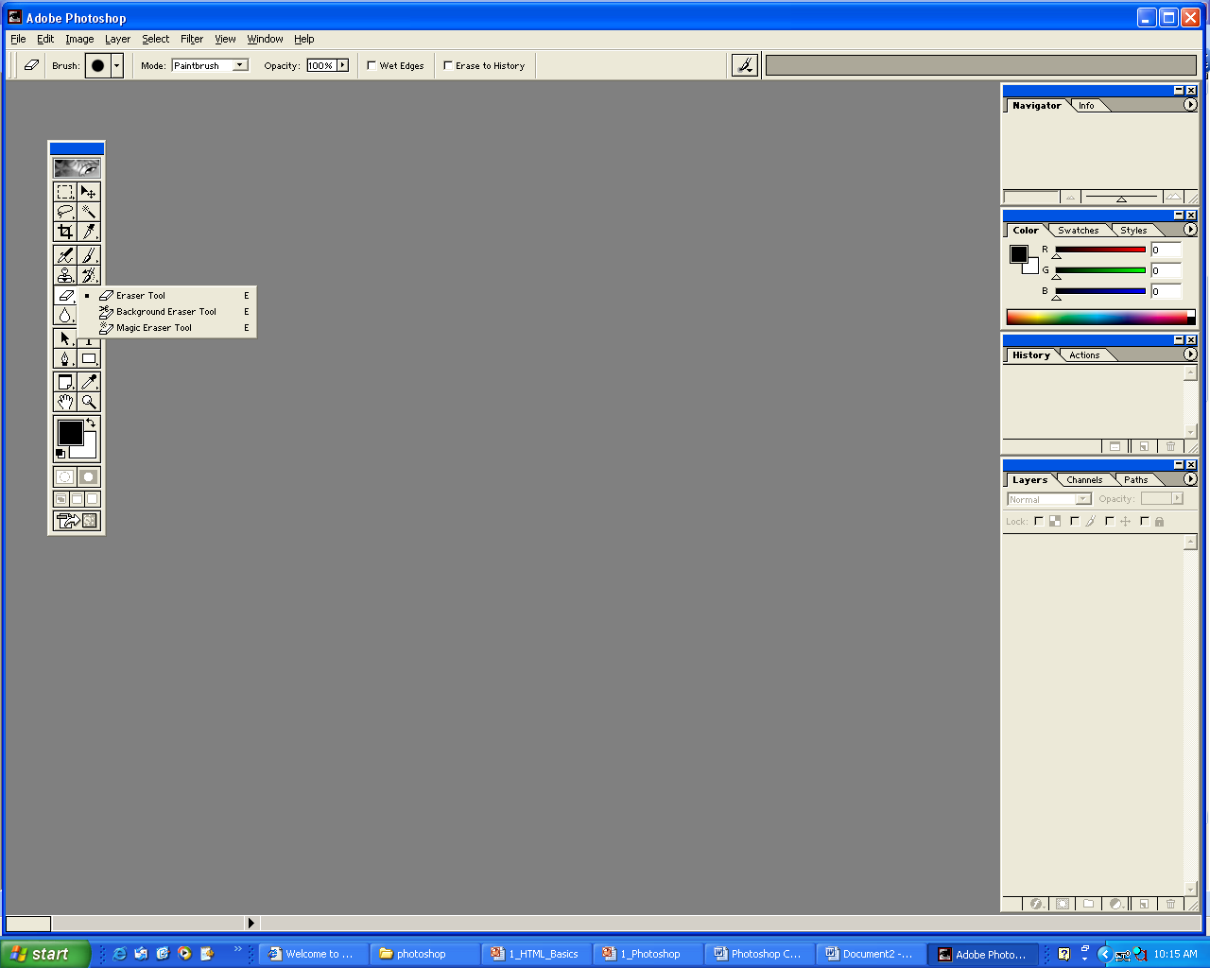  BACKGROUND ERASER: Erases areas to transparency by dragging.
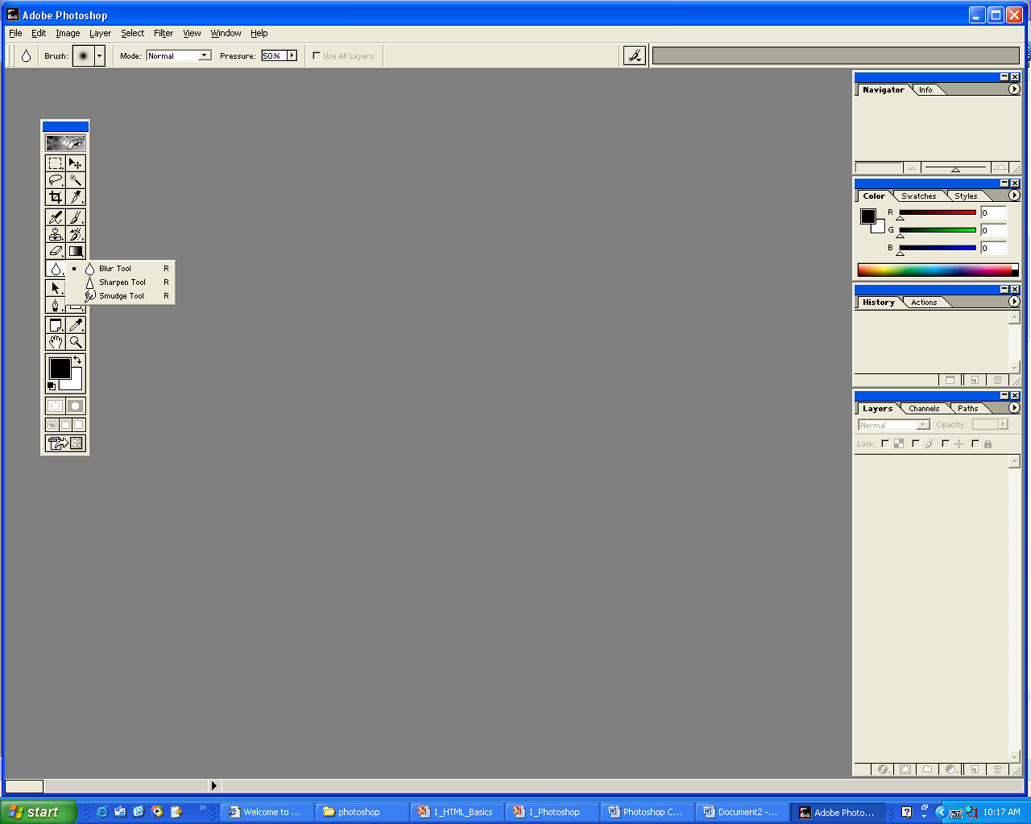  GRADIENT: Colors in your shapes by blending colors. Can be made transparent or opaque. | 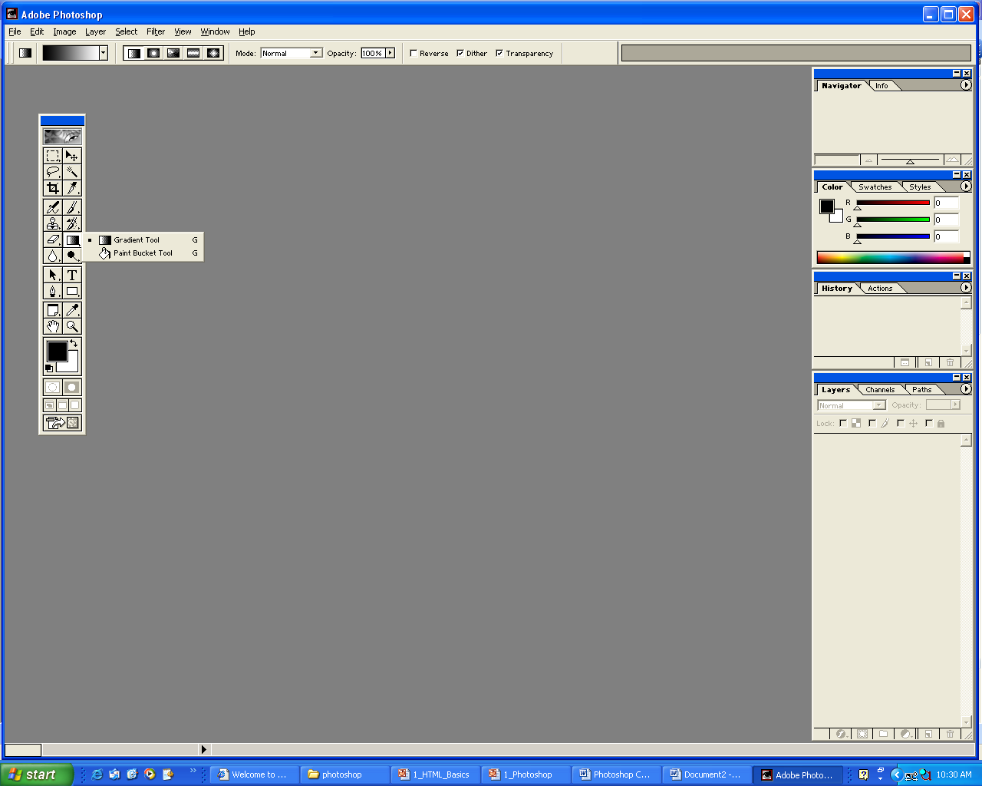  PAINT BUCKET: Fills similarly colored areas with the foreground color.
BLUR: Blurs hard edges in an image. | SHARPEN: Sharpens soft edges in an image.
SMUDGE: Smudges the image, just as rubbing a finger on a painting would. | TYPE: Create type on an image. The font, size, shape can be changed using the options on top.
EYEDROPPER: Selects colors in an image. | SHAPES: Lets you draw shapes from a shape list.
PEN: Lets you draw smooth edge paths, which means you can draw or outline any shape.

EXPERIMENT with Photoshop, but if you have any questions ask us!!!

