Directions to the Department
Please come in the front doors of the Watson CIT (picture below) and proceed through the lobby and through the second set of doors. An Artemis coordinator will be standing at the elevator to send you up to the fourth floor, where the reception will be held.

From 95 North or South
- Take Exit 20 onto 195 East (Cape Cod).
- Take Exit 2 to WICKENDEN Street.
- Turn LEFT at the light on to WICKENDEN and LEFT at the 2nd light on to BROOK St.
- Continue on Brook for several blocks to a traffic light.
- Our red brick building is on your left.
- The front of our building is on the other side, facing a quadrangle.
- Computer Science is on the 4th floor.

From 195 West
- Take the GANO St. exit and turn RIGHT at the end of the ramp.
- At the 3rd light, turn LEFT on ANGELL St.
- Continue for several blocks to the 2nd light at BROOK and turn LEFT.
- Our red brick building is opposite the light on the left corner.
- The front of our building is on the other side, facing a quadrangle.
- Computer Science is on the 4th floor

Parking
Even if you have a tag and can park in the visitor parking areas, space is very limited. If you're unable to find a space, you'll likely find on-street parking within walking distance of the CIT building (but watch out for 2- and 3-hour zones). There is additional visitor parking at the athletic complex (corner of HOPE and BOWEN) but you must have a hang tag to park there or the department you're visiting will be fined. HOPE parallels BROOK, one block over to the right.

Access via RIPTA buslines
The Department is easily accessible by a 5 minute bus ride from downtown. Bus and trolley stops are located in Kennedy Plaza. Two buses run through the Tunnel and stop at Thayer Street (which is a block away from the Computer Science Department)-- 40 Butler/Elmgrove and 42 Hope Tunnel. The fare is $.50. The trolley runs a bit more frequently. The fare for this is $1.00. More information can be found at the RIPTA website.

Area Map (the dot is the Watson CIT)

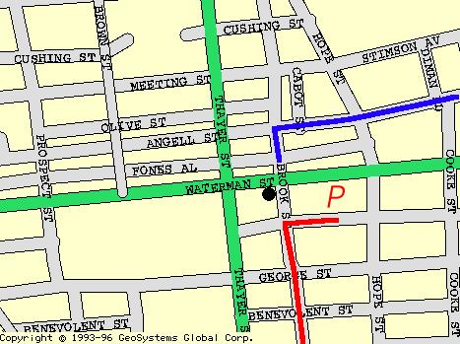

The Watson CIT The CIT is located rightnext to the Sciences Library

