### Indicator 2.C: High Expectations, Rigorous Instruction



School leadership and staff foster a culture of high expectations and rigorous instruction for most students, including multilingual learners, students with disabilities, and students from historically underserved backgrounds. School leadership and staff develop concrete plans for helping most students to engage in standards-aligned, grade-level work and have well-defined instructional expectations. However, some barriers to engaging all students may still exist. Most teachers are familiar with strategies to support high expectations and rigorous instruction, but these strategies may not be used consistently throughout the school.

#### OVERALL RATING SUMMARY:

Consistent with an established rating for this indicator, school leadership and staff foster a culture of high expectations, including historically underserved students. Staff develop concrete plans for helping most students to engage in standards-aligned, grade-level work, but there are some barriers to all students experiencing this instruction. Most teachers report familiarity with strategies to support high expectations, but CLASS observation scores in the low range suggest that these strategies are not yet implemented consistently within or across classrooms.

#### CLASSROOM OBSERVATIONS: CONTENT UNDERSTANDING \ CONCEPT DEVELOPMENT

Upper grades classrooms at this school averaged in the **middle** range. At the middle range, the focus of the class is sometimes on meaningful discussion and explanation of broad, organizing ideas. At other times, the focus is on discrete pieces of information. Class discussion and materials communicate some of the essential attributes of concepts and procedures, but examples are limited in scope or not consistently provided. The teacher makes some attempt to elicit and/or acknowledge students’ background knowledge or misconceptions and/or to integrate information with previously learned material; however, these moments are limited in depth or are inconsistent.

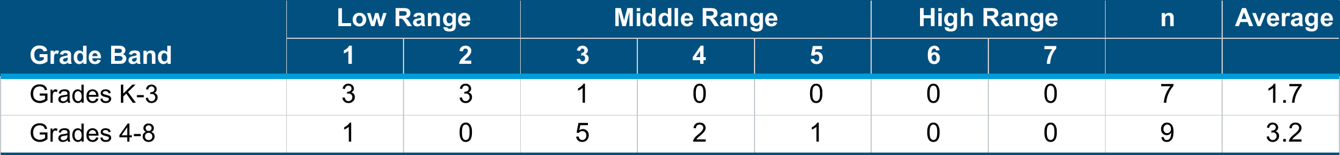

∗The school average is a weighted average calculation of the observation scores. Weighted Average = $\frac{\sum{Rating x Frequency}}{\sum{Frequency}}$

∗The CLASS observation protocols for this dimension vary by grade level. The K-3 tool focuses on Concept Development, whereas the tool used for all other grades focuses on Content Understanding.

Indicator 2.c: High Expectations, Rigorous Instruction (cONT.)

#### CLASSROOM OBSERVATIONS: INSTRUCTIONAL DIALOGUE \ LANGUAGE MODELING

Upper grades classrooms at this school averaged in the **low** range. At the low range, there are no or few discussions in the class, the discussions are not related to content or skill development, or the discussions contain only simple question-response exchanges between the teacher and students. The class is dominated by teacher talk, and discussion is limited. The teacher and students ask closed-ended questions; rarely acknowledge, report, or extend other students’ comments; and/or appear disinterested in other students’ comments, resulting in many students not being engaged in instructional dialogues.

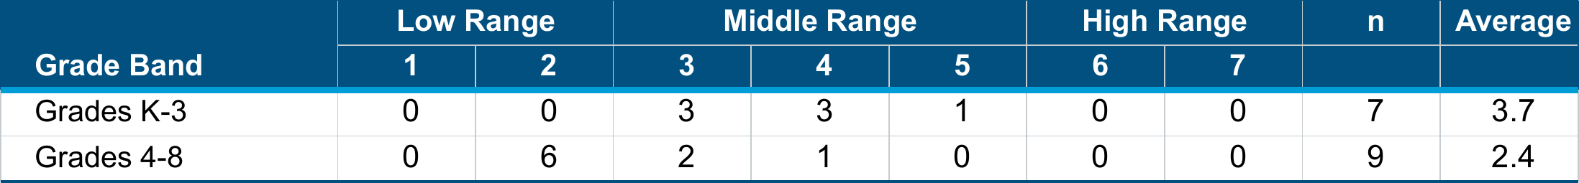

∗The school average is a weighted average calculation of the observation scores. Weighted Average = $\frac{\sum{Rating x Frequency}}{\sum{Frequency}}$

∗The CLASS observation protocols for this dimension vary by grade level. The K-3 tool focuses on Language Modeling, whereas the tool used for all other grades focuses on Instructional Dialogue.

#### CLASSROOM OBSERVATIONS: ANALYSIS & INQUIRY

Upper grades classrooms at this school averaged in the **low** range. At the low range, students do not engage in higher order thinking skills. Instruction is presented in a rote manner, and there are no opportunities for students to engage in novel or open-ended tasks. Students are not challenged to apply previous knowledge and skills to a new problem, nor are they encouraged to think about, evaluate, or reflect on their own learning. Students do not have opportunities to plan their own learning experiences.



∗The school average is a weighted average calculation of the observation scores. Weighted Average = $\frac{\sum{Rating x Frequency}}{\sum{Frequency}}$

∗This dimension does not appear in the CLASS K-3 manual. Therefore, scores represent upper grade classrooms only.

Indicator 2.c: High Expectations, Rigorous Instruction (cont.)

#### STAFF SURVEY RESPONSE:



#### STAFF PERSPECTIVES:

* Staff focus group participants shared that the AVID program has been raising school-wide expectations and providing instructional strategies to support high expectations. School leaders also reported that AVID strategies keep the curriculum engaging and meaningful for students. However, staff focus group participants noted a discrepancy in the level of AVID training among staff, with some teachers feeling adequately trained while others are not, which may impact the consistency of AVID implementation.
* Evidence of Learning Conditions (EJC): Nearly all staff survey respondents (97%) agreed or strongly agreed that teachers have a collective understanding of best practices and strategies for engaging students from historically underserved backgrounds in rigorous instruction. School leaders similarly reported that efforts to integrate culturally responsive practices into the curriculum to contribute to high expectations and rigorous instruction for all students. For example, teachers are integrating culturally responsive practices through project-based learning, which supports rigorous instruction by engaging students in meaningful, standards-aligned work.
* Almost all staff survey participants (98%) agreed or strongly agreed that school leaders actively monitor the level of rigor in teaching at the school. This perception aligns with school leaders' reports that teachers receive classroom observations regularly, sometimes on a daily basis.