### Indicator 3.B: Warm and Responsive Environment



School leadership and staff prioritize direct instruction of social-emotional competencies, and instruction is often tailored to students’ specific needs. Social-emotional competencies are integrated into classroom instruction and the curriculum, ensuring that they are not only taught but also consistently reinforced and actively monitored for effectiveness. School leadership and staff maintain a safe and nurturing learning environment that encompasses physical, social, emotional, and behavioral aspects. This commitment extends to the implementation of universal teaming structures, healing-centered supports, enrichment and engagement programming, and comprehensive re-entry planning. School leadership and staff have established clear behavioral expectations understood by the school community and have systems and policies to ensure equitable and consistent reinforcement of these expectations.

#### OVERALL RATING SUMMARY:

Consistent with a robust rating, school leadership and staff prioritize direct instructional support for social-emotional (SEL) competencies, and these practices are integrated into the curriculum, used in all classrooms daily, and implementation is tailored to meet students' needs. School leadership and staff have established an environment that has clear and consistent behavioral expectations, as well as created a safe and nurturing environment. These have been implemented consistently throughout the school, although some staff struggle to maintain consistency of expectations for students with IEPs.

#### CLASSROOM OBSERVATIONS: POSITIVE CLIMATE

Upper grades classrooms at this school averaged in the **middle** range. There are some indications that the teacher and students share a warm and supportive relationship, but some students may be excluded from this relationship, either by the teacher or the other students. Some relationships appear constrained—for example, the teacher expresses a perfunctory interest in students, or encouragement seems to be an automatic statement and is not sincere. Teachers and students sometimes demonstrate respect for one another.

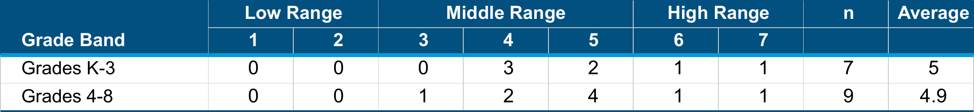

∗The school average is a weighted average calculation of the observation scores. Weighted Average = $\frac{\sum{Rating x Frequency}}{\sum{Frequency}}$

Indicator 3.B: Warm and Responsive Environment (CONT.)

#### CLASSROOM OBSERVATIONS: TEACHER SENSITIVITY

Upper grades classrooms at this school averaged in the **middle** range. The teacher is sometimes aware of student needs or aware of only a limited type of student needs, such as academic needs, not social-emotional needs. Or the teacher may be aware of some students' needs and not of other students' needs. The teacher does not always realize a student is confused and needs extra help or when a student already knows the material being taught. The teacher may be responsive at times to students, but at other times may ignore or dismiss students. The teacher may respond only to students who are upbeat and positive and not support students who are upset. The teacher is sometimes effective in addressing students’ concerns or problems, but not always.

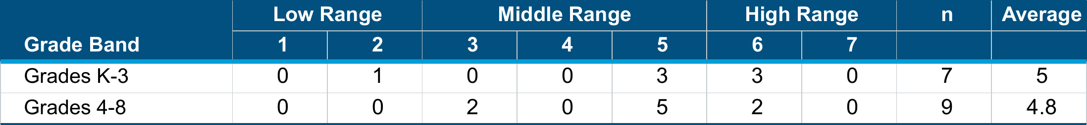

∗The school average is a weighted average calculation of the observation scores. Weighted Average = $\frac{\sum{Rating x Frequency}}{\sum{Frequency}}$

#### CLASSROOM OBSERVATIONS: BEHAVIOR MANAGEMENT

Upper grades classrooms at this school averaged in the **high** range. At the high range, the rules and guidelines for behavior are clear, and they are consistently reinforced by the teacher. The teacher monitors the classroom and prevents problems from developing, using subtle cues to redirect behavior and address situations before they escalate. The teacher focuses on positive behavior and consistently affirms students’ desirable behaviors. The teacher effectively uses cues to redirect behavior. There are no, or very few, instances of student misbehavior or disruption.

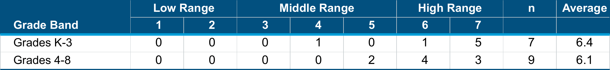

∗The school average is a weighted average calculation of the observation scores. Weighted Average = $\frac{\sum{Rating x Frequency}}{\sum{Frequency}}$

Indicator 3.B: Warm and Responsive Environment (CONT.)

#### CLASSROOM OBSERVATIONS: PRODUCTIVITY

Upper grades classrooms at this school averaged in the **high** range. The classroom runs very smoothly. The teacher provides a steady flow of activities for students, so they do not have downtime and are not confused about what to do next. The routines of the classroom are efficient, and all students know how to move from one activity to another and where materials are. Students understand the teacher’s instructions and directions. Transitions are quick, and there are not too many of them. The teacher is fully prepared for the lesson.

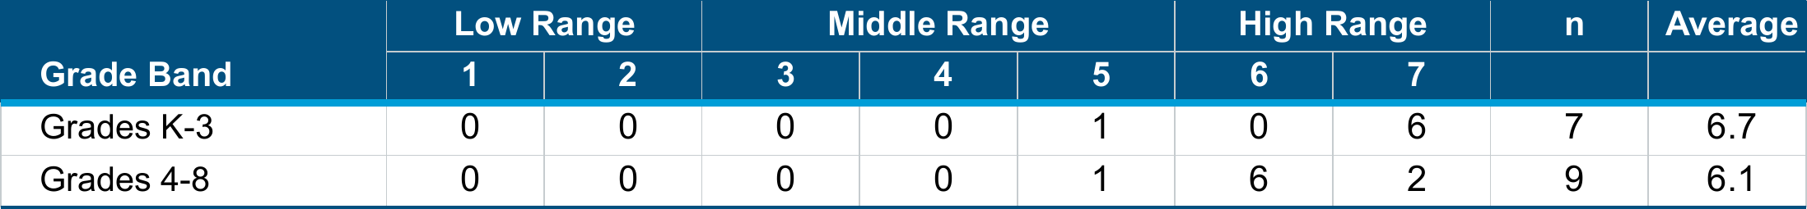

∗The school average is a weighted average calculation of the observation scores. Weighted Average = $\frac{\sum{Rating x Frequency}}{\sum{Frequency}}$

#### CLASSROOM OBSERVATIONS: NEGATIVE CLIMATE

Upper grades classrooms at this school averaged in the **low** range. There is no display of negativity. No strong expressions of anger or aggression are exhibited, either by the teacher or students; if there is such a display, it is contained and does not escalate. The teacher does not issue threats or yell to establish control. The teacher and students are respectful and do not express sarcasm.

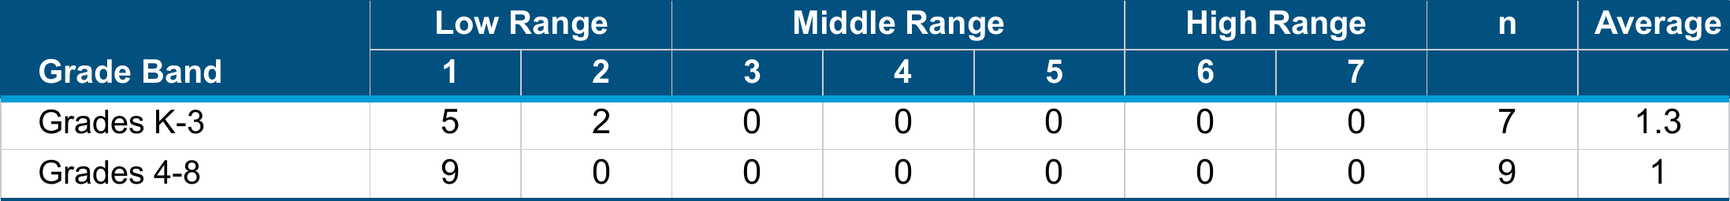

∗The school average is a weighted average calculation of the observation scores. Weighted Average = $\frac{\sum{Rating x Frequency}}{\sum{Frequency}}$

Indicator 3.B: Warm and Responsive Environment (CONT.)

#### STAFF SURVEY RESPONSE:



#### STAFF PERSPECTIVES:

* Although school leaders held mixed opinions, the majority of staff survey respondents (91%) agreed or strongly agreed that the school community universally understands behavioral expectations.
* Evidence of Student Learning (EJC): The majority of staff survey respondents (81%) agreed or strongly agreed that the school has expectations for student conduct that are enforced consistently no matter who the students are. Staff focus group participants agreed that behavioral expectations are consistent for most students but noted that maintaining consistency for students with IEPs, particularly those receiving additional behavioral and emotional support, can be challenging.
* Nearly all staff survey participants (98%) agreed or strongly agreed that the schedule includes adequate time to teach social-emotional learning strategies. School leaders explained that the "7 Mindsets" program is an integral part of the school's SEL curriculum and is taught daily. School leaders also described using Panorama to monitor social-emotional learning.