### Indicator 4.B: Inclusive and Differentiated Instruction



Most students have access to individualized support and high-quality, grade-appropriate instruction, grounded in Universal Design for Learning (UDL) practices, and receive individualized support that does not require them to miss substantial core instruction time. Most teachers use instructional scaffolds to differentiate instruction, and these scaffolds are often evident in lesson planning and observed in instruction. However, some barriers (e.g., staffing, scheduling, curricular materials, professional development) exist that hinder consistent implementation. Special education teachers sometimes co-teach or push into classrooms to provide additional support for student learning in core instructional periods. English learners often receive primary language supports through a combination of resources (e.g., dictionaries) or assistive technology (e.g., language applications) and a teacher or paraprofessional.

#### OVERALL RATING SUMMARY:

Consistent with an established rating for this indicator, most students have access to individualized supports, and instruction in most classrooms is grounded in Universal Design for Learning (UDL) practices, offering students access to high-quality, grade-appropriate instruction. Some teachers use scaffolds to support student learning, with CLASS scores for Quality of Feedback (which includes scaffolding) falling in the middle range. Push-in and co-teaching supports are available to allow students with individualized needs to participate in classes without regular exclusion. In addition, the school uses the Advancement Via Individual Determination (AVID) program, which supports differentiated and inclusive instruction.

#### CLASSROOM OBSERVATIONS: INSTRUCTIONAL LEARNING FORMATS

Upper grades classrooms at this school averaged in the **middle** range. At the middle range, the teacher sometimes facilitates engagement in the lesson, but at other times does not; or the teacher facilitates engagement for some students and not for other students. The teacher may not allow students enough time to explore or answer questions. Sometimes, the teacher uses a variety of modalities to help students reach a learning objective, but at other times the teacher does not. Student engagement is inconsistent, or some students are engaged and other students are not. At times, students are aware of the learning objective, but at other times they are not. The teacher may sometimes use strategies to help students organize information, but at other times does not.

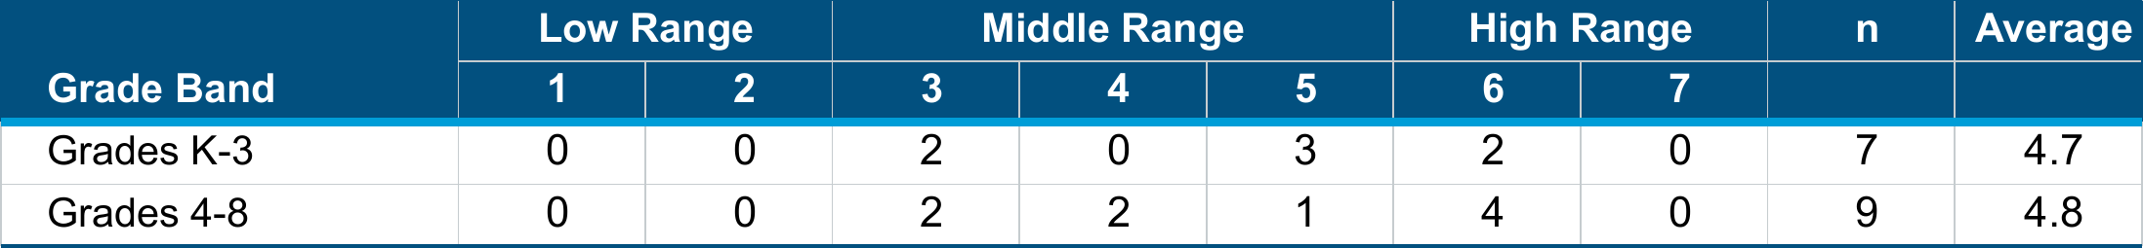

∗The school average is a weighted average calculation of the observation scores. Weighted Average = $\frac{\sum{Rating x Frequency}}{\sum{Frequency}}$

INDICATOR 4.B: INCLUSIVE AND DIFFERENTIATED INSTRUCTION (CONT.)

CLASSROOM OBSERVATIONS: QUALITY OF FEEDBACK

Upper grades classrooms at this school averaged in the **middle** range. In the middle range, the teacher sometimes provides scaffolds to students, but this is not consistent. On occasion, the teacher facilitates feedback loops so that students may elaborate and expand on their thinking, but these moments are not sustained long enough to accomplish a learning objective. The teacher sometimes asks students about or prompts them to explain their thinking and provides information to help students understand, but sometimes the feedback is perfunctory. The teacher sometimes encourages student efforts and persistence.

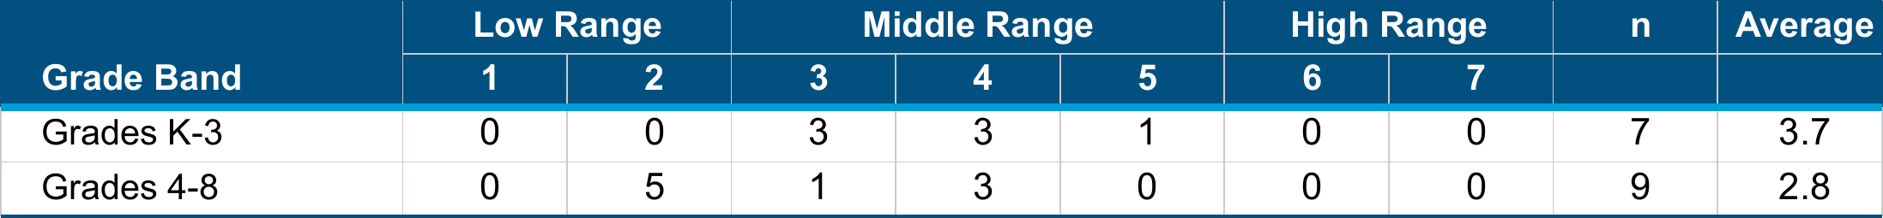

∗The school average is a weighted average calculation of the observation scores. Weighted Average = $\frac{\sum{Rating x Frequency}}{\sum{Frequency}}$

CLASSROOM OBSERVATIONS: STUDENT ENGAGEMENT

Upper grades classrooms at this school averaged in the **middle** range. In the middle range, students are passively engaged, listening to or watching the teacher; student engagement is mixed, with the majority of students actively engaged for part of the time and disengaged for the rest of the time; or there is a mix of student engagement, with some students actively engaged and some students disengaged.



∗ The school average is a weighted average calculation of the observation scores. Weighted Average = $\frac{\sum{Rating x Frequency}}{\sum{Frequency}}$

∗ This dimension does not appear in the CLASS K-3 manual. Therefore, scores represent upper grade classrooms only.

Indicator 4.B: Inclusive and Differentiated Instruction (CONT.)

#### STAFF SURVEY RESPONSE:



#### STAFF PERSPECTIVES:

* Evidence of Learning Conditions (EJC): Most staff survey respondents (89%) agreed or strongly agreed that push-in supports are available for students who require more individualized help. However, staff focus group participants indicated that push-in supports are not consistently available, which may hinder differentiated and inclusive instruction.
* School leaders described the school's efforts to support differentiation and inclusion across all grades. For example, teacher-created lesson plans include AVID strategies, and school leaders review these plans. School leaders also monitor teaching methods through daily classroom walkthroughs, looking for AVID strategies and small group instruction as evidence that staff are supporting diverse student needs. In addition, 91% of staff survey respondents agreed or strongly agreed that a majority of their instruction is grounded in Universal Design for Learning principals, which supports differentiation and inclusion.
* Evidence of Learning Conditions (EJC): While most school leaders agreed that school classrooms provide inclusive grade-level instruction supported by co-teaching or push-in special education, focus group participants reported that challenges in getting students into the MTSS can prevent students from receiving timely support.