CouchQuest local co op session platform
Microservices Development and Deployment
SEZG583 Scalable Services
CouchQuest coordinates local split-screen and shared-screen co-op sessions for two to four players. The solution implements Game Catalog and Play Session as independent microservices, each with its own database and deployment configuration.

Student and group details
Field | Details to complete
Student name | [Enter your name]
Student ID | [Enter your ID]
Group and members | [Enter group number and each member’s name and ID]
Submission date | 12 November 2026

Application and scope
Players use a local companion client or Postman to select a compatible game, create a lobby, allocate controller slots and mark themselves ready. Split-screen games render a separate viewport for each player; shared-screen games place all players in one common view. The catalog represents both modes.
The game engine remains on one PC or console. It handles rendering, input and gameplay. This backend records session preparation and lifecycle; its start endpoint does not launch an installed game. Twin Trails is a fictional two-player split-screen game used for the demonstration.

Core scenario
Alice creates a Twin Trails session with two controllers. Bob joins slot 2. An attempt by Eve to join is rejected because both slots are occupied. Alice and Bob mark themselves ready; Alice starts and later completes the session. The service rejects a start when minimum participation or readiness is missing.

Delivered scope
The accompanying package contains two service codebases, automated tests, Dockerfiles, separate PostgreSQL deployment configuration, Minikube manifests, a Postman collection and execution instructions. Identity, achievements and notifications are extension capabilities rather than implemented services.

1 Architecture and business capabilities
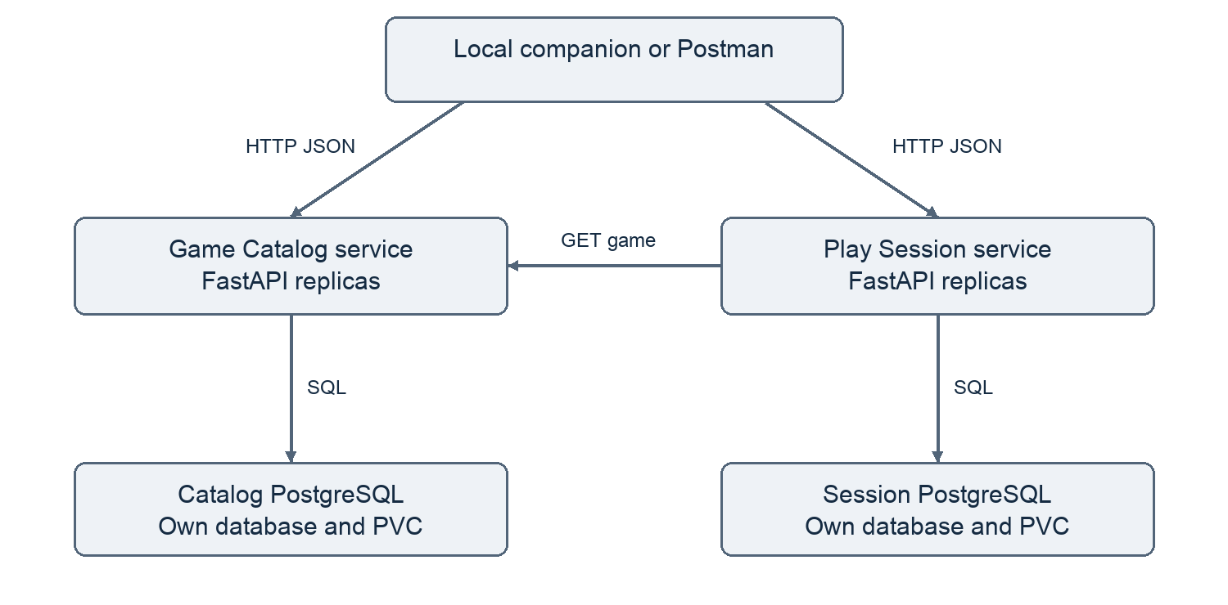
Figure 1 Implemented service collaboration and database ownership
Capability | Service and responsibility | Status
Compatibility and discovery | Catalog owns title, platform, display mode and player limits. | Implemented
Local session coordination | Session owns players, slots, readiness and lifecycle. | Implemented
Identity and access | Identity would verify player accounts and permissions. | Proposed
Results and achievements | Progress would persist game results and unlocks. | Proposed
Invitations and alerts | Notification would deliver invitations and completion alerts. | Proposed

Service boundaries follow business capabilities. Catalog changes need not be deployed with Session changes. There is no shared application database, shared table or cross-service SQL query. Each API can be built, tested and deployed independently.
Kubernetes provides an internal Service name for each API and database. Each API runs in its own Deployment. The teaching deployment uses one PostgreSQL instance and persistent volume per service. A future production gateway would provide TLS, authentication and rate limiting.

2 System operations and collaboration
Commands change state; queries read it. The API separates these operations through HTTP methods while keeping a single service-owned data store per capability.
Type | Owner | Operation and route
Command | Catalog | Register game POST /games
Query | Catalog | Find games GET /games
Query | Catalog | Read game GET /games/{game_id}
Command | Session | Create lobby POST /sessions
Query | Session | Read lobby GET /sessions/{id}
Command | Session | Join POST /sessions/{id}/players
Command | Session | Ready PUT /sessions/{id}/players/{player}/ready
Command | Session | Leave DELETE /sessions/{id}/players/{player}
Command | Session | Start POST /sessions/{id}/start
Command | Session | Finish POST /sessions/{id}/finish
Command | Session | Cancel POST /sessions/{id}/cancel

Creation sequence
1. Client sends game_id, host_id and controller_count to Session.
2. Session queries Catalog over HTTP and checks that the game exists.
3. Capacity becomes min(controller_count, max_players). A capacity below min_players is rejected.
4. Session saves a snapshot of the game metadata and assigns the host slot 1.
5. Session returns HTTP 201 with a new session ID.
Synchronous REST fits this operation because validation must finish before creation succeeds. The HTTP client has a three-second network timeout. A missing game maps to 404 and an unavailable Catalog maps to 503. Only Session writes data in this sequence, so no distributed transaction is necessary.
All subsequent session operations use the saved snapshot. Existing sessions continue during a Catalog outage. Catalog entries are immutable in this implementation; metadata editing would require an explicit policy for existing snapshots.

3 Data rules consistency and scaling

Data model
Store | Fields
Catalog games | id, title, platform, display_mode, min_players, max_players
Session sessions | id, version, data JSON
Session JSON content | Game snapshot, host ID, controller count, capacity, status, and players with player ID, slot and ready flag

The player array is bounded to four members. Keeping it in one aggregate makes slot assignment and readiness validation atomic with the session lifecycle. PostgreSQL is used in containers; separate SQLite files support quick local tests.

Lifecycle and business invariants
Valid transitions are LOBBY → IN_PROGRESS → COMPLETED, or LOBBY → CANCELLED. Joining, leaving and setting readiness require LOBBY. Starting requires the minimum player count and every participant ready. The host must cancel instead of leaving. Only the supplied host ID may start, finish or cancel.
Duplicate joins do not allocate another slot. Repeated readiness writes set the same value. Repeating start while already in progress or finish after completion succeeds with the current state. Create operations do not have idempotency keys, so clients should not automatically retry them after ambiguous failures.

Concurrent writes
Every mutation reads the stored version, validates the proposed state and updates only where the version still matches. A competing write causes the operation to reread and revalidate, up to five attempts. A remaining conflict returns 409. This optimistic concurrency check prevents lost updates and overbooking across API replicas.

Scaling and resilience
API replicas keep durable state in their own PostgreSQL database. Catalog and Session can scale independently. The optional HPA targets 70 percent CPU utilization with one to three replicas. Readiness checks database access; liveness checks the process. Resource requests and limits are included. Persistent volumes preserve data when API pods restart.
The teaching databases are single instances and remain availability bottlenecks. Production deployment needs database HA and backups, identity verification, TLS, schema migration jobs, observability and load testing. No production throughput result is asserted. Caller-supplied player IDs provide a demo convention, not secure authentication.

4 Implementation and project structure
Technology | Purpose
Python 3.12 and FastAPI | Independent REST APIs and generated API documentation
Pydantic | Input validation and player/controller bounds
SQLAlchemy and PostgreSQL 16 | Persistence with one database per service
HTTPX | Session-to-Catalog HTTP communication
pytest | Business-rule, failure and concurrency tests
Docker and Kubernetes | Container packaging, service discovery and deployment

catalog-service/ session-service/
app/main.py app/main.py
tests/test_api.py tests/test_api.py
Dockerfile Dockerfile
requirements.txt requirements.txt
requirements-dev.txt requirements-dev.txt
.github/workflows/ci.yml .github/workflows/ci.yml
README.md README.md
deployment/
compose.yaml kubernetes.yaml hpa.yaml .env.example
postman_collection.json smoke_test.py evidence/
Each service folder is a standalone repository root. It has its own dependency manifest, tests and Dockerfile, and does not import the other service’s code. The services are published in separate GitHub repositories linked in Section 8.

Implementation steps
Define capabilities and request models; implement Catalog persistence and queries; implement the REST lookup from Session; add capacity, readiness and lifecycle rules; protect mutations using version checks; test normal and failure cases; package the APIs; add PostgreSQL storage and Kubernetes probes.
Database tables are created at startup for simplicity. Start with one API replica so initialization completes before scaling. Replace this mechanism with a separate migration job in production. Dependencies are pinned directly in requirements files, but transitive versions and container digests are not fully locked.

Optional continuous integration
Each repository includes a GitHub Actions workflow that installs dependencies, runs its tests and builds its container image. This is a CI pipeline. Publishing images and deploying to a cluster are not configured.

5 Local execution and Docker deployment

Run services independently
Requires Python 3.12. In each service directory, create its own virtual environment, install dependencies and run the tests. Start the APIs in separate terminals.
python3 -m venv .venv
.venv/bin/python -m pip install -r requirements-dev.txt
.venv/bin/python -m pytest -q
# Catalog terminal from catalog-service
.venv/bin/python -m uvicorn app.main:app --port 8001
# Session terminal from session-service
.venv/bin/python -m uvicorn app.main:app --port 8002
Local defaults use separate SQLite files. The Session service calls http://localhost:8001. Interactive API documentation is available at http://localhost:8001/docs and http://localhost:8002/docs. From the package root, run python3 smoke_test.py.

Run Docker containers
Start the Docker engine. From the package root, copy the example environment file and replace its passwords with URL-safe alphanumeric values. The environment file must not be committed.
cp deployment/.env.example deployment/.env
docker compose --env-file deployment/.env \
-f deployment/compose.yaml up --build -d
docker compose --env-file deployment/.env \
-f deployment/compose.yaml ps
python3 smoke_test.py
The Compose deployment starts four containers: two APIs and two PostgreSQL databases. Database health checks gate API startup. Each database uses its own named volume. API host ports bind to 127.0.0.1, and the databases have no published host ports.

Configuration and health
DATABASE_URL selects each service’s private database. CATALOG_URL configures Session’s HTTP dependency. Containers run as a non-root user. GET /health/live reports process availability; GET /health/ready verifies a database connection. Container deployment requires PostgreSQL configuration; the container is not intended to write a local SQLite file under /app.

6 Kubernetes deployment plan
Install Minikube and kubectl and start Docker. Use the dedicated couchquest profile. Full copyable commands, including database Secrets, are in README.md under Minikube deployment.
minikube start -p couchquest --driver=docker \
--cpus=2 --memory=4096
kubectl config use-context couchquest
minikube -p couchquest image build \
-t couchquest-catalog:1.0 catalog-service
minikube -p couchquest image build \
-t couchquest-session:1.0 session-service
Create the couchquest namespace and the catalog-secret and session-secret objects before applying workloads. Each Secret needs password and database-url keys. Use matching passwords for the database and connection URL. Use the exact commands in README.md; never commit real credentials.
kubectl apply -f deployment/kubernetes.yaml
kubectl -n couchquest rollout status deployment/catalog-db
kubectl -n couchquest rollout status deployment/session-db
kubectl -n couchquest rollout status deployment/catalog
kubectl -n couchquest rollout status deployment/session
kubectl -n couchquest get deployments,pods,services,pvc
The manifests provide one Deployment and internal Service for each API and each database, plus two persistent volume claims. API startup probes allow initialization time. Readiness probes control routing; liveness probes detect an unhealthy process.

Access and inspect
Free local ports 8001 and 8002 first. Run these port forwards in separate terminals, then use Postman or the smoke test. Select couchquest in the dashboard namespace selector.
kubectl -n couchquest port-forward service/catalog 8001:8000
kubectl -n couchquest port-forward service/session 8002:8000
minikube -p couchquest dashboard

Scale independently
kubectl -n couchquest scale deployment/session --replicas=2
kubectl -n couchquest get pods
# Optional HPA after the manual scaling demonstration
minikube -p couchquest addons enable metrics-server
kubectl apply -f deployment/hpa.yaml
kubectl -n couchquest get hpa
Observe two ready Session pods while the Catalog and database replica counts stay unchanged. HPA needs working metrics and sufficient load; merely applying it does not prove that automatic scale-out occurred.

7 Validation and evidence

Verified locally
Twelve automated tests passed: four Catalog tests and eight Session tests. Eleven real HTTP calls also passed with two separately running Uvicorn APIs and separate SQLite databases. The flow reached COMPLETED, with expected 409 responses for premature start and a third player. The full responses are in evidence/local-http-transcript.json.
Area | Coverage
Catalog | Create, read, filter, invalid ranges/mode, missing game and health
Session rules | Readiness, lifecycle, host-ID checks, capacity, duplicate join, leave and cancel
Concurrency | Eight join attempts compete for one available slot; exactly one succeeds
Dependency failures | Catalog 404 and connection failure; existing session usable during outage
Real HTTP workflow | Catalog lookup, create, join, rejection, readiness, start, finish and final query

Docker Compose configuration was parsed successfully. The Docker engine was unavailable and Minikube was not installed in the preparation environment. PostgreSQL-backed execution, Kubernetes deployment, dashboard observations and the demonstration video therefore still require an actual run. Do not describe the SQLite evidence as a cluster deployment.

Screenshots to insert after your run
Evidence | What the screenshot should show
API creation | Game and session creation, HTTP 201, request and response body
Business rules | Third-player rejection with 409 and successful readiness/start/finish
Deployments and Pods | Desired/available replicas, Ready pods and restart counts
Services and storage | Internal service names, ports and Bound persistent volume claims
Scaling and persistence | Two Session pods; same session retrieved after API restart

[Insert your genuine Postman and Kubernetes dashboard screenshots here, with short captions describing the observed result. Add pages as needed.]
For persistence testing, retain a session ID, restart the Session API Deployment, wait for rollout and retrieve the same session. Restart a disconnected port-forward if needed. Do not delete database volumes or the namespace during this test.

8 Repositories and submission

Repository links
Catalog repository https://github.com/gchinar/couchquest-catalog
Session repository https://github.com/gchinar/couchquest-session
Complete solution https://github.com/gchinar/CouchQuest
Catalog and Session are published as separate repositories, each with its own dependencies, tests, Dockerfile and CI workflow. The complete solution repository contains deployment files, documentation and a snapshot of both services.

Demonstration video
Record an approximately six-minute demonstration: introduce the local co-op scenario and architecture; show the two repositories; show Minikube workloads; execute the Postman flow; inspect the dashboard; scale Session to two pods; restart the API and retrieve the saved session. Explain the database ownership and the limitations of the teaching deployment.
Video file or instructor-approved link [Insert after recording]

Final packaging
Add student and group details, repository links, screenshots, observed dashboard analysis and the video. Review the code so that you can explain the service boundaries, remote call, version check and deployment configuration. Rename the report with your student ID and package the final submission as STUDENT_ID_CouchQuest.zip, replacing STUDENT_ID with your actual ID.
The separate SUBMISSION_CHECKLIST.md lists the remaining evidence and packaging tasks. The deadline stated in the supplied assignment is 12 November 2026.

References
FastAPI container deployment
https://fastapi.tiangolo.com/deployment/docker/
Minikube setup
https://minikube.sigs.k8s.io/docs/start/
Minikube dashboard
https://minikube.sigs.k8s.io/docs/handbook/dashboard/
Kubernetes Minikube tutorial
https://kubernetes.io/docs/tutorials/hello-minikube/
These official references support the deployment procedures. CouchQuest’s application design and fictional sample game are specific to this solution.

