Large-scale flood mapping - Tutorial

November 2021

Guénolé Choné ([g.chone@yahoo.ca](mailto:g.chone@yahoo.ca))

Julia Mazgareanu ([julie.mazga@gmail.com](mailto:julie.mazga@gmail.com))

Concordia River Management Lab

# Purpose

The purpose of this document is to deliver step-by-step instructions about how to run forecasting simulations in Lisflood FP, as part of the large-scale flood modeling methodology developed by the River Management Lab at Concordia University in the context of the InfoCrue project. This document is a continuation of the steps described in the document entitled " Documentation_ConcordiaRiverLabTools2021_v3.0.9.docx".

# Simulations

If you have worked with the linear referencing branch to run the steps so far, it is required that you switch it to the "master" branch in order to run the simulation tools. Open GitHub Desktop, go to "Current branch" and click on "master". 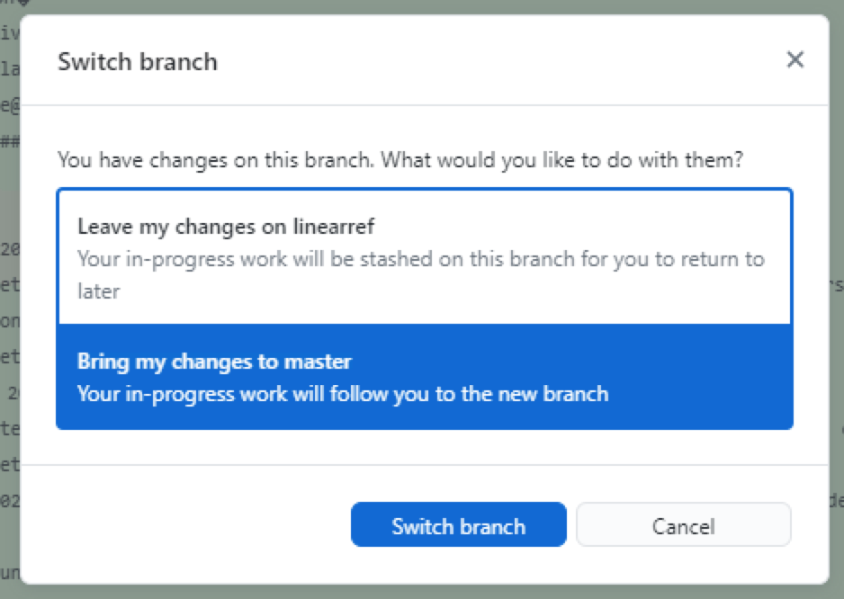

Before being able to run the simulations, we still have some intermediary steps to deal with: add boundary condition information to lakes and reservoirs and do the tiling.

If you are prompted with the message to the right, click on "Bring my changes to master", in order to not lose the RasterIO.py files once the switch between branches is done.

Before running the simulations, there are certain steps to deal with first: adding boundary condition information to lakes and reservoirs, transferring the input variables into a folder, and cutting the network into tiles.

## Lakes and reservoirs

### Processing lakes for Lisflood simulations run in the forecasting mode

* Copy the polygons of the lakes

Input: lakes_final or lakes_GRHQonnetwork

Output: lakes_forsim

* Create an additional feature in *lakes_forsim* at the downstream end of the study area. Include at least one cell of the DEM. This is to assign the model a downstream boundary condition.
* *Optional:* If lakes have extremely uneven shapes that, it is useful to create small polygons, roughly rectangle, where the river path flows into lakes. This will improve the creation of tiles.
* *Optional:* Additional features can be added to the *lakes_forsim* to exclude some areas from the hydraulic simulations.
* Add 1 field in *lakes_forsim* to store the minimum boundary (“*zlidm03*”), corresponding to the LiDAR elevation minus 30cm (this applies to all attributes within the *lakes_forsim*, including the downstream polygon).

## Transferring input data from a gdb to a folder

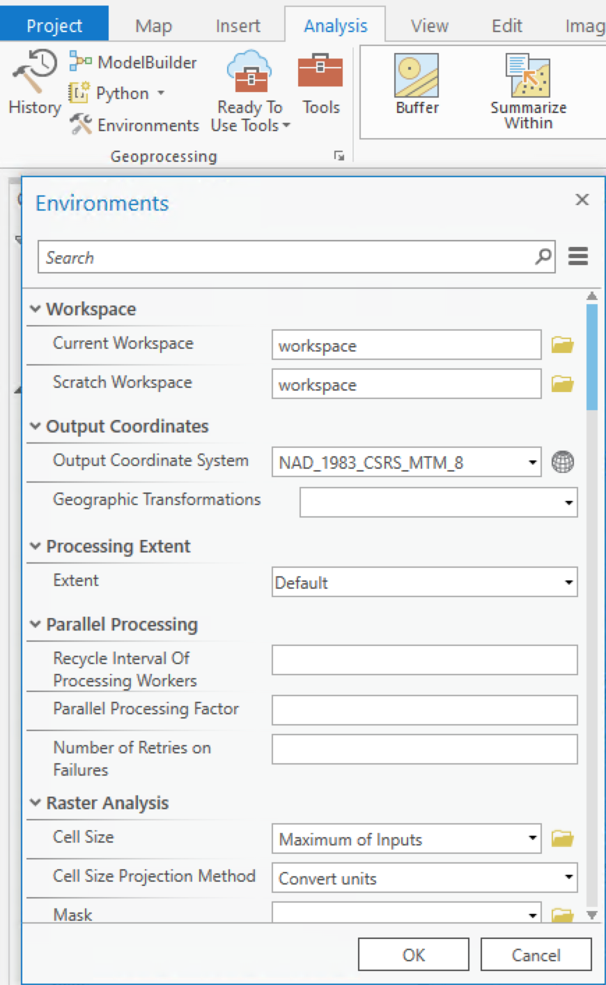

The tools within the "master" branch work with folders as workspaces. Therefore, make sure that when you use them, you modify the global environments, as follows (image on the right):

Additionally, input variables must be stored in a folder:

* Create a "Lisflood_inputs" folder
* Use *Copy Raster* to copy all necessary rasters to this folder (match Snap, Coordinate System, Extent to the lidar10m_avg):
  + *Lidar10m_Avg*
  + *Lidar10m_fd*
  + *Lidar10m_fa*
  + *Mask*
  + *N_floodplain*
* For the bed and the width, rerun the following steps and save the output directly to the "Lisflood_inputs" folder:
  + *Point to Raster* (match Output Coordinates, Processing Extent and Snap to the lidar10m_fd)

*Inputs: bathy_final_events*

*z*

*Cellsize: 10*

*Output: Lisflood_inputs\bathy*

* + *Point to Raster* (match Output Coordinates, Processing Extent and Snap to the lidar10m_fd)

*Inputs: width_final_events*

*Largeur_m*

*Cellsize: 10*

*Output: Lisflood_inputs\width*

* + Verify the result. If there are values outside of the D4 path, they need to be SetNull, so that there is only data along the D4 path and NoData elsewhere.
* *Feature Class to Feature Class* to copy the feature classes to shapefiles into the "Lisflood_inputs" folder (make sure they all share the same coordinate system):
  + *Lakes_forsim*
  + *From_pts*

## Tiling

The aim of this step is to divide the study network into multiple, smaller reaches, on which Lisflood is run independently, in order to ease processing. The tool to be used is *Découpage en zones.*

*Inputs:*

*Lisflood_inputs\lidar10m_fd*

*Lisflood_inputs\lakes_forsim.shp*

*Lisflood_inputs\from_pts.shp*

*zones (NB: create a new empty folder called “zones” to store all outputs of this tool)*

Two shapefiles are created by this tool, in the “zones” folder: *polyzones.shp* and *sourcepoints.shp*. The tiles are represented by the polygons in *polyzones.shp*. They must be checked and corrected if necessary. In particular, at confluences, a zone should not cut into meanders (see image below). Also, check in the attribute table of the polyzones that the “Lake_ID” corresponds to the lake that the zone (defined by the “grid_code”) is stopping at. Manually edit this if this is not the case.

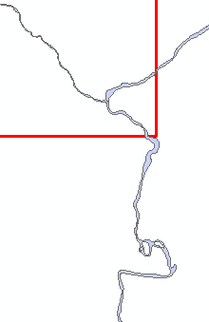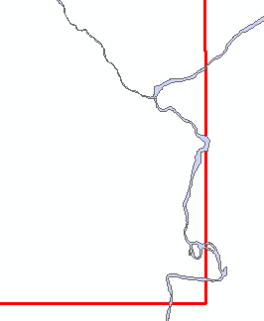

*Corner of a zone (used for the tributary in the upper-right corner) that need to be corrected, and the corrected zone.*

The sourcepoints determine where the processing starts for that zone and should be located inside each polyzone. When editing the polyzones, ensure that the sourcepoint is inside it and located on the flow path defined by the flow accumulation raster.

If zones are to be deleted, the corresponding source point should be deleted as well.

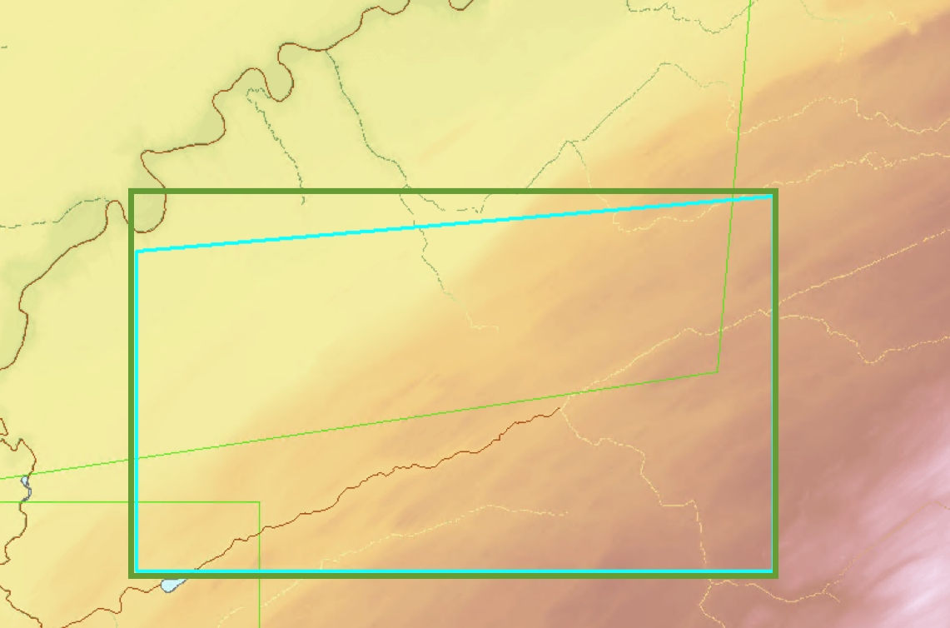The simulation tiles will be based on the envelope of the shapes in *polyzones.shp,* which will be created in the next step. The modified polyzones do not have to be perfectly rectangular, but attention must be given to their shape in relation to how the envelope is going to be created:

*Turquoise= modified polyzone; Green=envelope that will be created*

## Hydraulic simulations with LISFLOOD-FP

The hydraulic simulations are run with two steps.

### Preparation of the simulations

* *Préparation des simulations hydrauliques*

*Inputs:*

*Lisflood_inputs\lidar10m_fd*

*Lisflood_inputs\lidar10m_facc*

*Simulations\zones*

*Lisflood_inputs\lidar10m_avg*

*Lisflood_inputs\widthD4*

*Lisflood_inputs\bed*

*Lisflood_inputs\n_floodplain*

*Lisflood_inputs\mask*

*Simulations\sim_qprev (NB: create a new empty folder to store all outputs of this tool. This will also store the final results. Usually, name should be indicative of simulation done, e.g. sim_test, sim_qprev, etc.)*

This tool creates additional files in the “zones” folder as well as the input files to be used by Lisflood in the simulation folder (all variables clipped according to the zones in .txt format, .bci and .par files). Furthermore, it creates the inbci points (points of discharge) and outbci points (points of elevation) in the zones folder. *NB: See Lisflood manual for more details about .bci, .par files.*

### Running of the simulations

The simulations can be run in two modes: classical (using rasters of spatialized flood discharges of a given recurrence) or forecasting (using a csv file of a range of specific discharges). For the purpose of this document, only the forecasting mode will be described. Information about the classical model can be found in the "Documentation_ConcordiaRiverLabTools2020_v2.4.5.docx".

#### Forecasting mode

In the forecasting mode, a csv file of specific discharges (discharge per km2 of drainage area) is provided to Lisflood and simulations are run automatically for this range of discharges. The simulations can be run using the same simulation folder created with *Préparation des simulations hydrauliques* in step 2.4.1.

The csv containing the specific discharges needs to have the format illustrated below. An example “qspecific.csv” is also included in the data.

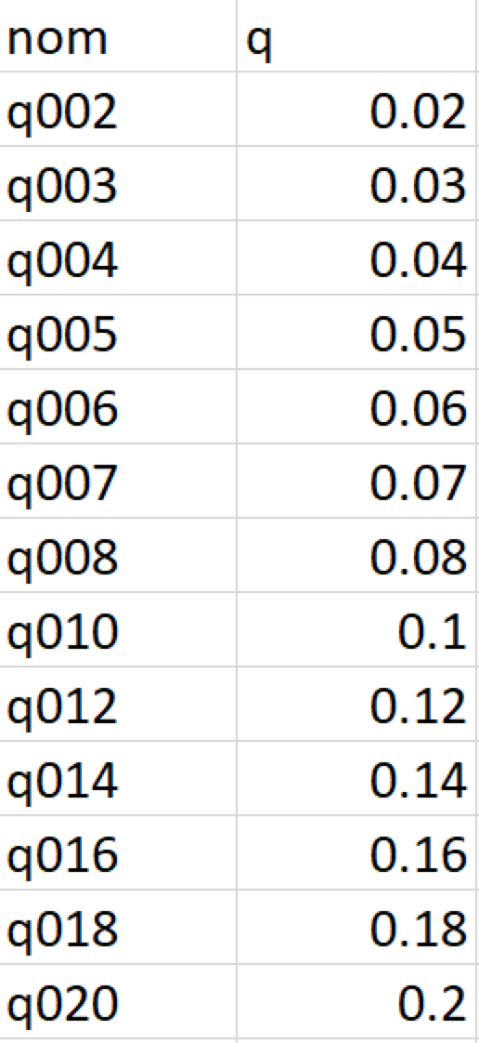

The range of specific discharges is, as mandated by the DEH, defined by a lower limit of 0.02 m3.s-1.km-2 to an upper limit determined by the maximum q350 Hydrotel value found on the study watershed (so make sure to not include points that are outside of the study network). To calculate the value:

* Join *Noeuds_Hydrotel_2020_avec_debits.shp* to Discharge.gdb*Qpts_match_Atlas by the tronçon ID*
* Export to new shapefile *Lisflood_inputs\Noeuds_qspec.shp*
* Create a new field “q350spec” (Field type = Double). Calculate field by dividing q350 by the drainage area (must be the Hydrotel drainage area):

*q350spec = [Q350_50e] / [Superficie]*

* sort in decreasing order and the maximum q350spec will be the upper limit of the specific discharges
* add as many values in between as needed. For example, the current methodology follows this rule, which roughly allows 30cm of elevation difference between individual flood maps:
  + - increase of 0.01, from 0.02 to 0.08 m3.s-1.km-2
    - increase of 0.02, from 0.08 to 0.5 m3.s-1.km-2
    - increase of 0.05, from 0.5 to the maximum

*NB: if the difference between individual flood maps is larger than 30cm for more than 1% of the linear network, an additional specific discharge has to be included.*

* *Lancement des simulations de prevision avec LISFLOOD-FP*

*Inputs:*

*Simulations\zones*

*Simulations\sim_qprev (same folder used as output for Prepa, step 2.4.1)*

*filepath containing Lisflood executable on your computer (e.g.* *C:\Users\user_x\LISFLOOD_FP_v7c\LISFLOOD_FP_v7c)*

*simulations\qspecific.csv*

*Lisflood_inputs\lakesforsim.shp (Field for boundary condition zlidm03)*

*Lisflood_inputs\bed*

*log.txt (records warning and error messages of the simulation, for reference)*

This tool creates separate folders for each specific discharge based on the name given in the qspecific.csv (e.g. q002). Elev_zone# results, .bdy and .mass files can be found within these folders. The watershed-wide, merged result is *res_qXXX* (e.g. res_q002) inside of the *sim_qprev* folder.  
  
Notes:

* .mass files can be copy-pasted to check the status of the simulation (i.e. compare Qin and Qout to see if and how long until the steady state is reached).
* *res_qXXX* represents the merged end result of the simulation and contains flood elevation values in meters. *(NB: It is created by Mosaic to New Raster of all elev_zone# rasters, by using the maximum as a merging rule.)*

## Post-processing of simulation results

The results need to be transferred to the DEH in a certain format, which requires some post-processing. Globally, the lisflood results need to be reprojected, resampled to 4m resolution and transformed from flood elevations to flood depths, with values only outside of the 1D channel.

Creating a 4m DEM and reprojecting it:

* *Aggregate* Forêt ouverte 1m DEM to 4m (by mean), name it "mnt4m_mtm"
* *Project Raster* to Lambert conformal conic (e.g. NAD 1983 CSRS Quebec Lambert), with Resampling Technique "BILINEAR", and name it "mnt4m"

Creating a 4m channel mask based on the channel poly:

* *Polygon to Raster* to transform the channel polygon into a raster (match Output Coordinates, Processing Extent and Snap to computed "mnt4m" raster)

Input: channelpoly.shp

Output: frompoly4m

* *IsNull* to have a value of 0 inside of the channel and 1 everywhere else

Input: frompoly4m

Output: chenal4m

Using the ModelBuilder tools "PostprocessingLisfloodResults.tbx":

Step 1: Create the following empty gdbs:

* + - channel_fill
    - resampled_depths
    - resultats_1var

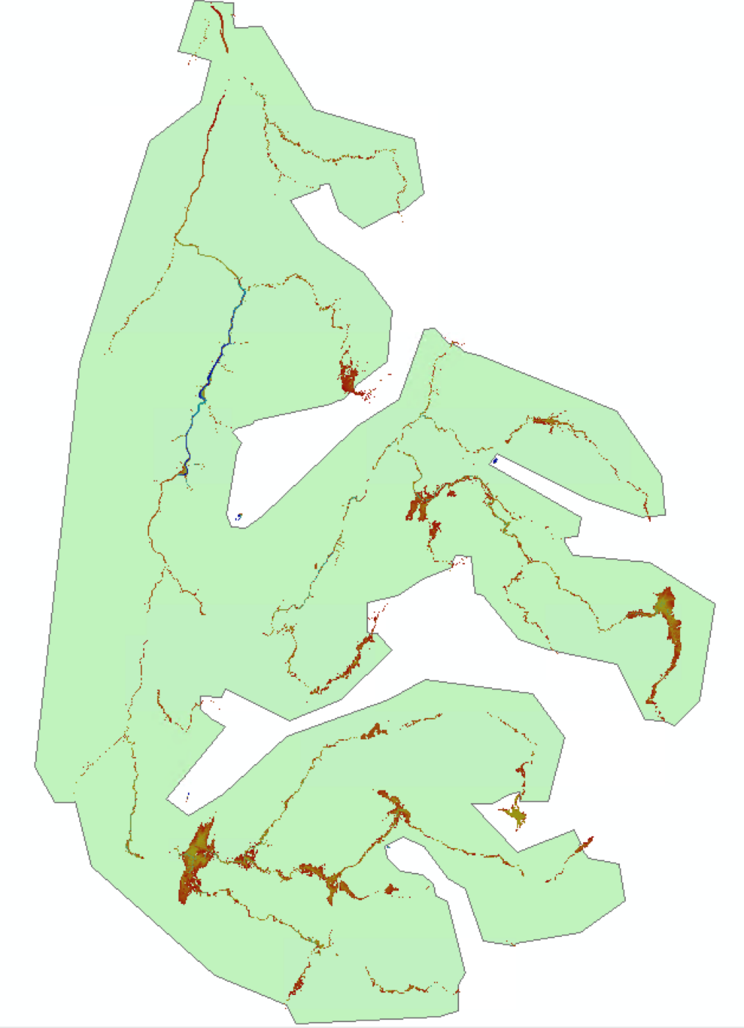Step 2: Create a new shapefile called *global_clip.shp* (in NAD 1983 CSRS Quebec Lambert) and roughly trace a contour that excludes what is flooded upstream of departure points, as well as flooded patches that are disconnected from the river. Display the Lisflood result of the highest simulated discharge and the *from_pts.shp* to do this.

Step 3: Go through each model (right click, Edit) and set up the filepaths of the inputs (blue circles) and outputs (green circle with "%Name% written on it) to match the equivalent files on your own local drive. For outputs, navigate with the file browser to the indicated output folder and type "%Name%" in the Name field.

* **1_Fill1Dchannel** fills NoData area along the 1D channel with flood elevations (working at 10m resolution)
  + double-click "Allocation euclidienne pour matrice à virgule flottante" and navigate to the location of the "ConcordiaRiverLab-RiversTools" on your local drive
  + 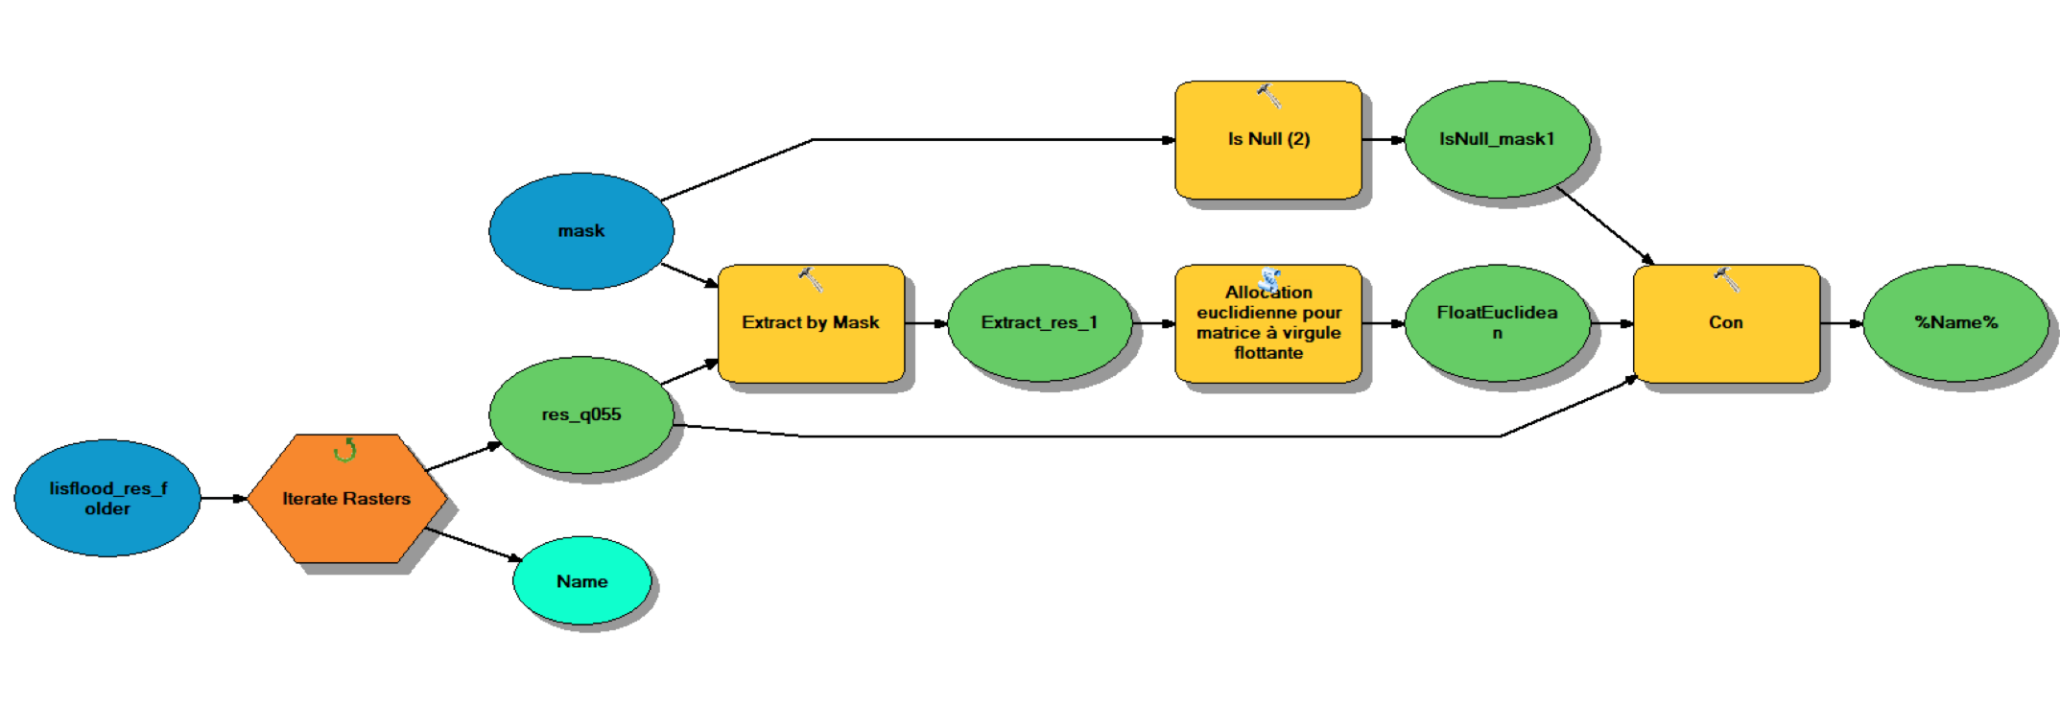Save results in "channel_fill" folder\%Name%
* **2_ Spreadupstream** spreads flood values upstream (working at 10m resolution)
  + 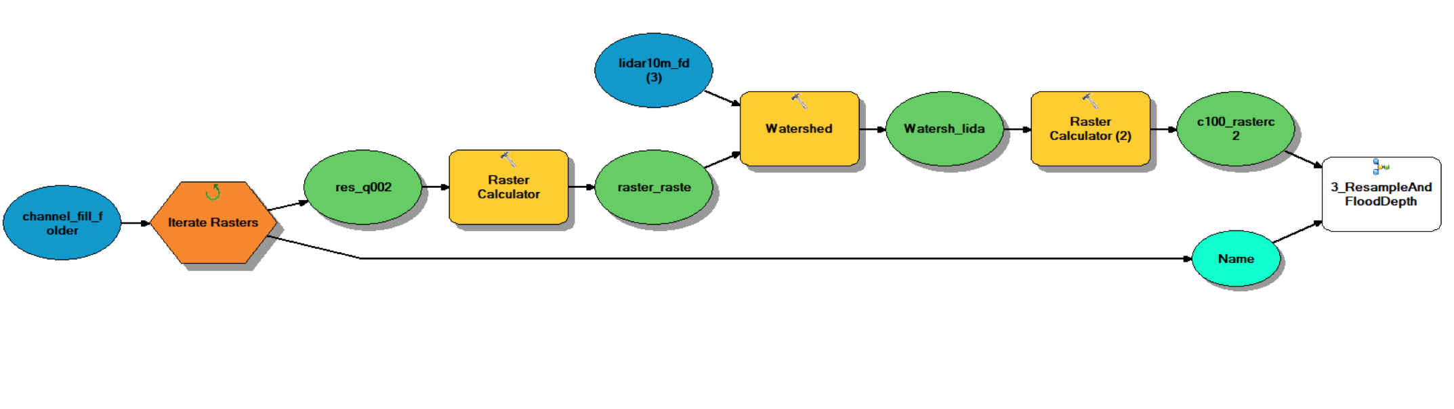double-click **3_ResampleAndFloodDepth** and update the filepath to match that of your local drive
* **3_ResampleAndFloodDepth** resamples previous result to 4m and calculates the flood depths (at 4m resolution)
  + For the input parameter "watershed tool result", copy paste the filepath of the raster "c100_rasterc2" from **2_ Spreadupstream**
  + Make sure that the resample tool has the output cell size 4 and the resample technique set to "Bilinear"
  + It may be that once you set up the filepaths for this model, all shapes will turn white. This is ok. (White indicates that the tool still requires information from the user before it can executed, but once model **2_ Spreadupstream** will finish running, it will have this information)
  + Save results in "resampled_depths" folder\%Name%

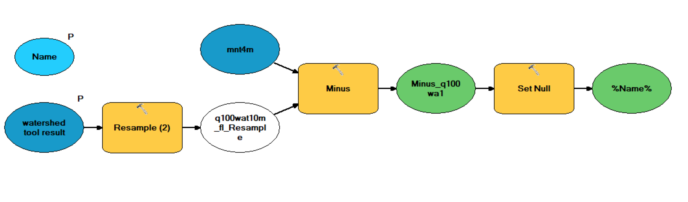

* **4_FinalClip** sets values inside the 1D channel to NoData, as well as clips areas that extend upstream the departure points and other disconnected flooded patches (these appear due to the spreading of the flood values in the previous step)
  + - 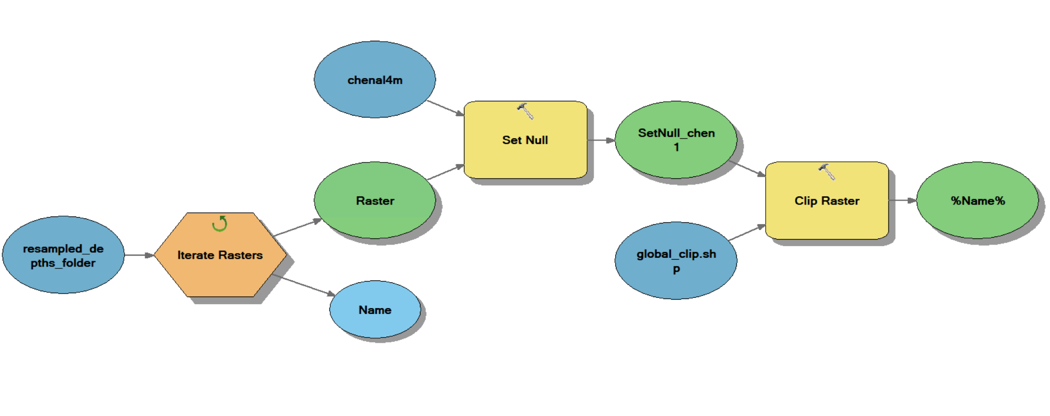Save results in "resultats_1var" folder\%Name%

Step 4: Run each model individually. Make sure that the output of each step respects the required spatial reference and resolution, as well as that they make sense.

## File delivery format

* Use the file *Nomenclature des fichiers* document (included in the data) to follow the guidelines regarding the file delivery format.
* Create an Excel spreadsheet called "Debits_simulations.xlsx" with the following sheets:
* "qspec1var": containing the same data as “qspecific.csv” created in step 2.4.2.2
* "qtroncons": containing the computed simulated discharge (in m3/s, not specific q) for each Atlas 2020 troncon. These are obtained by multiplying the **Hydrotel** drainage area (in km2) of each troncon by each specific discharge included in the simulation (e.g. area of SLS000003 in km2 * 0.02 = 134.01m3/s)

