Large-scale flood mapping – Tutorial
June 2025

Guénolé Choné (g.chone@yahoo.ca)mailto:
Julia Mazgareanu (julie.mazga@gmail.com)

Concordia River Management Lab

Purpose
The purpose of this document is to deliver step-by-step instructions about how to apply the large-scale flood modelling methodology developed by the River Management Lab at Concordia University.

Requirements

Software requirements and installation
- ArcGIS PRO, with Advanced licence and Spatial analyst extension. The 3D Analyst extension can also be useful but is not required.
- LISFLOOD-FP version 7 or above. (See http://www.bristol.ac.uk/geography/research/hydrology/models/lisflood/, https://zenodo.org/record/4073011#.ZCbhlXbMKUl). Make sure LISFLOOD-FP is working. You should have at least basic knowledge of LISFLOOD-FP inputs and outputs (using the coupled 1D/2D sub-grid channel model).
- ArcGIS tools developed by the lab, available at https://github.com/gchone/ConcordiaRiverLab-FloodTools/releases. Download the last version of the tools.
- Lastools by rapidlasso Gmbh (https://rapidlasso.com/lastools).

Data requirements
For a given watershed to be modelled, the following data are required:
- LiDAR LAS files (or LAZ files) with point timestamps (see section 5.2.2). Only LiDAR LAS file of the studied reaches is required.
- LiDAR 1m DEM of the rivers and their floodplains
- A coarser DEM covering the entire watershed (e.g. 10 m or 20 m resolution).
- (Optional) Vectorized stream network data, either from the National Hydro Network (https://open.canada.ca/data/en/dataset/a4b190fe-e090-4e6d-881e-b87956c07977) or from a provincial data source
- 2015 Land Cover of Canada : https://open.canada.ca/data/en/dataset/4e615eae-b90c-420b-adee-2ca35896caf6/resource/e8da7a31-e809-4fc8-91a8-3edf28c9f10c, or other land cover data.
- Discharge data from gauging stations in, or nearby, the study area, or from a hydrological model. These discharges should cover the time the LiDAR data were acquired. In addition, flood discharges (e.g. 100 yr flood) should also be available. Discharges should be available at least one point on the watershed, or nearby enough. These data could come from hydrological modelling or could be measured at discharge gauging stations. The Large-scale flood mapping process includes tools to assess discharges anywhere on the drainage network, using the discharges at specific points and the following equation:
$$Q= Q_{st}{\left(\frac{A}{A_{st}}\right)}^{β}$$
where $Q$ and $A$ are the discharge and drainage area at the computed point; $Q_{st}$ and $A_{st}$ are the discharge and drainage area a gauging station; $β$ can be assessed by statistical means prior to applying the Large-scale flood mapping process (especially for flood discharges), or set to 1 if this value is unknown.
- Estimated level of lakes and reservoirs to be used as downstream boundary conditions. The Large-scale flood mapping process provides flood elevation estimates for rivers, not lakes and reservoirs. The elevations of floods at lakes and reservoirs should be assessed independently.

Must read: some important notes before beginning
- All files that go into the tools described herein have to have the same cell size, number of columns and rows, extent and spatial reference of the flow direction raster (or DEM), as well as be snapped to it. If this condition is not respected, the tools will not run, will display errors/warnings or will output inaccurate results. As such, make sure to specify this in the Environments (ArcMap: these can be found in the interface of each tool; ArcPro: specified in the Analysis tab -> Geoprocessing menu -> Environments).
- For the sake of increased clarity, ArcGIS geoprocessing tools will be signified by an orange colour (ex: Polygon To Line), while homemade tools, as well as associated scripts, will be demarcated by a blue colour (ex: D4 flow direction).
- When using in-house tools, select input data from the Catalog, not from the Table of contents.

Process overview
The large-scale modelling approach takes place in three main steps.
First, the raw data must be processed in order to obtain width and bed elevation. These data are created in a vector format (points with width and bed elevation measurements along the river network).
Second, in the case hydraulic simulations are done in LISFLOOD-FP, data (including the width and bed elevation) are converted into the right format for LISFLOOD-FP. These inputs are mainly 6 rasters containing the following information:
- DEM
- Channel width
- Channel mask
- Bed elevation
- Flood discharge
- Manning’s n values for the floodplain
Third, the LISFLOOD-FP simulations can take place.

Data preparation

Identification of the river networks
The very first step of the methodology is to identify the river networks for which the flood assessment is needed. If a river network is not already targeted, it can be identified using a threshold on drainage area (e.g.: all streams with a drainage area greater than 200 km²).
In order to compute the drainage area, a first 10m resolution DEM at the watershed scale must be computed (section 5.1.1). Note that this DEM is a temporary one, used only for preliminary drainage area computation. It should not be used further in the process.
- The use of the three ArcGIS tools Fill, Flow direction and Flow accumulation gives a flow accumulation raster indicating the drainage area in a number of pixels (e.g.: with a 10m raster for example, the flow accumulation raster can be transformed into square-kilometers by dividing it by 10 000).
- using the Flow Accumulation result, Reclassify can be used to set a specific value (i.e. 1) to rivers with more than a predetermined threshold of drainage area.
- Raster to Polyline can turn the result into a shapefile, in order to have a representation of the river network as lines.
A temporary version of the river network with rivers represented as polygons is required to extract the LiDAR data needed for the estimation of bathymetry. This polygon river network can be created using the polygons from the NHN, with manual editing to cut out upstream parts and unwanted tributaries. For streams for which a NHN polygon doesn’t exist, but lines do exist in the NHN, a simple buffer (Buffer tool) with a crude approximation of the half-width value can be done and merged to the previous results.

LiDAR DEMs

Type of LiDAR DEMs
Two different sources of LiDAR data are used within the Large-scale flood modelling methodology:
- The 1m LiDAR DEM
Such a DEM can usually be downloaded from government agencies if LiDAR is available for a given area. These data are used for floodplain elevation in the Large-scale modelling process. More specifically, this DEM is used (with a coarser resolution) as the terrain for hydraulic simulations, and for computing flow depth in the post-processing final steps of the methodology. This 1m LiDAR DEM must therefore cover the floodplain of the rivers.
- The 1m DEMs by days of LiDAR acquisition
These DEMs must be computed from the LAS files. Rivers width and water surface elevation are extracted from these DEMs in order to compute the bathymetry. Consequently, the required LAS file needs to cover only the river channels.
For the majority of watersheds, several LiDAR surveys are available. Furthermore, the LiDAR data for any single LiDAR project also overlaps between two acquisition days. It is preferable to have all available LAS files when several LiDAR surveys overlap, unless there are reasons to believe one LiDAR surveys is preferable (e.g. the other survey being way older and/or of less points density).
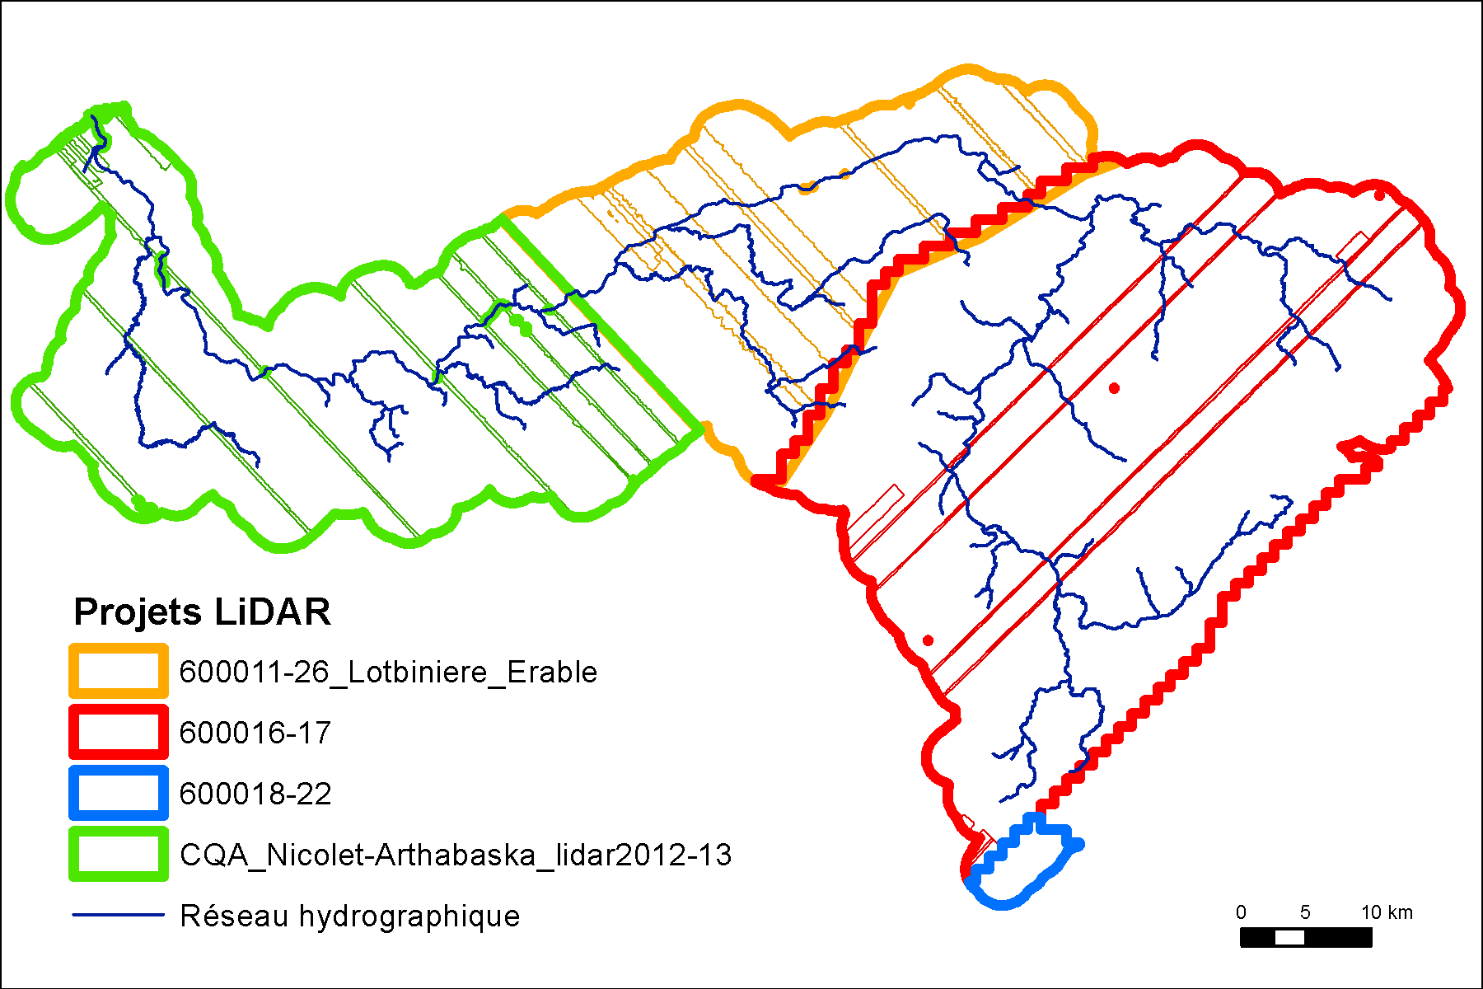
Example: the Bécancour watershed (Quebec, Canada) is covered by 4 different LiDAR projects (thick lines). Each LiDAR project required several days of LiDAR acquisition (thin lines).

Creation of LAS files by days of LiDAR acquisition
The points in the LAS files must be filtered by days of LiDAR acquisition, then a DEM must be generated for each day. These operations can be performed with any LAS file processing software. The following detailed steps explained how to do this using LAStools from rapidlasso GmbH (https://rapidlasso.com/lastools/) for LAS files processing and ArcGIS PRO for DEM creation. The LAS files must have time recorded as Adjusted Standard GPS time (see Las format specification, https://www.asprs.org/wp-content/uploads/2019/03/LAS_1_4_r14.pdf). This can be checked by running lasinfo from Lastools on a single LAS file to have a look at the time format.
Create by-day LAS files is the tool to filter the LAS files
Input:
Lastools bin folder: path of the folder “bin” from Lastools
Folder with LAS files: the folder with the LAS (or LAZ) files
UTC zone: The UTC local time (eg: -4 for Montreal during summer hours)
Output:
Intermediary results folder - Original LAS files split by days
Final result folder - LAS files by days
This tool can take quite some time if the river network cover hundreds of km of rivers (hours). Progress can be checked by looking at the files created in the intermediary results folder. It’s recommended to test the tool with a small subset of LAS files to begin with, to make sure the outputted dates make senses.
In the final result folder of the tools, LAS files by days of LiDAR acquisition are created along with shapefiles of the footprints. Aberrant points are occasionally included in the footprints and must be manually removed.

Conversion of the LAS files into DEMs by days of LiDAR acquisition
ArcGIS offers tools to convert LAS files into DEMs. LAS Dataset to Raster can be used for a straightforward conversion. Start by converting one (and only one) LAS file with this tool, choosing the appropriate coordinate systems and imposing a Cell Size = 1 (for creating a 1m resolution DEM). In the tool parameters, choose triangulation with linear interpolation. The remaining DEMS should be then created with the same tool and parameters with in addition the “Snap Raster” option using this first DEM (if an important number of days of LiDAR acquisition are present, such a task can be automated with ArcGIS Model Builder).
DEMs should then be clipped with the Clip Raster tool, using their footprint as the Output Extent (and the option Use Input Features for Clipping Geometry checked).

LiDAR survey selection
It is very common that there are overlaps between two or more acquisition days. Different LiDAR data differ in quality (density of LAS points) and in the discharge present during that day. These two factors greatly impact the water surface elevation and bathymetry estimation. It is therefore necessary to process the overlaps between different days so that the best available LiDAR surface is preserved (this is done by looking at the hillshades).
The main goal of this process is to clip the polygonal footprints of each LiDAR day so that there are no overlaps anymore. Using the clipped polygons, the DEMs themselves are to be clipped and combined into one single DEM, to be used for further processing (sections 5.6 and 5.7).

To do this, here are some general guidelines:
- the newest LiDAR data tend to be of better quality
- if the two overlapping surfaces are very similar, choose the one with the lowest discharge
- for shorter overlaps, it is best to clip in the middle of the overlap, since DEM margins tend to have a higher number of errors (this can be easily seen on hillshades, as illustrated in the image below. Left: low quality DEM margin; right: better quality surface for comparison)
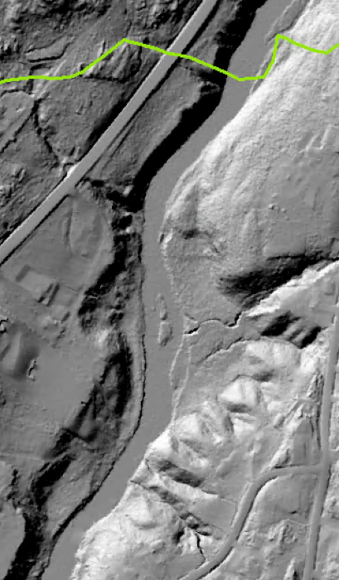
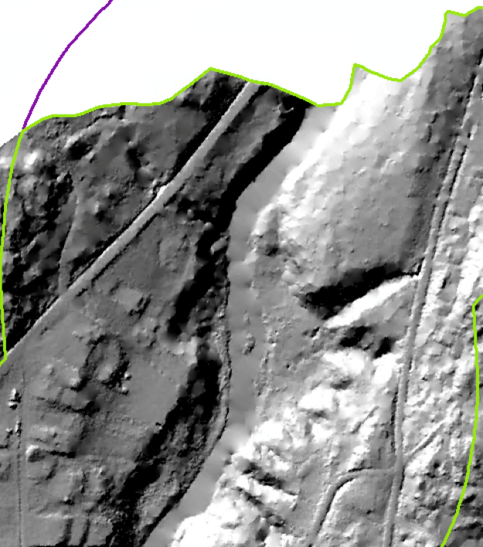

- for longer overlaps, clip so as to include the best quality LiDAR for as long as possible
- if possible, avoid clipping the polygon longitudinally along the river, like so:
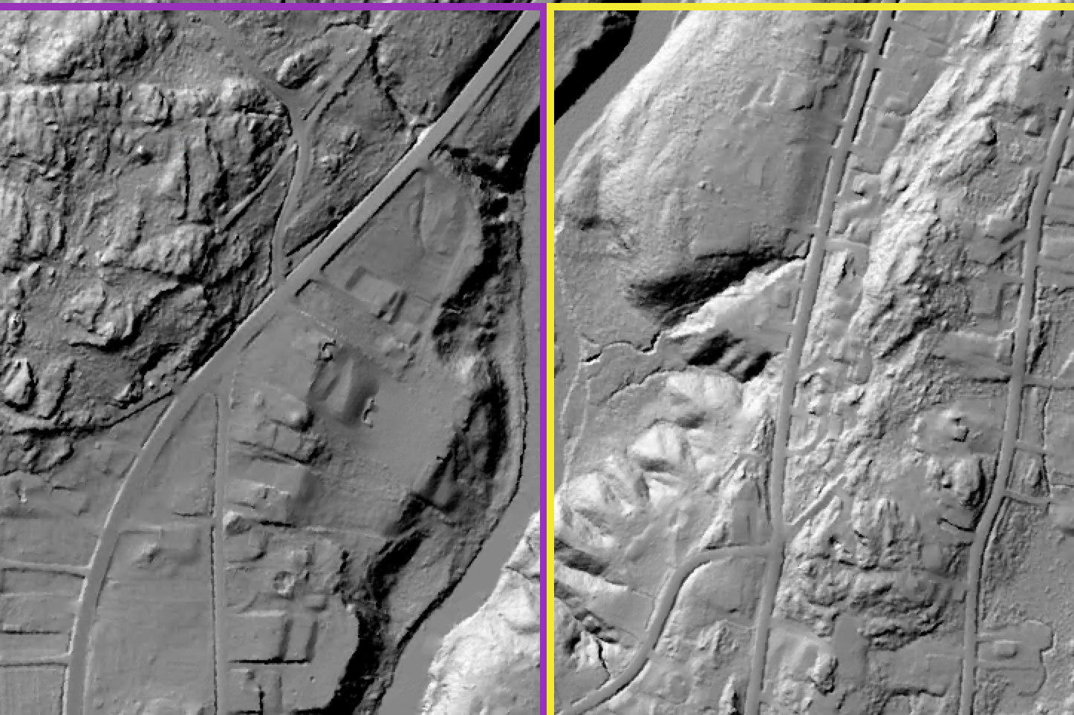
- avoid clipping the polygonal footprints in the vicinity of bank-to-bank interpolation errors (these look like TINs on the surface of the water). If you have little choice, place a bridge polygon (see section 5.4.1) that covers the TIN. Close to the edges of footprints, the water surface correction algorithm may not correct bank-to-bank interpolations, so in certain cases, it is better to ensure that this happens manually, by placing bridge polygons.
- avoid clipping the polygonal footprints at major breaks of water surface (at chutes or major steps). Ideally the transition between two days should be in a section of uniform slope.

Troubleshooting unusual issues in the LiDAR data
Possible types of issues with resulting DEMs:
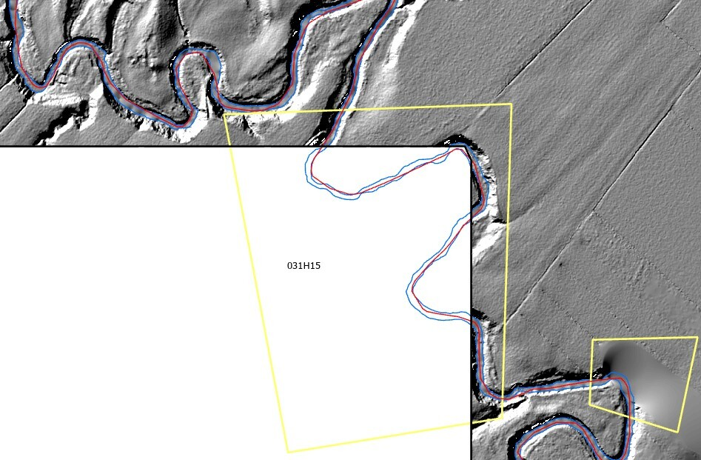
- Data gap. Solution: Additional LAS files are needed.
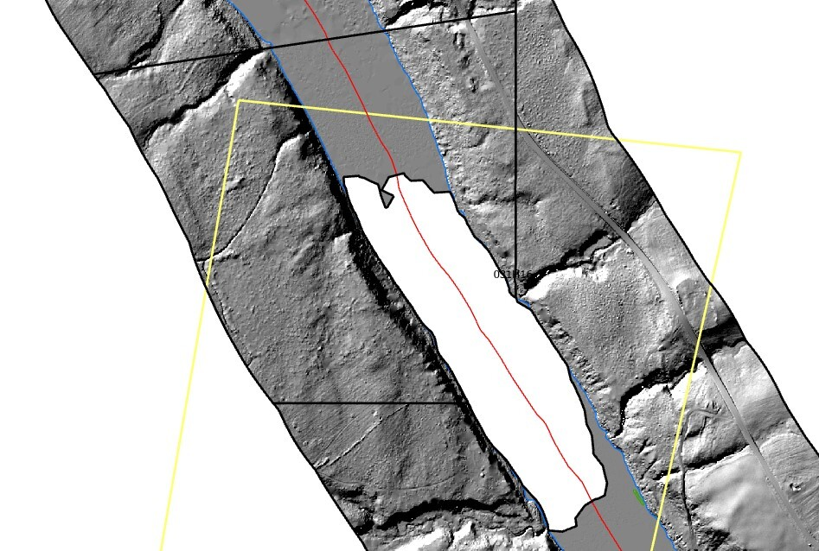
- Gap between two LiDAR dates. Solution: fill the gap by using Nibble. Make sure the produced water surface is realistic (compared to elevation upstream and downstream the gap).
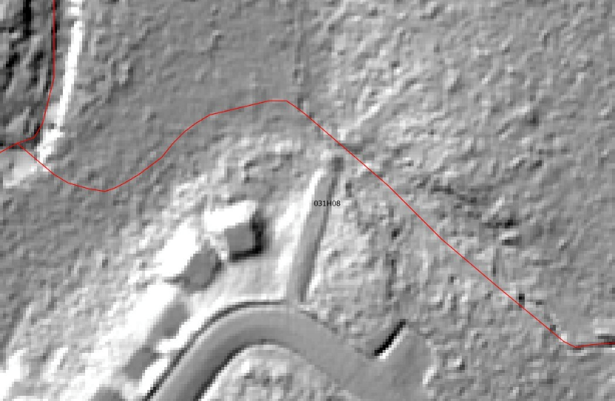
- Small tributary without a visible channel. Solution: such a case cannot be modelled. This needs to be removed from the network.

- Blurry data. Cases:
- Data is blurry both on the governmental 1m DEM. Solution: continue with current (blurry) data.
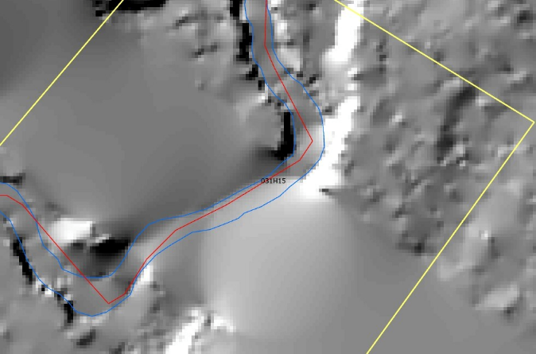
- Data is of good quality on the governmental 1m DEM, so there must be a superposition of multiple days. Solution: replace surface with good quality date.

When editing the individual footprint polygons is done:
- Merge all LiDAR footprints into one single file “Geometry.gdb\DEM_footprints”. Add a new field (Type = Text) called “ID_DEM” to store information that links each footprint with the corresponding DEM.
- Find Overlaps (ArcGIS Pro) to identify overlaps in the merged DEM footprints feature class
Input: Geometry.gdb\DEM_footprints
Output: Geometry.gdb\DEM_footprints_overlaps
Geometry.gdb\DEM_footprints_centroid
- Edit DEM_footprints to adjust the borders between two footprints so that they don’t overlap (you can do this by selecting both overlapping footprints and drawing a line between them via “Reshape”). They need to share the exact same border.

Identification of lakes and reservoirs
Because the hydraulic modelling uses a steady flow (constant discharge), lakes and reservoirs must be excluded from the hydraulic modelling, and require thus proper identification.
- Lakes and reservoirs can be first extracted from the NHN. The ones on the studied area can be identified by a Selection by Location, using the intersection with the polygonal river network.
Output: Geometry.gdb\lakesNHN_onnetwork
- Small lakes relative to the river width can be included in the hydraulic simulation, as their effect on hydraulic can be neglected: a threshold of 5 ha for small rivers, or 10 ha for wider ones (200m wide or more), can be used.

- Governmental data on dams can be helpful in finding small dams without reservoirs identified in the NHN. Reservoirs created by these dams must be digitized manually. To identify the reservoir, a longitudinal profile of the water surface elevation over roughly the length of the reservoir can be drawn with the 3D Analyst toolbar. Knickpoints in the longitudinal represent the extremities of the reservoir. These reservoirs can be then merged with lakesNHN_onnetwork. Output: Geometry.gdb/lakesfinal

River polygons
A polygon of the wetted channel from the LiDAR data is required. The produced polygon is mainly used to measure the channel width.
As flood modeling is not particularly sensitive to errors in channel width measurements, a coarse polygon representing the river can be used. Where NHN polygons are available, these polygons can be used as a first draft of the channel. They cannot however be used blindly, and must always be manually checked and corrected to better fit the wetted channel on the LiDAR data. Where the NHN polygons are not available, a manual digitization from scratch must be done.
The river polygon can be based on hillshades of the by-days DEMs processed in 5.2.3. The digitization must reflect the surface of the DEM/hillshade and only include what is submerged by water (e.g. sediment bars that have higher surface elevations than the wetted channel elevation must be excluded).
While you are editing the channel polygon, it is very useful to also identify the bridges that later need to be corrected in the water surface estimation step (section 5.7).
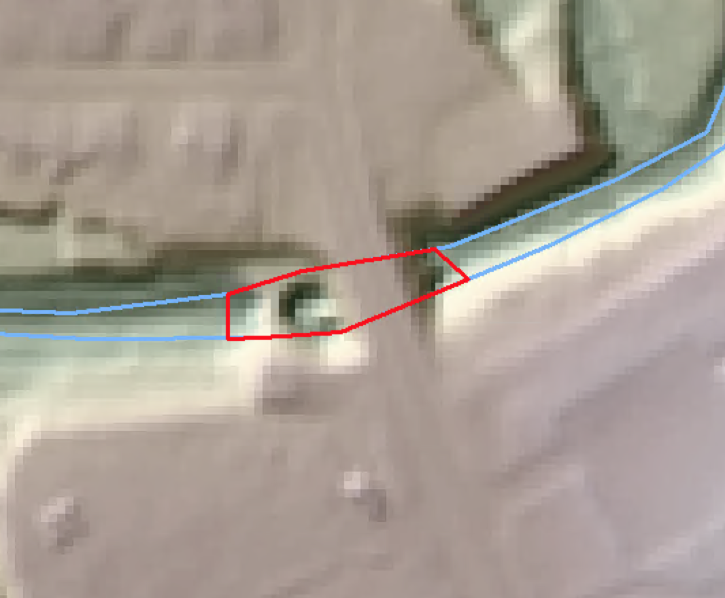
Create polygons of the bridges (having the same coordinate system as the DEM). The bridges should be small rectangles that contain at least one full cell of a lower elevation around the bridge (corresponding to channel below). The idea is to assign that polygon the lowest elevation value found within it, so this should ideally correspond to the channel. The bridge polygon doesn’t need to be wider than the channel. When the channel polygon is already at hand, the bridges can also be traced along the channel polygon edge.
Output: Geometry.gdb\bridges

Digitization of the streams included in the network of interest can be done using the hillshade rasters of the by-days DEMs (section 5.2.3). Ensure that the channel polygon corresponds to the clipped polygonal footprints of the DEMs.
- At the downstream end of the river, the river polygon must extend at least one full cell outside the DEM.
- As much as possible, try to end the channel polygons in a line that is transversal to the flow
- All sections of rivers with dead flow (e.g. oxbows) must be cut out
- Lake polygons (file lakesfinal, see 5.3) can be added directly to the results. No manual editing is required as the polygons around lakes don’t need to be as precise as for the rivers.
- The river network, including lakes, must, ultimately, be one and only one polygon. This can be done when you are done with editing the polygon by using Dissolve (with create multipart features unchecked): the resulting attribute table must contain one and only one row.

Output: Geometry.gdb\channelpoly

Tip: Change DEM symbology (colour ramp) and select DRA (dynamic range adjustment) from raster layer tab for the DEM to change the stretch according to the zoom applied. Try using different stretch types such as minimum-maximum and histogram equalize for the best visualization of the DEM.
To correct any errors while drawing the channel polygon, use the reshape tool and make sure that the snap to grid is ON. The trace tool can also be helpful if you would like to connect to two polygons to make the sure that the polygon has the same boundary. Use the split tool if you want to remove mid-channel bars (the endpoint lines need to intersect).

Linear river network
This step aims to produce a linear network of the rivers that matches the channel polygon (section 5.4).
- Over wide rivers, the linear network of the NHN can be used. It is however necessary to check that the river lines always fall inside the river polygons, and correct them if necessary.
- The NHN data is often too approximate for small streams. Manual digitization of the stream centerlines can be done.

- Alternatively, a centerline can be automatically derived from the river polygon (containing the lakes too) so that the line always falls inside the polygon:
(ArcGIS PRO only, for those who have the Production Mapping Licence) Polygon To Centerline to create a centerline based on the channel polygon
Input: Geometry.gdb/channelpoly
Output: Geometry.gdb/centerline

For those working with ArcMap or ArcGIS PRO without access to the Polygon To Centerline tool, this can be achieved by first converting the channel polygon to a polyline and then collapsing this to a centerline:
- Polygon To Line to create lines of the banks
Input: Geometry.gdb/channelpoly
Output: Geometry.gdb/polybanks
  - Collapse Dual Lines To Centerline to create a centerline
Input: Geometry.gdb/polybanks
Parameter: Maximum Width = the maximum width of the channels, not accounting for the lakes.
Output: Geometry.gdb/centerline

NB: For the Blanche, the raw centerline output without any edits is named “collapsedbanks”.
  - Edit the result to improve it (e.g. delete stray lines, connect lines, add lines in multichannels). Note that secondary channels are only needed to assess the width using the recommended cross-section method (see section 5.9). If any other method, including the Thiessen polygon method described in 5.9.2, is used to assess the river width, then digitizing the secondary channels in not necessary.
      - Delete stray lines and/or lines that go through oxbows or zones with no flow
      - Connect lines if disconnected
      - Keep and/or add important secondary channels. Add secondary channels only when they have a significant width and length compared to the main channel. NB: If the river branches out transversally to the flow direction, secondary channels do not have to be added.
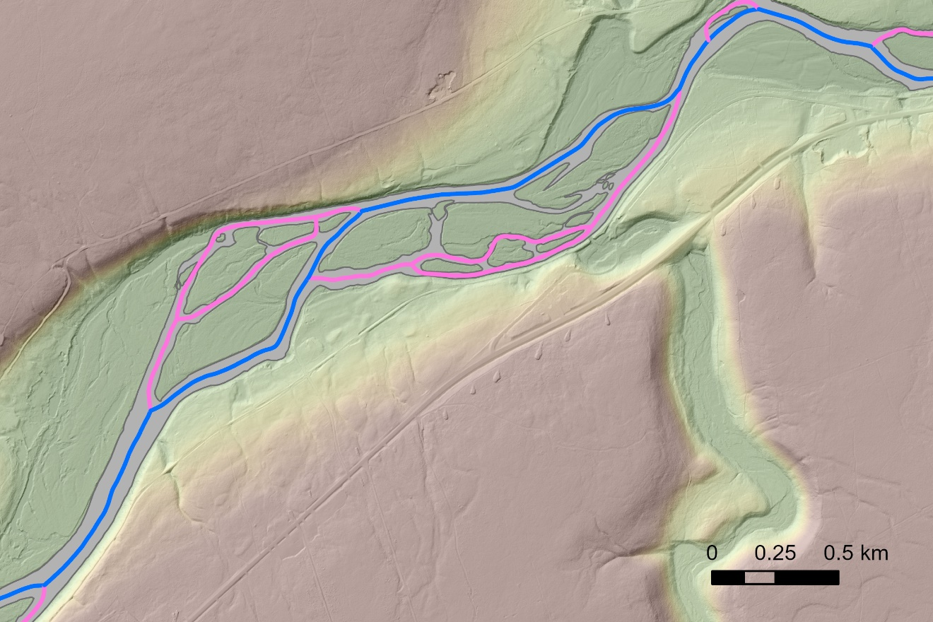
Main channel (in blue) and secondary channels (in pink). Narrow secondary channels, short ones created by small islands, narrow ones, and the ones more with a more transversal than longitudinal orientation are not added.
      - Do not create secondary channels at confluences (figure below)
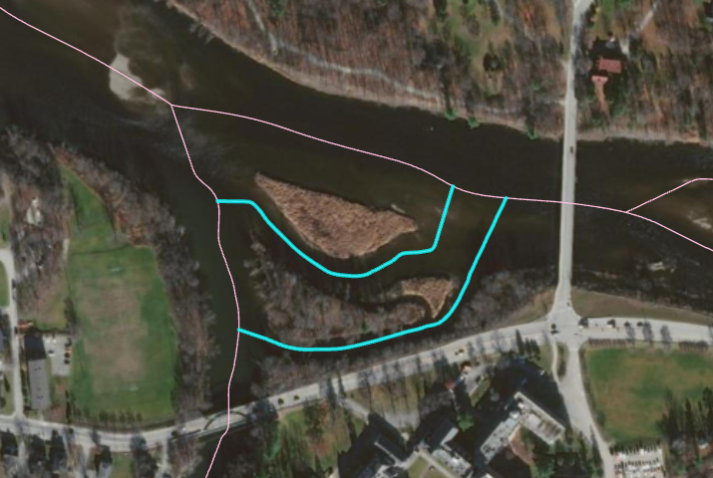
Incorrect secondary channels (in blue) connecting different reaches at a confluence.
  - Dissolve with Create multipart features unchecked. Verify that the line only splits at confluences (i.e. all intersections between lines).
Output: Geometry.gdb\linear_net_d_tmp
    - Add a field (Type = Short) called “Main” to the centerline. Main channels should receive a value of 1, whereas secondary channels should receive a value of 0.
    - Add a field (Type = Short) called “DownEnd” to the linear_net_d_tmp. The most downstream line should receive a value of 1, and the rest a value of 0.
    - Add a field (Type = Long) called “RID” to the linear_net_d_tmp. Copy the FID or OBJECTID values inside via Field Calculator.
Tip: Sometimes, it helps to check the shape_length in the attribute table of the result: by ordering the attributes by increasing length, small lines that extend beyond the network can be removed. These may appear due to manipulation errors, like the lines not being perfectly snapped to each other, and are most of the time so small that they are not visible by just going along the river network and observing it.
  - Smooth the network line (this is especially needed for a correct width assessment)
    - Divide network into 2 or 3 parts, according to the channel size (wide rivers need a lot of smoothing, whereas narrow rivers need little to no smoothing)
    - Smooth Line each divided segment (play around with different smoothing tolerance values, e.g. 100m for widths >100m, 10m elsewhere)
Output: linear_net_d_smXm, where X is the smoothing tolerance value
    - Check if smoothed lines go out of the channel polygon via Erase. Manually correct these situations or use less smoothing.
    - Merge smoothed divided segments into one.
Output: Geometry.gdb\linear_net_d
  - Within linear_net_d, select only the main channel lines (Main=1), Dissolve with Create multipart features unchecked.
Output: Geometry.gdb\linear_main_d
    - Add a field (Type = Short) called “DownEnd” to the linear_main_d. The most downstream line should receive a value of 1, and the rest a value of 0.
    - Add a field (Type = Long) called “RID” to the linear_main_d. Copy the FID or OBJECTID values inside via Field Calculator.
    - Check the output: lines should only split at confluences. If they don’t, there are probably very small lines that intersect at locations that are not confluences. These small lines need to be corrected on the linear_net_d (use snapping when correcting). Once that is done, rerun the Dissolve to create the linear_main_d and recheck if the lines split at confluences.

Watershed-scale DEM preparation
This step aims to create a 10m DEM for the whole, to be used as input in Lisflood, as well as generate basic files used in several subsequent steps. Make sure you have DEMs:
  - At 1m resolution (from LiDAR data) for the study reaches and their floodplain
- At any resolution for the rest of the watershed if it’s not entirely covered by LiDAR data

- Batch Process Aggregate individual LiDAR tiles from 1m to 10m using the average. Apply this both to the governmental DEMs and the by-days DEMs.
- Clip the 10m by-days DEMs according to the edited (non-overlapping) footprint polygons created in Section 5.2.1. Check “Use Input Features for Clipping Geometry” to use the exact shape that you have edited.
- Mosaic to New Raster to merge 10m DEM tiles into one single DEM
Inputs: all 10m LiDAR tiles (Governmental DEMs and by-days DEMs)
Parameters: Pixel Type: 32 float; Number of Bands: 1
Environments: once you have created the mosaicked governmental DEM, snap the by-days DEM to it
Outputs: lid10m_go, lid10m_days
- To create the final DEM used as an input for the Lisflood simulations, use Mosaic to New Raster to merge lid10m_days on top of lid10m_go:
Inputs: lid10m_go, lid10m_days (drag them in this order)
Parameters: Pixel Type: 32 float; Number of Bands: 1, Mosaic Operator: LAST)
Environments: Extent and Snap to lid10m_go
Outputs: lidar10m_avg
- burn streams into DEM (at the watershed scale):
  - In order to ensure that stream burning is applied correctly, first make sure that the river network/river polygon used in this step extend for at least one cell beyond the extent of the DEM is used in the stream burning.
  - Create a watershed-scale river network. This is only used in the stream burning process (a more comprehensive watershed-scale river network contributes to having more precise flow accumulation estimates).
    - Take the linear river network from the NHN database for the studied watershed and the neighboring watersheds (this is needed in order to prevent flow capturing from other watersheds in very flat terrain).
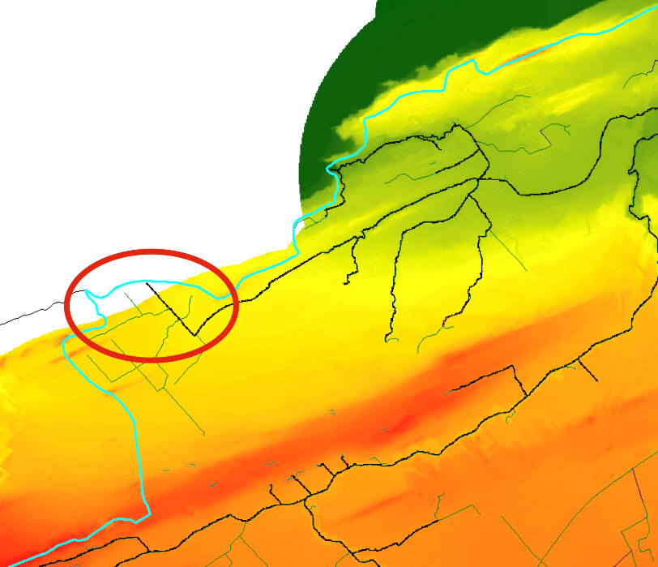
    - Double-check that the network is completely contained within the extent of your DEM, e.g. in the image on the right, lines that lie outside the DEM extent (red circle) must be cut. In other words, the only place where the line can extend outside of the DEM is at the watershed outlet.
    - Select Layer By Attribute the RH_L and simplify it by removing attributes with a Strahler order of 0 and -999 (O_STRAHLER = 0, O_STRALER = -999)
    - Erase GRHQ network lines within the channel polygon:
Input: RH_L
Geometry.gdb\channelpoly
Output: Geometry.gdb\RH_L_erased
    - Merge RH_L_erased with linear_main_d. Output: Geometry.gdb\watershed_net
  - Polygon to Raster to transform the channelpoly into a raster (match Cell size, Output Coordinates, Processing Extent and Snap to compute the 10m watershed-scale DEM, lidar10m_avg)
Input: channelpoly
Output: mask\frompoly
- Polyline to Raster (match Cell size, Output Coordinates, Processing Extent and Snap to compute the 10m watershed-scale DEM, lidar10m_avg)
Input: Geometry.gdb\watershed_net
Output: 10mDEMs.gdb\net_lines
  - Raster calculator to burn the streams into the DEM. This is done via a 2 steps approach: 1) the channel raster is burned 100m, 2) the network lines are burned another 100m from the raster obtained in 1)
Input: Con(IsNull("frompoly"), "lidar10m_avg", "lidar10m_avg" - 100)
NB: lidar10m_avg must be replaced by the watershed-scale DEM if they differ.
Output: 10mDEMs.gdb\lidar10mbpoly

Input: Con(IsNull("net_lines"), "lidar10mbpoly", "lidar10m_avg" - 200)
Output: 10mDEMs.gdb\lidar10m_burn
- Fill
Input: 10mDEMs.gdb\lidar10m_burn
Output: 10mDEMs.gdb\lidar10m_fill
- Flow direction
Input: 10mDEMs.gdb\lidar10m_fill
Output: 10mDEMs.gdb\lidar10m_fd
- Flow accumulation
Input: 10mDEMs.gdb\lidar10m_fd
Set Output Data Type to Integer
Output: 10mDEMs.gdb\lidar10m_facc
- (optional) Clip Raster the flow direction and the flow accumulation results to the studied area (use lidar10m_avg for the Output Extent) in case the studied area is a small subsection of the entire watershed
NB: This step was not done on the Blanche River.
- Create network from feature class to create a river network data structure from a line feature class, defined by a link table and a RouteID. This needs to be done twice, once for the network containing secondary branches and once for the main network:
Input: linear_net_d
RID (RouteID field)
DownEnd (Field identifying most downstream reach)
Main (Field identifying the main or secondary channel)
Output: Geometry.gdb\routes
Geometry.gdb\routes_links

Input: linear_main_d
RID
DownEnd
Output: Geometry.gdb\routes_main
Geometry.gdb\routes_main_links
- Flow Direction Network to extract a route following the D8 flow direction and relate the main route with this resulting route. Check that the output relate table contains both and “RID” and a “RID_1” field.
Input: routes_main
routes_main_links
RID
lidar10m_fd
Output: Geometry.gdb\routesD8
Geometry.gdb\linksD8
Geometry.gdb\pathpointsD8
Geometry.gdb\fd_net_relatetable
- Order Reaches to order the reaches in the main route. After running this tool, check that routes_main contains a field called “Qorder” with a distinct number for each attribute.
Input: routes_main
routes_main_links
RID
lidar10m_facc
routesD8
linksD8
pathpointsD8
fd_net_relatetable
Output: Qorder

Water surface detection
The aim of this step is to extract water surface elevation along the studied rivers. This is done using the DEMs from section 5.2.1. This process gives better results with a raster at fine resolution. A 3m resolution is often a good compromise (finer resolution can be too long to process and produce too big files). For huge watersheds, a 5m resolution could be needed.
- Batch Process Aggregate individual by days LiDAR tiles from 1m to 3m using the minimum.
- Clip the by days DEMs according to the edited (non-overlapping) footprint polygons created in Section 5.2.1. Check “Use Input Features for Clipping Geometry” to use the exact shape that you have edited.
- Create a new geodatabase called “WaterSurface.gdb” to store all files created in this section
- Mosaic to New Raster to merge clipped 3m DEM tiles into one single DEM
Inputs: all 3m LiDAR tiles (by days DEMs)
Parameters: Pixel Type: 32 float; Number of Bands: 1
Outputs: WaterSurface.gdb\lidar3m_min
- Bridges and culverts correction to correct bridges and culverts on the 3m DEM
Input: WaterSurface.gdb\lidar3m_min
Geometry.gdb\bridges
Output: WaterSurface.gdb\lidar3m_forws

Burn the lidar3m_forws in lakes with the routes main:
- Clip routes_main over lakesfinal
Input: Geometry.gdb\routes_main
Geometry.gdb\lakesfinal
Output : Geometry.gdb\routes_main_lakes

- Edit manually the routes_main_lakes at the upstream and downstream ends of the lake to be sure that they are extending out of the lake by a couple of cells (2 and more) and into the channelpoly along the Routes_main.

- Add field to routes_main_lakes, Name: rastervalue, Type : Short

- Calculate field in the routes_main_lakes so the rastervalue of all attributes is 1

- Polyline to Raster (match Cell size, Output Coordinates, Processing Extent and Snap to compute the lidar3m_forws)
Input: Geometry.gdb\routes_main_lakes (Value field = rastervalue)
Output: Watersurface.gdb\Lakes_burn
- Raster calculator to burn the Lakes_burn into the lidar3m_forws (or lidar3m_forws_check, if applicable).
Input: Con(IsNull("Lakes_burn"), "lidar3m_forws", " lidar3m_forws " - 10)
Output: Watersurface.gdb\ lidar3m_forws_lakes
Use the lidar3m_forws_lakes instead of the lidar3m_forws in the next steps

- Flow Direction for Water Surface Assessment (LargeScaleFloodModeling_Toolbox)
Input: Geometry.gdb\routes_main
WaterSurface.gdb\lidar3m_forws_lakes
WaterSurface.gdb\DEM_footprints
Output: WaterSurface.gdb (this is a workspace where the outputs are stored, i.e. a flow direction raster for each footprint)
- Mosaic to New Raster to merge all flow direction rasters into one
- NB: If there are errors with certain areas, the tool can be rerun by selecting the affected footprints within the DEM_footprints feature class
- Create from points and split points to create from points and splits along the network
Input: Geometry.gdb\routes_main
Geometry.gdb\routes_main_links
Output: Geometry.gdb\from_pts
Geometry.gdb\splits (with the routes_main, there should be no splits, so this output should come out empty)
- Create network from flow direction raster
Input: lidar3m_fd
from_pts
Output: WaterSurface.gdb\wsroutesD8
WaterSurface.gdb\wslinksD8
WaterSurface.gdb\ws_pathpointsD8

NB: If there are issues with the lidar3m_fd, the tool will return an error message containing point coordinates between two footprints. In that case, the Flow Direction for Water Surface Assessment needs to be rerun by selecting from the DEM_footprints only the footprint(s) downstream of the indicated point(s).
NB #2: if still returning warning message (warning not error message) and that it’s giving point coordinates between two footprints. In that case, it means the footprint is crossing 2 times the main_routes in a single 3m cell, that’s the source of the problem. To bypass the problem, copy the footprint feature class, manually edit the copied footprint so it's not crossing 2 times the main_routes (see below). Then restart the steps with the copied footprint from the “Flow Direction for Water Surface Assessment”.
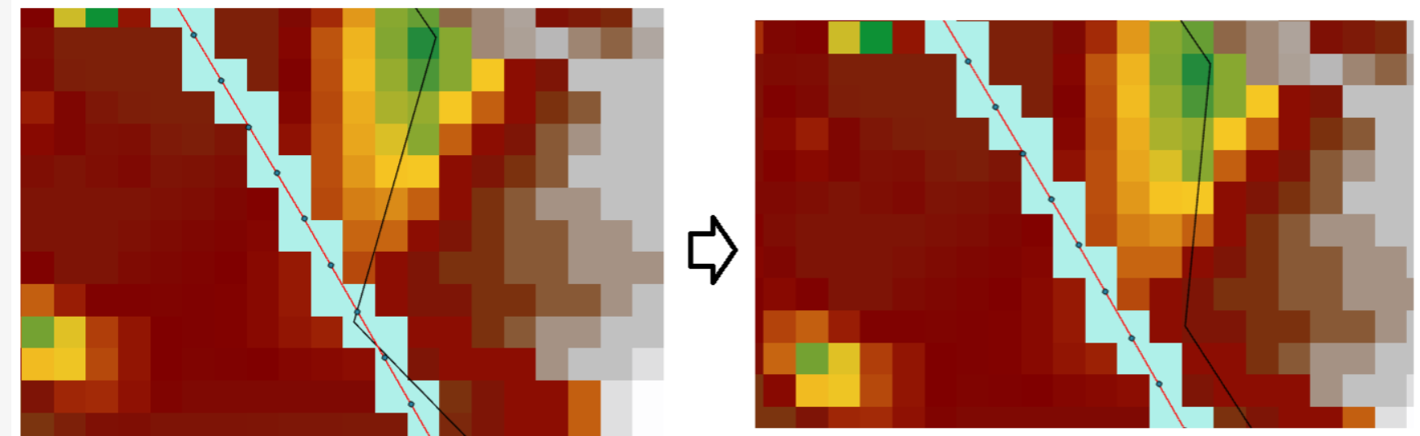

- Make sure the resulting lines reproduce the river network (if there is a hole in the data, the result can stop before reaching the downstream end.)
- Create points along route feature class to create the points used to extract the water surface, discharge and width for the computation of the bathymetry.
Input: Geometry.gdb\routes_main
Geometry.gdb\routes_main_links
RID
Interval: 5m
Output: Geometry.gdb\target_pts_raw

- Delete points outside of the DEM (3m one) in Geometry.gdb\target_pts_raw, if any, as well as points under the identified bridges
    - To display the target_pts, run Make Route Event Layer
Inputs: Geometry.gdb\routes_main
RID
Geometry.gdb\target_pts
RID
Point
MEAS
Output: target_pts_Events
    - Save the points by right-clicking target_pts_Events, select Data Export Features
Output: Geometry.gdb\target_pts
    - Manually select and delete the points outside of the 3m DEM
    - Use Select By Location to select points under the polygons in Geometry.gdb\bridges and delete them
    - Save Edits

- Relate a D8 network layer using topological comparison
Input:
WaterSurface.gdb\wsroutesD8
RID
WaterSurface.gdb\wslinksD8
Geometry.gdb\routes_main
RID
Geometry.gdb\routes_main_links
Geometry.gdb\from_pts
Output: WaterSurface.gdb\net_relate_table
- Extract Water Surface
Input:
Geometry.gdb\routes_main
Geometry.gdb\routes_main_links
RID
Qorder
WaterSurface.gdb\wsroutesD8
RID
WaterSurface.gdb\net_relate_table
WaterSurface.gdb\ws_pathpointsD8
X
Y
WaterSurface.gdb\lidar3m_forws (DO NOT USE lidar3m_forws_lakes)
Geometry.gdb\DEM_footprints
ID_DEM
Geometry.gdb\target_pts
ObjectID_1
RID
MEAS
Output: WaterSurface.gdb\smoothed_pts

LiDAR discharge
Discharges for all the days of LiDAR acquisition must be available for at least one point on the watershed, or nearby enough. These data could come from hydrological modelling or could be measured at discharge gauging stations. The tool Spatialize discharges from gauging stations – Q LiDAR will compute discharges at the same place the water surface was previously computed (file WaterSurface.gdb\smoothed_pts), from the available data. This is done using the following equation:
$$Q= Q_{st}{\left(\frac{A}{A_{st}}\right)}^{β}$$
Where $Q$ and $A$ are the discharge and drainage area at the computed point; $Q_{st}$ and $A_{st}$ are the discharge and drainage area a gauging station; $β$ must be passed as a parameter to the tool (use 1 if this value is unknown).
The observed discharges (from the gauging stations) must be stored in a csv file, with the days of LiDAR acquisition as rows (ID_DEM) and gauging stations as columns. A shapefile of the gauging stations must also be available (with their names as a field).
Example of discharges file:
ID_DEM | s01BO001 | s01BO002 | s01BO003
d20150818 | 26.5 | 0.5 | 3.2
d20150819 | 24.4 | 1 | 3.7
d20150829 | 35.8 | 3.3 | 0.6
d20150830 | 30.1 | 0.8 | 1

- Locate features Along Routes should be used to locate the gauging stations on the D8 river network
Inputs: Shapefile of the gauging stations
Geometry.gdb\routesD8
RID
Adjust Search Radius depending on the situation
Output: Discharge.gdb\QStations_D8

- Spatialize discharges from gauging stations – Q LiDAR
Inputs: 10mDEMs.gdb\lidar10m_facc
Geometry.gdb\routesD8
RID
Geometry.gdb\linksD8
Geometry.gdb\pathpointsD8
Geometry.gdb\fd_net_relatetable
Geometry.gdb\routes_main
Geometry.gdb\routes_main_links
RID
Discharge.gdb\QStations _D8
OBJECTID
Field with the gauging station name
Field with the drainage area of the stations
RID
MEAS
CSV file
Geometry.gdb\DEM_footprints
ID_DEM
Beta coefficient
Output: Discharge.gdb\Qpts_spatialized_D8

- Make Route Event Layer to visualize the points
Inputs: Geometry.gdb\routesD8
RID
Discharge.gdb\Qpts_spatialized_D8
RID
POINT
dist
Output: Qpts_spatialized_D8 Events
- Add Join between Qpts_spatialized_D8 Events (Input Join Field: RID) and the fd_net_relatetable (Join Table Field: RID_1)

- Project point to the closest point on the network (LargeScaleFloodModeling_Toolbox)
Inputs: Qpts_spatialized_D8 Events
computedQLiDAR
MEAN
Geometry.gdb\routes_main
RID
WaterSurface.gdb\smoothed_pts
RID
MEAS
Fields to match in the data points:
RID [fd_net_relatetable.RID]
ID_DEM
Fields to match in the target points:
RID
ID_DEM
Output: Discharge.gdb\Qpts_spatialized

Channel width
Width can be assessed by two different ways. Either cross-sections are drawn and their length measured (cross-sections method), or the rivers polygons are split in chunks using Thiessen polygons, and the width is assessed for each chunk by dividing their area by their length (Thiessen polygons method). The cross-sections methods is recommended in the vast majority of the cases. However, this method cannot provide accurate results in areas with complex multiple channels and the computed widths require manual correction in these cases. In the presence of multiple channels, the Thiessen polygons method is more practical. A river can be treated with both methods, in total or in parts, in order to keep the result of one method or the other depending on the context.

Cross-section method
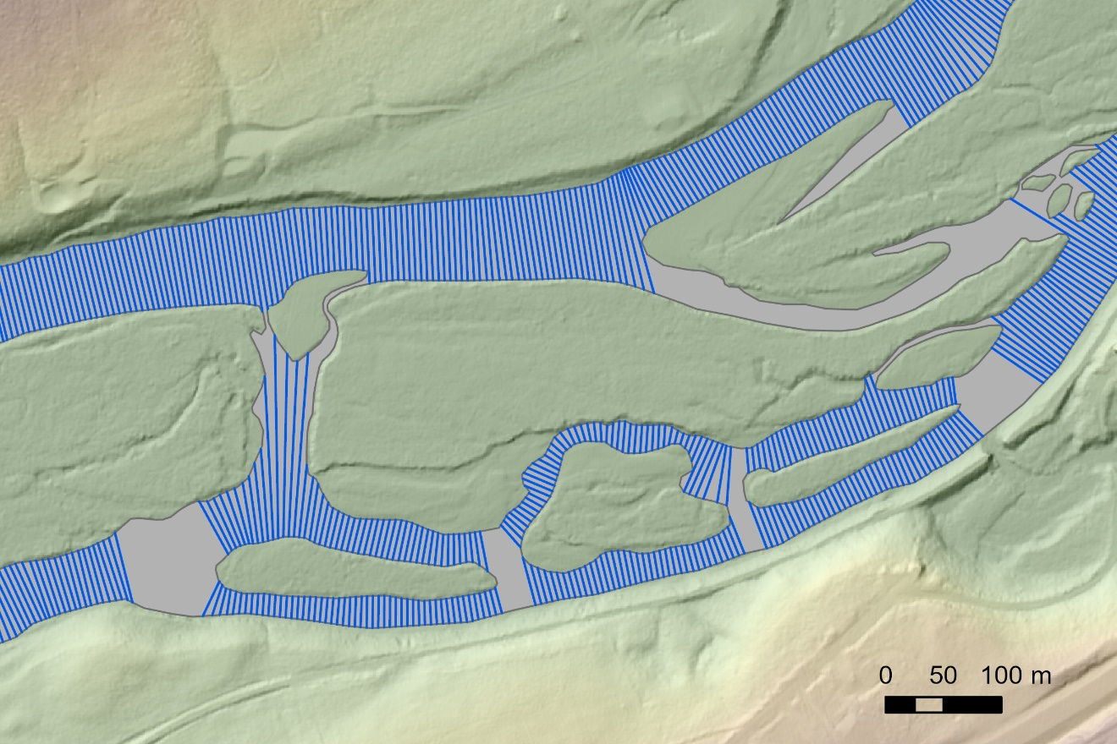
Width assessment by cross-sections. Cross-sections are not placed at confluences or in channels where no secondary channels lines were created. Some cross-sections are not correctly oriented (red circle) and width assessment should be manually corrected in such cases.
- Create a “Width.gdb” to store the results created in this section
- Calculate the width at transects:
  - Width by cross-sections (LargeScaleFloodModeling_Toolbox)
Input: Geometry.gdb\routes
RID
Geometry.gdb\channelpoly
1000
5
Output: Width.gdb\width_transects
Width.gdb\width_pts
  - Visually check the width_transects. Delete corresponding points (within width_pts) (or manually correct the associated width at these points) if some transects seem to not correctly represent the river width. This could be in particular the case if the routes extend beyond of the channelpoly. This can also happen if an island is present and a secondary channel was not added (figure below).
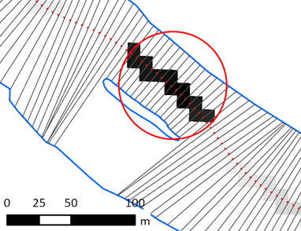
Example of points that need to be deleted.

- WidthPostProc
Inputs: Geometry.gdb\routes
RID
Main
Geometry.gdb\routes_main
RID
Shape_Length
Qorder
Geometry.gdb\routes_main_links
Width.gdb\width_pts
CSid
RID
Distance_m
Largeur_m
WaterSurface.gdb\smoothed_pts
ObjectID_1
MEAS
RID
Output: Width.gdb\width_postpro
Known bug: WidthPostProc can go into an infinite loop if several reaches in a row do not have associated width measurements points. To solve this problem, either simplify the routes network (removing secondary channels) or add points in the width_pts layer (don’t forget to fill appropriately the fields in the attribute table).

Thiessen polygons method
Channel width is estimated by cutting the channel polygons and the channel lines into reaches (based on Thiessen polygons created from cross-section points at a specific interval) and transforming these into areas and lengths (width of reach polygon = area of reach polygon/ length of reach line).
- Create points along route feature class to place points along the network, at a specific interval. The distance used can vary with the size of the river. A distance of 100m can be used for small head streams, while a distance of 500m can be used for major rivers. If different distances are used within the same watershed, several files must be created and then merged manually into one single cross section shapefile (=xsect.shp).
Input:
Geometry.gdb\routes_main
Geometry.gdb\routes_main_links
RID
Interval between points = 200 (or 500)
Output: Width.gdb\width_pts_table

- Make Route Event Layer to visualize the points
Inputs: Geometry.gdb\routes_main
RID
Width.gdb\width_pts_table
RID
Point
MEAS
Output: width_pts_table Events
- Export width_pts_table Events into a feature class
Output: Width.gdb\width_pts
- Edit the points in order to add more points where the width of river changes rapidly (the idea is to capture, as much as possible, sudden variations in width). If new points are added, they need to be placed on the flow path (from the flow accumulation). Points can be deleted as well.
- Create Thiessen Polygons
Input: Width.gdb\width_pts
Output: Width.gdb\thiessen
Output Fields: All fields
- Verify and edit the Thiessen polygons so that they split the river polygons in reaches. This can be done with the Reshape tool within an editing session. Check in particular confluences, sharp meanders, areas around lakes, and places of sharp changes of width. (The Thiessen polygon should extend completely from one bank to the opposite bank of the river reach described by the cross section point on which the Thiessen polygon is based.) See some examples below.
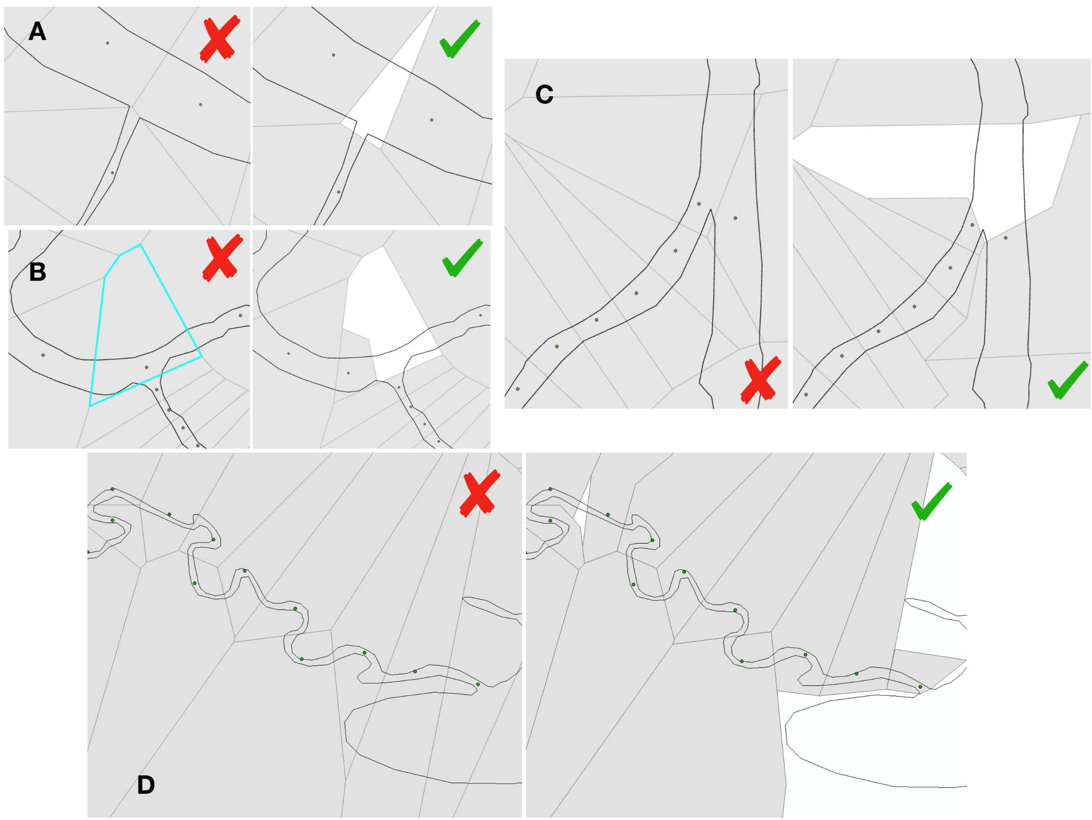
- Intersect Thiessen polygons with rivers polygons
Input:
Width.gdb\thiessen
Geometry.gdb\channelpoly
Output: Width.gdb\reaches_poly
- Intersect Thiessen polygons with rivers main lines
Input:
Width.gdb\thiessen
Geometry.gdb\routes_main
Output: Width.gdb\reaches_lines
- Dissolve the polygons according to ObjectID_1
Input: Width.gdb\reaches_poly
Output: Width.gdb\reaches_poly_d
- Dissolve the lines according to ObjectID_1
Input: Width.gdb\reaches_lines
Output: Width.gdb\reaches_lines_d
- Add Field to Width.gdb\width_pts to store Width (Type: Float)
- Join Field to add areas to Width.gdb\width_pts
Input:
Width.gdb\width_pts
ObjectID_1
Width.gdb\reaches_poly_d
ObjectID_1
Select transfer fields
Transfer Fields: Shape_Area
- Join Field to add lengths to Width.gdb\width_pts
Input:
Width.gdb\width_pts
ObjectID_1
Width.gdb\reaches_lines_d
ObjectID_1
Select transfer fields
Transfer Fields: Shape_Length
- Calculate Field to calculate "Width" field = Shape_Area/Shape_Length
- Delete points that fall into lakes (by selecting them by location). Check extreme values (by sorting the attribute table and Width.gdb\width_pts by Width, ascending and descending, and make sure no incoherent data was computed.
  - Interpolate Points (LargeScaleFloodModeling_Toolbox)
Inputs: Width.gdb\width_pts
ObjectID_1
RID
MEAS
Width
WaterSurface.gdb\smoothed_pts
ObjectID_1
RID
MEAS
Geometry.gdb\routes_main
RID
Qorder
Geometry.gdb\routes_main_links
Output: Width.gdb\width_postpro

Bed elevation
The bed elevation is estimated through an inverse hydraulic problem given the already known variables of channel width and LiDAR discharge.
- Create a “Bathy.gdb” to store the results created in this section
- Join Width.gdb\width_postpro, Discharge.gdb\Qpts_spatialized and WaterSurface.gdb\smoothed_pts together by ObjectID_1 (NB: if doing this in a gdb doesn’t work, exporting the three tables to .dbf and doing the join like that works)
- Export result to “bathy_input_pts”
- Bed Assessment
Inputs: Geometry.gdb\routes_main
RID
Qorder
Geometry.gdb\routes_main_links
Bathy.gdb\bathy_input_pts
ObjectID_1
RID
MEAS
Qlidar
Largeur_m
Zsmooth
ID_DEM
0.03
Minimum energy slope: for the moment, use 0.00001
Output: bathy _pts

Transformation to Lisflood format
- Create a new geodatabase “Lisflood_inputs.gdb” to store files created in this section
- Create a local folder called “workspace”. Analysis\Geoprocessing\Environments: Set current workspace and scratch workspace as folder “workspace” (this will store temporary files when running the tools)
- D4 flow direction to extract the D4 path of the flow direction (Lisflood requires a D4 path for its inputs)
Input: 10mDEMs.gdb\lidar10m_fd
10mDEMs.gdb \lidar10m_fill
Geometry.gdb\from_pts
Workspace
Output: Lisflood_inputs.gdb\d4fd
- Flow Direction Network to extract a route following the D4 flow direction and relate the main route with this resulting route. Check that the output relate table contains both and “RID” and a “RID_1” field
Input: Geometry.gdb\routes_main
Geometry.gdb\routes_main_links
RID
Lisflood_inputs.gdb\d4fd
Output: routesD4
linksD4
pathpointsD4
D4fd_net_relatetable
- Add a field “Qorder” (Type = Short) to routesD4
- Join the D4fd_net_relatetable to the routesD4 (Input Join Field = RID, Join Table Field = RID_1), then join the routes_main to the routesD4 (Input Join Field = d4fd_net_relatetable.RID., Join Table Field = RID)
- Via Field Calculator, copy Qorder values of the route_main into the newly created Qorder field of the routesD4
- For the bed elevation:
  - Make Route Event Layer
Inputs: Geometry.gdb\routes_main
RID
Bathy.gdb\bathy_pts
RID
Point
MEAS
Output: bathy_on_mainroute
  - Add Join between bathy_on_mainroute (Input Join Field: RID) and the D4fd_net_relatetable (Join Table Field: RID)
  - Project point to the closest point on the network (LargeScaleFloodModeling_Toolbox)
Inputs: bathy_on_mainroute
z
MAX
routesD4
RID
pathpointsD4
RID
dist
RID_1
RID
Output: bathy_on_D4
  - Interpolate Points (LargeScaleFloodModeling_Toolbox)
Inputs: bathy_on_D4
id
RID
dist
z
pathpointsD4
id
RID
dist
routesD4
RID
Qorder
linksD4
Output: bathy_final
  - Make Route Event Layer
Inputs: routesD4
RID
bathy_final
RID
Point
dist
Output: bathy_final_events
  - Point to Raster (match Output Coordinates, Processing Extent and Snap to the lidar10m_fd)
Inputs: bathy_final_events
z
Cellsize: 10
Output: bathy
  - Verify that output makes sense
- For the width:
  - Make Route Event Layer
Inputs: Geometry.gdb\routes_main
RID
Width.gdb\width_postpro
RID
Point
MEAS
Output: width_on_mainroute
  - Add Join between width_on_mainroute (Input Join Field: RID) and the D4fd_net_relatetable (Join Table Field: RID)
  - Project point to the closest point on the network (LargeScaleFloodModeling_Toolbox)
Inputs: width_on_mainroute
Largeur_m
MEAN
routesD4
RID
pathpointsD4
RID
dist
RID_1
RID
Output: width_on_D4
  - Interpolate Points (LargeScaleFloodModeling_Toolbox)
Inputs: width_on_D4
id
RID
dist
Largeur_m
pathpointsD4
id
RID
dist
routesD4
RID
Qorder
linksD4
Output: width_final
  - Make Route Event Layer
Inputs: routesD4
RID
width_final
RID
Point
dist
Output: width_final_events
  - Point to Raster (match Output Coordinates, Processing Extent and Snap to the lidar10m_fd)
Inputs: width_final_events
Largeur_m
Cellsize: 10
Output: width
  - Verify that output makes sense

Channel mask
The channel mask tells Lisflood what component is processed by the 1D model (=SuperGrid, i.e. channels larger than 15m width) and what component is processed by the 2D model (=SubGrid, i.e. channels smaller than 15m width and floodplains).
- Create a “Mask” folder to store the results created in this section
- Polygon to Raster to transform the channel polygon into a raster (match Output Coordinates, Processing Extent and Snap to computed flow direction raster)
Input: Geometry.gdb\channelpoly
Output: mask\frompoly
- Polyline to Raster to transform the multi-channel lines into a raster (match Output Coordinates, Processing Extent and Snap to computed flow direction raster)
Input: Geometry.gdb\routes
Output: mask\fromroutes

- Raster Calculator to have 1 where the raster made from the channel polygon has a value, or where the D4 has a value, or where there are multi channels. This ensures that the streams are always comprised of at least one cell.
Con(IsNull("fromroutes"),Con(IsNull("frompoly"),Con(IsNull("d4fd") == 0,1),1),1)
Output: mask\mask_temp
- Raster to Polygon to transform the channel mask back into a polygon in order to be able to subsequently modify it according to channel width.
Input: mask\mask_temp
Output: mask\mask_poly.shp
Simplify polygons unchecked
- Display width, and change the symbology to “Classified”. Use 2 classes, with a break value at 15m.
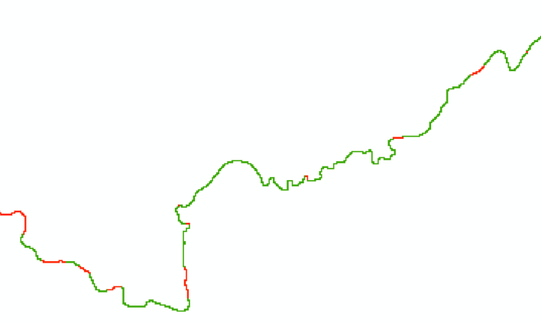
- Edit the mask_poly.shp file to cut out reaches that will be modelled with the SubGrid technique (width < 15 = no mask). NB: The mask should at best represent widths >15m. For reaches smaller than ~1km where the width varies, follow the general characteristic of the larger section, e.g. in the image below, the general characteristic is defined by green (=SubGrid), so this entire section should be cut out from the mask.
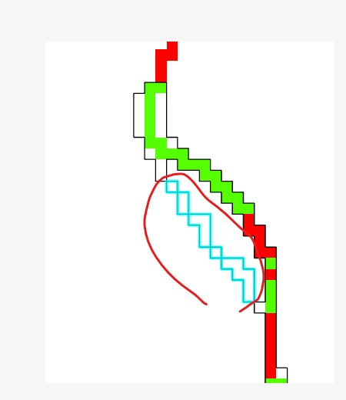
- Select the mask_poly.shp by clicking on it in an area where it overlaps with the D4fd. This should result in a selection that covers most of the mask_poly.shp. Only isolated cells and isolated secondary branches should not be included in the selection. Inverse this selection (so that now these isolated cells and isolated secondary branches get selected) and delete these attributes (see circled selection in image on the right).
    - Note: since Lisflood can only make connections between adjacent cells in 4 directions (so not diagonally), the presence of diagonal paths poses problems and need to be deleted.
- Polygon to Raster to transform the result back into a raster (match Output Coordinates, Processing Extent and Snap to computed flow direction raster).
Input: mask\mask_poly.shp (Value: gridcode, to ensure that the mask will have a value of 1 inside the channel)
Output: mask\mask

Manning’s n for floodplain
This process shows how to generate Manning’s n for the floodplain, based on land cover data. The 2020 Land Cover of Canada is used hereafter, but this process can be modified for other land use data.
- Create a ManningFP.gdb to store the results create in this section
- Clip Raster the land cover raster previously downloaded over basin/study area
Output: ManningFP.gdb\LC_2020_clip

- Raster to Polygon to transform the landuse into a polygon in order to join it to the good nManning value.
Input: ManningFP.gdb\landuse_clip
Output: ManningFP.gdb\landuse_poly
Simplify polygons unchecked
- Add Join to created landcover shapefile with data from CanadaLC2015manning.csv, based on "covtype".
Input table: ManningFP.gdb\landuse_poly
Input join field : gridcode
Join table: CanadaLC2020manning.csv
Join table field : cov_type
- Polygon to Raster with Manning’s n assigned as Value Field (match Output Coordinates, Processing Extent and Snap to flow direction/DEM)
Input: ManningFP.gdb\landuse_poly
Output: n_floodplain

Simulations
Before running the simulations, there are certain steps to deal with first: adding boundary condition information to lakes and reservoirs, transferring the input variables into a folder, and cutting the network into tiles.

Lakes and reservoirs
- Copy the polygons of the lakes
Input: lakesfinal
Output: lakes_forsim
- Create an additional feature in lakes_forsim at the downstream end of the study area. Include at least one cell of the DEM. This is to assign the model a downstream boundary condition. The size of this polygon doesn’t matter, as long the river main line cross it.
- Optional: If lakes have extremely uneven shapes that, it is useful to create small polygons, roughly rectangle, where the river path flows into lakes. This will improve the creation of tiles.
- Optional: Additional features can be added to the lakes_forsim to exclude some areas from the hydraulic simulations.
- Add one field in lakes_forsim for each flood discharge to simulate. Store within the boundary condition (lake elevation) associated with each flood discharge for each lake.

Transferring input data from a gdb to a folder
Some tools used hereafter come from an older version of the Large-scale flood assessment tools and do not work with folders as workspaces. Therefore, make sure that when you use them, you modify the ArcGIS environments so the “Current workspace” and “Scratch workspace” are folders and not geodatabases.
Additionally, input data must be stored in a folder:
- Create a "Lisflood_inputs" folder
- Use Copy Raster to copy all necessary rasters to this folder (match Snap, Coordinate System, Extent to the lidar10m_avg):
  - Lidar10m_Avg
  - Lidar10m_fd
  - Lidar10m_fa
  - Mask
  - N_floodplain
- For the bed and the width, run the following steps and save the output directly to the "Lisflood_inputs" folder:
  - Point to Raster (match Output Coordinates, Processing Extent and Snap to the lidar10m_fd)
Inputs: bathy_final_events
z
Cellsize: 10
Output: Lisflood_inputs\bathy
  - Point to Raster (match Output Coordinates, Processing Extent and Snap to the lidar10m_fd)
Inputs: width_final_events
Largeur_m
Cellsize: 10
Output: Lisflood_inputs\width
  - Verify the result. If there are values outside of the D4 path, they need to be SetNull, so that there is only data along the D4 path and NoData elsewhere.
- Feature Class to Feature Class to copy the feature classes to shapefiles into the "Lisflood_inputs" folder (make sure they all share the same coordinate system):
  - Lakes_forsim
  - From_pts

Tiling
The aim of this step is to divide the study network into multiple, smaller reaches, on which Lisflood is run independently, in order to ease processing. The tool to be used is Tiling.
Inputs:
Lisflood_inputs\lidar10m_fd
Lisflood_inputs\lakes_forsim.shp
Lisflood_inputs\from_pts.shp
Tiles folder (NB: create a new empty folder called “Tiles” to store all outputs of this tool)
Two shapefiles are created by this tool, in the “Tiles” folder: polyzones.shp and sourcepoints.shp. The tiles are represented by the polygons in polyzones.shp. They must be checked and corrected if necessary. In particular, at confluences, a tile should not cut into meanders (see image below). Also, check in the attribute table of the polyzones that the “Lake_ID” corresponds to the lake that the tile (defined by the “grid_code”) is stopping at. Manually edit this if this is not the case.
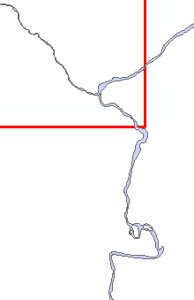
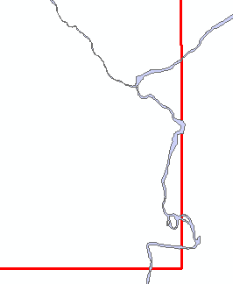

Corner of a tile (used for the tributary in the upper-right corner) that need to be corrected, and the corrected tile.

The sourcepoints determine where the processing starts for that zone and should be located inside each polyzone. When editing the polyzones, ensure that the sourcepoint is inside it and located on the flow path defined by the flow accumulation raster.
If tiles are to be deleted, the corresponding source point should be deleted as well.
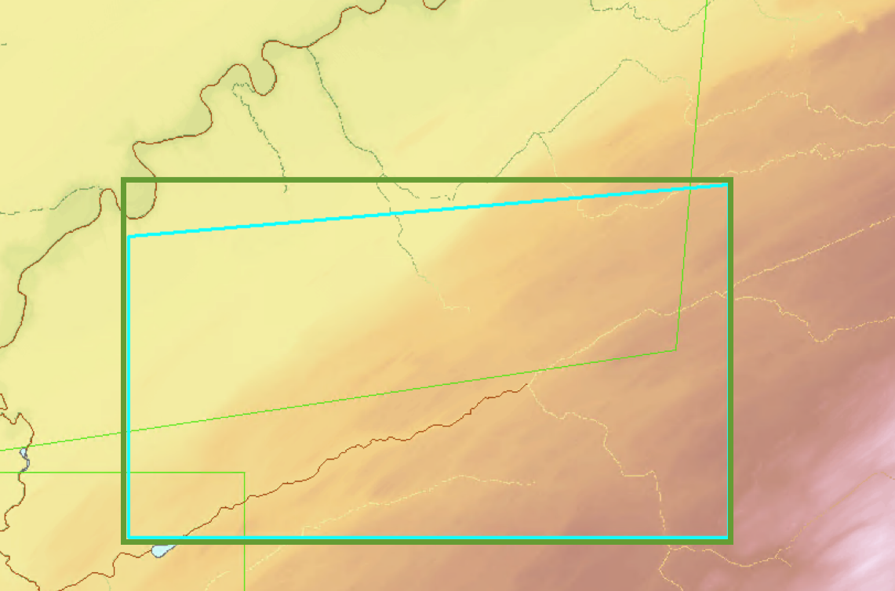
The simulation tiles will be based on the envelope of the shapes in polyzones.shp, which will be created in the next step. The modified polyzones do not have to be perfectly rectangular, but attention must be given to their shape in relation to how the envelope is going to be created:
Turquoise= modified polyzone; Green=envelope that will be created

Hydraulic simulations with LISFLOOD-FP
The hydraulic simulations are run with two steps.

Preparation of the simulations
- Hydraulic simulations preparation. This tool creates additional files in the “Tiles” folder as well as the input files to be used by Lisflood in the simulation folder (all variables clipped according to the zones in .txt format, .bci and .par files). NB: See Lisflood manual for more details about .bci, .par files.
Inputs:
Lisflood_inputs\lidar10m_fd
Lisflood_inputs\lidar10m_facc
Simulations\Tiles
Lisflood_inputs\lidar10m_avg
Lisflood_inputs\widthD4
Lisflood_inputs\bed
Lisflood_inputs\n_floodplain
Lisflood_inputs\mask
Simulations\sims (NB: create before this new empty folder to store all outputs of this tool. This will also store the final results. Name can be changed).

Flood discharges
Flood discharges (e.g. 20 year or 100 year floods) should be available at points, and can be estimated elsewhere with a similar process than the LiDAR discharges using the same equation:
$$Q= Q_{st}{\left(\frac{A}{A_{st}}\right)}^{β}$$
with $β$ obtained from a statistical study on gauging stations.
As for the LiDAR discharges, the input flood discharges (from the gauging stations) must be stored in a csv file, with the different discharges to simulate as rows and gauging stations as columns. A shapefile of the gauging stations must also be available (with their names as a field).
Example of discharges file:
Discharge | s01BO001 | s01BO002 | s01BO003
Q20 | 500 | 8 | 58
Q100 | 600 | 10 | 65
Q350 | 650 | 15 | 80

The process aims to add discharges values in the inbci.shp file in the “Tiles” folder.
- Make sure all points in inbci.shp falls on the D4 path of the rivers. Some mismatches occasionally occur due to the transformation of D8 flow into D4. This can be done by doing a Extract Multi Value to Points to add the data from Lisflood_inputs.gdb\d4fd to the inbci.shp file. Points in inbci.shp that are not on the D4 path should be manually move onto it.

- Locate features Along Routes should be used to locate the gauging stations on the D8 river network (if the flood discharge gauging stations differ from the ones used for assessing the LiDAR discharges)
Inputs: Shapefile of the gauging stations
Geometry.gdb\routesD8
RID
Adjust Search Radius depending on the situation
Output: Discharge.gdb\QStations_floods_D8

- Spatialize discharges from gauging stations – Q flood
Inputs: 10mDEMs.gdb\lidar10m_facc
Geometry.gdb\routesD8
RID
Geometry.gdb\linksD8
Geometry.gdb\pathpointsD8
Discharge.gdb\QStations_floods_D8
OBJECTID
Field with the gauging station name
Field with the drainage area of the stations
RID
MEAS
Field with the discharge at the stations. Re-run this tool several times and create multiple output files if several flood discharges are desired.
Beta coefficient
Output: Discharge.gdb\Qflood_D8

- Make Route Event Layer to visualize the points
Inputs: Geometry.gdb\routesD8
RID
Discharge.gdb\Qflood_D8
RID
POINT
dist
Output: Qflood_D8 Events
- Add Spatial Join to add the computed discharge to Tiles\inbci.shp (repeat with the different output of the previous step if several flood discharges are desired).
Input:
Tiles\inbci.shp
Discharge.gdb\ Qflood_D8 Events
Keep All Target Features checked
Match Option Closest
Permanently Join Fields checked
In the Fields section, remove all fields but the one with the discharge

Running the simulations
- Run hydraulic simulations with LISFLOOD-FP. If flood simulations for multiple discharges are required, it is recommended to do the flood simulations for one discharge first, then check the result and correct possible errors before proceeding with the simulations for all discharges.
Inputs:
Simulations\zones
List of fields, in the inbci.shp shapefile, with the flood discharges to simulate
Simulations\sims (same folder used as output for Prepa, step 6.4.1)
filepath containing Lisflood executable on your computer
Lisflood_inputs\lakesforsim.shp
Fields in the lakesforsim.shp shapefile, with the downstream boundary conditions
Channel Manning’s n: 0.03 by default
Maximum simulation time: 300000 by default
Courant–Friedrichs–Lewy condition: 0.5 by default
Lisflood_inputs\bed
log.txt (file created by the tool. Records warning and error messages of the simulation, for reference)
This tool creates separate folders for each specific discharge based on the name given in the fields in the inbci.shp shapefile. Elev_zone# results, .bdy and .mass files can be found within these folders. The watershed-wide, merged result is res_XXX (with XXX the discharge field name) inside the sim_qprev folder.
Notes:
- For each discharge, a folder is created. Inside these folders, the simulation results for each tile is stored. The creation of these files can be checked to monitor the overall simulation progress during the simulations. If a warning “Steady state not reached” appears, the simulation results should be checked for the given discharge and tile. The .mass filescan be checked to look at the evolution of discharges input Qin and output Qout during the simulation. The Qin increases slowly until it reaches its nominal value, for stability purposes. The Qout should increase and reach the Qin (or almost) and the end of the simulation. Simulations should normally end automatically when the Qout is stable and close to the Qin. If the “Steady state not reached” warning appears, this simulation stopped instead when the maximum simulation time (in the tool parameter) was reached.
  - If the Qout is close to the Qin, the simulation is correct, the warning can be ignored.
  - If the Qout and/or the Qin behave chaotically (sudden increase/decrease, abnormal values), the simulation is unstable. Lowering the CFL criteria could help. If it doesn’t, changing the tile size (especially the downstream end) could help too.
  - If the Qout increase steadily but the simulation ends before it’s close to the Qin, the maximum simulation time can be increased. It is also recommended to look at the flood results to see if the water doesn’t reach some area where a steady-flow hydraulic model is not appropriate (water reaching another watershed, in particular).

- res_qXXX represents the merged end result of the simulation and contains flood elevation values in metres. It is created by Mosaic to New Raster of all tiles results, by using the maximum as a merging rule.

Post-processing of simulation results
Post-processing can help create more accurate flood maps from the LISFLOOD-FP results. Post-processing can be done to improve/change 4 aspects of the results:
- Resolution can be improved;
- Elevations can be turned into flow depths;
- Hydraulically unconnected basins can be flooded;
- Incoherent data can be removed.
In addition, rasters can be transformed into polygons to create flood map.

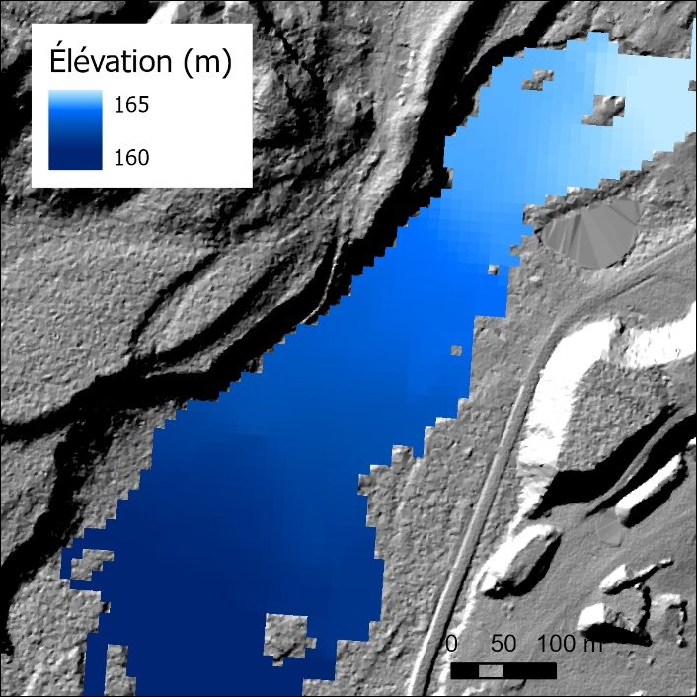
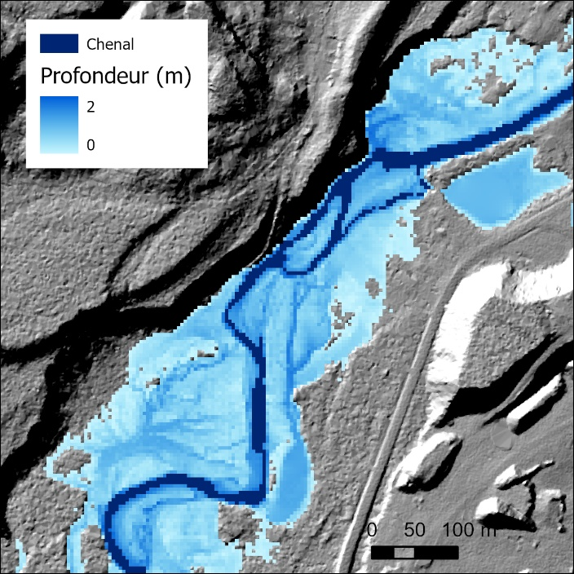
Data post-processing, with depth at a finer resolution obtained, and unconnected basins flooded
A
B
As the post-processing can be tailored to the results a user want, only the main concepts are described here, not a step-by-step process.
Flood results must be propagated upstream using the tool Watershed. As this tool only accepts rasters with integer data, the flood results should be turned beforehand into a Integer (with Raster Calculator: Int(“raster”*100) so precision up to the centimetre is kept), and the result of the Watershed tool can be turned back to float after (with Raster Calculator: Float(“raster”)/100.). The result can be than compared to a fine resolution DEM (like the 1m LiDAR DEM). Such a process improves the resolution of the simulated floods and flood the disconnected basins. If an area is not considered floodable (an area lower in elevation than the flood but protected by levees), this should be identified and corrected manually.
Floods results (post-processed at a finer resolution or not) usually extend in not-simulated tributaries as well as upstream the extremities of the model. Results in these areas should be removed manually.
For map production, it is advised to remove data in the channels if flow depths are mapped, as bed elevation in the channels are incorrect. If polygons of flood zones are created, best results are obtained by reclassified raster results (0 if not flooded, 1 if flooded) and apply a Focal Statistics tool with “Majority” statistic to smooth the results (several consecutive run of the tool could be needed). Polygons can also be smoothed (Smooth polygons tool), and small islands/holes should be removed.

