**Hurtownie Danych - Ćwiczenia 2**

z1.

z2.

z3.

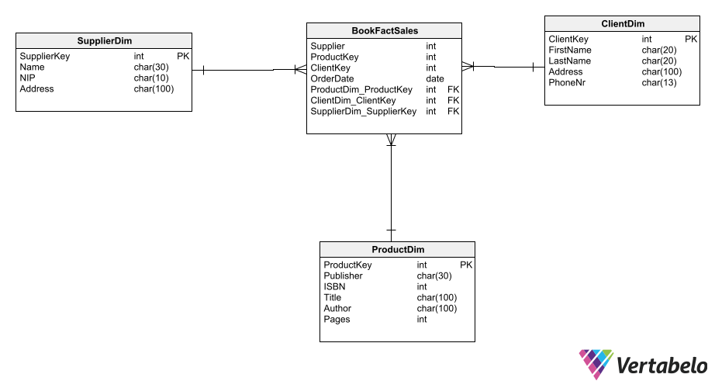

-- Table: BookFactSales

CREATE TABLE BookFactSales (

SaleKey int NOT NULL,

SupplierDim_SupplierKey int NOT NULL,

ClientDim_ClientKey int NOT NULL,

ProductDim_ProductKey int NOT NULL,

Supplier int NOT NULL,

ProductKey int NOT NULL,

ClientKey int NOT NULL,

OrderDate date NOT NULL,

CONSTRAINT BookFactSales_pk PRIMARY KEY (SaleKey)

);

-- Table: ClientDim

CREATE TABLE ClientDim (

ClientKey int NOT NULL,

FirstName char(20) NOT NULL,

LastName char(20) NOT NULL,

Address char(100) NOT NULL,

PhoneNr char(13) NOT NULL,

CONSTRAINT ClientDim_pk PRIMARY KEY (ClientKey)

);

-- Table: ProductDim

CREATE TABLE ProductDim (

ProductKey int NOT NULL,

Publisher char(30) NOT NULL,

ISBN int NOT NULL,

Title char(100) NOT NULL,

Author char(100) NOT NULL,

Pages int NOT NULL,

CONSTRAINT ProductDim_pk PRIMARY KEY (ProductKey)

);

-- Table: SupplierDim

CREATE TABLE SupplierDim (

SupplierKey int NOT NULL,

Name char(30) NOT NULL,

NIP char(10) NOT NULL,

Address char(100) NOT NULL,

CONSTRAINT SupplierDim_pk PRIMARY KEY (SupplierKey)

);

-- Reference: Copy_of_FruitSalesFact_ClientDim (table: BookFactSales)

ALTER TABLE BookFactSales ADD CONSTRAINT Copy_of_FruitSalesFact_ClientDim

FOREIGN KEY (ClientDim_ClientKey)

REFERENCES ClientDim (ClientKey);

-- Reference: Copy_of_FruitSalesFact_FruitDim (table: BookFactSales)

ALTER TABLE BookFactSales ADD CONSTRAINT Copy_of_FruitSalesFact_FruitDim

FOREIGN KEY (SupplierDim_SupplierKey)

REFERENCES SupplierDim (SupplierKey);

-- Reference: Copy_of_FruitSalesFact_StoreDim (table: BookFactSales)

ALTER TABLE BookFactSales ADD CONSTRAINT Copy_of_FruitSalesFact_StoreDim

FOREIGN KEY (ProductDim_ProductKey)

REFERENCES ProductDim (ProductKey);

z4.

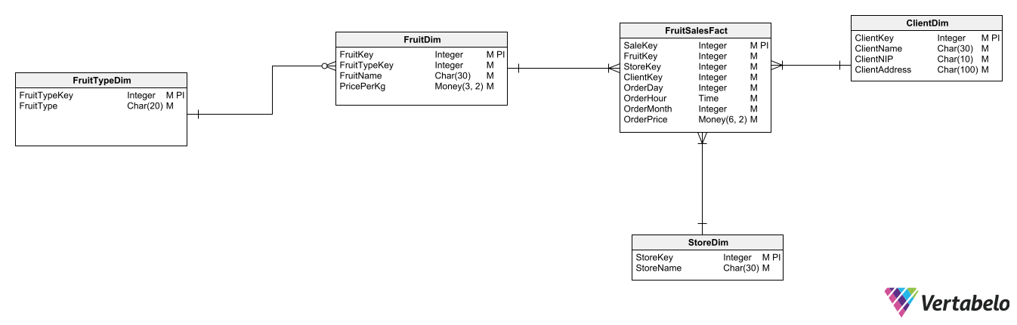

-- Table: ClientDim

CREATE TABLE ClientDim (

ClientKey int NOT NULL,

ClientName char(30) NOT NULL,

ClientNIP char(10) NOT NULL,

ClientAddress char(100) NOT NULL,

CONSTRAINT ClientDim_pk PRIMARY KEY (ClientKey)

);

-- Table: FruitDim

CREATE TABLE FruitDim (

FruitKey int NOT NULL,

FruitTypeKey int NOT NULL,

FruitName char(30) NOT NULL,

PricePerKg money NOT NULL,

FruitTypeDim_FruitTypeKey int NOT NULL,

CONSTRAINT FruitDim_pk PRIMARY KEY (FruitKey)

);

-- Table: FruitSalesFact

CREATE TABLE FruitSalesFact (

SaleKey int NOT NULL,

FruitKey int NOT NULL,

StoreKey int NOT NULL,

ClientKey int NOT NULL,

OrderDay int NOT NULL,

OrderHour time NOT NULL,

OrderMonth int NOT NULL,

OrderPrice money NOT NULL,

FruitDim_FruitKey int NOT NULL,

ClientDim_ClientKey int NOT NULL,

StoreDim_StoreKey int NOT NULL,

CONSTRAINT FruitSalesFact_pk PRIMARY KEY (SaleKey)

);

-- Table: FruitTypeDim

CREATE TABLE FruitTypeDim (

FruitTypeKey int NOT NULL,

FruitType char(20) NOT NULL,

CONSTRAINT FruitTypeDim_pk PRIMARY KEY (FruitTypeKey)

);

-- Table: StoreDim

CREATE TABLE StoreDim (

StoreKey int NOT NULL,

StoreName char(30) NOT NULL,

CONSTRAINT StoreDim_pk PRIMARY KEY (StoreKey)

);

-- foreign keys

-- Reference: FruitSalesFact_ClientDim (table: FruitSalesFact)

ALTER TABLE FruitSalesFact ADD CONSTRAINT FruitSalesFact_ClientDim

FOREIGN KEY (ClientDim_ClientKey)

REFERENCES ClientDim (ClientKey);

-- Reference: FruitSalesFact_FruitDim (table: FruitSalesFact)

ALTER TABLE FruitSalesFact ADD CONSTRAINT FruitSalesFact_FruitDim

FOREIGN KEY (FruitDim_FruitKey)

REFERENCES FruitDim (FruitKey);

-- Reference: FruitSalesFact_StoreDim (table: FruitSalesFact)

ALTER TABLE FruitSalesFact ADD CONSTRAINT FruitSalesFact_StoreDim

FOREIGN KEY (StoreDim_StoreKey)

REFERENCES StoreDim (StoreKey);

-- Reference: FruitTypeDim (table: FruitDim)

ALTER TABLE FruitDim ADD CONSTRAINT FruitTypeDim

FOREIGN KEY (FruitTypeDim_FruitTypeKey)

REFERENCES FruitTypeDim (FruitTypeKey);

z5.

-- tables

-- Table: EmployeeFact

CREATE TABLE EmployeeFact (

EmployeeKey int NOT NULL,

Name char(30) NOT NULL,

PESEL char(11) NOT NULL,

Salary decimal(10,2) NOT NULL,

CONSTRAINT EmployeeFact_pk PRIMARY KEY (EmployeeKey)

);

-- Table: EmployeeRateDim

CREATE TABLE EmployeeRateDim (

EmployeeKey int NOT NULL,

EmployeeSurrKey int NOT NULL,

Rate int NOT NULL,

EffectiveDate date NOT NULL,

"Current" bit NOT NULL,

EmployeeFact_EmployeeKey int NOT NULL,

CONSTRAINT EmployeeRateDim_pk PRIMARY KEY (EmployeeSurrKey)

);

-- foreign keys

-- Reference: EmployeeRateDim_EmployeeFact (table: EmployeeRateDim)

ALTER TABLE EmployeeRateDim ADD CONSTRAINT EmployeeRateDim_EmployeeFact

FOREIGN KEY (EmployeeFact_EmployeeKey)

REFERENCES EmployeeFact (EmployeeKey);

z6.

-- tables

-- Table: ProductDetailsDim

CREATE TABLE ProductDetailsDim (

ProductSurrKey int NOT NULL,

ProductDim_ProductKey int NOT NULL,

Details char(200) NOT NULL,

Version int NOT NULL,

CONSTRAINT ProductDetailsDim_pk PRIMARY KEY (ProductSurrKey)

);

-- Table: ProductDim

CREATE TABLE ProductDim (

ProductKey int NOT NULL,

Name char(30) NOT NULL,

Brand char(30) NOT NULL,

CONSTRAINT ProductDim_pk PRIMARY KEY (ProductKey)

);

-- Table: StorageDim

CREATE TABLE StorageDim (

StorageDimKey int NOT NULL,

Address char(100) NOT NULL,

Country char(30) NOT NULL,

CONSTRAINT StorageDim_pk PRIMARY KEY (StorageDimKey)

);

-- Table: StorageFact

CREATE TABLE StorageFact (

StorageFactKey int NOT NULL,

ProductDim_ProductKey int NOT NULL,

StorageDim_StorageDimKey int NOT NULL,

Amount int NOT NULL,

Date date NOT NULL,

CONSTRAINT StorageFact_pk PRIMARY KEY (StorageFactKey)

);

-- foreign keys

-- Reference: ProductDetailsDim_ProductDim (table: ProductDetailsDim)

ALTER TABLE ProductDetailsDim ADD CONSTRAINT ProductDetailsDim_ProductDim

FOREIGN KEY (ProductDim_ProductKey)

REFERENCES ProductDim (ProductKey);

-- Reference: StorageFact_ProductDim (table: StorageFact)

ALTER TABLE StorageFact ADD CONSTRAINT StorageFact_ProductDim

FOREIGN KEY (ProductDim_ProductKey)

REFERENCES ProductDim (ProductKey);

-- Reference: StorageFact_StorageDim (table: StorageFact)

ALTER TABLE StorageFact ADD CONSTRAINT StorageFact_StorageDim

FOREIGN KEY (StorageDim_StorageDimKey)

REFERENCES StorageDim (StorageDimKey);