**Hurtownie danych - ćwiczenia 3**

Z1.

Z2.

Z3.

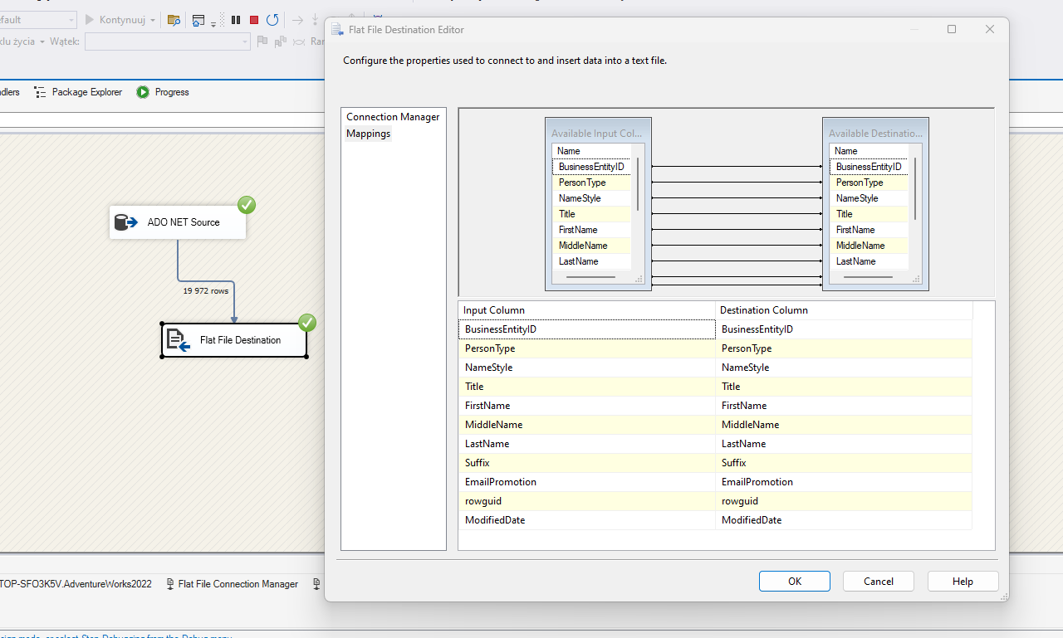

Z4.

Z7.

