**Hurtownie Danych – Ćwiczenia 4**

Z1.

Model logiczny.

Model fizyczny.

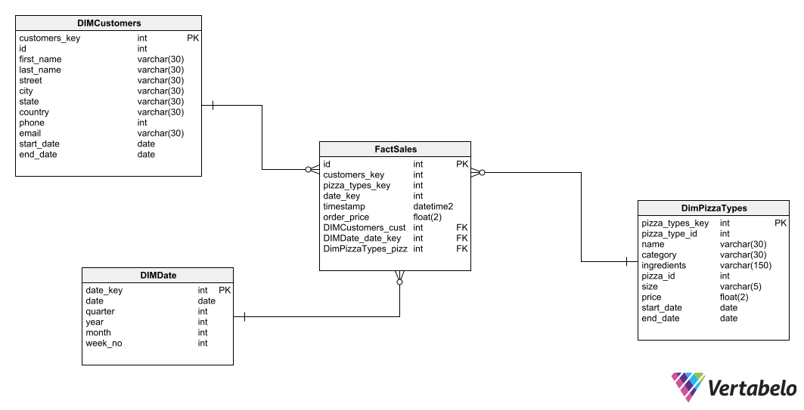

Z2.

Z3.

Z4.

Error, z którym nie wiedziałem co zrobić.

Z5.

Z6.

