z. 1

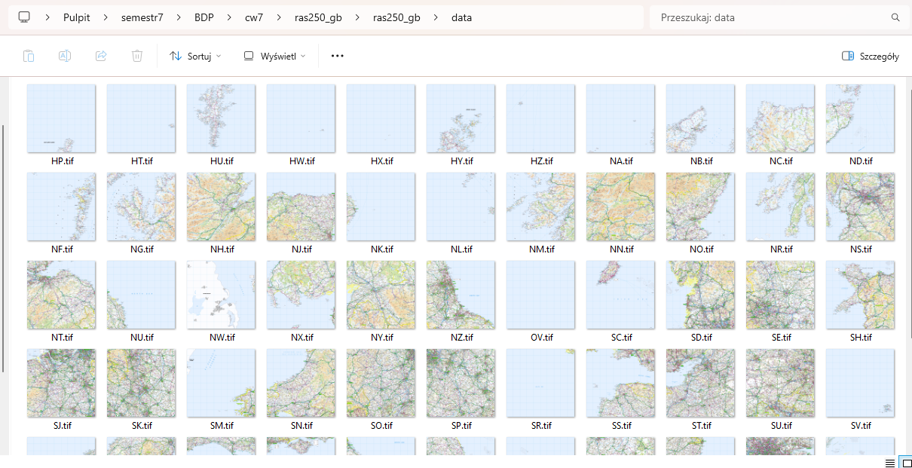

z. 2a

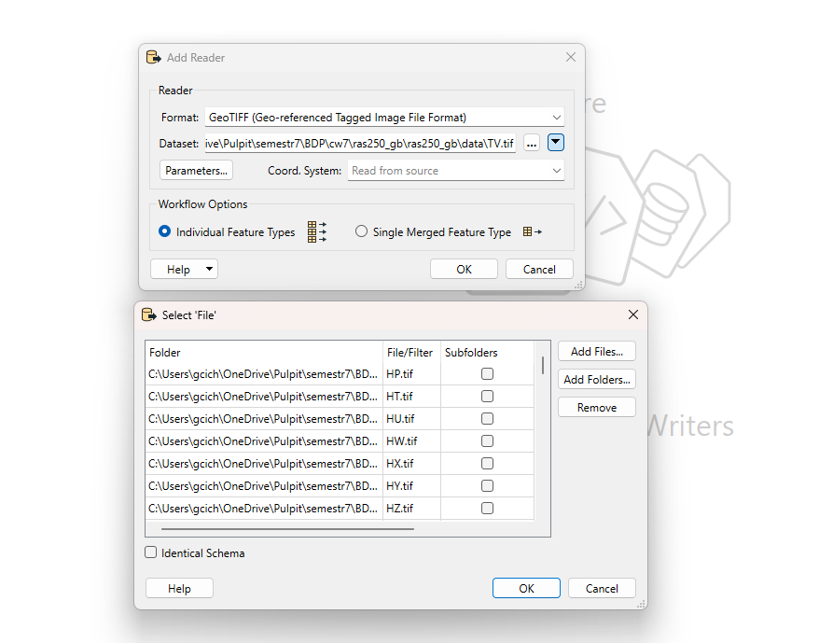

z. 2b

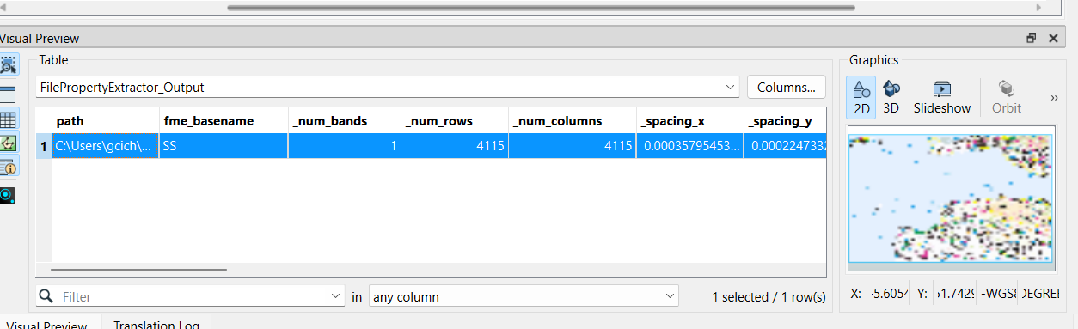

z. 2c

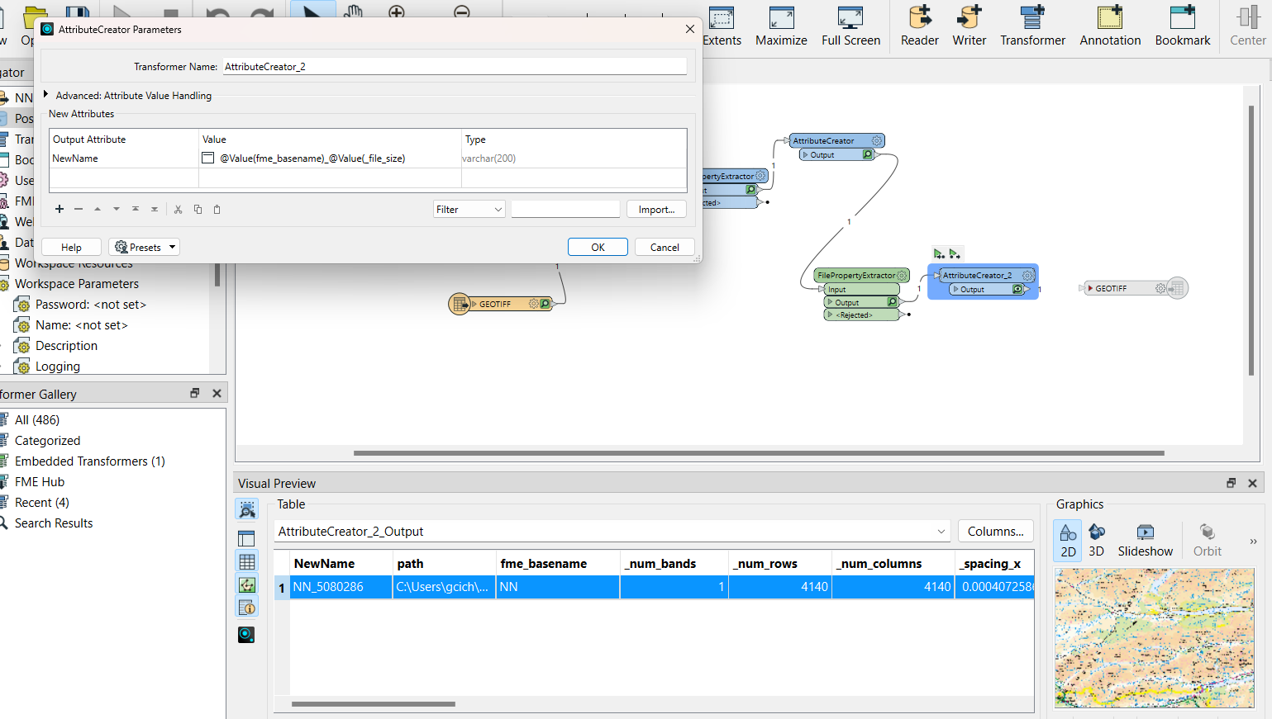

z. 2d

