PS1

Gage Clawson

1/12/2020

## Question 1

### Compare and contrast changes in mean density for adults

In 2009, all fish species had significantly higher densities at Aitutaki than those species at Rarotonga, except yellow damselfish, which had a higher density at Aitutaki, but was not significant.

In 2018, spotted damselfish and surgeonfish had signficantly higher densities at Aitutaki than at Rarotonga. Coral trout had a higher density (non-significant) at Aitutaki than at Rarotonga. Yellow damselfish had higher densities at Rarontonga than at Aitutaki, however this result is non-significant.

From 2009 to 2018, spotted damselfish, and coral trout densities significantly decreased at both locations. Surgeonfish significantly decreased at Rarotonga, but increased (non-significant), at Aitutaki. Yellow damselfish significantly increased at both locations between the years.

In 2009, coarse-branching corals (non-significant), fine-branching corals (non-significant), and sea anenomes (significant), had higher densities at Aitutaki than at Rarontonga. Mounding corals (non-significant) and algae (non-significant) had higher densities at Rarotonga than at Aitutaki.

In 2018, coarse-branching corals (significant), fine-branching corals (significant), and sea anenomes (significant), had higher densities at Aitutaki than at Rarontonga. Mounding corals (non-significant) and algae (significant) had higher densities at Rarotonga than at Aitutaki.

From 2009 to 2018, coarse-branching coral densities decreased at Aitutaki (non-significant) and Rarotonga (significant). Mounding coral densitites increased at Aitutaki (non-significant) and decreased at Rarotonga (non-significant). Mounding coral densitites increased at Aitutaki (non-significant) and decreased at Rarotonga (significant). Sea anenome densitites significantly decreased at Aitutaki and Rarotonga. Algae densitites decreased at Aitutaki (non-significant) and increased at Rarotonga (significant).

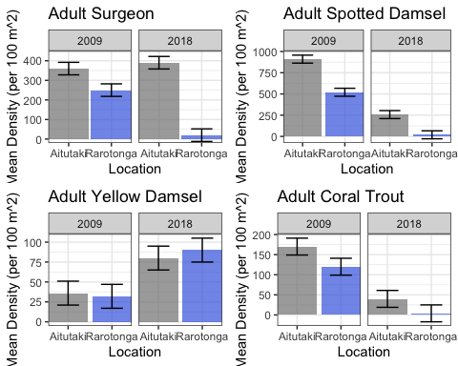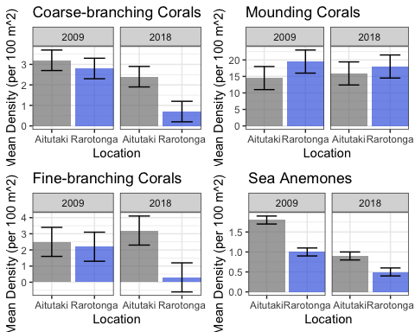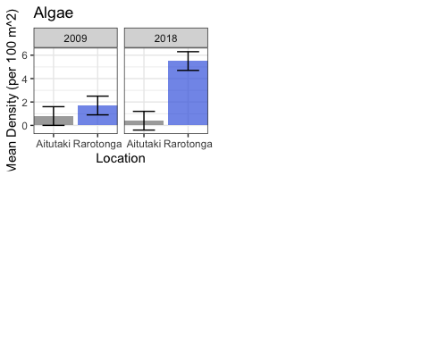

## Question 2

### Compare and contrast changes in mean density for recruits

Make a histogram of mean denisty for each organism (y-axis) on both Rarotonga and Aitutaki in 2009 and 2018

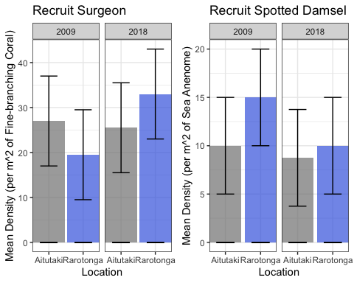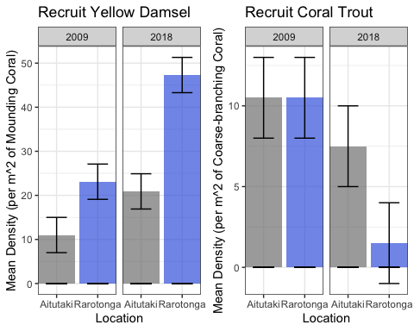

### Question 3

Calculate Recruits per 100 m^2 reef area and graph adult vs recruits scatterplots

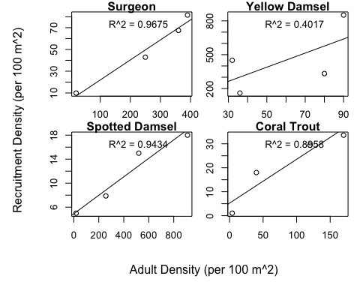

### Question 4

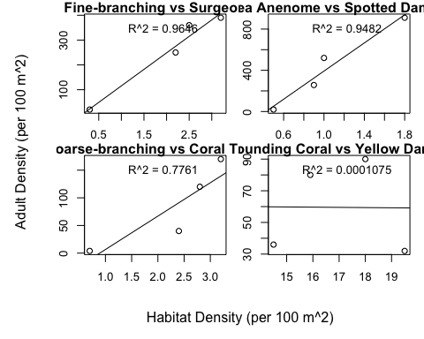

### Question 5

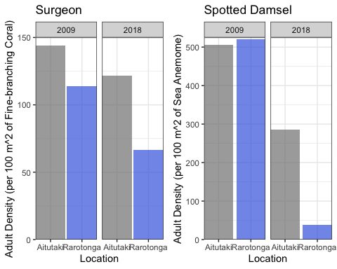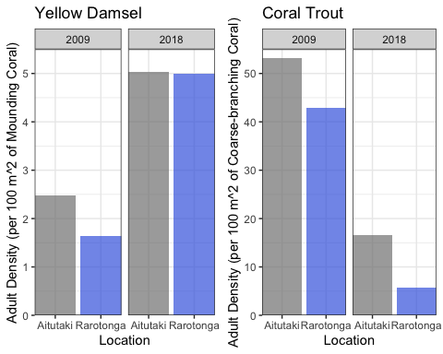

### Question 6

Make scatterplots of all Adult Densities

* surgeonfish vs coral trout
* surgeonfish vs yellow damsel
* surgeonfish vs spotted damsel
* coral trout vs spotted damsel
* coral trout vs yellow damsel
* yellow damsel vs spotted damsel

