Homework 4

Gage Clawson, Juan Silva

5/31/2019

1. Write down a plausible functional form for the marginal cost of abatement for sector A. Use regression analysis to estimate the parameters of that function. Repeating this for sectors B, C, and D will give you a model of the marginal cost of abatement function for each sector. How well do your models fit the data for each sector? You may need to experiment with different functional forms. Produce a plot of the estimated marginal abatement cost functions in all four sectors (this plot should go in your memo).

##   
## Table 1: Regression Results  
## ======================================================================  
## Dependent variable:   
## ----------------------------------------  
## mc_a mc_b mc_c mc_d   
## (1) (2) (3) (4)   
## ----------------------------------------------------------------------  
## abatement 0.577*** 0.199*** 0.784*** 0.260***   
## (0.048) (0.046) (0.079) (0.064)   
##   
## Constant -8.644* 9.318** -11.655 9.688   
## (4.257) (4.091) (6.963) (5.606)   
##   
## ----------------------------------------------------------------------  
## Observations 16 16 16 16   
## R2 0.910 0.566 0.875 0.543   
## Adjusted R2 0.904 0.535 0.866 0.511   
## Residual Std. Error (df = 14) 8.917 8.569 14.584 11.742   
## F Statistic (df = 1; 14) 142.288*** 18.291*** 98.214*** 16.661***  
## ======================================================================  
## Note: *p<0.1; **p<0.05; ***p<0.01

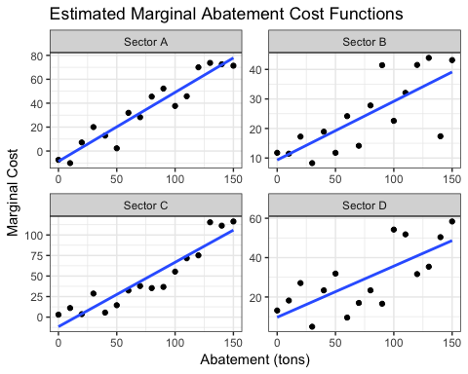

Marginal Cost of Abatement Functions:

$$MC_{A}=−8.65+0.58(Abatement)$$

$$MC_{B}=9.32+0.2(Abatement)$$

$$MC_{C}=−11.66+0.78(Abatement)$$

$$MC_{D}=9.69+0.26(Abatement)$$

1. Using these models and the current level of carbon emissions, derive each sector’s demand curve for carbon emissions. In other words, how much would each sector be willing to pay for the right to pollute the first unit, second unit, etc? Draw these demand curves on a graph. Which sector is willing to pay the most for the first unit of carbon emissions?

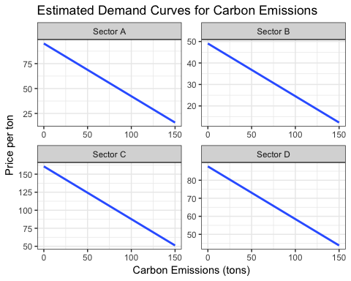

Demand for emission functions:

$$Demand_{A}=−0.529(Emissions)+95.2$$

$$Demand_{B}=−0.245(Emissions)+49.1$$

$$Demand_{C}=−0.731(Emissions)+160.8$$

$$Demand_{D}=−0.292(Emissions)+87.67$$

* Sector C is willing to pay the most for the first unit of carbon emissions.

1. Now focus on country X (which contains sectors A, B, and C). Assume there are no “co-benefits” from carbon abatement (i.e. that there are no local pollutants that are affected by carbon abatement). Suppose to meet the Paris Accord commitments, country X needs to cut all carbon emissions in half. For each of the policy options listed below, derive: (1) the total cost of meeting the target in country X, (2) the cost (or benefit) to each sector, and (3) the tax revenue generated.
2. Cap on carbon. Each sector (A, B, and C) must cut its carbon emissions by 100 tons (thus reducing total emissions from 600 down to 300).
3. Tax on carbon. To emit a ton of carbon in country X, you must pay a tax of $t. You will need to find the tax that accomplishes the desired reduction.
4. Cap and trade. Each sector (A, B, C) is allocated carbon permits equal to their current emissions minus 100 (same as in (a) above), thus achieving the total reduction of 300. Then, these three sectors are allowed to trade with each other. You will need to derive the outcome of that trading.