|  |  |  |  |  |
| --- | --- | --- | --- | --- |
| 输入及外部条件 | 有效等价类 | 等价类编号 | 无效等价类 | 等价类编号 |
| 输入的类型 | 数字字符 | 1 | 非数字字符 | 5 |
| a,b,c | a+b>c | 2 | a+b<=c | 6 |
| a,b,c | a+c>b | 3 | a+c<=b | 7 |
| a,b,c | b+c>a | 4 | b+c<=a | 8 |

等价类划分表

测试用例

有效等价类

|  |  |  |  |  |  |
| --- | --- | --- | --- | --- | --- |
| 序号 | 输入数据 | | | 预期输出 | 覆盖范围（）等价类编号 |
| a | b | v |
| 1 | 1 | 1 | 1 | True | 1234 |
|  |  |  |  |  |  |
|  |  |  |  |  |  |
|  |  |  |  |  |  |

无效等价类

|  |  |  |  |  |  |
| --- | --- | --- | --- | --- | --- |
| 序号 | 输入数据 | | | 预期输出 | 覆盖范围（）等价类编号 |
| a | b | v |
| 1 | x | 1 | 1 | False | 5 |
| 2 | 1 | 1 | 2 | False | 6 |
| 3 | 1 | 2 | 1 | False | 7 |
| 4 | 2 | 1 | 1 | False | 8 |

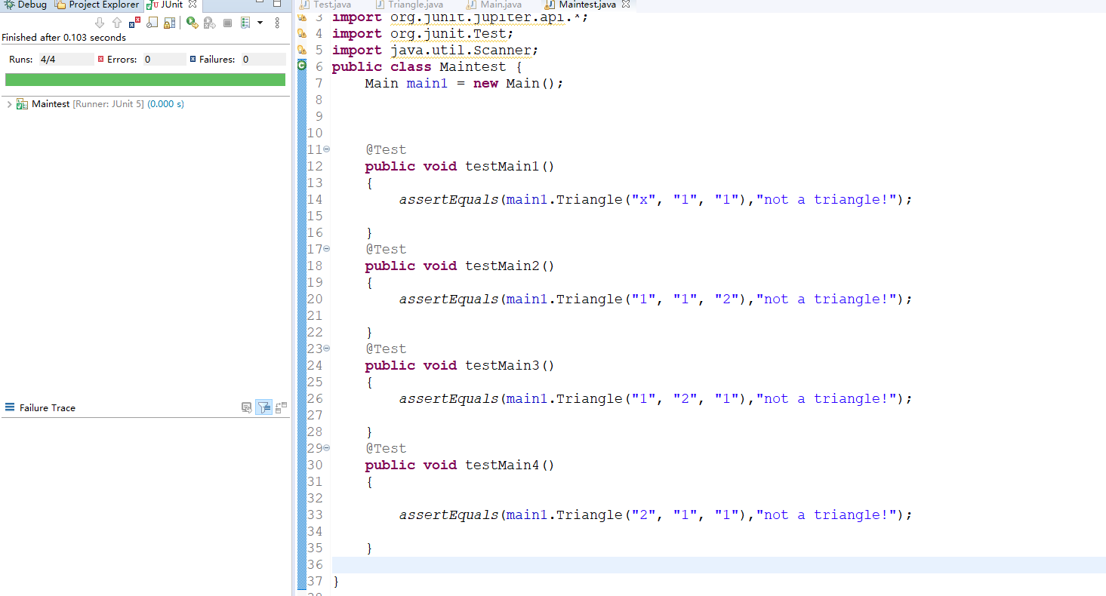

缺陷：三角形构成条件去掉x+y>z判断

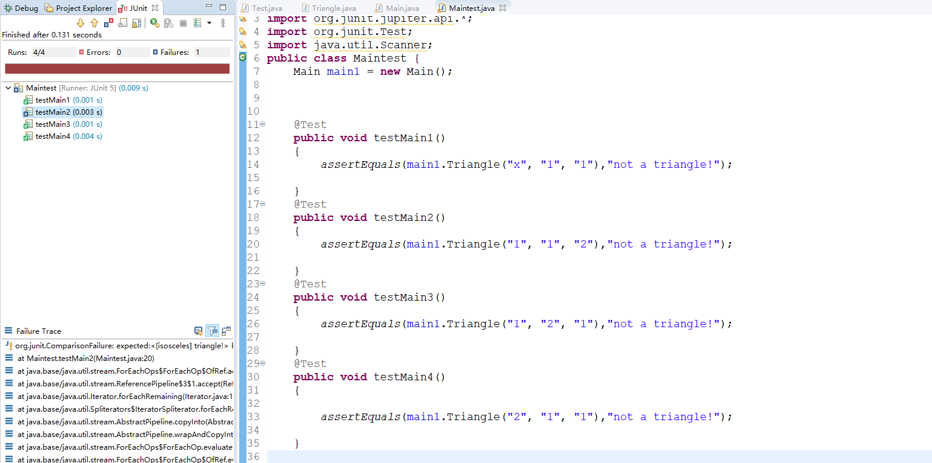

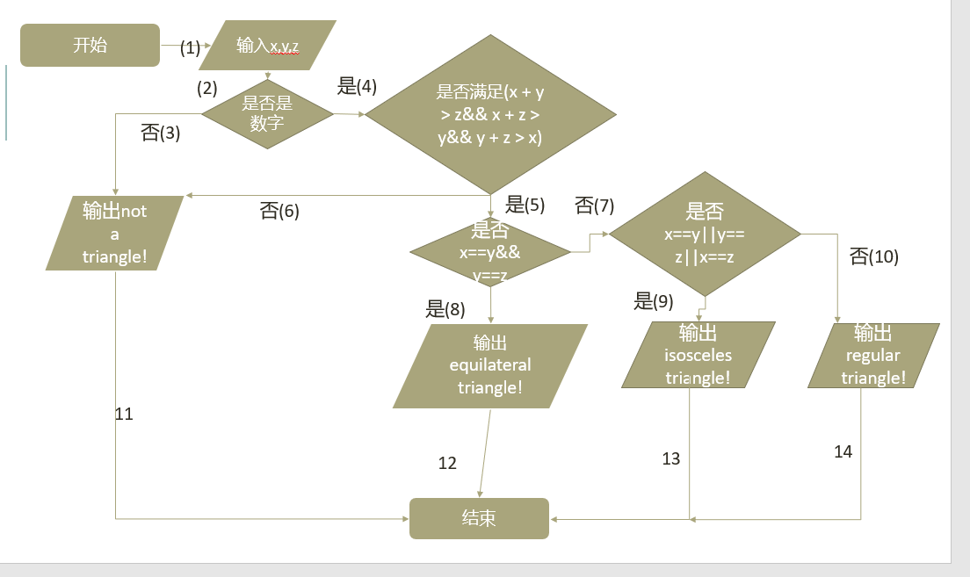

|  |  |
| --- | --- |
| 输入 | 执行路径 |
| x 1 1 | 1 2 3 11 |
| 1 1 1 | 1 2 4 5 8 12 |
| 5 5 7 | 1 2 4 5 7 9 13 |
| 3 4 5 | 1 2 4 5 7 10 14 |
| 1 1 2 | 1 2 4 6 11 |
|  |  |
|  |  |

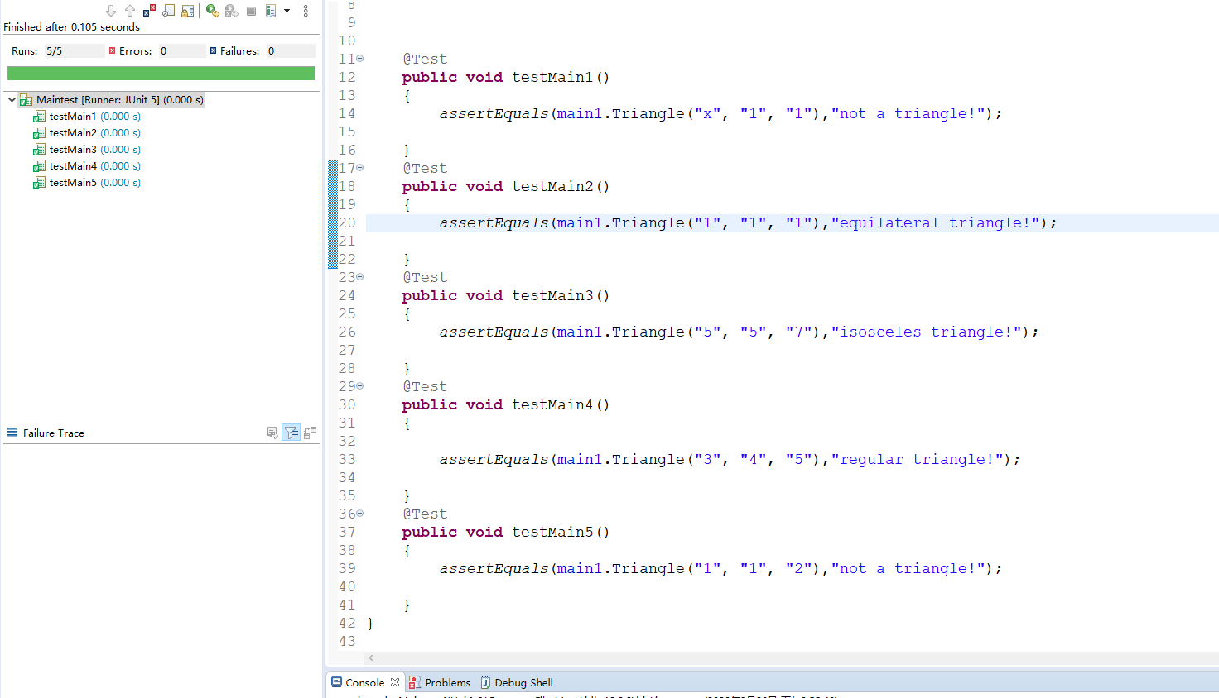

缺陷：更改等边三角形判断输出

