# Additional APIs:

1. **POST webservice to login**

1. **POST webservice to logout**

1. **GET webservice to retrieve all flights**

1. **GET webservice to get role from decodedToken**

1. **GET webservice to get bookings from a certain userid**

# Modified APIs:

1. **GET webservice to retrieve info of direct flights by airportid**

Added parameter (embarkDate)

1. **GET webservice to retrieve a user's data by id**

**PUT webservice to update a user's data**

**POST webservice to add new booking for a flight**

**GET webservice to get all bookings of a user**

Added User Verification function (checking for access rights)

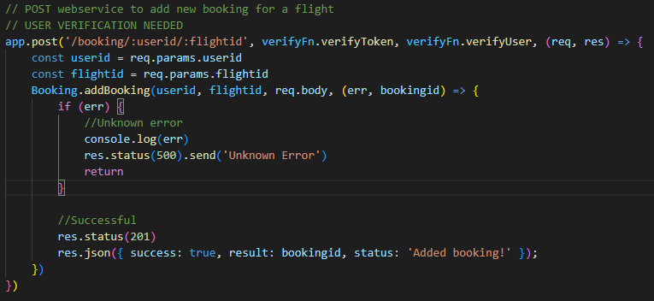

Example of user verification added to API (POST booking)

1. **POST webservice to add new airport to database**

**POST webservice to add new flight to database**

Added Admin Verification (checking for access rights)

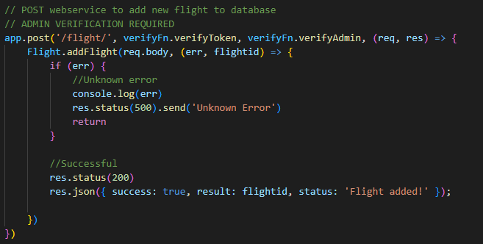

Example of admin verification added to API (POST flights)

# Modified functions in back-end models

1. **updateUser**

SQL query does not update password, role and profile_pic_url

1. **getAirports**

SQL query includes description when selecting

1. **New getFlights function**

SQL query select all flights

1. **getDirectFlightInfo**

SQL Query now

* returns all data where embarkDate matches the user’s input date,
* returns the country of the corresponding airports.

