Homework 2 – Adversarial Search Chapter 5

**Due:** See online for exact date

Name: Gregory Montilla

*Directions: You must work on this assignment alone.*

1. [10pts] Write the Minimax values for nodes A-G in the following minimax tree:

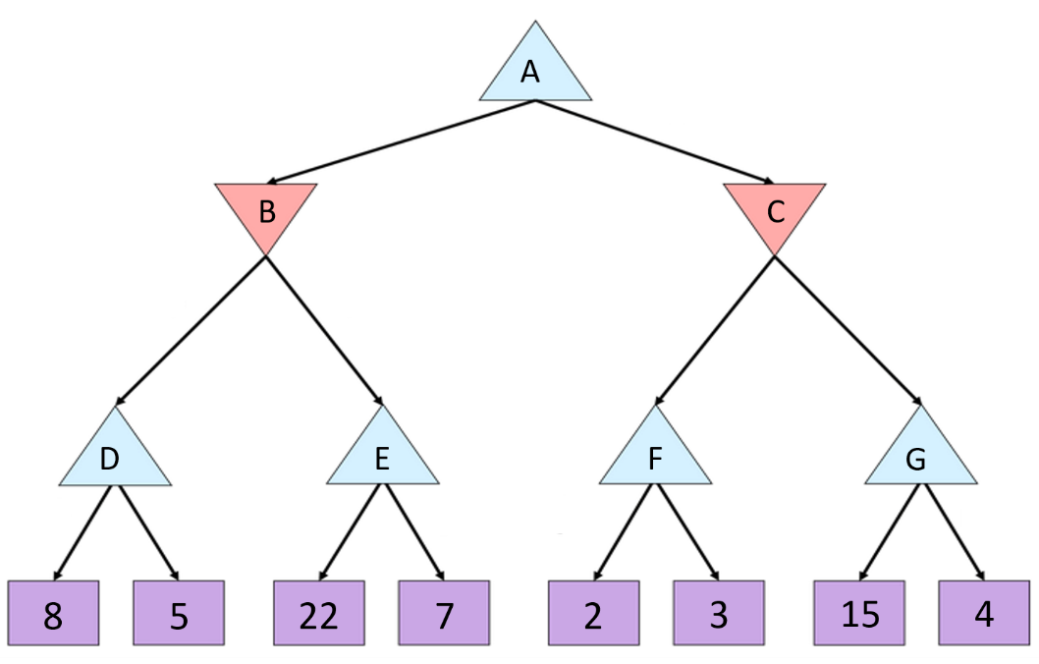



1. [10pts] Fill in the Minimax values for each node in the following minimax tree:

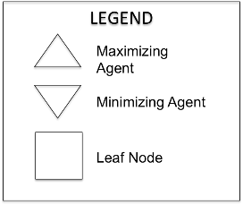 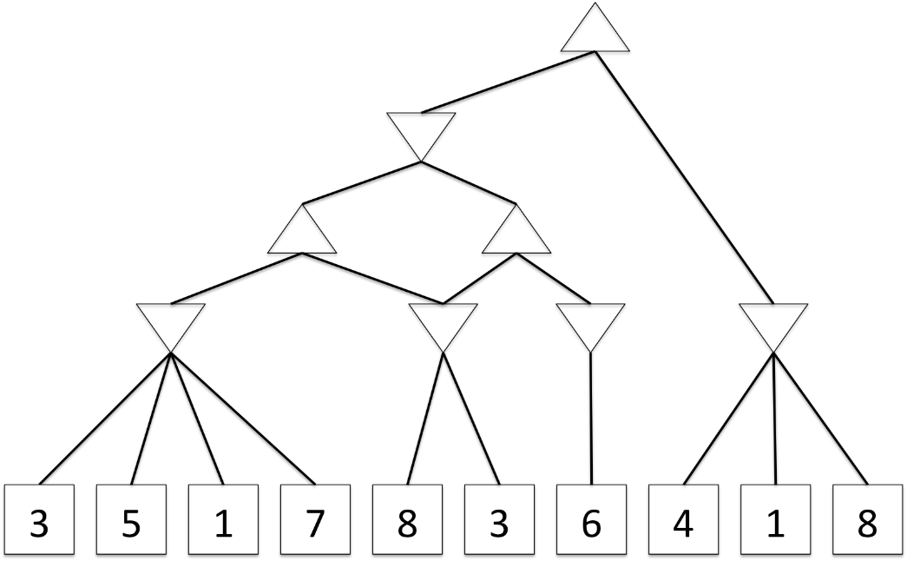



1. [60pts] Perform alpha-beta pruning on the tree from #1. Assuming we use the variable *v* to represent the value currently assigned to the node, list the alpha(α), beta (β) and value (*v*) variables of each node as (α, *v*, β), as we did in class.

Generate the tree in the space below (you may want to do it on a separate piece of paper and then copy it over when you are sure you have it) using a **depth-first search**. When alpha-beta pruning determines that you can prune certain nodes, then draw an “X” instead of the corresponding node or sub-tree.

*NOTE: For a decent Youtube demonstration of alpha-beta pruning,* [*click here*](https://www.youtube.com/watch?v=xBXHtz4Gbdo)*.*





Use the table to help you keep track of the current (α, *v*, β) state of each node. So, the (α, *v*, β) state at the bottom of each row represents the current state of that node. Values in the same row have no meaning…**the most important thing is that each value on the bottom of each column represents the current (α, *v*, β) values for that state upon completion of the search**.

|  |  |  |  |  |  |  |
| --- | --- | --- | --- | --- | --- | --- |
| A | B | C | D | E | F | G |
| (-∞, *v*, +∞) | (-∞, *v*, +∞) | (-∞, *v*, +∞) | (-∞, *v*, +∞) | (-∞, *v*, +∞) | (-∞, *v*, +∞) |  |
| (-∞, 8, +∞) | (-∞, -∞*,* +∞) | (8, ∞*,* +∞) | (-∞, -∞*,* +∞) | (-∞, -∞*,* 8) | (8, *v*, +∞) |  |
|  | (-∞, 8*,* +∞) | (8, 3*,* +∞) | (-∞, 8*,* +∞) | (-∞, 22*,* 8) | (8, 2, +∞) |  |
|  |  |  |  |  | (8, 3, +∞) |  |
|  |  |  |  |  |  |  |
|  |  |  |  |  |  |  |
|  |  |  |  |  |  |  |

1. [20pts] Assign values to the nodes for the following expectimax tree:

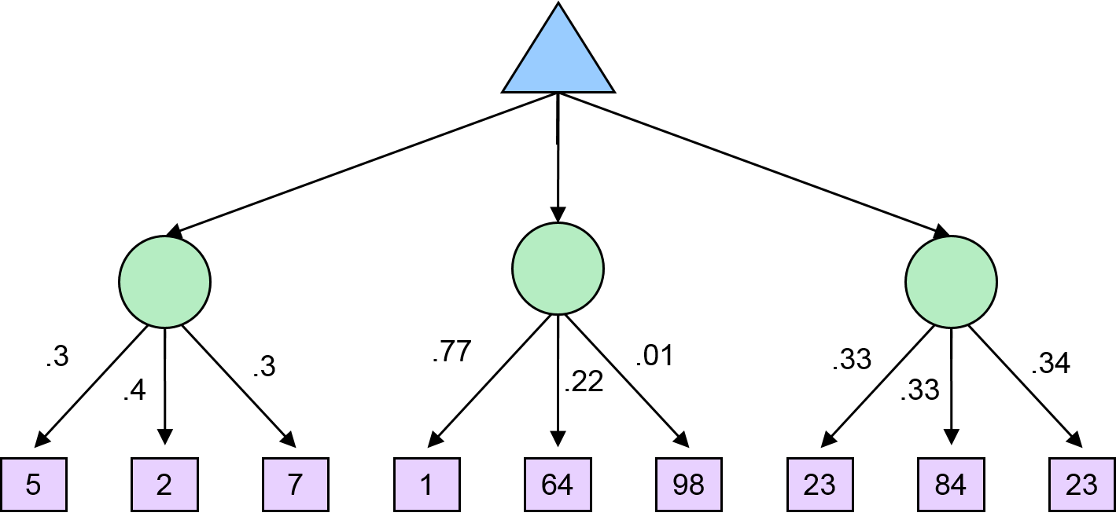



|  |  |  |
| --- | --- | --- |
| = 3(5) + .4(2) + .3(7)  = 1.5 + .8 + 2.1  = 11.6 | = .77(1) + .22(64) +.01(98)  = .77 + 14.08 + .98  = 15.83 | = .33(23) + .33(84) + .34(23)  = 7.59 + 27.72 + 7.82  = 43.13 |