* 類別

car

hov(重型車輛)

person

motorcycle

* 2022/10/3

Training Dataset_v3

* + 1003-1(300代)
  + ~~img-size 1280~~ #沒辦法收斂
  + img size 640
  + python train.py --data data/Drone.yaml --cfg models/yolov5x_Drone.yaml --hyp data/hyps/hyp.scratch-high_Drone.yaml --img-size 640 --batch 8 --epochs 300 --weights yolov5x.pt --image-weight --cache --label-smoothing 0.01

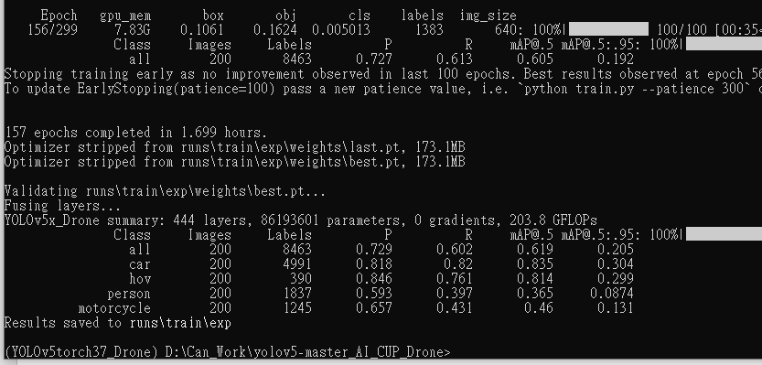

* 2022/10/3

Training Dataset_v3

+ VisDrone 2022

* + 1003-2(300代)
  + img size 640
  + python train.py --data data/Drone.yaml --cfg models/yolov5x_Drone.yaml --hyp data/hyps/hyp.scratch-high_Drone.yaml --img-size 640 --batch 8 --epochs 300 --weights yolov5x.pt --image-weight --cache --label-smoothing 0.01