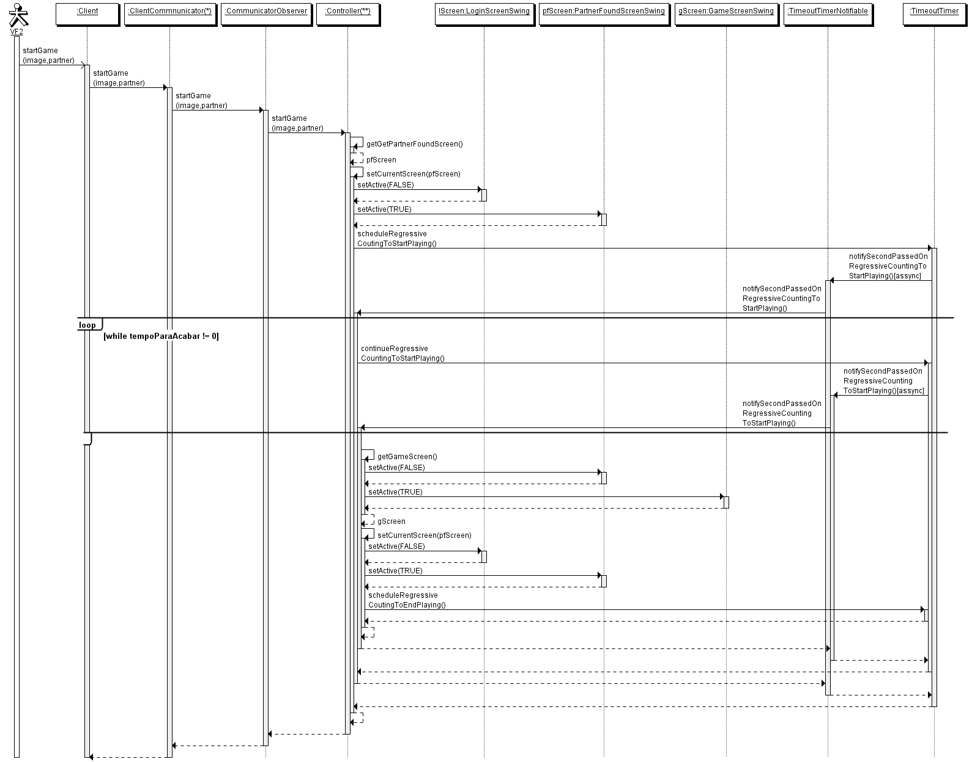
OBS: São mostradas as interfaces envolvidas Client e Communicator Observer. (*) ClientCommunicator implementa Client e Communicator, (**) Controller implementa CommunicatorObserver

