**Instructions with MiWiPRO package configured in Star Topology**

**Device Types**

Role is defined in file: *miwi/inc/Config_App.h*

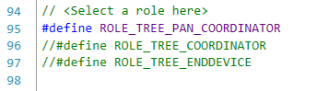

1. PC = Pan Coordinator = Fully Functional Device
   1. Device that cannot go to sleep
   2. Device that will start/create the network
   3. Device that will be the parent device for all the sleeping end devices
2. ED = End Device = Reduced Functional Device
   1. Device that can go to sleep
   2. Device that will join an existing network
   3. RFD devices do not allow other devices to join

**Hardware**

SAMR34 Xplained Pro  
Optionally a WINC1500 Xplained Pro

Software

ED.zip contains the Atmel Studio project for the End Device  
PC.zip contains the Atmel Studio project for the Pan Coordinator  
PC_WINC1500.zip contains the Atmel Studio project for the Pan Coordinator with Wi-Fi enabled

**Instructions**

1. Mark a device as PC and open terminal window TeraTerm corresponding the COM port of the SAMR34 Xplained Pro connected
2. Program the device with the PC Solution shared
3. Mark the other devices ED and open terminal window TeraTerm corresponding the COM port of the SAMR34 Xplained Pro connected
4. Program the device with the ED solution shared

**Demo Notes**

Use ED.zip and PC.zip to demonstrate a local network between a PC and several EDs.  
Use ED.zip and PC_WINC1500.zip to demonstrate a PC to push temperature data received from the EDs to an MQTT broker.

The Sub-GHz Frequency Band can be selected in file: *miwi/tal/sx1276/inc/radio_registers_SX1276.h*

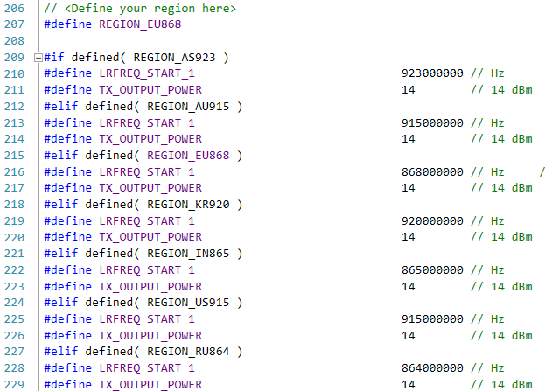

The Wi-Fi settings of the router can be configured in *wifi_app.h*

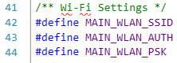

The MQTT connection parameters can be configured in *wifi_app.h*