Application Form Composer and Interview Tool

Technical Documentation

Last Modified: 13.01.2010
Author: Guillermo C. Martínez

Email: gcomesana@cnio.es
Team: -
Client: Genetic & Molecular Epidemiology Group



Table of Contents
1. Introduction 4
2. Application Structure - MVC (Model-View-Controller pattern) 4
3. Server side architecture 5
3.1 Conceptual data model 5
3.1.1 Users submodel 6
3.1.2 Questionnaires submodel 6
3.1.3 Performance submodel 7
3.2 Physical data model 8
3.2.1 Tables 8
3.2.2 Triggers 10
3.2.3 Functions 10
3.2.4 Views 11
3.3 Application Server logic 11
3.3.1 Object-Relational Mapping 12
3.3.2 Utility clases 12
3.3.2.1 Dump classes 13
3.3.3 Servlets and filters 14
3.3.4 Authentication system 14
3.3.4.1 Password recovery 16
3.3.5 Audit 17
3.3.6 Java Server Pages Resources 17
3.3.6.1 Interview tool JSP resources 18
4 Client Side Architecture 19
4.1 Client Side resources 19
4.2 Dynamic behaviour 19
4.2.1 Cascading Style Sheets 20
4.2.2 Javascript 20
4.2.3 Interview Tool Design & Implementation 21
4.2.3.1 Interview configuration 21
4.2.3.2 Interview performance 22
Appendix A. Administration Tool application 25
A.1 Server logic 25
A.2 Client logic 26
Appendix B. Building, Deploying and Installation from the scratch 28
B.1 Setting up the source code 28
B.2 Build 28
B.3 Deployment 29
B.4 Deployment from the scratch 29
B.4.1 Setting up the database 29
B.4.2 Application(s) deployment 30
Appendix C. Database description report 32
C.1 Tables description 32
C.2 View description 62
C.3 Functions and triggers description 63
C.4 EER Model diagram 79

Application Form System. Technical Documentation

1. Introduction
This documentation is intended to give a technical description of the questionnaire tool delivered to the Epidemiological Group at CNIO from the technological, architectural and organizational point of view.
The result is a Java-based web application which complies with the Servlet 2.4 specification, is deployed on a Tomcat6 application server (ideally it can be deployed on any other servlet 2.4-certified application server, like JBoss) and uses as backend data repository a PostgreSQL 8.3 server. In addition, taking into account the necessary, sometimes complex but continuous database access, Hibernate3 ORM was used as middleware between the server side code and the database objects. Table 1 shows the layers the application is split in.
From this point on, the document is organized as follows. First, an overview of the MVC design pattern used to build the application is commented to give an overview of the application architecture. Then, the overall application description is split in server side and client side. Server side includes database and application server logic description. Then, files used only on client side (images, css, …) and their organization are described

User Interface Layer | Web Browser (AJAX)
Network Layer | Tomcat 6.0.18 application server
Logic Layer | Servlet 2.4 spec (servlet, filters, jsp’s)
Middleware Layer | Hibernate3 & Annotations
Data Layer | File system | PosgreSQL 8.3 RDBMS
Table 1. Application layers structure

2. Application Structure - MVC (Model-View-Controller pattern)
As many other web applications, this one was written keeping in mind the use of the Model-View-Controller design pattern. The principle of this pattern is the separation of different parts of the application in order to allow to perform changes without affecting only to a small part of the application.
So, the model layer refers to the datamodel of the application; the view layer means the user interface (in this case web pages) and the controller is the layer that gets the user input to do something in the data model. Or, with different words, MVC breaks the problem into three distinct pieces: model (stores the application's state), view (interprets data in the model and presents it to the user) and controller (processes user input, and either updates the model or displays a new view).
The approach used here is not considered a pure MVC pattern as the boundaries between view and controller are blurred in the J2EE technology used in the application and, as is known, JSPs can hold both controller and view logic. This decision was adopted in the early development stages but it was evolving to a different implementation approach, by removing code from the new coded JSPs and using servlets as controller and dynamic HTML (javascript and AJAX technology and frameworks) as the view layer and some kind of control logic. With this approach, and by using some standard format to set the communication between server and client, it is possible a completely separation between server and client logic, while the model remains separated.
Lately, the ExtJs framework was used to implement dialogs and to help interview configuration proccess in order to avoid semantic errors as much as possible. In a hypothetical future evolution of the tool, this framework would be a good choice to implement logic and control. More information about the framework can be obtained from its website at www.extjs.com.

3. Server side architecture
The server side is the side where the backbone of any web application is found. For this application, the following components are supporting the application:

Database server | PostgreSQL 8.3 on Ubuntu Linux 2.6, supports the model
Application server | Apache Tomcat 6.0.18 on Ubuntu Linux 2.6, supports most of the controller

Following, the server side infrastructure supporting the application is described. This infrastructure is formed by the datamodel implementation and the application server logic. First, the database conceptual and physical models (the datamodel) are described. Then, the application server logic, which is the controller part of the application, is explained.

3.1 Conceptual data model
The conceptual data model describes the data requeriments of a (new) information system using different notations and formal models. So, it can be said the conceptual data model is one of the results of the requirement analysis. The model used is the well known Extended Entity-Relationship (EER) model. No matter the database server or implementation technology used in this stage, only the data conceptual requeriments have to be taken into account.
The picture of the EER model is showed in a whole[x]. Besides, as this diagram can be heavy at first sight, three submodels are provided.

3.1.1 Users submodel
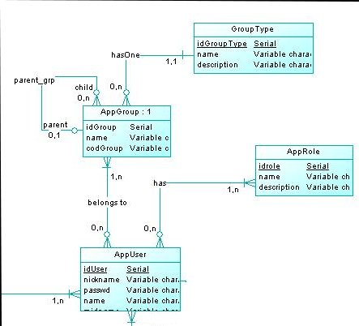

Figure 1. Users conceptual submodel
The model captures the user requeriments for this system. Users have to have a set of users privileges (given by AppRole entity), which control the user’s available actions in the application; and data access (given by AppGroup and GroupType entities), which control the set of data an user can access. Besides, the groups can get grouped into hierarchies.

3.1.2 Questionnaires submodel
The following conceptual submodel (blue shaded in the global model) supports the structure of the questionnaires, which means all sections and questionnaire items belong to interview templates or questionnaires and, these ones, belong to projects.
As Project, (entity/table name given for questionnaire or interview template), Section and Item have just a few attributes (name and description besides foreign keys), it is worth a commentary about the rest of tables in this submodel.
The most important attributes in the Interview table are:
- source, to know whether or not an interview is cloned from another source interview. This is done to be able to have similar interviews with different languages. There is not features to make changes in a cloned interview if changes are made in the source interview.
- can_create_subject, it allows the creation of a subject when performing an interview.
- can_shorten, to be able to perform a subset of a whole interview. Implies a justification
- is_sample_intrv, as samples are intended to have a different type of identifier, this one (and other features) has to be indicated by this switch
An Item is defined like something inside a section in a questionnaire. It has the following particular attributes:
- item_order is the order of the item in the section, necessary to be rendered properly
- ite_iditem is a foreign key representing a container-containee association between items
- highlight, a rough definition of decorations to display the item content
- repeatable gives the possibility to replicate the item on performance. This one is useful when one question can have several answers.
As something is an abstract concept, it has to get concrete in Texts and Questions. A Text is just that, a text in the interview, without possible answer; a Question is an Item which has to be answered with some AnswerItem. Again, this is an abstract concept (answer item can be an integer, a decimal, a word or a choice from a list). So, in order to get this concept concrete, AnswerType and EnumType are related. An EnumType object is just a list of choices as answer; an AnswerType is just a simple type (like a lable or number) as answer for some question.
Next the submodel for questionnaires is showed (Figure 2).
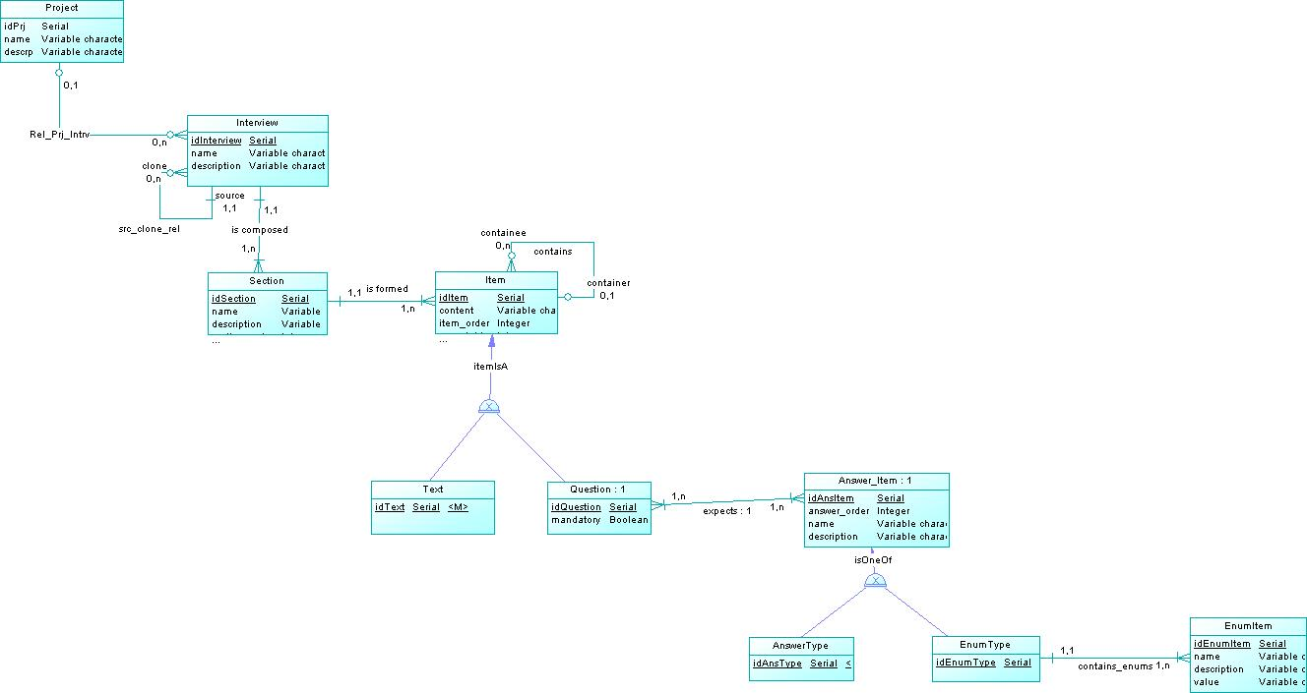

Figure 2. Questionnaire or interview template submodel
An EnumType, as it was said above, is composed by a list of choices. In the database, the choices are represented by the EnumItem entity, where one EnumType element can have several EnumItem elements, but one EnumItem element is related to only one EnumType element. The EnumType table has three particular attributes (in addition to primary key id):
- name, this is the name will be displayed
- thevalue is the value which will be stored on the database if this entry is chosen as answer
- listorder, the order of this choice in the list of choices
Remark that an Interview is self-contained, which makes possible to be cloned. This means a questionnaire contains (via relationships) all questions, texts and answer types necessary to be exported or, as it is done, replicated

3.1.3 Performance submodel
This submodel (green shaded in the global model) supports the interviews to the subjects involved in the study (Figure 3). There are two entities that take part in many relationships.
Entity Performance represents a questionnaire instance. Actually, it is a quaternary relationship raised to a weak entity. Its meaning can be made out as “AppUser (an user) performs an Interview to a Patient and belongs to AppGroup”. The AppUser entity in the relationship is mostly intended for audit purposes. The performances are accessible for the group of users who belongs to AppUser’s group. Patient can be either a case or a control, and it is the naming convention used by monitors.
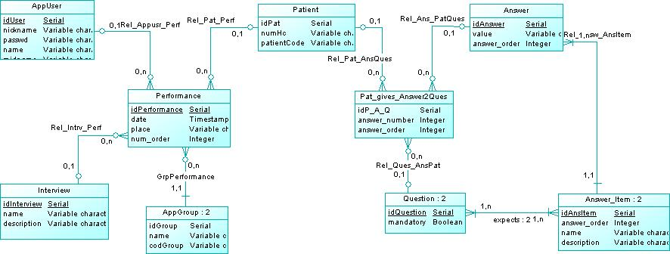

Figure 3. Interview Performance and patient submodel
The other ternary relationship raised to weak entity is Pat_gives_Answer2Ques. This one asserts that it “holds the Answer(s) given by a Patient for each Question from an Interview”. In this way, thanks to the this ternary relationship, every question for every interviewed subjet can be retrieved.
Rest of entities, those ones with a :2 on the caption, are duplicated entities which are there to clarify the diagram model.

3.2 Physical data model
The physical data model is the conversion of the conceptual data model into another model ready to be implemented in a database server. The relational model is used here as the previous step to set up the physical model in the database server, in this case a relational database server. By using relational mapping rules, entities and relationships in the EER model are converted into tables in the relational model, which is implemented in the server.

3.2.1 Tables
So, following is the list of relational tables that are part of the database and a comment for each of them describing its purpose.
- ANSWER. This table represents the value(s) answered for a question (notice that one question can have several answers for a single subject).
- ANSWER_ITEM. This table represents each item of response for a question, considering that any question can be more than one item as response (for instance, month and years, or amount and a dimensional unit as hours, minutes or seconds). It can be seen as a generalized concept of data types answers in the context of the application as generalizes answer types (ANSWERTYPE table) and enum types (ENUMTYPE table, types which are actually enumerated types), both of them are, actually, types of answers.
- ANSWERTYPE. Represents simple answer types. Up to date, there are three simple answer types: label (a normal string), number (an integer number) and decimal (a float number).
- APPGROUP. A set of users with similar data access boundaries. All users in a group will have access to the same data, but not all of them will have the same rights (which will be given by the role concept/APPROLE table)
- APPLOG. This table hold log messages from all over the application.
- APPUSER. This table represents the individuals which are going to use the application.
- ENUMITEM. The items belonging to a single enumeration type (ENUMTYPE). These items are basically trios (name, value, order).
- ENUMTYPE. The type enumeration is intended as a container of a set of discrete values (ENUMITEM).
- GROUPTYPE. This is a table to define the group type, which can be, in this case, a country as a main group and a hospital or lab as the secondary group. Larger hierarchies can be set (but they need programming logic to be effective).
- INTERVIEW. This table holds the interview templates, which means the questionnaires, opposite to PERFORMANCE interviews, which are intended as the interviews to the study subjects. Three particular attributes of this entity are can_shorten, can_create_subject and is_sample_intrv which are switches indicating that the interview can be performed just by answering a short number of questions (can_shorten); whether or not a new subject can be performed by the interview (can_create_subject) and if the questionnaire is to manage samples (is_sample_intrv).
- INTRV_GROUP. Relation between an interview and a group. This is to define which main group (country in this case, could be a company or something more generic) the interview belongs to.
- ITEM. Superclass entity which serves as an entity to represent both texts, questions and text/question grouping (item grouping).
- PAT_GIVES_ANSWER2QUES. This is a table result of a ternary relationship with the meaning: ‘Several patients gives several answers for the questions’. The ternary relationship connects or relates the patients and answers and questions. There are two important attributes here:
- answer_number, for questions with several answers (repeatitivity)
- answer_order, for questions with multiple values for the answer, for ex, a frequency value.
- PATIENT. A subject involved in the study and who was interviewed.
- PERFORMANCE. This can be defined as the instance of a questionnaire. The database stores application form models or questionnaires (called interview in the database context), but these questionnaires have to be realized (performed) by performing an interview to some subject (patient). So, the realization (performance) of the interview is done by an interviewer (in this context, an user with the appropiate role) to some patient chosen from some target patient/people database for some application form model (chosen from the interview repository or database).
- PERF_HISTORY. This is a sort of history log to track the performances for a subject. Every time a performance is started or resumed for a subject (defined by the subject code), information about the performance (such that user, performance, timestamp and justification in the case of short interview) is stored in here
- PROJECT. A project is composed by interviews and has several users associated with it
- QUESTION. This represents the question in a section in a interview
- QUESTION_ANSITEM. One question can expect more than one item as response, even although only one would be the normal situation. Opposite, an answer-item can be present as an answer-item for several questions. So, this table is the result of this M-N relationship
- REL_GRP_APPUSR. Typical membership relation between users and groups
- REL_PRJ_APPUSERS. Similar to groups and users, this is a relation between the projects and the users which can work on this project
- ROLE. The roles will be assigned to the application users. As usual, the roles will allow different capabilities (edit interviews, just viewing interviews,...)
- SECTION. A piece a interview is splitted in to contain several related questions and text items
- TEXT. This is just an item text. The content of an instance of this entity is the field 'content' of the item table
- USER_ROLE. Relationship to set the roles for a application user
Every table has a sequence object (to increase automatically the primary key for each new inserted row) and one or more index on columns (index by the primary key, to autoincrement the primary key value, or unique index on columns where the values have to be unique). Along with this set of tables, the database holds the following objects:

3.2.2 Triggers
- onInsertLog. This trigger is used in order to get the server correct time to insert into the APPLOG table
- onLogout. This trigger logs to the applog table the users' logout in the application. This logout can be automatic as the server session can expire
- logAnswerUpdate. This one audits changes in answers
- onCreateUser. This one is triggered when a new user is created to set the default very first password

3.2.3 Functions
- log_appsession_end. This function gets the previous row in the APPLOG table for the same session id and inserts a new row auditing the user logged out. This function is used by the onLogout trigger.
- set_log_time. This is a trigger function to insert the correct time value in the 'thetime' field in the APPLOG table to avoid:
- nulls from hibernate (when the user session automatically expires)
- time mismatching between the application server machine and the db machine.
This function is used in the onInsertLog trigger to avoid the time mismatching.
- answers_curation. When a interview is performed in autosaving mode, questions can be left out. But, by requeriments, all questions have to be an answer in the database. This function loops over interviews to fill all missing answers for questions.
- fill_answers. This is the function which, actually, insert the value for missing answers from a interview id and a patient id. It does not insert values for repeatable grouped questions.
- log_upd_answer. Function used by logAnswerUpdate trigger to audit the change in an answer.
- resetPasswd. Function used by onCreateUser trigger to encrypt and set the very first password.
The rest of the functions on the database come from the PostgeSQL pg_crypto library.

3.2.4 Views
- viewlog. This object provides a view of the applog table ordered by time descendent.
This model will continue evolving as new requeriments can affect the datamodel.

3.3 Application Server logic
The business logic located in the server is supported by Apache Tomcat 6.0.20, which is a JSP 2.1 and Servlet 2.5 container. So, it is a J2EE based application server (not supporting J2EE full specification). Most of the application code in the server side is part of the controller but there is an object-relational mapping (ORM) which can be considered part of the model.
The server logic application Java source code is organized in packages as follows:
- org.cnio.appform.entity, package where (annotated) entity classes are placed
- org.cnio.appform.util, package where utility classes can be found
- org.cnio.appform.util.captcha, package where jcaptcha classes are held
- org.cnio.appform.util.dump, database data dump classes. The only interface is command line
- org.cnio.appform.audit, package where logging related classes are
- org.cnio.appform.servlet, package for servlet implementation classes
- org.cnio.appform.servlet.filter, package for servlet filters implementation classes
- org.cnio.appform.jaas, package for classes implementing a JAAS authentication service
- org.cnio.appform.test, package holding (not formal) test classes to test specific functionality difficult to test on application server. Not included on deployment

On the other hand, many of these classes are used by JSP pages, which are organized in several directories (all of them under a common /web directory) as is showed next:
- jsp, main jsp's are here. The only used files here are index.jsp and noprofile.jsp and setprimarygrp.jsp.
- jsp/ajax. These ones are jsp pages which, actually, act like scripts. All of them are written to communicate back to client json strings. This is done to avoid continuous page transitions when many requests have to be sent to server. Here, these jsps are acting in the controller layer.
- jsp/inc. These are includes or jsp fragments. The template composing part of the application is made with this jsp fragments.
- jsp/intrv, jsp/intrv/ajaxjsp. These two directories are used in the Interview tool, the part of the web application employed for interview performances. The functionality of this part of the application is based on the ajaxjsp files, which also act in the contoller layer.
- getpass. It is not inside the jsp directory and holds classes files involved in the password recovery/change procedure. There are several js files in getpass/js subdirectory, but the only important are those named *passyui.js, ajaxresponses.js and changepasswd.js.
The base /web directory is in the development structure is not deployed when the war file is yielded, and it is a convenient way to develop the project inside the applications directory of the server only reloading when classes are changed.
Besides all of this, a build.xml ant file is provided to produce the war file necessary for deployment. This war is an absolutely standard web application archive file deployable on any Servlet 2.4, JSP 2.0 complaint server. To customize the tasks in the build ant file the variables on the top of the file have to be rewritten.

3.3.1 Object-Relational Mapping
In a nutshell, object-relational mapping (ORM) is the automated (and transparent) persistence of objects in a application to the tables in a relational database, and/or viceversa, using metadata that describes the mapping between the objects and the database. In this application, this mapping is done by using Hibernate3, which is a framework for Java and .Net technologies providing ORM mapping.
In addition to provide an ORM framework, Hibernate provides some more features, as connection pooling or efficient object retrieving among others. Details about Hibernate are out of the scope of this document and there are plenty of resources about it on Intervet.
The entity classes (classes which map to relational tables) are located in the org.cnio.appform.entity package. Barely business logic is found in this classes (except for replication logic in some classes), but only mappings.

3.3.2 Utility clases
The org.cnio.appform.util package holds utility classes, which make heavy use of the entity classes. Classes in this package encapsulates many of the business logic methods used to implement the application functionality. Many of these methods are static as it is not necessary to instanciate classes to perform most of the business logic. The classes in this package are:
- AppUserCtrl. This class contains methods to control the application users properties and relationships. Basically, read operations are made on users and user-related objects (groups, roles and projects) in the database (via instantiation as entity class objects). The only write-operations remove an user from a group or a project.
- HibController. This class contains business methods and inner classes to control objects of different persistent classes. It has three inner classes:
  - HibController.EnumTypeCtrl, contains business methods for the enumeration types (EnumItem and EnumType clases)
  - HibController.ItemManager, contains convenient methods for questionnaire items (texts and questions) management.
  - HibController.SectionCtrl, inner static class encapsulating methods with operations on Section objects.
- HibernateUtil. Set of convenient and utility static methods, many of them answer and answer types oriented and others doing miscelaneous logic. The most important feature of this class is the initialization of the Hibernate configuration with the annotated entity classes and the creation at startup time of the Hibernate SessionFactory object, which is responsible for the Hibernate session creation.
- IntrvController. This class contains methods to deal with questionnaire (interview template) tasks such as creation, removing, cloning or assignment to project and users.
- IntrvFormCtrl. Business logic used in interview-performance time, mostly related to CRUD operations on performance and answer objects.
- LogFile. This is a simple wrapper for the log4j API (logging capabilities). The web application creates 100Kb long log files in ${catalina_home}/logs/appform. This features can be changed by modifying the log4j.xml file in the WEB-INF directory.
- RenderEng. This inner class contains methods to render the questions and answers in a correct way. This class is employed in the file items4sec.jsp to render the forms per section on-demand.
- TransportSender. This class encapsulates all neccessary logic to send and email. It is used only when an email has to be sent upon password change or recovery. For inmediate information, the mail sent to users has the following features:
  - mime type is “text-plain/charset=UTF-8”
  - sender is simply noreply@cnio.es
  - the reply to field is null
The body is a text in english with a embedded URL where the user can change the password.

3.3.2.1 Dump classes
This classes are located in org.cnio.appform.util.dump package. There are just three classes:
- DBDump is just a interface for the real dump classes
- NewRetriever is the class where the dumping logic is. In order to dump database data correctly, the next steps have to be followed:
  - the questions will be the columns of the table and the rows will display the answer values for a patient for each question. As there will be patients with more answers than others, because of questions with variable number of answers, so there will be rows with larger number of values.
  - so, to accomplish with the previous requierement, first of all, the largest number of answers for all patients has to be worked out, as well as the patient who yielded it
  - from that patient, the header for the dump can be built up
  - then, we can retrieve the answers for each patient and place them in the right column.
So, the class implents this functionality through three private methods, plus a couple of interface methods (named getdump (…))
- DataWriter class writes out a file the rows retrieved by a NewRetriever object.
- KeyComparator and InvKeyComparator are two key comparator classes to set the order of the header items. There is three elements to set the order: i) the order of the question in the section (as the questions are rendered on screeen); ii) the number of answers for a question (repeatable questions); and iii) the order of the answer items (when a question has to be answered with two or more values). So, the KeyComparator class set the order taking first i) and the ii); and the InvKeyComparator set the order taking ii) then i). Setting exactly the same order than questionnaire rendering is not affordable as, when making a dump so many subjects data are being dumpled, whereas rendering is just for one subject.

3.3.3 Servlets and filters
Servlets are Java scripts that acts as snippets for server programming. They only receive requests, make some processing and return a response to the client. Filters are like interceptors: intercept requests matching some rules and perform some actions before the request is relayed to the next filter or to the target servlet resource.
There are four servlets registered in the web descriptor file (web.xml, see [x]). They are located in the org.cnio.appform.servlet package and have quite specific functions:
- AjaxUtilServlet. This is a servlet which started being used as controller for some admintool application. As requirements were growing up, this class got fatter to accommodate more functions, specially related to POST actions such as removing items and saving single answers when working in autosaving mode.
- JaasServlet. This servlet is started at application startup time to set up the authentication service (Authentication system, see abajo).
- MngGroupsServlet. Servlet for requests to active a group if the user belongs to several groups, primary or secondary ones. The doPost (req, resp) method will be operating here as the database has to be changed.
- MngPasswordServlet handles the password change/recovery procedure by checking the captcha value, composing the email and sending back to user and checking new passwords to meet the requirements. All this actions are performed upon receiving ajax requests and send back a json object as response.
- QryServlet. This servlet is mostly focused to response GET requests. It will have a bunch of getter methods for any kind of requesto to retrieve information. So, it is mostly a servlet to response queries.
- ImgCapchaServlet. This servlet generates a captcha for the client using the jcaptcha api.
- IntrvServlet. This servlet manages requests and updates the database with the parameters provided by the user at interview configuration time, just before staring the interview.
On the other hand, only a filter is implemented and registered for the application. This filter. org.cnio.appform.servlet.filter.AuthenticationFilter filters all http requests for this application. Its function is to set up session parameters for the user just after signing in and creating the session. In this way, this task is carried out just once in a defined location in the source code.

3.3.4 Authentication system
There are three elements involved in the authentication system, which are:
- Database server, as the user authentication data are taken from the database, this means, users’ information is stored there.
- Tomcat 6 application server, provides embedded services to use different types of authentication services.
- The Java Authentication and Authorization Service, JAAS, by which the authentication process is done.
JAAS allows doing authentication and authorization by using an abstract layer between the application and the underlying authentication mechanisms. For instance, the underlying authentication mechanism here can be seen as the database, but minor change should be made to the entire application in the case of changing that mechanism in order to use, for example, an LDAP server. Figure 4 depict the JAAS high level overview diagram, where the different underlying systems are showed (in this case, RDBMS is used).
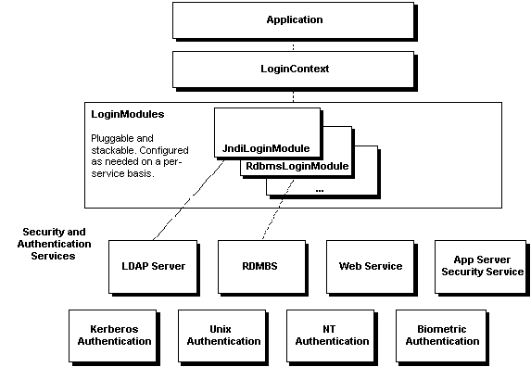

Figure 4. JAAS overview diagram (extracted from http://www.javaworld.com/javaworld/jw-09-2002/jw-0913-jaas.html)
The JAAS related classes are located in the org.cnio.appform.jaas package. Besides, the JaasServlet servlet class is used as a startup servlet (as defined in the web.xml application descriptor file, [x]) to load the JAAS configuration file (as also defined in web.xml as a servlet initialization parameter, <init-param …>) into the JAAS configuration class. In this configuration file, the implementation of the LoginModule to be used and some flags are declared.
A tutorial to know the JAAS how-to can be found in the Javasoft website or from the URL indicated at Figure 4. Regarding to this application, the process is outlined as follows:
- At startup time the initialization method of the JaasServlet is executed, the JAAS configuration file is loaded and the implementation of the JAAS service in the application is initialized. At this time, the authentication system is ready to be used.
- The JAAS realm of Tomcat 6 is used as authentication realm (this is defined in META-INF/context.xml, only for this application). So, when an username and password is submitted from the application form login, the implementation of the LoginModule interface (as is in the JAAS configuration file, org.cnio.appform.jaas.AppLoginModule in this case) gets into the scene.
- The LoginModule implementation has to implement a login () method. This is the method called back (behind the scenes) to perform the authentication mechanism, which was custom coded to use the application own authentication method. In this case, username-password matching is checked in the database.
- A few more actions are carried out in the login() method taking advantage of the flexibility provided for the authentication service, specially some user data update in the database and set credential to use in the just started session.

3.3.4.1 Password recovery
In order to fully comply with the data protection laws it was necessary to implement a recovery password system in the case of the password expires or is lost. The procedure follows the typical steps to recover passwords: the user makes a request to reset the password introducing some “private” parameters (as email); an email is sent back to the user with an url to reset the password; the user introduce the new password. This proccess is depicted in Figure 5.
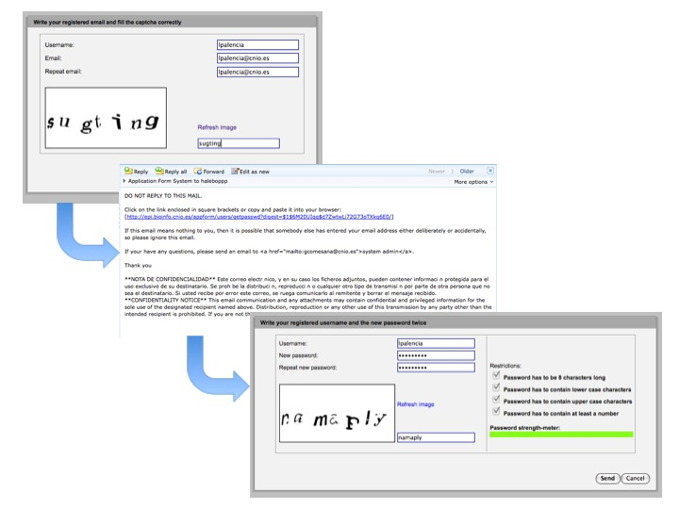
Figure 5. Recovery password process. Top dialog is to request password; then, an email with the URL to reset the password and the dialog to reset it. Here, the password strength bar shows a good password. In both dialogs, captchas can be seen
From a development point of view, all files involved in this process are located under the /appform/web/getpass directory in the repository. There are just few custom files involved and the process is AJAX based involving both YUI and JQuery libraries. The files involved (all of them under getpass directory) are as follows:
- index.jsp, is a very simple jsp page which shows the entry dialog to submit in order to get an email with the location of the reset password form. This file is supported by the next file described
- js/reqpassyui.js, is the js file which uses YAHOO.widget.Dialog component to render a modal dialog from some <div> component in index.jsp. Validation for the form is provided in this file as well as AJAX submission of parameters. In addition, as a captcha image is in the form dialog as an additional control, a method to refresh captcha on user demand is provided (PasswdReqCtrl.refreshCaptcha()). The submission URL goes to a servlet to process the request an send an email
- org.cnio.appform.servlet.MngPasswordServlet as described in section 3.3.3 Servlets and filters.
- resetpass.jsp, as the index.jsp file, this one, supported by resetpassyui.js, contains a form to set the new password. The bit java code in the jsp is to retrieve the user from the encrypted password received as parameter (the digest parameter). There is a dynamic behaviour to check if the new password comply with the constraint rules controlled by the resetpassyui.js file.
- js/resetpassyui.js, has the same structure that reqpassyui.js with an additional method onKeyUp (…) to process onkeyup javascript events when introducing the new password in order to check password restrictions on the fly and display the strength of the new password. The form submission is sent to the same MngPaswordServlet as before.

3.3.5 Audit
The last set of classes are those which do logging or audit actions. These (two) classes are found in the org.cnio.appform.audit package. The most important logging information (related to authentication and data manipulation by users) is stored in the database APPLOG table as it can have impact in the data, as well as signing in and out information.
The org.cnio.appform.audit.ActionsLogger class is just a convenient class to insert log entries in the database. This class is often used all along the application.
The org.cnio.appform.audit.AppSessionListener performs actions to update the user state on session destruction time. Actually, this is a session listener captures creation and destruction events. When the session is destroyed, the database is updated for the user data and, inside the database, a procedure is triggered to insert in the log table a row to audit the user sign out.

3.3.6 Java Server Pages Resources
The Java Server Pages (JSPs) resources are located under the /web/jsp directory, which has the following structure:
web
+-jsp
| +---ajax
| +---inc
| +---intrv
| | +---ajaxjsp

Most of them are used in the Composer tool, as the jsp/index.jsp resource is composed by several jsp fragments (located in the jsp/inc directory), which are included in depending on query string parameters. Specifically, every page that can be seen across the Composer tool is formed by different jsp fragments from the inc directory. So, the page composition is built up on two files:
- jsp/index.jsp. First of all, a main variable is defined with the current type of object (if this request is about project, interview, item…), then, the fragments which define the page layout are included (header, center, left and footer, all jsp pages in inc dir). The parameters on query string, which are interpreted on the different fragments, are the following (for composer tool):
  - t, the type of item the page is displaying information of
  - op, the operation which is to be performed on the page
  - frmid, is the database identifier for the item (whether it is project, question, …)
  - spid, is the container for the current element. This parameter only is present depending on the operations to perform on the item.
The page can be the result of some operation or, just a request to display elements. This means the page can be reached after update or create an element or from the container part -for instance, the list of elements for a section can be reached from the list of sections or, after performing an action, from the element edition-.
- jsp/inc/header.jsp. The main logic in this jsp fragment is aimed at the creation of “breadcrumbs” to display the “place” from the root project where the user is working and can go back quicker. The long script for the breadcrumb creation takes most of the logic in the file and it is based on the combination of parameters above described.
- jsp/inc/center.jsp. This is a kind of proxy and content page. The proxy capabilities come from include diferent operational jsps depending on the operation and type of element and the roles of the user. Here is a short description of them:
  - detailprj.jsp gets the list of interviews for the project identifier parameter.
  - detailsec.jsp show details for a section, including its contained items
  - editelem.jsp is the main page to edit/compose an section item, which can be a text or a question
  - editintr.jsp, editprj.jsp, editsec.jsp are scripts to edit interview, project and sections respectively regarding to names and descriptions.
  - mngsec.jsp, lists sections based on an questionnaire identifier. Similar to detailprj.jsp.
  - nogranted.jsp, is a error page to report the user is not granted to perform the requested operation.
  - prjlist.jsp, lists the projects. It is the first page after loging in and choosing group (if necessary)
On the other hand, there are a bunch of jsp resources under jsp/ajax directory which are used as server scripts without presentation purposes. They just perform a particular action (as saving sections, items, reordering items) and return a simple JSON response to client.

3.3.6.1 Interview tool JSP resources
Finally, the Interview tool has its own JSP resources. They are located under the jsp/intrv directory. Taking into account this is a full AJAX development The intrv.jsp just has the basic layout of the page. The mycodes.jsp page is to retrieve the codes introduced for an hospital. The resources under the jsp/intrv/ajaxjsp directory do the controller tasks and they work like server scripts. Here is a list and short description of the jsp directly involved in the Interview tool, all of them under jsp/intrv directory:
- index.jsp is the entry point to the interview performance. This page has not HTML code as it just raises a dialog to configure the interview is about to be performed. This dialog is ExtJS based and it is found in /js/intrvctrl/sampledlgcfg.js or introdlg.js.
- intrv.jsp is the file which supports the entire layout for the questionnaire after rendering.
- mycodes.jsp is a script to show the subject codes used for the active hospital for the current interview, which means, the subjects registered for the current active hospital.
- setsecondarygrp.js is currently not used. Actually it raises a dialog to choose the hospital to use with the interview
On the other hand, the jsp files under jsp/intrv/ajaxjsp are focused in posting and retrieving data to/from the database. The data can be the answers for the questions, in the case of resuming an interview and/or data to refresh the sections on the left side. These files along with the javascript files in /js/intrvctrl work closely to provide the dynamic functionality to the Interview tool. This process is described in more detail in Interview Tool Design & Implementation section further below. The list of files and short description is as follows:
- intropage.jsp renders the first page in the interview. The first page is a bit different as, in previous requeriments, it was which the subject code was input in (subject code is the key data for the interview) and, with current requirements, a special textarea has to be rendered depending on the type of interview (short or normal).
- items4sec.jsp renders a section items on demand. If it has to render the first page, it uses the previous script; otherwise, the logic of this script is used to render a form with all questions for this section inside it. The most important code is a small loop over all elements of this section.
- saveintro.jsp; this script is called when saving the first page of every interview. This was decided in this way as special proper components can be placed on this page.
- saveform.jsp is the jsp which handles and posts answers for questions into the database. This file does not have logic to save individual items on the fly, which is done in AjaxUtilServlet described in the Servlets and filters section.
- secs4intrv.jsp retrieves the sections for the interview and returns to the client a JSON object with the list of the sections and, in addition, a switch to indicate if the section was visited previously.

4 Client Side Architecture
This side of the application is mainly focused on view layer in the MVC pattern regarding to this application. However, some logic of the controller layer is performed at client side to minimize the server requests.

4.1 Client Side resources
These client resoures are organized, just under the application root directory, as follows:
- img, pictures and images files.
- css, cascading style sheets files.
- html, holding just newtypedlg.jsp which is the application answer items management form.
- js, where javascript files are located.
- js/lib, holds the ExtJs files.
The CSS and javascript code are who provide the dynamic behaviour for the user interface.

4.2 Dynamic behaviour
The application user interface is so simple as it was developed thinking in minimize the page size regarding to network traffic in any conditions. But, on the other hand, the application (and, so, web pages) needs to be dynamic and friendly enough to allow using it to interviewers in almost any condition.
In order to achieve it, many simple checks and view features make heavy use of AJAX and DHTML. This dynamic functionality is achieved by using javascript and cascading style sheets technologies.

4.2.1 Cascading Style Sheets
Cascading style sheets (CSS) files, which provides visual features across the application, are found under the css directory. The main file is portal_style.css, which is used all across the application and set the visual style. The rest of css files found under this directory are:
- display.css, used by the Questionnaire Comparison tool to display the results of the questionnaires comparison.
- newtype.css, used in the answer types form window.
- overlay.css, necessary to implement web dialogs using a jquery library.
There is a directory under css, called theme, which is again necessary for the web dialog implementation. This is the dialog that can be seen when the user has to select a group.

4.2.2 Javascript
But most of the dynamic behaviour is provided by javascript code and javascript frameworks. Specifically JQuery 1.3 and YUI 2.7 and ExtJs 3.0 are used. All the scripts are found under the js directory, and all directories under that one (except intrvctrl) are resources for the javascript frameworks. Following is a description of every custom javascript file in the js directory:
- main.js, this is the main javascript file for the Composer tool. Instantiate objects belonging to custom javascript classes depending on whether or not they are needed. Classes are in the javascript fileas and depending on the side of the application (if editing an interview or a question, for instance) different of these javascript files are included.
- formitemctrl.js, contains classes to provide dynamic and checking features when editing a text or question element. This file contains two classes: FormItemCtrl and ElemAjaxResponse, the latter to host the AJAX callbacks. This is included only when editing questions or texts.
- listitemctrl.js, contains classes to provide dynamic behaviour to list of elements (in order to delete, update and/or rearrage) and to raise preview and interview screens. Two classes in it: ListItemsCtrl, providing checks and dynamic behaviour and ListAjaxResponses, which support the AJAX callbacks.
- ctrlprj.js, provides dynamic behaviour and checkings in the project list page and for the interview list (project details) page. As usual, two classes (PrjFormCtrl and PrjAjaxResponse) are defined in this file.
- ctrlintr.js, contains two classes (IntrFormCtrl and IntrAjaxResponse for AJAX callbacks) to provide control and dynamic capabilities for the form on the questionnaire list of sections (questionnaire details).
- ctrlsec.js, similar to the two previous ones, provide dynamic functionality for the sections list page and the sections details. Similar structure than the previous ones (SecFormCtrl and AjaxResponse are the classes in this file)
- core.js, contains three accesory classes (Dom, Event and BrowserDetect) and initializes switches to control the other custom classes objects, as different javascript files are loaded depending on each part of the application.
- ajaxreq.js, this is a wrapper for encapsulating an AJAX request based on the YUI Connection Manager component. In this way, handy methods to make AJAX requests are published.
- intrvctrl/ctrlforms-prot.js, contains a prototype class to provide dynamic behaviour to the entire Interview tool, along with the support provided by another files. This implementation is based on the prototype pattern more than the module pattern, which is the pattern used to implement all other files. This is necessary here as this script perform more complex actions and has to be self-reference. This file contains the class ControlForms with a bunch of methods to control and provide dynamic behaviour for section transition, answer checking, real time answers sending, components colouring, dynamic section form loading and group change (when available).
- intrvctrl/ajaxresp.js, contains AJAX callback methods to perform actions like colouring left sections list as they are completed, get the forms for every section and set into the page and or display information messages, all actions on response to the server requests.
- intrvctrl/repelems.js, contains only a class (FormManager) and two methods (addElem and rmvElem) and is focused on providing functionality to repeat interview elements for questions with undefined number of answers (as it would be a question for the name of subject’s relatives –the number of them is unknown-).
- intrvctrl/mycodes.js, contains classes and methods to send an AJAX request to retrieve the codes for the current active hospital group
- intrvctrl/introdlgactions.js, contains ajax callback functions, data and validation definitions to use by the extjs components on the interview configuration dialog.
- intrvctrl/introdlg*.js, contain extjs scripts to build the interview configuration dialog when the interview is going to be performed to a subject (not a sample)
- intrvctrl/sampledlg*.js are the files containing the logic necessary to initiate and configure a sample-oriented interview. This files contain classes based on ExtJs 3.0 to display and control a dialog to set the interview for a sample handling.
- the rest of files in those directories are files belonging to the javascript frameworks used to support and simplify the development.

4.2.3 Interview Tool Design & Implementation
This section can be intended as a special section as it is addressed to explain the implementation and design of the Interview Tool, as there are many elements which have to be coordinated to provide the dynamic functionality.
This is a completely AJAX based application. Just only two web pages make up the site, and the rest of processing is made by using AJAX calls against JSP’s (which could be just servlets) whose response is embedde on a html layer over and over. Lets see in more detail.

4.2.3.1 Interview configuration
As the subject interview became more complex with more constraints than ever before, a dialog is raised to ease the configuration parameters, as group, subject code (tightly related to group) and check for questionnaire constraints (enable to create new subjects in the system or perform short interviews).
This dialog was implemented by using the extjs capabilities to build windows, forms and, especially, (cross) component validation. The main file implementing the dialog is introdlg.js. The file introdlgactions.js contains data definitions, ajax callbacks for the dialog components and validation code necessary for the dialog, entirely defined in introdlg.js. The dialog implementation make requests (both GET and POST) to server in order to retrieve and create (when needed) data in database. The middleware in server side to process the request is the IntrvServlet servlet.
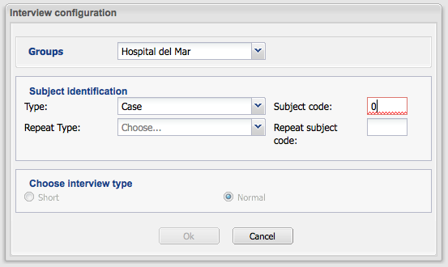

Figure 6. Interview configuration dialog
In the figure above a snapshot of the interview configuration dialog is showed. The red-bordered textfield shows an error input as three digits are needed to satisfy the subject code restriction. Besides, the panel to choose the type of interview is disabled until the subject code is filled and correct (this panel is only showed if the questionnaire allows short interviews). The submit button is also enable when all fields are filled and correct.
Mostly, the heaviest AJAX processing is done when the Ok button is clicked. At that time, several AJAX requests are submitted to server to check the restrictions against the database and, if everything is ok, make the changes on the database (insert a new subject and performance if required and, always, saving a new entry in the performance history table).
For more information about stores, validation and component extension check the freely available ExtJs documentation at http://www.extjs.com.

4.2.3.2 Interview performance
When the interview configuration is done, the interview performance starts. It looks mostly as follows:
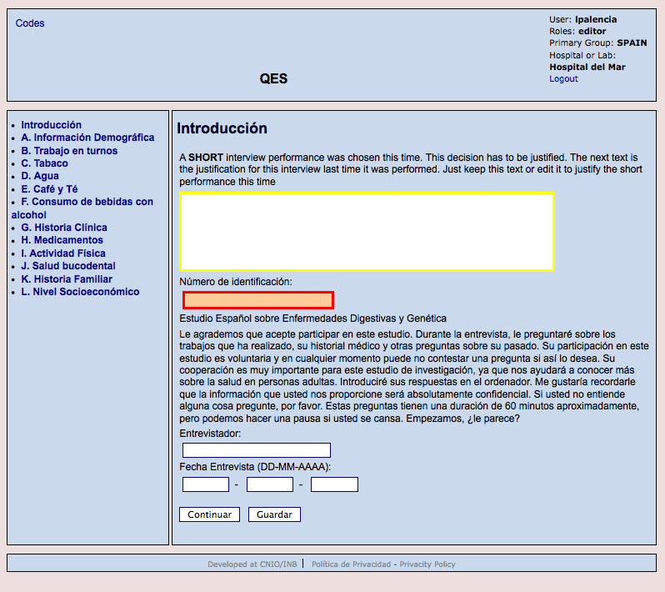
Figure 7. Introduction section for a interview. The yellow-bordered textarea has the focus. The red-bordered textfield shows an error as it has to be filled before committing the section
In the header side, information about the current session in the application is displayed, the name of the questionnaire which is going to be used and, when interviewing, the code for the current subject. A link to show the subject codes currently in database belonging to this hospital is displayed on the left side of header. The footer just holds information about the project and group. The other two areas (left and center, sections and forms) actually hold the interesting things. All four areas are laid out in jsp/intrv/intrv.jsp file and all dynamic behaviour is performed by using AJAX and DHTML.
The javscript files involved are js/intrvctrl/ajaxresp.js and js/intrvctrl/ctrolforms-prot.js. One third file, js/intrvctrl/repelems.js is also used, but it is focused on replicate form elements dynamically on questions with undefined number of answers.
When the page intrv.jsp is loaded, after configuring the interview and creating objects to control de dynamic behaviour, sections and initial form are loaded (rendered) on the page. The process of section transition when a form is fulfilled is an event-driven proccess.
YUI (and also ExtJs) features custom events definition and creation. So, YUI was used to create two custom events on IntrvAjaxResp object creation, which is done on ControlForms object initialization (no creation, which is earlier). The events are named formComplete and secsComplete. On ControlForms initializiation, this object is suscribed to these events. When any of Continue or Save buttons on the bottom of any form is clicked, the method send (form) in ControlForms class is run, and the formComplete event is fired when callback function IntrvAjaxResp.onSaveForm (o) is executed.
When an event is fired, a method of the suscribed objects is then executed. So it is for the ControlForms object. And what the callback method does is load the new section (which is another AJAX call). Approximately the same applies to the form load when a section (in blue font color) is clicked.
All the code is enclosed in two files: intrv/ctrlforms-prot.js and intrv/ajaxresp.js. Both are close related.

Appendix A. Administration Tool application
The Adminisration Tool was developed as necessary companion to the main application to manage and administer mostly users, but also projects and groups and questionnaire copies. An screenshot can be seen on the next figure.
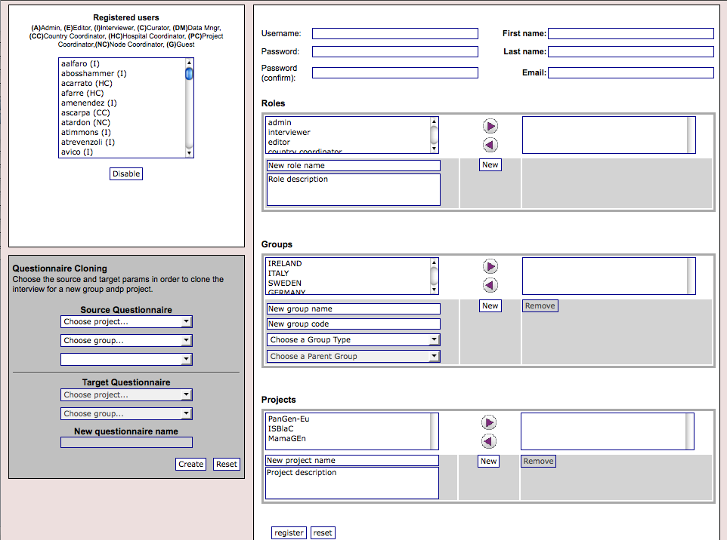
Figure 8. Administrator tool. On the left side, user list (top) and questionnaire copy component (bottom). Right side is the content area, displaying user information
Although it was set as a separate application, the core of this one, which means the entity classes, database schema, utility classes and application server, as well as the authentication system, are the same as the main questionnaire builder application. The main difference is the the client interface and the way it uses to communicate with server: this is done by communicating client and server through JSON objects by using Javascript classes in client side and Java servlets and few Java server pages in server side. So, the client it can be seen is formed by a single JSP page, the rest of JSP pages perform processes for saving and getting data.
The same SVN repository where the files for the questionnaire composer and performer application are placed stores the files for the administration tool. The URL to the root of this project in the SVN repository is http://trac.bioinfo.cnio.es/svn/episrc/admtool.
In order to describe the development of the administration tool, the common parts with the main application will be skipped, focusing in this application specific parts.

A.1 Server logic
Just a few JSPs and servlets are specifically involved. They are found under the jsp directory and in the org.cnio.appform.servlet package in the source (src) directory. The rest of source code is similar to that used in the main application as it was said above.
So, the files can be found under jsp directory are:
- index.jsp; this is the entry point to the admin tool. Actually, because of authentication restrictions, the entry point is login.jsp, which is just in the root (upper) directory. The index.jsp contains the layout can be seen on Figure 7 and few Java snippets embedded into the HTML to preload the default elements: list of users, roles, groups and projects. No AJAX communication at this point, just page rendering with data retrieved from database by using utility methods. As this is the only webpage renderable, all javascript files (described below) will be loaded in this file.
- getdata.jsp; this scripts returns a JSON object with all attributes for an user identified by the param frmid, which has to have a valid database identifier for an user. The normal call from the client is /jsp/getdata.jsp?what=usr&frmid=XXXXXX, XXXXXX a database identifier.
- admin.jsp; this script accepts requests for a new user signing up. It performs all necessary checks in order to assure the received parameters match each other in order to keep consistency among the parameters. Returns a JSON object with all attributes stored for the user or a smaller JSON object if there was an error.
- addelem.jsp; this scripts add a single element, group, project or role in the database. It returns an usual JSON object to the client
- swithcdata.jsp; switches the state of an user from enable to disable or viceversa. A disabled user won’t be able to log in the application

A.2 Client logic
As it was mentioned above, the administration tool application is an one-single-webpage application. It performs requests to application server without page transitions via AJAX calls. These calls along with client Javascript logic allows dynamic page components updates instead doing page requests, transitions and updates.
All javascript code is located inside de /js directory, as showed on the directory tree:
+-js
| +---event
| +---jquery
| +---ui
| +---lib
| | +---ext
| +---yahoo

Four Javascript files hold all client logic for this tool, which are located just in /js directory. Before describing these four scripts, the directory tree under js directory is as follows:
- event; contains YUI 2.0 Event utilities to create custom events.
- jquery; contains the jquery library, versions 1.2.6 and 1.3 (the version used when this document was writing is 1.2.6). Plus, JQuery plugins Form and Json.
- ui; user interface componens for JQuery (unused)
- lib/ext; ExtJs library version. Currently not used; future (complex) visual features can be made up using this library
- yahoo; YUI 2.0 library directory. There is a custom file, ajaxreq.js, which stores the AjaxReq custom class that encapsulates all AJAX request programming logic.
Just under js directory, the custom application scripts are located, which are:
- adminctrl.js; this file contains one class (AdmFormCtrl) and it is the entry point of the javascript execution. On page ready, an AdmFromCtrl object (and an Overlay object) is created. This class has methods to send AJAX requests to create or update users, roles, groups or projects; AJAX methods to retrieve all information from an user and to disable/enable an user, both of this features upon selecting an user from the users list. In order to dynamically refresh on-page visual components (lists, textfields,…) JQuery 1.2.6 was used and an proprietary AJAX class based on YUI 2.0 ConnectionManager was used, as throughout the application, to make the Ajax requests.
- admin-ajaxresp.js; this is the counterpoint to the previous file, as it stores all AJAX callbacks for all AJAX methods in adminctrl.js. The name of the methods in this file is like onNNNN, where NNNN is an arbitrary name. The structure of all this methods is similar among them. As previously, JQuery is used to update visual elements in the web page.
- cloningctrl.js; this file is composed by one class (CloneFormCtrl) and controls the small form on the lower left side focused on cloning questionnaires. This class controls the small cloning form works correctly and no request for cloning can be sent with the wrong values and/or number of parameters. There is just two public methods: init () and fillIntrvSrc (). The method createClone () is which send the ultimate request to clone the questionnaire.
- clon-ajaxresp.js; As the above mentioned file admin-ajaxresp.js, this one is the counterpoint to cloningctrl.js file. Which means, it has the callback methods to AJAX requests for cloning questionnaires. Only two public methods, onGetIntrvs(JSON) is triggered when a request to get questionnaires based on project and/or group is accomplished; onCloned(JSON) is triggered when a request to clone a questionnaire is accomplished as well. The method onFail is raised when the client gets a wrong response from server.

Appendix B. Building, Deploying and Installation from the scratch
A bundle with the source code, documentation and sql scripts for the application form tool can be found in a svn repository through the URL http://trac.bioinfo.cnio.es/svn/episrc/appform (/admtool for the administration tool as described in Appendix A). In this location, the preferences to set up the project in an Eclipse IDE environment are included, but it is not guaranteed this settings work fine on every Eclipse environment. For the entire development, the Lomboz distribution (http://lomboz.ow2.org/) was used and it is mostly recommended for a straight set up. For other Eclipse versions, the documentation should be checked.
As it was told on the Application Server logic section, a build.xml file is supplied to be able to build the war file for the application without any IDE. The file also has several targets also to build up jar files for different purposes, but there are two main targets as the deployment is for a pre-production or production environment. The main difference between the deployment tasks in the Ant build file is the hibernate.cfg.xml shipped in the war file, which is different for the tasks. In this file, the database server address is defined, while the rest of the application keeps the same. In addition, it can be necessary to update some configuration properties from those found at the top of the file.

B.1 Setting up the source code
While developing the project, the entire application source was placed on the webapps directory of Apache Tomcat. When an application war file or ‘unfolded’ application is dropped under the webapps directory, the application is automatically deployed and started up by Tomcat. In such a way, instant access to new application features as they are added is provided if no code recompilation is necessary (recompilation affects to java code, not JSPs). To do this, just checkout the repository source code into the $TOMCAT_DIR/webapps directory, load or import the project in Eclipse and review the build settings to be sure everything remains correct.
It is possible to place the application code in any other location as well. If this one is the decision and the application wants to be seen through Tomcat, a file called context.xml (samples are located in META-INF directory) has to be placed under $TOMCAT_DIR/conf/Catalina/hostname, where hostname use to be localhost. Substitute the docbase attribute for the path where the application is located to get the web application working. The Eclipse Lomboz configuration process regarding to some new project location is well-described in the wide Eclipse documentation.

B.2 Build
Although, as mentioned, it is strongly recommended to build the whole project from an IDE (Eclipse Lomboz bundle specially recommended as it was said above), it is possible to use Ant (http://ant.apache.org) along with a build.xml file to build the project. In fact, the final build, the application war file, is yielded by using Ant. In order to build the application with Ant and the build.xml file provided, first thing is to review and configure the properties at the top of the file to match with the environment if necessary.
Then run ant <target> as specified in the Ant manual. The supplied build.xml file provides targets to build production and pre-production war files (only difference is the target server and hibernate.cfg.xml file, so these targets MUST be customized) and to compile the source code. There is NO target to move/copy/transfer the yielded war files to the deployment server machines, but they can be added.

B.3 Deployment
After building it, the yielded war file has to be deployed on a servlet and JSP container in order to work. The only container installed in the INB-Central Node environment is Tomcat 5.5.x and 6.0.x, as mentioned in the introduction, although any other servlet and JSP container (lets say JBoss) could be used, although further custom server configuration could be necessary.
To deploy the application on the server in a easy way, two approaches can be followed:
- just drop the war file on the $(TOMCAT_HOME)/webapps directory and it will be automatically deployed. A file named appform.xml will be created in $(TOMCAT_HOME)/conf/Catalina/localhost/ with the content of the META-INF/context.xml file. This is the configuration file for the application and contains the realm used for authentication.
- a server manager can be used for deployment. For Tomcat, Lambda Probe (http://www.lambdaprobe.org/d/index.htm) is recommended, as provides a clean and detailed view of all applications deployed on the server while it is free of charge. To deploy a new war file on the server, just click on the Deployment tab and follow in-page instructions.
After this deployment, assuming the hibernate.cfg.xml file is properly configured to connect the right database server and it is up and running, the web application should startup and run.

B.4 Deployment from the scratch
The question appears when no database is set to work with the application. So, this section will describe the whole process in the case of this application is to be installed in a completely clean (no previous installations of this software) and new environment.

B.4.1 Setting up the database
As it was said in the first sections of this document, the database server used to work along with the application is PostgreSQL 8.3 (postgres from this point on). In order to run successfully the application, a database schema with few initial data has to be set up in advance. Two postgres SQL scripts are provided to set up the database, which are located under the sql directory from repository. A file sql script named appform-schema.sql builds up the database, but it requires the database is created in advance. This script build all database objects into de database: tables, views, triggers, functions, indexes and sequences. So, starting off a previously untouched postgres server, the sequence of commands to init the database would be:
hostname$ psql –h <dbserver> –U <dbuser> –d postgres
Welcome to psql 8.2.5 (server 8.3.8), the PostgreSQL interactive terminal.

Type: \copyright for distribution terms
\h for help with SQL commands
\? for help with psql commands
\g or terminate with semicolon to execute query
\q to quit

WARNING: You are connected to a server with major version 8.3,
but your psql client is major version 8.2. Some backslash commands,
such as \d, might not work properly.

SSL connection (cipher: DHE-RSA-AES256-SHA, bits: 256)

postgres=# create database appform with encoding ‘UTF-8’;
postgres=# \c appform;
postgres=# \i startup-appform-schema.sql
A few notes on the lines above:
- The user <dbuser> has to be granted to create databases in the server and run scripts. If the user is not admin, the user may have to be granted to create database objects.
- The name of the database is arbitrary and the user who owns the database as well, but all these parameters have to match with the database parameters for Hibernate in the configuration file WEB-INF/classes/hibernate.cfg.xml.
- As the application needs the postgres library pgcrypto (library used for encrypting sensitive data), errors can be raised if pgcrypto functions are already available when running the script or the library itself is not available in the database server. You will have to check your postgres version documentation and installation upon raising this kind of errors.
At this point, the database schema with all necessary objects (structure) is ready, but it is empty. Some init data needs to be preloaded into the database to start working with the form application tool or, at least, with the administration tool. A minimal initialization data script is found in a script file called startup-appform-data.sql -which is located just beside the database initialization file- and needs to be run just after the schema initialization, such as:
postgres=# \i startup-appform-data.sql
The last two commands in the postgres client (psql) assume the script files are located in the directory where the psql program was run from.

B.4.2 Application(s) deployment
At this point, the database is initialized with a single user (‘adminusr’), seven roles and the two group types (‘COUNTRY’ and ‘HOSPITAL’) and the next step is to deploy the administration tool (Appendix A). In order to do that, the following steps should be done:
- if no war file was yielded, get the administration tool code from the repository as it was said in Appendix A. The administration tool has a build.xml file to be built with Ant. To yield the war file, the same steps used to build the main application form builder are valid
- once the war file is yielded with the correct configuration in META-INF/context.xml and WEB-INF/classes/hibernate.cfg.xml (note the former file has to have configured the docbase and realm and the latter the database and connection names) it can be already deployed on the application server by dropping it on the web applications directory or by using some deployment manager
- suppossing the server has auto-deploy (auto detection of new applications), the administration tool should be ready at this point. The login screen should look like that showed in the Figure 8.
- log in using the only user available and, once inside, create groups and projects and users for those groups and projects with the right roles. The application form builder needs at least an user with a country and a hospital assigned to him as, in order to work normally, no user can work with the form application builder if no group is assigned to it. This one affects to the default user as well –note the default admin user has NO group assigned to, just role–.
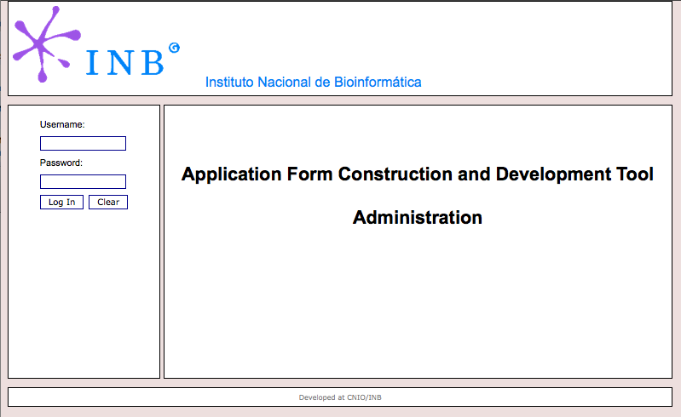

Figure 9. Administration tool entry point
- now the application form builder tool can be deployed (follow the steps to build the application if not built yet). Log in using the administration account or one of the new created users.

Appendix C. Database description report

C.1 Tables description
Date / Time: |  |  | 11 December 2009 |  |  |  |  |  |  |  |  |  |  |  |  |  | User: |  |  |  |  |  | gcomesana
Database: |  |  | appform |  |  |  |  |  |  |  |  |  |  |  |  |  | Table: |  |  |  |  |  | public.answer
 | Table: public.answer
 | Fields
 | Name |  |  |  |  |  |  | Type |  |  |  |  |  |  |  |  |  |  |  |  | Not Null |  |  |  | Unique |  |  |  |  | P/K |  |  | Def Val
 | idanswer |  |  |  |  |  |  | integer |  |  |  |  |  |  |  |  |  |  |  |  | Not Null |  |  |  | Yes |  |  |  |  | Yes |  |  | nextval('answer_idanswer_seq'::regclass)
 | thevalue |  |  |  |  |  |  | varchar(8192)
 | Description: |  |  | The value which will held the answer
 | answer_order |  |  |  |  |  |  | integer
 | Description: |  |  | This is the order of the answer when the question has several answer items (f.ex. when the question ask a frequency, amount/time units)
 | codansitem |  |  |  |  |  |  | integer |  |  |  |  |  |  |  |  |  |  |  |  | Not Null
 | Foreign Keys
 | Foreign Key Name |  |  |  |  | On Field |  |  |  | FK Table |  |  |  |  |  | FK Field |  |  |  | On Update |  |  |  |  |  |  | On Delete |  |  |  |  | Defer |  |  |  |  |  | Moment
 | fk_answer_rel_answ__answer_i |  |  |  |  | codansitem |  |  | public.answer_item |  |  |  |  |  | idansitem |  |  |  | Cascade |  |  |  |  |  |  | Cascade
 | Indices
 | Index Name |  |  |  |  |  |  |  |  |  | On Field |  |  |  |  |  |  |  |  |  |  |  |  | Unique |  |  |  |  | Method |  |  |  |  |  |  | Function
 | pk_answer |  |  |  |  |  |  |  |  |  | idanswer |  |  |  |  |  |  |  |  |  |  |  |  | Yes |  |  |  | btree
 | Triggers
 | Trigger Name |  |  |  | A/B |  | Events |  |  |  |  |  | Function |  |  |  |  | Arguments |  |  |  |  |  |  |  |  |  |  |  |  |  |  |  |  | Disabled
 | logAnswerUpdate |  |  |  | after |  | update |  |  |  |  | public.log_upd_answer
 | Description
 | This table represent the value(s) answered for a question (pay attention that one question can have several answers for a single patient)

 | Table: public.answer_item
 | Fields
 | Name |  |  | Type |  |  |  |  |  |  |  | Not Null |  | Unique |  |  |  |  | P/K |  |  | Def Val
 | idansitem |  |  | integer |  |  |  |  |  |  |  | Not Null |  | Yes |  |  |  |  | Yes |  |  | nextval('answer_item_idansitem_seq'::regclass)
 | answer_order |  |  | integer
 | Description: | Not used
 | name |  |  | varchar(128)
 | Description: | This is the name of the answer item (ex, decimal)
 | description |  |  | varchar(128)
 | codintrv |  |  | integer
 | Description: | The interview which the answer item belongs to. This is to be able to encapsulate a whole interview template and to be able to use the same answer item with different interviews by cloning them
 | for_clone |  |  | integer
 | Description: | This field says whether or not this answer item was created for a clone interview in a xclusive way or it was created previously. This is done to be able to assign new answer items to a new questions in clones (supposed forbidden...)
 | Foreign Keys
 | Foreign Key Name |  | On Field |  |  | FK Table |  |  | FK Field |  | On Update |  |  |  |  | On Delete |  |  |  |  | Defer |  |  |  | Moment
 | fk_ansitem_intrv |  | codintrv |  | public.interview |  |  | idinterview |  | Cascade |  |  |  |  | Cascade
 | Indices
 | Index Name |  |  |  |  |  | On Field |  |  |  |  |  | Unique |  |  |  |  | Method |  |  |  |  | Function
 | pk_answer_item |  |  |  |  |  | idansitem |  |  |  |  |  | Yes |  |  |  | btree
 | Description
 | This one represents each response for a question, considering that any question can be more than one item as response (for ex, month and years, or amount and a dimensional unit as time, weight...). It includes answer types (answertype table) and enum types (enumtype table, types which are actually enumerated types)

 | Table: public.answertype
 | Fields
 | Name |  |  | Type |  |  |  |  |  |  |  | Not Null |  | Unique |  |  |  |  | P/K |  |  | Def Val
 | idanstype |  |  | integer |  |  |  |  |  |  |  | Not Null |  | Yes |  |  |  |  | Yes
 | Description: | This is a type which represents a 'simple' type like numbers or labels
 | pattern |  |  | varchar(256)
 | Description: | Not used. Intended to define a fixed pattern for labels
 | Foreign Keys
 | Foreign Key Name |  | On Field |  |  | FK Table |  |  | FK Field |  | On Update |  |  |  |  | On Delete |  |  |  |  | Defer |  |  |  | Moment
 | fk_answerty_isoneof_answer_i |  | idanstype |  | public.answer_item |  |  | idansitem |  | Cascade |  |  |  |  | Cascade
 | Indices
 | Index Name |  |  |  |  |  | On Field |  |  |  |  |  | Unique |  |  |  |  | Method |  |  |  |  | Function
 | pk_answertype |  |  |  |  |  | idanstype |  |  |  |  |  | Yes |  |  |  | btree
 | Description
 | Represents normal answer types, as label, number...

 | Table: public.appgroup
 | Fields
 | Name |  | Type |  |  |  |  |  |  |  | Not Null |  | Unique |  |  |  |  | P/K |  |  | Def Val
 | idgroup |  | integer |  |  |  |  |  |  |  | Not Null |  | Yes |  |  |  |  | Yes |  |  | nextval('appgroup_idgroup_seq'::regclass)
 | name |  | varchar(128)
 | codgroup |  | varchar(128)
 | tmpl_holder |  | integer |  |  |  |  |  |  |  |  |  |  |  |  |  |  |  |  |  | 0
 | parent |  | integer
 | codgroup_type |  | integer
 | Foreign Keys
 | Foreign Key Name | On Field |  |  | FK Table |  |  | FK Field |  | On Update |  |  |  |  | On Delete |  |  |  |  | Defer |  |  |  | Moment
 | fk_grouptype | codgroup_type |  | public.grouptype |  |  | idgrouptype |  | Cascade |  |  |  |  | Set Default
 | fk_parent_group | parent |  | public.appgroup |  |  | idgroup |  | Cascade |  |  |  |  | Set Default
 | Indices
 | Index Name |  |  |  |  | On Field |  |  |  |  |  | Unique |  |  |  |  | Method |  |  |  |  | Function
 | pk_appgroup |  |  |  |  | idgroup |  |  |  |  |  | Yes |  |  |  | btree
 | Description
 | A group of users. All users in a group will have access to the same data, but not all of them will have the same rights (which will be given by the role concept/table)

 | Table: public.applog
 | Fields
 | Name |  |  |  |  | Type |  |  |  |  | Not Null |  | Unique |  |  | P/K | Def Val
 | logid |  |  |  |  | integer |  |  |  |  | Not Null |  | Yes |  |  | Yes | nextval('applog_logid_seq'::regclass)
 | userid |  |  |  |  | integer |  |  |  |  | Not Null |  |  |  |  |  | 250
 | Description: |  | This is the id of the user in the appuser table. Useful to query by user. The default value is the id of the admin user by 08.2009.
 | sessionid |  |  |  |  | varchar(256)
 | Description: |  | This is the application session id. It can be null as sometimes the session id is not available (for scheduled db process, for example)
 | thetime |  |  |  |  | timestamp
 | patientid |  |  |  |  | integer
 | intrvid |  |  |  |  | integer
 | logmsg |  |  |  |  | varchar(1024)
 | lastip |  |  |  |  | varchar(128)
 | Description: |  | This is the last ip got from the ip packet as returned by ServletRequest.getRemoteAddr() method
 | Indices
 | Index Name |  |  |  |  |  | On Field |  |  |  |  | Unique |  |  | Method |  |  |  |  | Function
 | applog_pkey |  |  |  |  |  | logid |  |  |  |  | Yes |  | btree
 | Triggers
 | Trigger Name |  |  | A/B | Events |  |  |  | Function | Arguments |  |  |  |  |  |  |  |  | Disabled
 | onInsertLog |  |  | before | insert |  |  | public.set_log_time
 | Description: | This trigger simply set the database server time in the NEW row to insert in the applog table
 | Description
 | This table hold log messages from all over the application

 | Table: public.appuser
 | Fields
 | Name |  |  |  |  | Type |  |  |  |  |  |  |  |  |  |  | Not Null |  | Unique |  |  |  |  | P/K |  |  | Def Val
 | iduser |  |  |  |  | integer |  |  |  |  |  |  |  |  |  |  | Not Null |  | Yes |  |  |  |  | Yes |  |  | nextval('appuser_iduser_seq'::regclass)
 | username |  |  |  |  | varchar(128) |  |  |  |  |  |  |  |  |  |  | Not Null |  | Yes
 | passwd |  |  |  |  | varchar(128) |  |  |  |  |  |  |  |  |  |  | Not Null
 | c_date |  |  |  |  | timestamp |  |  |  |  |  |  |  |  |  |  |  |  |  |  |  |  |  |  |  |  | now()
 | u_date |  |  |  |  | timestamp
 | codhosp |  |  |  |  | integer
 | Description: | Not used. The table rel_grp_appusr supplies this information and replaces this one.
 | country |  |  |  |  | varchar(16)
 | Description: | Not used. Intended to set the country for the user. Replaced by the relationship rel_grp_appusr
 | firstname |  |  |  |  | varchar(255)
 | lastname |  |  |  |  | varchar(255)
 | removed |  |  |  |  | integer |  |  |  |  |  |  |  |  |  |  |  |  |  |  |  |  |  |  |  |  | 0
 | Description: | This field says if the user was removed (actually disabled) from the database. This means it can not access to the app
 | loggedin |  |  |  |  | integer |  |  |  |  |  |  |  |  |  |  |  |  |  |  |  |  |  |  |  |  | 0
 | Description: | Indicates in the database when one user is using the application or not.  This field is deprecated. Concurrent login is controlled by the singleton pattern (a 'formal' generalization of a static class). Further developments should use the object construction of scala language
 | loggedfrom |  |  |  |  | varchar(128)
 | Description: | This field represents the IP address where the user is online from. If the user is not online, will be null
 | login_attempts |  |  |  |  | integer
 | Description: | This is a counter to track how many login attemps the user tries and to disable the user if so
 | email |  |  |  |  | varchar(1024)
 | Description: | The email of the user. Necessary to contact with him/her, mostly in the case of password loose
 | last_passwd_change |  |  |  |  | date
 | Description: | The date of the last password change. It will be the reference to check for the next passwd change
 | Foreign Keys
 | Foreign Key Name |  |  | On Field |  |  |  | FK Table |  |  |  |  | FK Field |  |  | On Update |  |  |  |  | On Delete |  |  |  |  | Defer |  |  |  |  |  | Moment
 | fk_hospital_user |  |  | codhosp |  |  | public.hospital |  |  |  |  | idhosp |  |  | No Action |  |  |  |  | No Action
 | Indices
 | Index Name |  |  |  |  |  |  |  | On Field |  |  |  |  |  |  |  |  | Unique |  |  |  |  | Method |  |  |  |  |  |  | Function
 | appuser_username_key |  |  |  |  |  |  |  | username |  |  |  |  |  |  |  |  | Yes |  |  |  | btree
 | pk_appuser |  |  |  |  |  |  |  | iduser |  |  |  |  |  |  |  |  | Yes |  |  |  | btree
 | Triggers
 | Trigger Name |  | A/B |  | Events |  |  |  |  |  | Function |  |  | Arguments |  |  |  |  |  |  |  |  |  |  |  |  |  |  | Disabled
 | onCreateUser |  | before |  | insert or update |  |  |  |  | public.resetPasswd
 | onLogout |  | after |  | update |  |  |  |  | public.log_appsession_end
 | Description
 | This entity represents the individuals which are going to use the application.

 | Table: public.enumitem
 | Fields
 | Name |  |  | Type |  |  |  |  |  |  |  | Not Null |  | Unique |  |  |  |  | P/K |  |  | Def Val
 | idenumitem |  |  | integer |  |  |  |  |  |  |  | Not Null |  | Yes |  |  |  |  | Yes |  |  | nextval('enumitem_idenumitem_seq'::regclass)
 | codenumtype |  |  | integer |  |  |  |  |  |  |  | Not Null
 | name |  |  | varchar(1024)
 | Description: | The name of this item in the enum type
 | description |  |  | varchar(128)
 | thevalue |  |  | varchar(128)
 | Description: | The value which will be held by this enum item
 | listorder |  |  | integer
 | Description: | The order of this enumeration item in the enumeration type
 | Foreign Keys
 | Foreign Key Name |  | On Field |  |  | FK Table |  |  | FK Field |  | On Update |  |  |  |  | On Delete |  |  |  |  | Defer |  |  |  | Moment
 | fk_enumitem_contains_enumtype |  | codenumtype |  | public.enumtype |  |  | idenumtype |  | Cascade |  |  |  |  | Cascade
 | Indices
 | Index Name |  |  |  |  |  | On Field |  |  |  |  |  | Unique |  |  |  |  | Method |  |  |  |  | Function
 | pk_enumitem |  |  |  |  |  | idenumitem |  |  |  |  |  | Yes |  |  |  | btree
 | Description
 | The items belonging to a single enumeration type

 | Table: public.enumtype
 | Fields
 | Name |  |  | Type |  |  |  |  |  |  |  | Not Null |  | Unique |  |  |  |  | P/K |  |  | Def Val
 | idenumtype |  |  | integer |  |  |  |  |  |  |  | Not Null |  | Yes |  |  |  |  | Yes
 | numitems |  |  | integer
 | Description: | Intended to provide the number of enum items for this enumeration type
 | Foreign Keys
 | Foreign Key Name |  | On Field |  |  | FK Table |  |  | FK Field |  | On Update |  |  |  |  | On Delete |  |  |  |  | Defer |  |  |  | Moment
 | fk_enumtype_isoneof2_answer_i |  | idenumtype |  | public.answer_item |  |  | idansitem |  | Cascade |  |  |  |  | Cascade
 | Indices
 | Index Name |  |  |  |  |  | On Field |  |  |  |  |  | Unique |  |  |  |  | Method |  |  |  |  | Function
 | pk_enumtype |  |  |  |  |  | idenumtype |  |  |  |  |  | Yes |  |  |  | btree
 | Description
 | The type enumeration is intended as a container of a set of discrete values (enumitem)

 | Table: public.grouptype
 | Fields
 | Name | Type |  | Not Null |  | Unique |  |  | P/K | Def Val
 | idgrouptype | integer |  | Not Null |  | Yes |  |  | Yes | nextval('grouptype_idgrouptype_seq'::regclass)
 | name | varchar(128) |  | Not Null
 | description | varchar(1024)
 | Indices
 | Index Name |  | On Field |  | Unique |  |  | Method |  |  | Function
 | pk_grouptype |  | idgrouptype |  | Yes |  | btree
 | Description
 | This is a relation to define the group type, which can be, in this case, a country as a main group and a hospital or lab as the secondary group. Higher hierarchies can be set

 | Table: public.hospital
 | Fields
 | Name | Type |  | Not Null |  | Unique |  |  | P/K | Def Val
 | idhosp | integer |  | Not Null |  | Yes |  |  | Yes | nextval('hospital_idhosp_seq'::regclass)
 | name | varchar(128) |  | Not Null
 | hospcod | integer |  | Not Null
 | c_date | timestamp |  |  |  |  |  |  |  | now()
 | u_date | timestamp
 | Indices
 | Index Name |  | On Field |  | Unique |  |  | Method |  |  | Function
 | pk_hospital |  | idhosp |  | Yes |  | btree
 | Description
 | Not used. This was replace by a combination of appgroup and grouptype elements

 | Table: public.interview
 | Fields
 | Name |  |  | Type |  |  |  |  |  |  |  | Not Null |  | Unique |  |  |  |  | P/K |  |  | Def Val
 | idinterview |  |  | integer |  |  |  |  |  |  |  | Not Null |  | Yes |  |  |  |  | Yes |  |  | nextval('interview_idinterview_seq'::regclass)
 | name |  |  | varchar(128)
 | description |  |  | varchar(128)
 | codprj |  |  | integer
 | Description: | FK. The id of the project which this interview belongs to
 | codusr |  |  | integer
 | Description: | FK. This is the user which created this interview.
 | c_date |  |  | timestamp |  |  |  |  |  |  |  |  |  |  |  |  |  |  |  |  |  | now()
 | Description: | Creation date. Not used so far.
 | u_date |  |  | timestamp
 | Description: | Update date. Not used so far.
 | source |  |  | integer
 | Description: | FK. Parent-child relationship to set if an interview is cloned from another. This has to be done as the clone interviews don't have the same properties as the source (parent) interview
 | can_create_subject |  |  | integer |  |  |  |  |  |  |  |  |  |  |  |  |  |  |  |  |  | 0
 | Description: | This is a parameter to define whether the performances for this questionnaire can create new subjects.
 | can_shorten |  |  | integer |  |  |  |  |  |  |  |  |  |  |  |  |  |  |  |  |  | 0
 | Description: | This is a parameter to define whether or not a performance for this interview can be made shorter than normal
 | is_sample_intrv |  |  | integer
 | Foreign Keys
 | Foreign Key Name |  | On Field |  |  | FK Table |  |  | FK Field |  | On Update |  |  |  |  | On Delete |  |  |  |  | Defer |  |  |  | Moment
 | fk_cloned_from |  | source |  | public.interview |  |  | idinterview |  | Cascade |  |  |  |  | Set Default
 | fk_interview_belongs_user |  | codusr |  | public.appuser |  |  | iduser |  | Set Default |  |  |  |  | Set Default
 | fk_interview_is_formed_project |  | codprj |  | public.project |  |  | idprj |  | Cascade |  |  |  |  | Cascade
 | Indices
 | Index Name |  |  |  |  |  | On Field |  |  |  |  |  | Unique |  |  |  |  | Method |  |  |  |  | Function
 | pk_interview |  |  |  |  |  | idinterview |  |  |  |  |  | Yes |  |  |  | btree
 | Description
 | This table holds the interview templates, which means the questionnaires, opposite to performance interviews, which are intended as the interviews to the study subjects.

 | Table: public.intr_instance
 | Fields
 | Name |  | Type |  |  |  |  |  |  |  | Not Null |  | Unique |  |  |  |  | P/K |  |  | Def Val
 | idinstance |  | integer |  |  |  |  |  |  |  | Not Null |  | Yes |  |  |  |  | Yes |  |  | nextval('intr_instance_idinstance_seq'::regclass)
 | place |  | varchar(256)
 | date_ini |  | timestamp
 | date_end |  | timestamp
 | codinterview |  | integer |  |  |  |  |  |  |  | Not Null
 | Foreign Keys
 | Foreign Key Name | On Field |  |  | FK Table |  |  | FK Field |  | On Update |  |  |  |  | On Delete |  |  |  |  | Defer |  |  |  | Moment
 | fk_instance_interview | codinterview |  | public.interview |  |  | idinterview |  | Restrict |  |  |  |  | Restrict
 | Indices
 | Index Name |  |  |  |  | On Field |  |  |  |  |  | Unique |  |  |  |  | Method |  |  |  |  | Function
 | pk_intr_instance |  |  |  |  | idinstance |  |  |  |  |  | Yes |  |  |  | btree
 | Description
 | (none)

 | Table: public.intrv_group
 | Fields
 | Name |  |  | Type |  |  |  |  |  |  |  | Not Null |  | Unique |  |  |  |  | P/K |  |  | Def Val
 | idintrv_group |  |  | integer |  |  |  |  |  |  |  | Not Null |  | Yes |  |  |  |  | Yes |  |  | nextval('intrv_group_idintrv_group_seq'::regclass)
 | codintrv |  |  | integer |  |  |  |  |  |  |  | Not Null
 | Description: | The id of the interview
 | codgroup |  |  | integer |  |  |  |  |  |  |  | Not Null
 | Description: | The id of the group which the interview will belong to
 | Foreign Keys
 | Foreign Key Name |  | On Field |  |  | FK Table |  |  | FK Field |  | On Update |  |  |  |  | On Delete |  |  |  |  | Defer |  |  |  | Moment
 | fk_intrvgroup_group |  | codgroup |  | public.appgroup |  |  | idgroup |  | Cascade |  |  |  |  | Cascade
 | fk_intrvgroup_intrv |  | codintrv |  | public.interview |  |  | idinterview |  | Cascade |  |  |  |  | Cascade
 | Indices
 | Index Name |  |  |  |  |  | On Field |  |  |  |  |  | Unique |  |  |  |  | Method |  |  |  |  | Function
 | pk_intrv_group |  |  |  |  |  | idintrv_group |  |  |  |  |  | Yes |  |  |  | btree
 | Description
 | Relation between interviews and a group. This is to define which main group (country in this case, it should be a company or something more generic) the interview belongs to

 | Table: public.item
 | Fields
 | Name |  |  | Type |  |  |  |  |  |  |  | Not Null |  | Unique |  |  |  |  | P/K |  |  | Def Val
 | iditem |  |  | integer |  |  |  |  |  |  |  | Not Null |  | Yes |  |  |  |  | Yes |  |  | nextval('item_iditem_seq'::regclass)
 | idsection |  |  | integer
 | Description: | FK. The section id which this item will be inside of
 | ite_iditem |  |  | integer
 | Description: | The parent item for this item in the case of this item belongs to a group of items
 | content |  |  | varchar(10240)
 | Description: | The text for this item, either text item or question
 | item_order |  |  | integer
 | Description: | The order of the item into the section
 | c_date |  |  | timestamp |  |  |  |  |  |  |  |  |  |  |  |  |  |  |  |  |  | now()
 | Description: | Creation date. Not used so far.
 | u_date |  |  | timestamp
 | Description: | Update date. Not used so far.
 | repeatable |  |  | integer
 | Description: | Indicates whether or not this item (and its subitems) are repeatable in the interview to the subject (ex. for names of the siblings is necessary this functionality as you dont know how many siblings a subject has)
 | highlight |  |  | integer |  |  |  |  |  |  |  |  |  |  |  |  |  |  |  |  |  | 0
 | Description: | A number for indicating if this item has to be highlighted (this means to use bold, italic or underline)
 | Foreign Keys
 | Foreign Key Name |  | On Field |  |  | FK Table |  |  | FK Field |  | On Update |  |  |  |  | On Delete |  |  |  |  | Defer |  |  |  | Moment
 | fk_item_contains_item |  | ite_iditem |  | public.item |  |  | iditem |  | Cascade |  |  |  |  | Cascade
 | fk_item_is_formed_section |  | idsection |  | public.section |  |  | idsection |  | Cascade |  |  |  |  | Cascade
 | Indices
 | Index Name |  |  |  |  |  | On Field |  |  |  |  |  | Unique |  |  |  |  | Method |  |  |  |  | Function
 | pk_item |  |  |  |  |  | iditem |  |  |  |  |  | Yes |  |  |  | btree
 | Description
 | Superclass entity which serves as an entity to represent both texts, questions and text/question grouping (item grouping)

 | Table: public.pat_gives_answer2ques
 | Fields
 | Name |  |  | Type |  |  |  |  |  |  |  | Not Null |  | Unique |  |  |  |  | P/K |  |  | Def Val
 | idp_a_q |  |  | integer |  |  |  |  |  |  |  | Not Null |  | Yes |  |  |  |  | Yes |  |  | nextval('pat_gives_answer2ques_idp_a_q_seq'::regclass)
 | codpat |  |  | integer
 | Description: | FK. The patient id.
 | codanswer |  |  | integer
 | Description: | The answer id for this question and this patient
 | codquestion |  |  | integer
 | Description: | The question id.
 | answer_number |  |  | integer
 | Description: | The number of answer in the case of the question is a repeatable question with a undefined number of answers.
 | answer_order |  |  | integer
 | Description: | The answer order in the case this question has several answer items (ex, in the case you have to provide a frequency, which is a number / time unit)
 | answer_grp |  |  | integer
 | Description: | Not used. This is in the case there is several group of question nested each other.
 | Foreign Keys
 | Foreign Key Name |  | On Field |  |  | FK Table |  |  | FK Field |  | On Update |  |  |  |  | On Delete |  |  |  |  | Defer |  |  |  | Moment
 | fk_pat_give_rel_ans_p_answer |  | codanswer |  | public.answer |  |  | idanswer |  | Cascade |  |  |  |  | Cascade
 | fk_pat_give_rel_pat_a_patient |  | codpat |  | public.patient |  |  | idpat |  | Cascade |  |  |  |  | Cascade
 | fk_pat_give_rel_ques__question |  | codquestion |  | public.question |  |  | idquestion |  | Cascade |  |  |  |  | Cascade
 | Indices
 | Index Name |  |  |  |  |  | On Field |  |  |  |  |  | Unique |  |  |  |  | Method |  |  |  |  | Function
 | pk_pat_gives_answer2ques |  |  |  |  |  | idp_a_q |  |  |  |  |  | Yes |  |  |  | btree
 | Description
Several patients gives several answers for the questions. This is the ternary relationship to connect the patients and answers and questions.
The two attributes are:
- answer_number, for questions with several answers (repeatitivity)
- answer_order, for questions with multiple values for the answer, for ex, frequencies

 | Table: public.patient
 | Fields
 | Name |  | Type |  | Not Null |  | Unique |  |  | P/K | Def Val
 | idpat |  | integer |  | Not Null |  | Yes |  |  | Yes | nextval('patient_idpat_seq'::regclass)
 | name |  | varchar(256)
 | codpatient |  | varchar(15) |  | Not Null |  | Yes
 | Description: | This will be the subject identifier to use all along the study and for the tracking interviews. This is the full code for the patient, built with the study code, hospital/group code, case/control digit and the number of patient
 | address |  | varchar(512)
 | phone |  | varchar(20)
 | numhc |  | varchar(32)
 | c_date |  | timestamp |  |  |  |  |  |  |  | now()
 | u_date |  | timestamp
 | codprj |  | varchar(8)
 | Description: | The code of the project or study where this patient is involved
 | codhosp |  | varchar(8)
 | Description: | The code of the hospital (secondary group) where this subject belongs to
 | cod_type_subject |  | varchar(8)
 | Description: | This field indicates if the subject is case (1) or control (2)
 | codpat |  | varchar(8)
 | Description: | The patient code as assigned by monitor at interview start
 | Indices
 | Index Name |  |  | On Field |  | Unique |  |  | Method |  |  | Function
 | patient_codpatient_key |  |  | codpatient |  | Yes |  | btree
 | pk_patient |  |  | idpat |  | Yes |  | btree
 | Description
The subject who is gonna be interviewed.
The fields here are not commented as it is possible this information is moved to another database

 | Table: public.perf_history
 | Fields
 | Name |  |  | Type |  |  |  |  |  |  |  | Not Null |  | Unique |  |  |  |  | P/K |  |  | Def Val
 | idhistory |  |  | integer |  |  |  |  |  |  |  | Not Null |  | Yes |  |  |  |  | Yes |  |  | nextval('perf_history_idhistory_seq'::regclass)
 | thetimestamp |  |  | timestamp |  |  |  |  |  |  |  |  |  |  |  |  |  |  |  |  |  | now()
 | coduser |  |  | integer |  |  |  |  |  |  |  | Not Null
 | Description: | FK for the current user
 | codperf |  |  | integer |  |  |  |  |  |  |  | Not Null
 | Description: | FK for current performance
 | iduser_role |  |  | integer
 | justification |  |  | varchar(8192)
 | Description: | In this field a comment for a short interview is set. It is found here as there can be several different justifications on different performances
 | Foreign Keys
 | Foreign Key Name |  | On Field |  |  | FK Table |  |  | FK Field |  | On Update |  |  |  |  | On Delete |  |  |  |  | Defer |  |  |  | Moment
 | perf_history_fk |  | codperf |  | public.performance |  |  | idperformance |  | Cascade |  |  |  |  | Cascade
 | user_history_fk |  | coduser |  | public.appuser |  |  | iduser |  | Cascade |  |  |  |  | Cascade
 | Indices
 | Index Name |  |  |  |  |  | On Field |  |  |  |  |  | Unique |  |  |  |  | Method |  |  |  |  | Function
 | perf_history_pkey |  |  |  |  |  | idhistory |  |  |  |  |  | Yes |  |  |  | btree
 | Description
 | (none)

 | Table: public.performance
 | Fields
 | Name |  |  | Type |  |  |  |  |  |  |  | Not Null |  | Unique |  |  |  |  | P/K |  |  | Def Val
 | idperformance |  |  | integer |  |  |  |  |  |  |  | Not Null |  | Yes |  |  |  |  | Yes |  |  | nextval('performance_idperformance_seq'::regclass)
 | coduser |  |  | integer
 | Description: | The user which has done the interview.
 | codinterview |  |  | integer
 | Description: | The interview id which was performed by the user to the subject (patient)
 | codpat |  |  | integer
 | Description: | The subject id (patient id) for the interview which has done by the interviewer (user)
 | date_ini |  |  | timestamp
 | Description: | The starting date of the performance. Mostly not used so far.
 | date_end |  |  | timestamp
 | Description: | The finish date of the performance. Mostly not used so far.
 | place |  |  | varchar(256)
 | num_order |  |  | integer
 | Description: | Not used.
 | last_sec |  |  | integer |  |  |  |  |  |  |  |  |  |  |  |  |  |  |  |  |  | 1
 | Description: | This is the last section which was last performed. As the interview performance can be resumed, this field is useful to resume from the last point.
 | codgroup |  |  | integer
 | Description: | The group id this performance will belong to
 | Foreign Keys
 | Foreign Key Name |  | On Field |  |  | FK Table |  |  | FK Field |  | On Update |  |  |  |  | On Delete |  |  |  |  | Defer |  |  |  | Moment
 | fk_performa_rel_appus_appuser |  | coduser |  | public.appuser |  |  | iduser |  | Cascade |  |  |  |  | Set Null
 | fk_performa_rel_group |  | codgroup |  | public.appgroup |  |  | idgroup |  | Cascade |  |  |  |  | Cascade
 | fk_performa_rel_intrv_intervie |  | codinterview |  | public.interview |  |  | idinterview |  | Cascade |  |  |  |  | Cascade
 | fk_performa_rel_pat_p_patient |  | codpat |  | public.patient |  |  | idpat |  | Cascade |  |  |  |  | Cascade
 | Index Name |  |  |  |  |  | On Field |  |  |  |  |  | Unique |  |  |  |  | Method |  |  |  |  | Function
 | perf_unique_intrv-pat-grp |  |  |  |  |  | codinterview, codgroup, codpat |  |  |  |  |  | Yes |  |  |  | btree
 | pk_performance |  |  |  |  |  | idperformance |  |  |  |  |  | Yes |  |  |  | btree
 | Description
This is the instance of a interview.
The database stores application form (interview) models, but these models have to be realized (performed) by making the interview to someone (a patient). So, the realization (performance) of the interview is done by an interviewer for some application form model (chosen from the interview repository or database) to some patient chosen from some target patient/people database.

 | Table: public.project
 | Fields
 | Name | Type |  | Not Null |  | Unique |  |  | P/K | Def Val
 | idprj | integer |  | Not Null |  | Yes |  |  | Yes | nextval('project_idprj_seq'::regclass)
 | name | varchar(128)
 | description | varchar(128)
 | c_date | timestamp |  |  |  |  |  |  |  | now()
 | u_date | timestamp
 | project_code | varchar(255)
 | Indices
 | Index Name |  | On Field |  | Unique |  |  | Method |  |  | Function
 | pk_project |  | idprj |  | Yes |  | btree
 | Description
 | A project is compound by interviews and has several users associated with it

 | Table: public.question
 | Fields
 | Name |  |  | Type |  |  |  |  |  |  |  | Not Null |  | Unique |  |  |  |  | P/K |  |  | Def Val
 | idquestion |  |  | integer |  |  |  |  |  |  |  | Not Null |  | Yes |  |  |  |  | Yes |  |  | nextval('question_idquestion_seq'::regclass)
 | repeatable |  |  | integer
 | codquestion |  |  | varchar(16)
 | Description: | This is a particular question code for every question in order to discriminate questions when the gross data has to be processed
 | mandatory |  |  | integer |  |  |  |  |  |  |  |  |  |  |  |  |  |  |  |  |  | 0
 | Description: | Not used so far. All questions are mandatory. Further functionality can make use of this field.
 | Foreign Keys
 | Foreign Key Name |  | On Field |  |  | FK Table |  |  | FK Field |  | On Update |  |  |  |  | On Delete |  |  |  |  | Defer |  |  |  | Moment
 | fk_question_itemisa2_item |  | idquestion |  | public.item |  |  | iditem |  | Cascade |  |  |  |  | Cascade
 | Indices
 | Index Name |  |  |  |  |  | On Field |  |  |  |  |  | Unique |  |  |  |  | Method |  |  |  |  | Function
 | pk_question |  |  |  |  |  | idquestion |  |  |  |  |  | Yes |  |  |  | btree
 | Description
 | This represents the question in a section in a interview

 | Table: public.question_ansitem
 | Fields
 | Name |  |  | Type |  |  |  |  |  |  |  | Not Null |  | Unique |  |  |  |  | P/K |  |  | Def Val
 | id |  |  | integer |  |  |  |  |  |  |  | Not Null |  | Yes |  |  |  |  | Yes |  |  | nextval('question_ansitem_id_seq'::regclass)
 | codansitem |  |  | integer |  |  |  |  |  |  |  | Not Null
 | Description: | The id of the answer item for this question
 | codquestion |  |  | integer |  |  |  |  |  |  |  | Not Null
 | Description: | The question id which the answer item is related to
 | answer_order |  |  | integer
 | Description: | The answer order for this answer item for the question. Answer items has to be ordered to know which answer item is being used in every case
 | pattern |  |  | varchar(255)
 | Description: | Not used.
 | Foreign Keys
 | Foreign Key Name |  | On Field |  |  | FK Table |  |  | FK Field |  | On Update |  |  |  |  | On Delete |  |  |  |  | Defer |  |  |  | Moment
 | fk_answer_item |  | codansitem |  | public.answer_item |  |  | idansitem |  | Cascade |  |  |  |  | Cascade
 | fk_question |  | codquestion |  | public.question |  |  | idquestion |  | Cascade |  |  |  |  | Cascade
 | Indices
 | Index Name |  |  |  |  |  | On Field |  |  |  |  |  | Unique |  |  |  |  | Method |  |  |  |  | Function
 | pk_question_ansitem |  |  |  |  |  | id |  |  |  |  |  | Yes |  |  |  | btree
 | Description
 | One question can expect more than one item as response, even although only one would be the normal situation. Opposite, an answer-item can be present as an answer-item for several questions

 | Table: public.rel_grp_appusr
 | Fields
 | Name |  |  | Type |  |  |  |  |  |  |  | Not Null |  | Unique |  |  |  |  | P/K |  |  | Def Val
 | idgrp_usr |  |  | integer |  |  |  |  |  |  |  | Not Null |  | Yes |  |  |  |  | Yes |  |  | nextval('rel_grp_appusr_idgrp_usr_seq'::regclass)
 | codgroup |  |  | integer |  |  |  |  |  |  |  | Not Null
 | Description: | The group id for this relationship
 | coduser |  |  | integer |  |  |  |  |  |  |  | Not Null
 | Description: | The user id for this relationship
 | active |  |  | integer |  |  |  |  |  |  |  |  |  |  |  |  |  |  |  |  |  | 0
 | Description: | This field indicates when a group is CURRENTLY active for the current session for the owner user. 1 means active
 | Foreign Keys
 | Foreign Key Name |  | On Field |  |  | FK Table |  |  | FK Field |  | On Update |  |  |  |  | On Delete |  |  |  |  | Defer |  |  |  | Moment
 | fk_rel_grp__rel_grp_a_appgroup |  | codgroup |  | public.appgroup |  |  | idgroup |  | Cascade |  |  |  |  | Cascade
 | fk_rel_grp__rel_grp_a_appuser |  | coduser |  | public.appuser |  |  | iduser |  | Cascade |  |  |  |  | Cascade
 | Indices
 | Index Name |  |  |  |  |  | On Field |  |  |  |  |  | Unique |  |  |  |  | Method |  |  |  |  | Function
 | pk_rel_grp_appusr |  |  |  |  |  | idgrp_usr |  |  |  |  |  | Yes |  |  |  | btree
 | Description
 | Typical membership relation between users and groups

 | Table: public.rel_prj_appusers
 | Fields
 | Name |  | Type |  |  |  |  |  |  |  | Not Null |  | Unique |  |  |  |  | P/K |  |  | Def Val
 | idprj_usrs |  | integer |  |  |  |  |  |  |  | Not Null |  | Yes |  |  |  |  | Yes |  |  | nextval('rel_prj_appusers_idprj_usrs_seq'::regclass)
 | codprj |  | integer |  |  |  |  |  |  |  | Not Null
 | coduser |  | integer |  |  |  |  |  |  |  | Not Null
 | Foreign Keys
 | Foreign Key Name | On Field |  |  | FK Table |  |  | FK Field |  | On Update |  |  |  |  | On Delete |  |  |  |  | Defer |  |  |  | Moment
 | fk_rel_prj__rel_prj_a_appuser | coduser |  | public.appuser |  |  | iduser |  | Cascade |  |  |  |  | Cascade
 | fk_rel_prj__rel_prj_a_project | codprj |  | public.project |  |  | idprj |  | Cascade |  |  |  |  | Cascade
 | Indices
 | Index Name |  |  |  |  | On Field |  |  |  |  |  | Unique |  |  |  |  | Method |  |  |  |  | Function
 | pk_rel_prj_appusers |  |  |  |  | idprj_usrs |  |  |  |  |  | Yes |  |  |  | btree
 | Description
 | Similar to groups and users, this is a relation between the projects and the users which can work on this project.

 | Table: public.role
 | Fields
 | Name | Type |  | Not Null |  | Unique |  |  | P/K | Def Val
 | idrole | integer |  | Not Null |  | Yes |  |  | Yes | nextval('role_idrole_seq'::regclass)
 | name | varchar(128)
 | description | varchar(128)
 | c_date | timestamp |  |  |  |  |  |  |  | now()
 | u_date | timestamp
 | Indices
 | Index Name |  | On Field |  | Unique |  |  | Method |  |  | Function
 | pk_role |  | idrole |  | Yes |  | btree
 | Description
The roles will be assigned to the application users. As usual, the roles will allow different capabilities (edit interviews, just viewing interviews,...)
This table can be expanded in the case of implementing a theoretical RBAC (Role-Based Access Control) model.

 | Table: public.section
 | Fields
 | Name |  |  | Type |  |  |  |  |  |  |  | Not Null |  | Unique |  |  |  |  | P/K |  |  | Def Val
 | idsection |  |  | integer |  |  |  |  |  |  |  | Not Null |  | Yes |  |  |  |  | Yes |  |  | nextval('section_idsection_seq'::regclass)
 | name |  |  | varchar(128)
 | description |  |  | varchar(128)
 | section_order |  |  | integer
 | Description: | The order of the section in the interview
 | codinterview |  |  | integer
 | Description: | The interview where this section is contained in. This is, the parent interview
 | c_date |  |  | timestamp |  |  |  |  |  |  |  |  |  |  |  |  |  |  |  |  |  | now()
 | Description: | Creation date. Not used so far.
 | u_date |  |  | timestamp
 | Description: | Update date. Not used so far.
 | Foreign Keys
 | Foreign Key Name |  | On Field |  |  | FK Table |  |  | FK Field |  | On Update |  |  |  |  | On Delete |  |  |  |  | Defer |  |  |  | Moment
 | fk_section_is_formed_interview |  | codinterview |  | public.interview |  |  | idinterview |  | Cascade |  |  |  |  | Cascade
 | Indices
 | Index Name |  |  |  |  |  | On Field |  |  |  |  |  | Unique |  |  |  |  | Method |  |  |  |  | Function
 | pk_section |  |  |  |  |  | idsection |  |  |  |  |  | Yes |  |  |  | btree
 | Description
 | A piece which a interview is splitted in to contain several related questions. This is the normal way to compose an interview template.

 | Table: public.text
 | Fields
 | Name |  |  | Type |  |  |  |  |  |  |  | Not Null |  | Unique |  |  |  |  | P/K |  |  | Def Val
 | idtext |  |  | integer |  |  |  |  |  |  |  | Not Null |  | Yes |  |  |  |  | Yes |  |  | nextval('text_idtext_seq'::regclass)
 | highlighted |  |  | integer
 | Description: | Not used. Instead, the highlight field in the item table.
 | Foreign Keys
 | Foreign Key Name |  | On Field |  |  | FK Table |  |  | FK Field |  | On Update |  |  |  |  | On Delete |  |  |  |  | Defer |  |  |  | Moment
 | fk_text_itemisa_item |  | idtext |  | public.item |  |  | iditem |  | Cascade |  |  |  |  | Cascade
 | Indices
 | Index Name |  |  |  |  |  | On Field |  |  |  |  |  | Unique |  |  |  |  | Method |  |  |  |  | Function
 | pk_text |  |  |  |  |  | idtext |  |  |  |  |  | Yes |  |  |  | btree
 | Description
 | This is just an item text. The content of this element is the field 'content' of the item table

 | Table: public.user_role
 | Fields
 | Name |  |  | Type |  |  |  |  |  |  |  | Not Null |  | Unique |  |  |  |  | P/K |  |  | Def Val
 | iduser_role |  |  | integer |  |  |  |  |  |  |  | Not Null |  | Yes |  |  |  |  | Yes |  |  | nextval('user_role_iduser_role_seq'::regclass)
 | coduser |  |  | integer |  |  |  |  |  |  |  | Not Null
 | Description: | The id of the application user
 | codrole |  |  | integer |  |  |  |  |  |  |  | Not Null
 | Description: | The id of the application role
 | username |  |  | varchar(128)
 | Description: | This is necessary to implement JDBCRealm in Tomcat. It is redundant, as the username field is in the appuser table
 | rolename |  |  | varchar(128)
 | Description: | This is necessary to implement JDBCRealm in Tomcat. It is redundant, as the rolename field is in the role table
 | Foreign Keys
 | Foreign Key Name |  | On Field |  |  | FK Table |  |  | FK Field |  | On Update |  |  |  |  | On Delete |  |  |  |  | Defer |  |  |  | Moment
 | fk_userrole_role |  | codrole |  | public.role |  |  | idrole |  | Cascade |  |  |  |  | Cascade
 | fk_userrole_user |  | coduser |  | public.appuser |  |  | iduser |  | Cascade |  |  |  |  | Cascade
 | Indices
 | Index Name |  |  |  |  |  | On Field |  |  |  |  |  | Unique |  |  |  |  | Method |  |  |  |  | Function
 | pk_user_role |  |  |  |  |  | iduser_role |  |  |  |  |  | Yes |  |  |  | btree
 | Description
 | Relationship to set the roles for a application user.

C.2 View description
View: public.viewlog
DDL
CREATE VIEW "public"."viewlog" (
thetime,
userid,
logmsg,
lastip,
sessid)
AS
SELECT a.thetime, a.userid, a.logmsg, a.lastip, a.sessionid AS sessid
FROM applog a
ORDER BY a.thetime DESC;

CREATE RULE "deleteRow" AS ON DELETE TO "public"."viewlog"
DO INSTEAD (DELETE FROM applog WHERE applog.thetime = old.thetime AND applog.userid = old.userid AND applog.logmsg::text = old.logmsg::text);

COMMENT ON VIEW "public"."viewlog"
IS 'This view shows the last entries in the applog table, this means, the last logged entries';

Description
This view shows the last entries in the applog table, this means, the last logged entries

C.3 Functions and triggers description
Function: public.answers_curation()
DDL
CREATE OR REPLACE FUNCTION "public"."answers_curation" () RETURNS integer AS
$body$
DECLARE
interviews record;
counter integer; -- counter for number of interviews updated
rows_upd_tot integer; -- number of accumulated rows updated
rows_upd integer; -- number of rows updated on every function call
logmesg varchar;
BEGIN
counter := 0;
rows_upd_tot := 0;
logmesg := 'Starting answer values curation process for all questionnaires';
insert into applog (thetime, logmsg, userid)
values (now(), logmesg, default);
-- loop over interviews
for interviews in select distinct codinterview, codpat from performance
order by 1, 2
loop
rows_upd := fill_answers (interviews.codinterview, interviews.codpat);
if (rows_upd > 0) then
rows_upd_tot := rows_upd_tot + rows_upd;
counter := counter + 1; -- only update if any row was inserted
end if;

end loop;

logmesg := 'End of answer values curation procces. Interviews updated: ';
logmesg := logmesg || counter ||'. Rows updated: '|| rows_upd_tot;
insert into applog (thetime, logmsg, userid)
values (now(), logmesg, default);

return counter;
END;
$body$
LANGUAGE 'plpgsql' VOLATILE CALLED ON NULL INPUT SECURITY INVOKER;

COMMENT ON FUNCTION "public"."answers_curation"()
IS 'This functions gets all interviews from performance table and, for each of the rows, performs the fill_answers function. This is the function who "curate" the database taking care of filling missing answers. Missing answers will occur mostly during real time performances';

Description
This functions gets all interviews from performance table and, for each of the rows, performs the fill_answers function. This is the function who "curate" the database taking care of filling missing answers. Missing answers will occur mostly during real time performances

Function: public.fill_answers(intrid integer, patid integer)
DDL
CREATE OR REPLACE FUNCTION "public"."fill_answers" (intrid integer, patid integer) RETURNS integer AS
$body$
DECLARE
counter integer; -- hold the number of rows updated
cursor_count integer; -- number of rows in the cursor
new_ansid integer; -- hold the id for the new row inserted
fst_ansid integer; -- the answer larger id before starting the process
cursorRow record;
testvar varchar;

cursorQues cursor (intrid integer, patid integer) is
-- preguntas de un cuestionario
select q.idquestion as idq, q.codquestion as codq, qa.answer_order as ansord,
qa.codansitem as codait, it.content as content
from interview i, section s, item it, question q, question_ansitem qa
where s.codinterview = i.idinterview
and i.idinterview in (intrid)
and it.idsection = s.idsection
and q.idquestion = it.iditem
and qa.codquestion = q.idquestion
except
-- ver si las entrevistas para alg˙n paciente tienen alg˙n 9999
-- select q.codquestion as codques, it2.content, a.thevalue
select q.idquestion as idq, q.codquestion as codq, qa.answer_order as ansord, qa.codansitem as codait,
-- a.thevalue, pga.idp_a_q,
it2.content as content
from pat_gives_answer2ques pga, question q, answer a, question_ansitem qa, item it2
where q.idquestion in
(select q.idquestion
from interview i, section s, item it, question q
where s.codinterview = i.idinterview
and i.idinterview = intrid
and it.idsection = s.idsection
and q.idquestion = it.iditem
)
and pga.codquestion = q.idquestion
and pga.codanswer = a.idanswer
and pga.codpat = patid -- 850 -- 103
-- and a.thevalue = '9999'
and q.idquestion = it2.iditem
and qa.codquestion = q.idquestion
and qa.answer_order = a.answer_order
order by 2, 3;

logmesg varchar;
BEGIN
open cursorQues (intrid, patid);
-- new_ansid := -1;
counter := 1;
cursor_count := 0;

-- Audit the beginning of the process
logmesg := 'Missing values curation start for questionnaire with id ';
logmesg := logmesg || intrid || ' and subject with id '||patid;
insert into applog (thetime, patientid, logmsg, intrvid, userid)
values (now(), patid, logmesg, intrid, default);

select into fst_ansid max(idanswer) from answer;

loop
fetch cursorQues into cursorRow;
if not found then
logmesg := ''||(counter-1)||' missing values were curated for the questionnaire with id ';
logmesg := logmesg || intrid || ' and subject with id '||patid;
insert into applog (thetime, patientid, intrvid, logmsg, userid)
values (now(), patid, intrid, logmesg, default);

exit;
end if;

-- cursor_count := cursor_count + 1;
BEGIN
new_ansid := fst_ansid + counter;
-- inserting new values into the answer and pag_gives_answer2ques table
insert into answer (idanswer, thevalue, answer_order, codansitem)
values (new_ansid, '9999', cursorRow.ansord, cursorRow.codait);

insert into pat_gives_answer2ques (codpat, codanswer, codquestion, answer_order, answer_number)
values (patid, new_ansid, cursorRow.idq, cursorRow.ansord, 1);
-- end of inserting new rows

testvar := 'last testId: '||new_ansid::varchar||': '|| cursorRow.idq||','||cursorRow.codq||','||cursorRow.ansord||',';
testvar := testvar || ','||cursorRow.codait;
-- insert into test (content) values (testvar);

counter := counter + 1;
EXCEPTION
WHEN unique_violation THEN
perform setval('answer_idanswer_seq', max(idanswer)) from answer;
perform setval('pat_gives_answer2ques_idp_a_q_seq', max(idp_a_q))
from pat_gives_answer2ques;
END;

end loop; -- end loop
close cursorQues;

return counter-1;
end; -- function
$body$
LANGUAGE 'plpgsql' VOLATILE CALLED ON NULL INPUT SECURITY INVOKER;

COMMENT ON FUNCTION "public"."fill_answers"(intrid integer, patid integer)
IS 'This function takes as parameters identifiers for subject and interview and scans the interviews for unanswered questions, this is, questions without any row in answer table. For that set of questions, inserts a new row in answer table with the value 9999 (default value for missing answers).
Returns the number of rows inserted and audit the process beginning and end';

Description
This function takes as parameters identifiers for subject and interview and scans the interviews for unanswered questions, this is, questions without any row in answer table. For that set of questions, inserts a new row in answer table with the value 9999 (default value for missing answers).
Returns the number of rows inserted and audit the process beginning and end

Function: public.log_appsession_end()
DDL
CREATE OR REPLACE FUNCTION "public"."log_appsession_end" () RETURNS trigger AS
$body$
/*
OLD and NEW are the row updated on appuser table
*/
DECLARE
last_log applog%ROWTYPE;
msglog varchar;
mytime timestamp;
strtime varchar;
BEGIN
if (TG_OP = 'UPDATE') THEN
select into last_log * from applog
where userid=NEW.iduser and sessionid <> ''
order by thetime desc;

IF FOUND THEN
IF (NEW.loggedin = 0 and OLD.loggedin = 1) THEN
mytime = now ();
strtime = to_char (mytime, 'DD Mon YYYY HH24:MI:SS');
msglog = 'User \''||NEW.username||'\' logged out sucessfully at '||strtime;

insert into applog (userid, sessionid, logmsg, thetime, lastip)
values (last_log.userid, last_log.sessionid, msglog, now(), last_log.lastip);
end if;
END IF;

END IF;
return null;

END;
$body$
LANGUAGE 'plpgsql' VOLATILE CALLED ON NULL INPUT SECURITY INVOKER;

COMMENT ON FUNCTION "public"."log_appsession_end"()
IS 'This function gets the previous row in the applog table for the same session id and inserts a row logging the user logged out. This function is used by the onLogout trigger';

Description
This function gets the previous row in the applog table for the same session id and inserts a row logging the user logged out. This function is used by the onLogout trigger

Function: public.log_upd_answer()
DDL
CREATE OR REPLACE FUNCTION "public"."log_upd_answer" () RETURNS trigger AS
$body$
DECLARE
applog_row applog%ROWTYPE;
msglog varchar;
intrvname varchar;
myintrvid integer;

mydata RECORD;
rowcount integer;

BEGIN
if (TG_OP = 'UPDATE') THEN
select q.idquestion as idq, q.codquestion as codq, t.name as intrname,
p.idpat as idpat, p.codpatient as codpat, pf.idperformance as idperf,
u.username as thename, u.iduser as usrid
into mydata
from question q, pat_gives_answer2ques pg, answer a, item i,
section s, interview t, patient p, performance pf, appuser u,
perf_history ph
where pg.codanswer = a.idanswer
and a.idanswer = OLD.idanswer
and pg.codquestion = q.idquestion
and q.idquestion = i.iditem
and i.idsection = s.idsection
and s.codinterview = t.idinterview
and pg.codpat = p.idpat
and pf.codpat = p.idpat
and pf.codinterview = t.idinterview -- this check is neccessary as, one idpat corresponds with several performids
-- and pf.coduser = u.iduser
and ph.coduser = u.iduser
and ph.codperf = pf.idperformance;

get diagnostics rowcount = ROW_COUNT;
if (rowcount = 1) then
select into applog_row a.*
from applog a
where a.userid = mydata.usrid
order by a.thetime desc;
-- insert into test (content) values ('sessionid: '||applog_row.sessionid);

msglog = 'Value for question '|| mydata.codq || ' from interview ';
msglog = msglog || mydata.intrname || ' updated: OLD='|| OLD.thevalue;
msglog = msglog || ' -> NEW=' || NEW.thevalue || ' for patient with code: ';
msglog = msglog || mydata.codpat || ' by user ''' || mydata.thename || '''';

if (applog_row.sessionid is not NULL) then
msglog = msglog || ' and sessionid is: '||applog_row.sessionid;
insert into applog (userid, sessionid, thetime, patientid, intrvid, logmsg, lastip)
values (mydata.usrid, applog_row.sessionid, now(), mydata.idpat,
mydata.idperf, msglog, applog_row.lastip);
ELSE
insert into applog (userid, sessionid, thetime, patientid, intrvid, logmsg, lastip)
values (mydata.usrid, '-1', now(), mydata.idpat,
mydata.idperf, msglog, applog_row.lastip);
end if;
/* insert into test (content) values (msglog);

else
insert into test (content) values ('Nothing was updated');
*/
end if;

end if; -- if TG_UPDATE
return null;

END;
$body$
LANGUAGE 'plpgsql' VOLATILE CALLED ON NULL INPUT SECURITY INVOKER;

Description
(none)

Function: public.resetPasswd()
DDL
CREATE OR REPLACE FUNCTION "public"."resetPasswd" () RETURNS trigger AS
$body$
DECLARE
newpasswd varchar;
oldpasswd varchar;

user_row appuser%ROWTYPE;
BEGIN
-- This is to encrypt the password when new user is added
if (NEW.passwd = NEW.username) then
oldpasswd = NEW.passwd;
newpasswd = crypt (NEW.passwd, gen_salt('md5'));
NEW.passwd = newpasswd;
-- insert into test (content) values ('passwd = username: new password: '||NEW.passwd);
-- this is to encrypt the password when a new password is requested
ELSEif (NEW.passwd <> OLD.passwd) then
newpasswd = crypt (NEW.passwd, gen_salt('md5'));
NEW.passwd = newpasswd;
-- insert into test (content) values ('new.passwd <> old.passwd: new password: ' || NEW.passwd);
end if;
-- insert into test (content) values ('algo es algo para '|| NEW.username);
return NEW;
END;
$body$
LANGUAGE 'plpgsql' VOLATILE CALLED ON NULL INPUT SECURITY INVOKER;

Description
This function reset the password in the database for a user by setting it to the username

Function: public.set_log_time()
DDL
CREATE OR REPLACE FUNCTION "public"."set_log_time" () RETURNS trigger AS
$body$
DECLARE
mytime timestamp;
BEGIN
mytime = now ();
NEW.thetime = mytime;

return NEW;
END;
$body$
LANGUAGE 'plpgsql' VOLATILE CALLED ON NULL INPUT SECURITY INVOKER;

COMMENT ON FUNCTION "public"."set_log_time"()
IS 'This is a trigger function to insert the correct time value in the ''thetime'' field in the applog table to avoid:
- nulls from hibernate
- time mismatching between the application server machine and the db machine

The function returns null to skip the current operation on the row using a row-level trigger';

Description
This is a trigger function to insert the correct time value in the 'thetime' field in the applog table to avoid:
- nulls from hibernate
- time mismatching between the application server machine and the db machine
The function returns null to skip the current operation on the row using a row-level trigger

Trigger: logAnswerUpdate on public.answer
DDL
CREATE TRIGGER "logAnswerUpdate" AFTER UPDATE
ON "public"."answer" FOR EACH ROW
EXECUTE PROCEDURE "public"."log_upd_answer"();

Description
(none)

Trigger: onCreateUser on public.appuser
DDL
CREATE TRIGGER "onCreateUser" BEFORE INSERT OR UPDATE
ON "public"."appuser" FOR EACH ROW
EXECUTE PROCEDURE "public"."resetPasswd"();

Description
(none)

Trigger: onInsertLog on public.applog
DDL
CREATE TRIGGER "onInsertLog" BEFORE INSERT
ON "public"."applog" FOR EACH ROW
EXECUTE PROCEDURE "public"."set_log_time"();

COMMENT ON TRIGGER "onInsertLog" ON "public"."applog"
IS 'This trigger simply set the database server time in the NEW row to insert in the applog table';

Description
This trigger simply set the database server time in the NEW row to insert in the applog table

C.4 EER Model diagram
Take into account this diagram (and the other database figures all along this document) were generated using Sybase Powerdesigner 12. Files *.cdm are ready to be loaded on this program to make reports and evolve the schema. In addition, this is an high level view of the database. For a detailed view, the previous sections in this appendix should be refered.

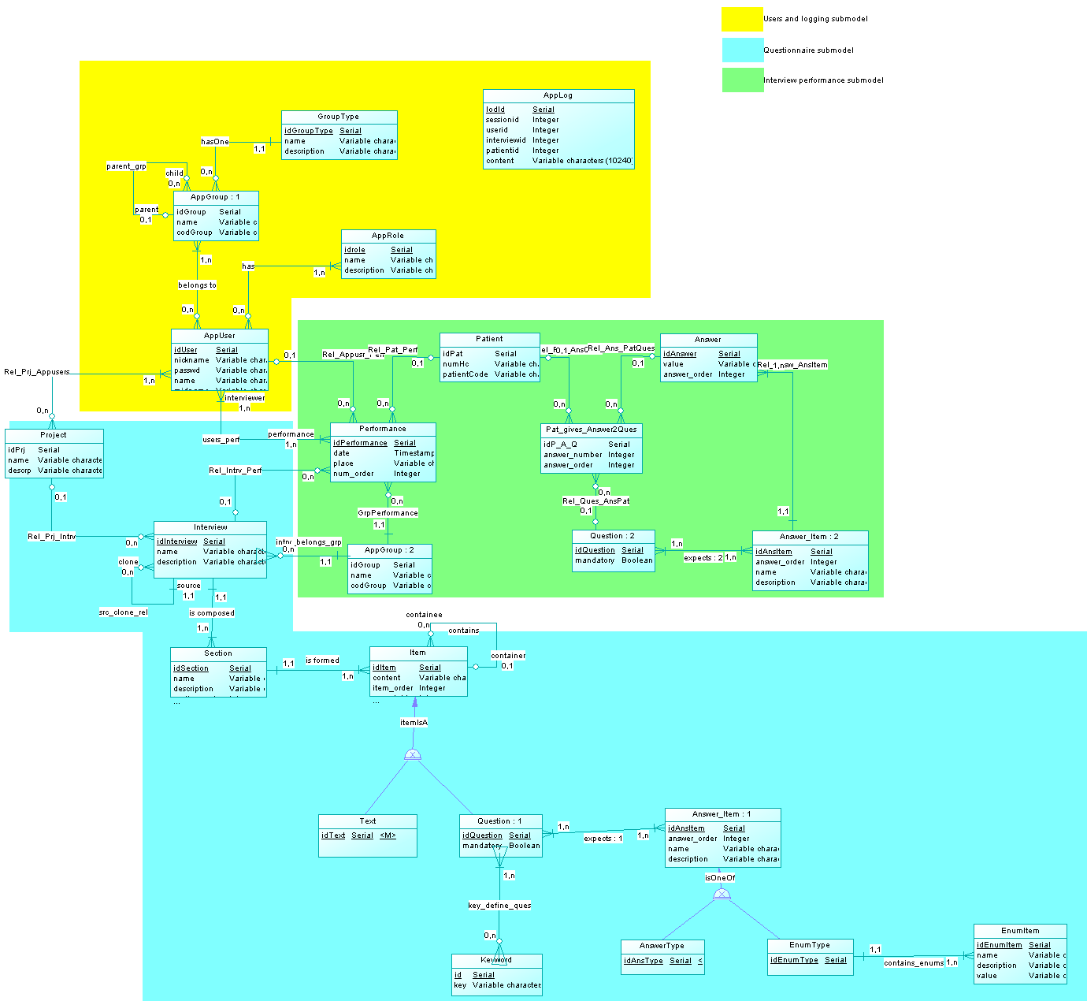
Figure 10. Full EER model

