# Configurar Maven para usar servlet 3.0

1. I usually create the 2.3 webapp then change it to 3.0 version. The steps are approximatly:
2. In pom.xml: add maven-compiler-plugin configuration. source and target set to current java version (1.8), add servlet-api, jsp-api, jstl to dependencies.
3. Delete web.xml.
4. Open project properties (Alt+Enter on the project explorer)
5. Click on Project Facets
6. Uncheck checkbox for Dynamic Web Module, change version to 3.0
7. Check checkbox back. Click further configuration, change WebContent to src/main/webapp.
8. Generate Deployment Descriptor (in project explorer, right click Deployment Descriptor/Generate Deployment Descriptor Stub)
9. Targeted Runtimes of project

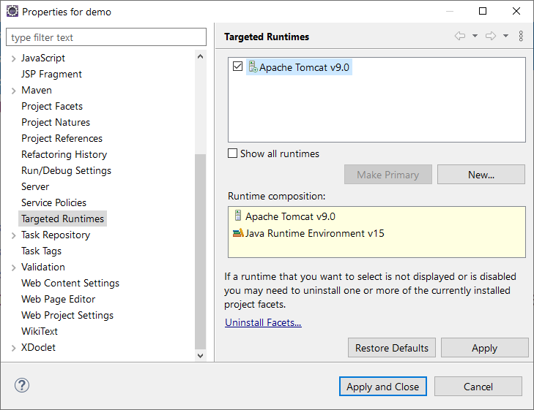

<dependency>

<groupId>org.apache.maven.plugins</groupId>

<artifactId>maven-compiler-plugin</artifactId>

<version>3.8.1</version>

<type>maven-plugin</type>

</dependency>

<dependency>

<groupId>javax.servlet</groupId>

<artifactId>servlet-api</artifactId>

<version>3.0-alpha-1</version>

</dependency>

<dependency>

<groupId>javax.servlet.jsp</groupId>

<artifactId>javax.servlet.jsp-api</artifactId>

<version>2.3.3</version>

</dependency>