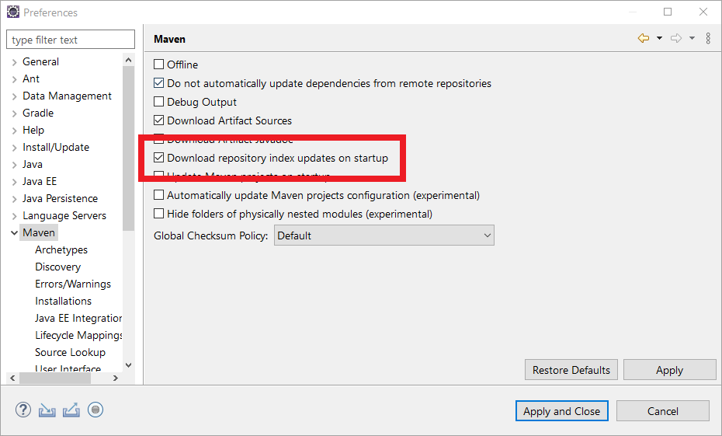

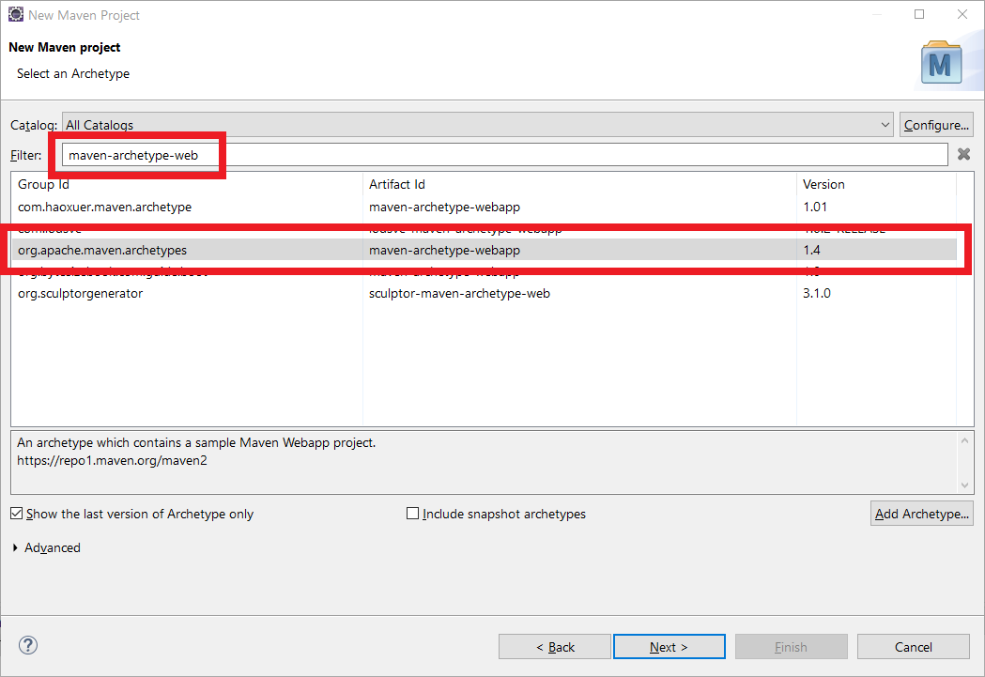

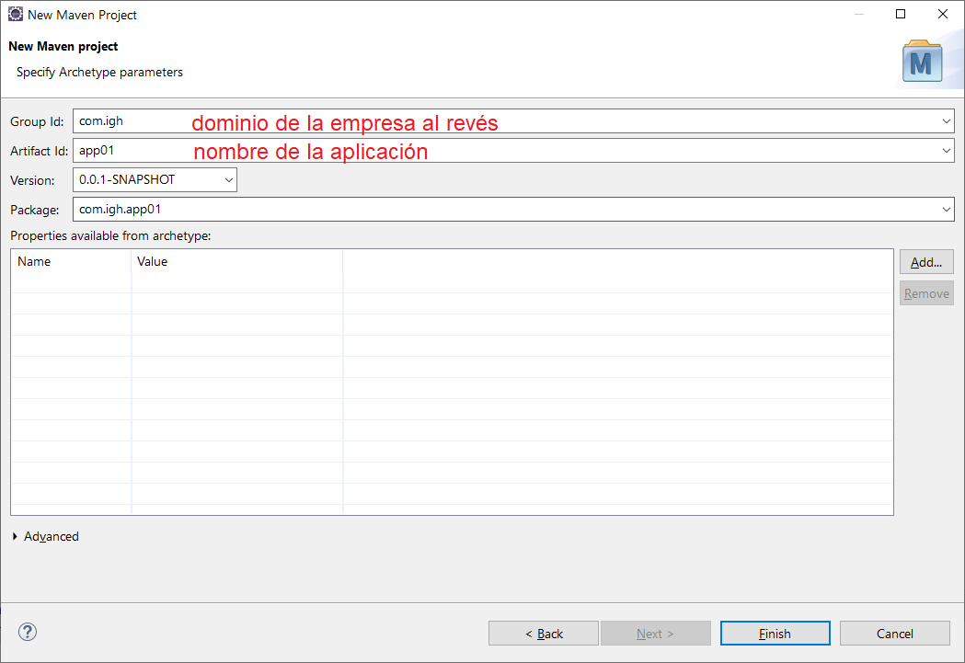

<dependency>

<groupId>javax.servlet</groupId>

<artifactId>javax.servlet-api</artifactId>

<version>4.0.1</version>

</dependency>