Integrantes:

- PALHUA

-PEREZ

-LLOCTUN

-------------------------------------------------------------------------------------

1.- select name from v$database;

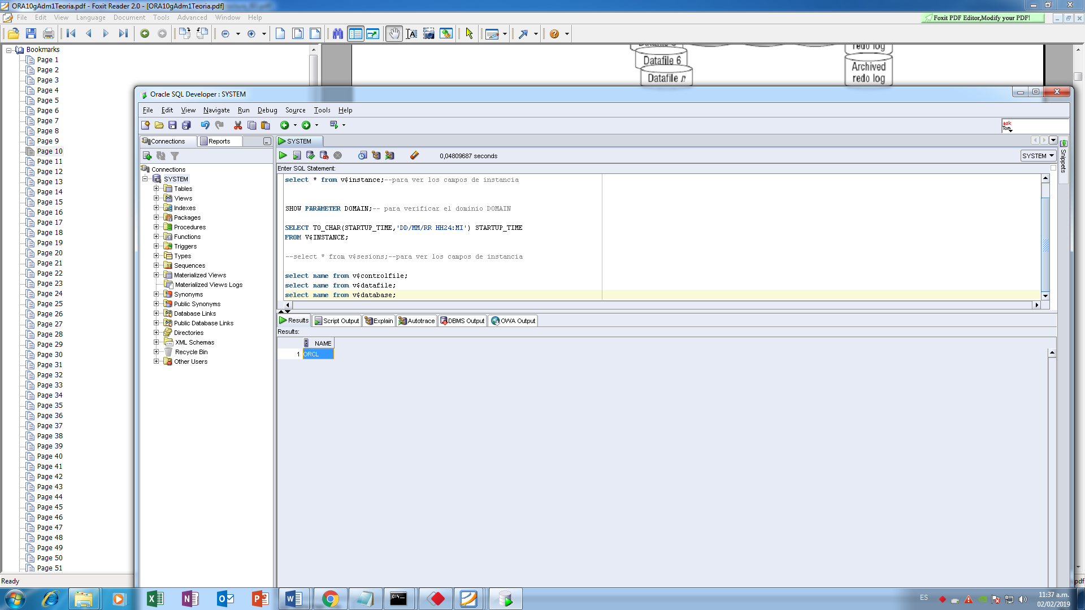

2.- select instance_name from v$instance;

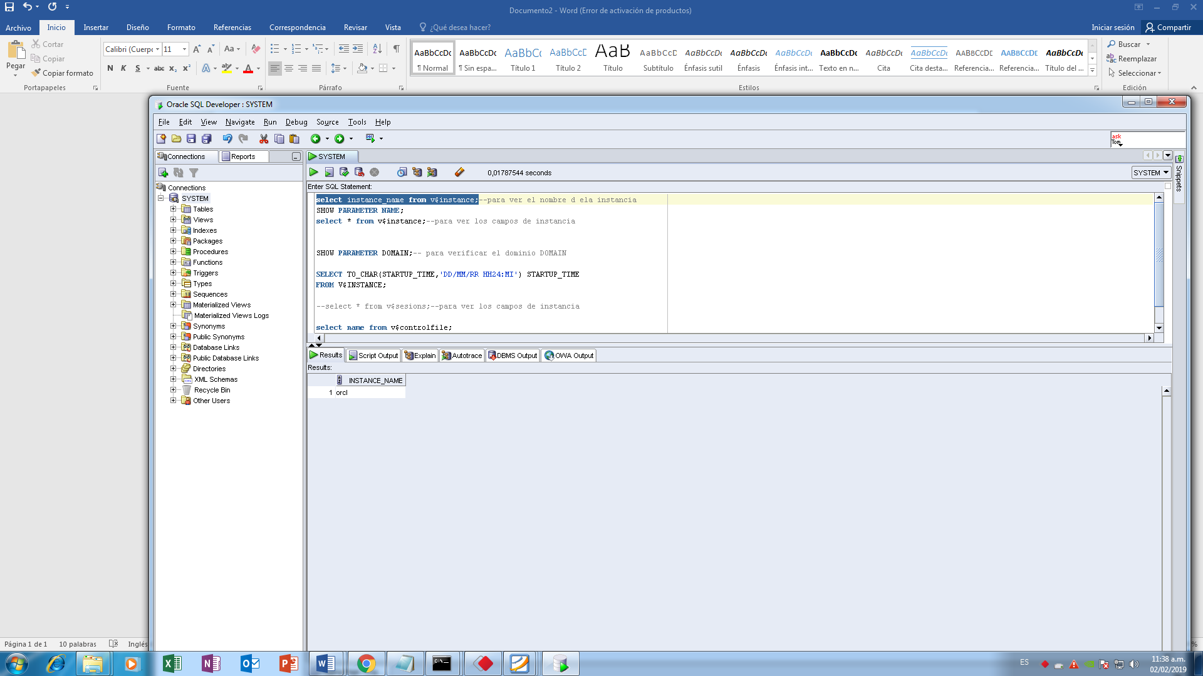

3.- SHOW PARAMETER DOMAIN;

1521

4.- select name from v$services;

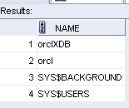

5.-

5.1.-

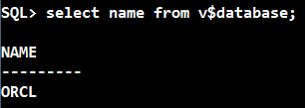

5.2.-

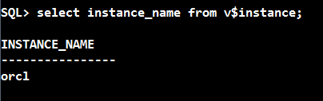

5.3.- 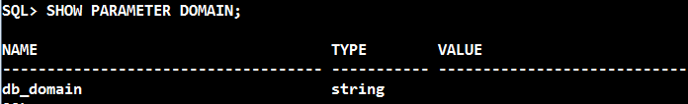

5.4.-

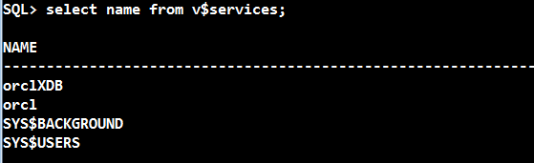

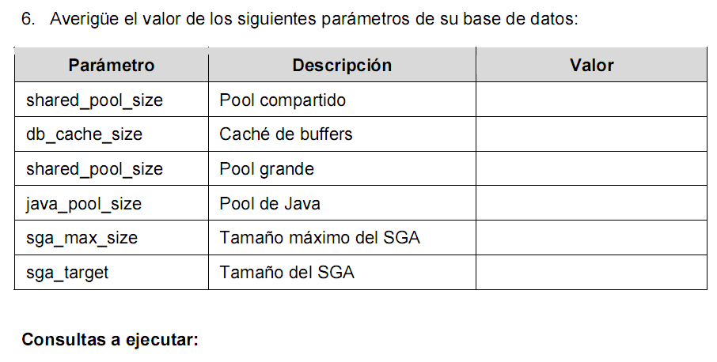

1.- select name, description, value from v$parameter

where NAME ='shared_pool_size'

AND DESCRIPTION='size in bytes of shared pool';

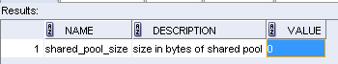

2.- select name, description, value from v$parameter

where NAME ='db_cache_size'

AND DESCRIPTION='Size of DEFAULT buffer pool for standard block size buffers';

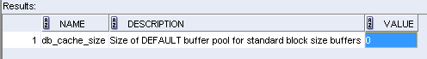

3.- select name, description, value from v$parameter

where NAME ='large_pool_size'

AND DESCRIPTION='size in bytes of large pool';

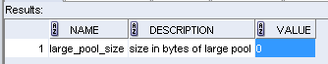

4.- select name, description, value from v$parameter

where NAME ='java_pool_size';

AND DESCRIPTION='size in bytes of java pool';

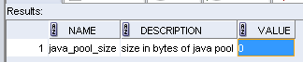

5.- select * from v$parameter

where NAME ='sga_max_size'

AND DESCRIPTION='max total SGA size';

Resultado:



6.- select name, description, value from v$parameter

where NAME ='sga_target'

AND DESCRIPTION='Target size of SGA';

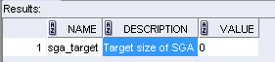

7.- select name from v$controlfile;

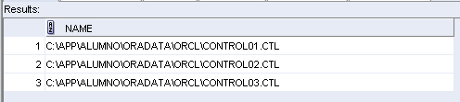

8.- select name from v$datafile;

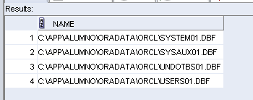

9.- select member from v$logfile;

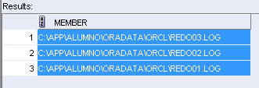

Nombre de archivos log:

REDO01.log, REDO02.log, REDO03.log.

10.- select group#, member from v$logfile;

