select \* from v$log;

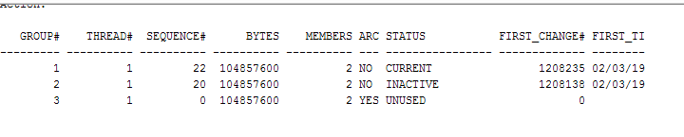

alter system switch logfile;

alter database drop logfile group 1;

alter database

add logfile group 1

(

'C:\app\Alumno\oradata\orcl\REDO01A.log','C:\app\Alumno\oradata\orcl\REDO01B.log'

)

size 100 M;

alter database drop logfile group 2;

alter database

add logfile group 2

(

'C:\app\Alumno\oradata\orcl\REDO02A.log','C:\app\Alumno\oradata\orcl\REDO02B.log'

)

size 100 M;

alter database drop logfile group 3;

alter database

add logfile group 3

(

'C:\app\Alumno\oradata\orcl\REDO03A.log','C:\app\Alumno\oradata\orcl\REDO03B.log'

)

size 100 M;