This repository was created with the objective to solve the problems shared in the website: <https://projecteuler.net/>

**Exercises description**

**16.** 215 = 32768 and the sum of its digits is 3 + 2 + 7 + 6 + 8 = 26. What is the sum of the digits of the number 21000?

**19.** You are given the following information, but you may prefer to do some research for yourself.

* 1 Jan 1900 was a Monday.
* Thirty days has September,  
  April, June and November.  
  All the rest have thirty-one,  
  Saving February alone,  
  Which has twenty-eight, rain or shine.  
  And on leap years, twenty-nine.
* A leap year occurs on any year evenly divisible by 4, but not on a century unless it is divisible by 400.

How many Sundays fell on the first of the month during the twentieth century (1 Jan 1901 to 31 Dec 2000)?

**24.** A permutation is an ordered arrangement of objects. For example, 3124 is one possible permutation of the digits 1, 2, 3 and 4. If all of the permutations are listed numerically or alphabetically, we call it lexicographic order. The lexicographic permutations of 0, 1 and 2 are:

012   021   102   120   201   210

What is the millionth lexicographic permutation of the digits 0, 1, 2, 3, 4, 5, 6, 7, 8 and 9?

**37.** The number 3797 has an interesting property. Being prime itself, it is possible to continuously remove digits from left to right, and remain prime at each stage: 3797, 797, 97, and 7. Similarly we can work from right to left: 3797, 379, 37, and 3. Find the sum of the only eleven primes that are both truncatable from left to right and right to left.

**NOTE:** 2, 3, 5, and 7 are not considered to be truncatable primes.

**57.** It is possible to show that the square root of two can be expressed as an infinite continued fraction.

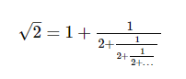

By expanding this for the first four iterations, we get:

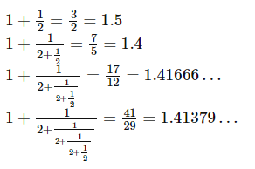

The next three expansions are 99/70, 239/169, and 577/408, but the eighth expansion, 1393/985, is the first example where the number of digits in the numerator exceeds the number of digits in the denominator.

In the first one-thousand expansions, how many fractions contain a numerator with more digits than the denominator?