Salesforce is the platform

for the Agentic Enterprise.
Our deeply unified platform brings together apps, data, agents, and metadata to drive customer and employee success. With trust and governance built in, Salesforce ensures your AI and business scale securely, reliably, and with confidence.


Launch faster with 16+ Agentforce solutions, built for your industry.
Designed with industry expertise, these out-of-the-box solutions align with your workflows, data, and customer needs, so you can modernize faster, go to market sooner, and deliver value from day one.

Financial Services
Connect with customers proactively to deliver AI-powered, high-value experiences.

Retail
Acquire profitable customers faster with unified, real-time data.

Consumer Goods
Transform your business with consumer goods technology made for your industry.

Manufacturing
Integrate all your data across a unified value chain to better serve customers and channel partners.

Automotive
Drive personalised experiences, explore new revenue models and power software-defined vehicles.

Healthcare & Life Sciences
Elevate your workforce with AI agents for healthier businesses, outcomes, and communities.

Education
Elevate the education experience with the #1 AI CRM for learner and institution success.

Media
Enhance your digital media solution that has advanced sales intelligence and automation, driving higher seller productivity.

Over 150,000 companies, both big and small, are growing their business with Salesforce.


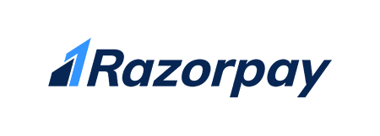


See why analysts agree Salesforce should be your Agentic AI partner.
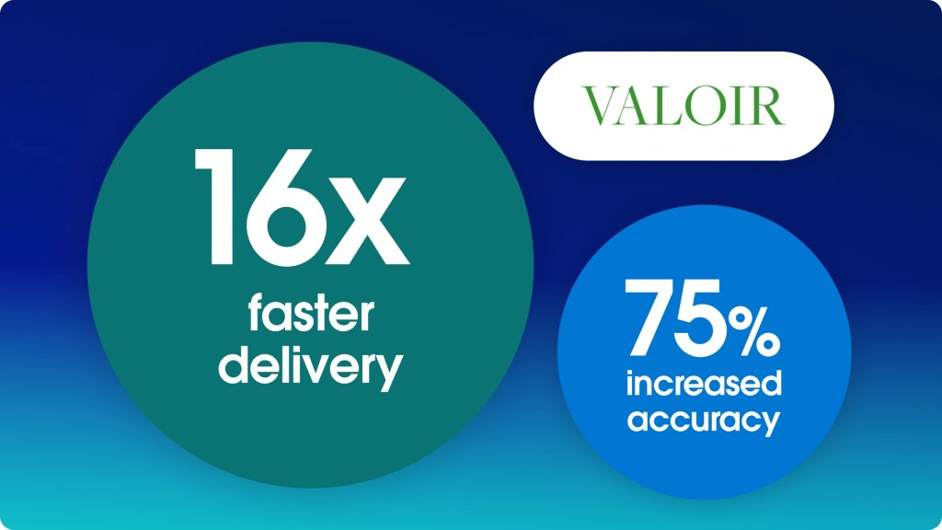
Report

Agentforce delivers ROI faster and at a lower cost than a DIY approach.
Report

Salesforce is voted the #1 Global Software Company on G2.
Report

Futurum report explains why Agentforce is the fastest path to enterprise value.

Become an Agentblazer.
Learn essential AI and Agentforce skills required to shape the future of work for free.
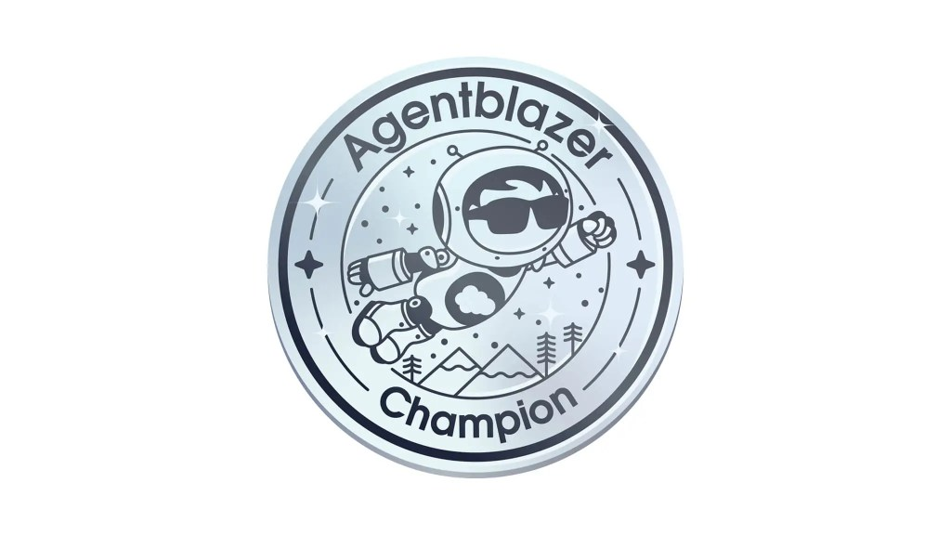
Level 1

Champion
Confidently explain Agentforce concepts and business impact.
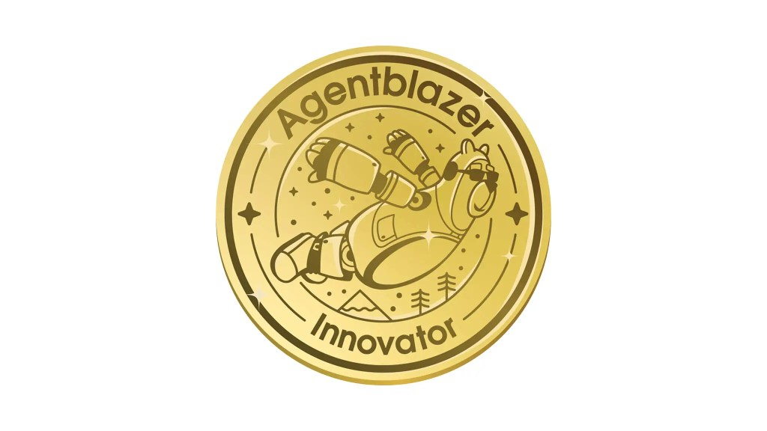
Level 2

Innovator
Implement Agentforce solutions to drive measurable business outcomes.
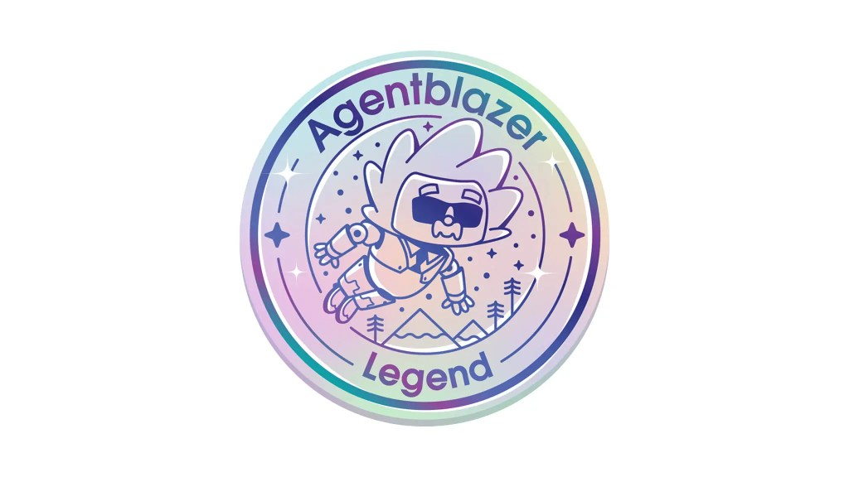
Level 3

Legend
Understand advanced concepts and design complex strategies.
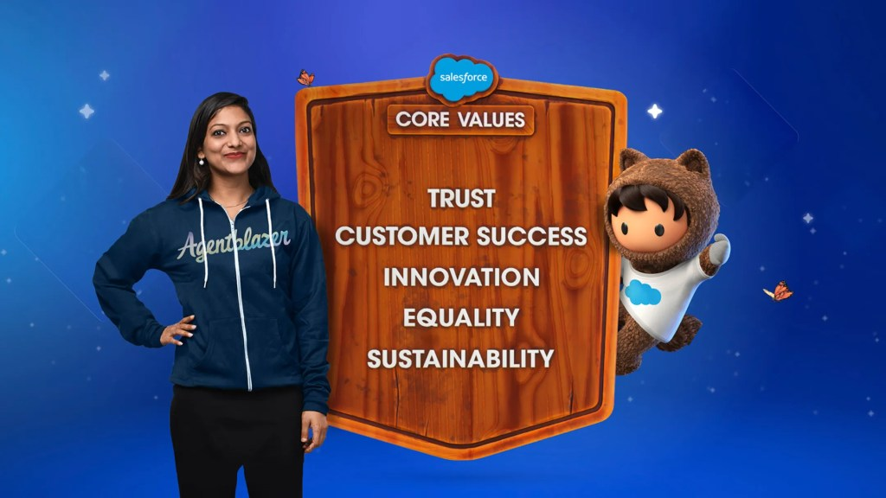

We believe that business is the greatest platform for change.
Grounded in trust, customer success, innovation, equality, and sustainability, we’re committed to doing well in business and doing good in the world — investing 1% of our equity, technology, and time to create lasting change. We’re also a founder and champion of Pledge 1%, a global movement to ensure giving back is part of companies of all sizes.

Get the latest from Salesforce.


Catch all the Dreamforce 2025 highlights.
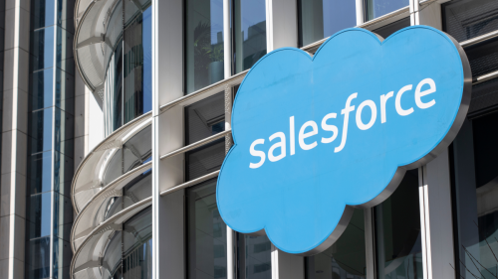

Salesforce India Continues to Record Strong Growth, Bets Big on Agentic Enterprise Transformation
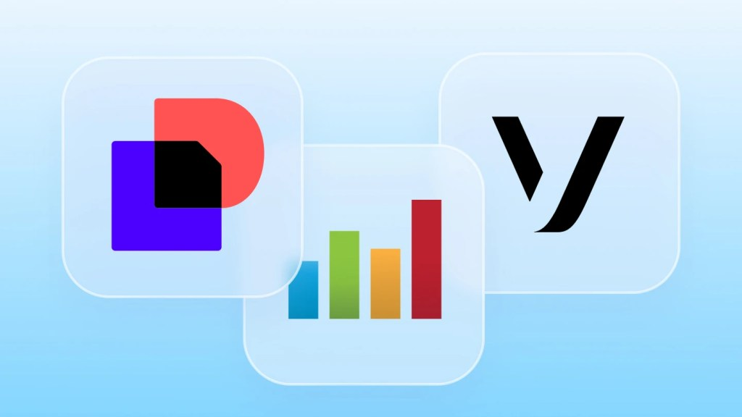

Get the most out of Salesforce with partners, apps, and agents.

Get started today.

There's nothing to install. No credit card required. Free for 30 days.

Frequently Asked Questions

What is Salesforce?
Salesforce is the #1 AI CRM (customer relationship management) platform. We bring companies and customers together by providing a unified set of applications — powered by agentic AI and data — that help every department, including sales, service, marketing, commerce, and IT, work as one. You can learn more about what Salesforce is and what Salesforce does by visiting our official resources. Our cloud-based agentic solutions help you find more leads, close more deals, and provide better service to your customers, all on a single, integrated agentic platform.

What is CRM and why do I need one?

What is agentic AI and how is it used in Salesforce?

How does Salesforce CRM help my small business grow?
Call us at 1800-420-7332

New to Salesforce?
- Why Salesforce
- What is CRM?
- Explore All Products
- SaaS
- Customer Success
- Product Pricing

About Salesforce
- Our Story
- Careers
- Press
- Blog
- Security and Performance
- Salesforce.org
- Best CRM Software
- Sustainability
- Legal
- Give us your Feedback

Popular Links
- New Release Features
- Salesforce Mobile App
- Business App Store
- Dreamforce
- CRM Software
- Salesforce Plus
- Salesforce for startups
- Legal
- Terms of Service
- Privacy
- Responsible Disclosure
- Trust
- Contact
- Cookie Preferences
- Your Privacy Choices
© Copyright 2025 Salesforce, Inc. All rights reserved. Various trademarks held by their respective owners.

