Garbage.py

This program is written in Python Language

Created for Lab purposes with regulations of Nature Labs

Purpose:

Remove any Garbage and unnecessary words for Google Search Engine

Create CSV Data of unique keywords named, grabage.csv in a folder.

C:\google\serpapi\indias\data\Indias_googlengine_temple_States_and_UTs

*Execute garbages.py*

*C:\google\serpapi\indias*

python garbages.py

*grabage.csv will be generated in the above folder.*

*Save garbages.py directory*

*C:\google\serpapi\indias*

*Download From Git Hub*

Usage :

cd C:\google\serpapi\indias

python garbages.py

Code History :

|  |  |  |
| --- | --- | --- |
| Code | version | date |
| garbages.py | 0.1 | June 20, 2022 |
| garbages.py | 0.2 | June 26, 2022 |

Design and Developed :

Kyndryl Solution Private Limited

G1, 6th Floor, Manyata Tech Park

Bangalore, India

Developed by Google Cloud Architect: V Ramamurthy

Email: ramamurthy.valavandan@kyndryl.com

Google Cloud Research: gcpguild@gmail.com

Date: June 20, 2022

Latest version: 2.0

Date of the final version: June 26, 2022.

Download from Git Hub

<https://github.com/gcpguild/googlengine/blob/main/garbages.py>

After downloading getserp.py from the Git Hub link

<https://github.com/gcpguild/googlengine/blob/main/garbages.py>

Save the python program in your local system

C:\google\serpapi\indias

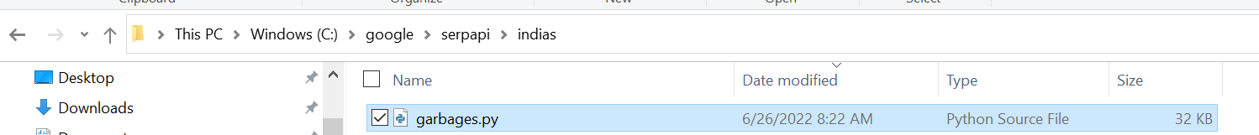

Execute garbages.py

C:\google\serpapi\indias>python garbages.py

Result:

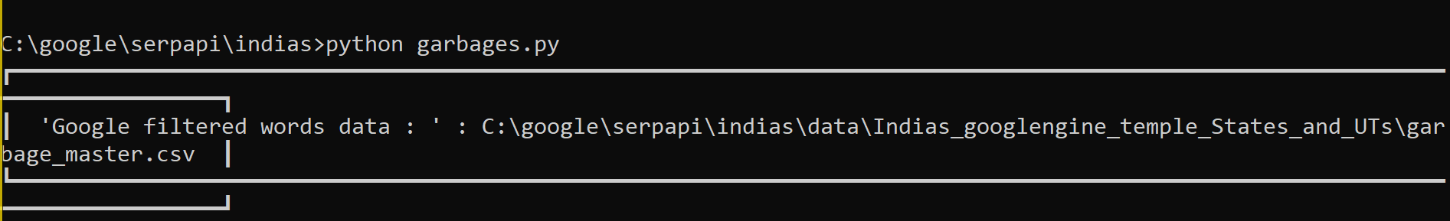

Output

