parseserpapijson.py

This program is written in Python Language

Created for Lab purposes with regulations of Nature Labs

Purpose:

This program is an extension of generating the JSON file based on Google Search Engine API – SerpAPI.

Google Search Key: *Temples West Bengal*

JSON file input: Indias_West-Bengal_62b115ac2e7d6bafc2e13610.json

This program is used to parse JSON file, which is generated by Google Search API (SerpAPI)

JSON file has the information of the Google Search Engine.

Create the necessary folders in local and download and save JSON for locally parse the search key.

Generate two CSV files will be generated from Google Search Engine JSON.

1. Indias_West-Bengal_Temples_Google_SerpApi.csv
2. Indias_West-Bengal_Google_Paginations_Links_SerpApi.csv

C:\google\serpapi\indias\data\Indias_googlengine_temple_States_and_UTs\West-Bengal

*Execute filters.py*

*C:\google\serpapi\indias*

python parseserpapijson.py

Two CSVs *will be generated in the data folder*

*c:\google\serpapi\indias\data\Indias_googlengine_temple_States_and_UTs*

*.*

*Save parseserpapijson.py*

*Directory : C:\google\serpapi\indias*

*Download From Git Hub*

Pre-requirements

Input for this program

1. Indias_West-Bengal_62b115ac2e7d6bafc2e13610.json.

The information on Generating the JSON and downloading locally is available in Git Hub.

[gcpguild/googlengine: Google engine is Google API for data cleaning, search api (github.com)](https://github.com/gcpguild/googlengine)

1. Ind_googlengine_states_ut_master.csv

<https://github.com/NATURE-LABS/India/blob/main/Python%20Lab%20India_states_UT.docx>

Usage :

cd C:\google\serpapi\indias

python parseserpapijson.py

Code History :

|  |  |  |
| --- | --- | --- |
| Code | version | date |
| garbages.py | 0.1 | June 20, 2022 |
| garbages.py | 0.2 | June 26, 2022 |

Design and Developed :

Kyndryl Solution Private Limited

G1, 6th Floor, Manyata Tech Park

Bangalore, India

Developed by Google Cloud Architect: V Ramamurthy

Email: ramamurthy.valavandan@kyndryl.com

Google Cloud Research: gcpguild@gmail.com

Date: June 20, 2022

Latest version: 2.0

Date of the final version: June 26, 2022.

Download from Git Hub

<https://github.com/gcpguild/googlengine/blob/main/parseserpapijson.py>

After downloading getserp.py from the Git Hub link

<https://github.com/gcpguild/googlengine/blob/main/parseserpapijson.py>

Save the python program in your local system

C:\google\serpapi\indias

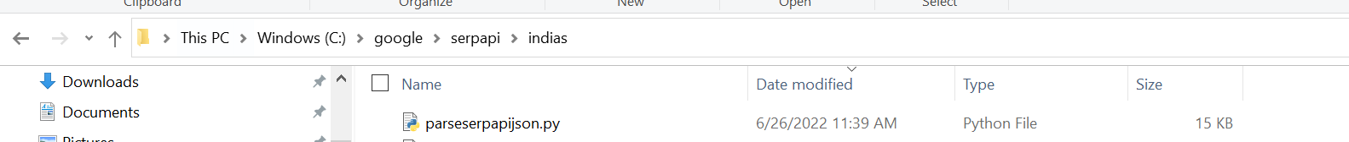

Execute python : Parse SerpAPI Json

C:\google\serpapi\indias>python parseserpapijson.py

Result:

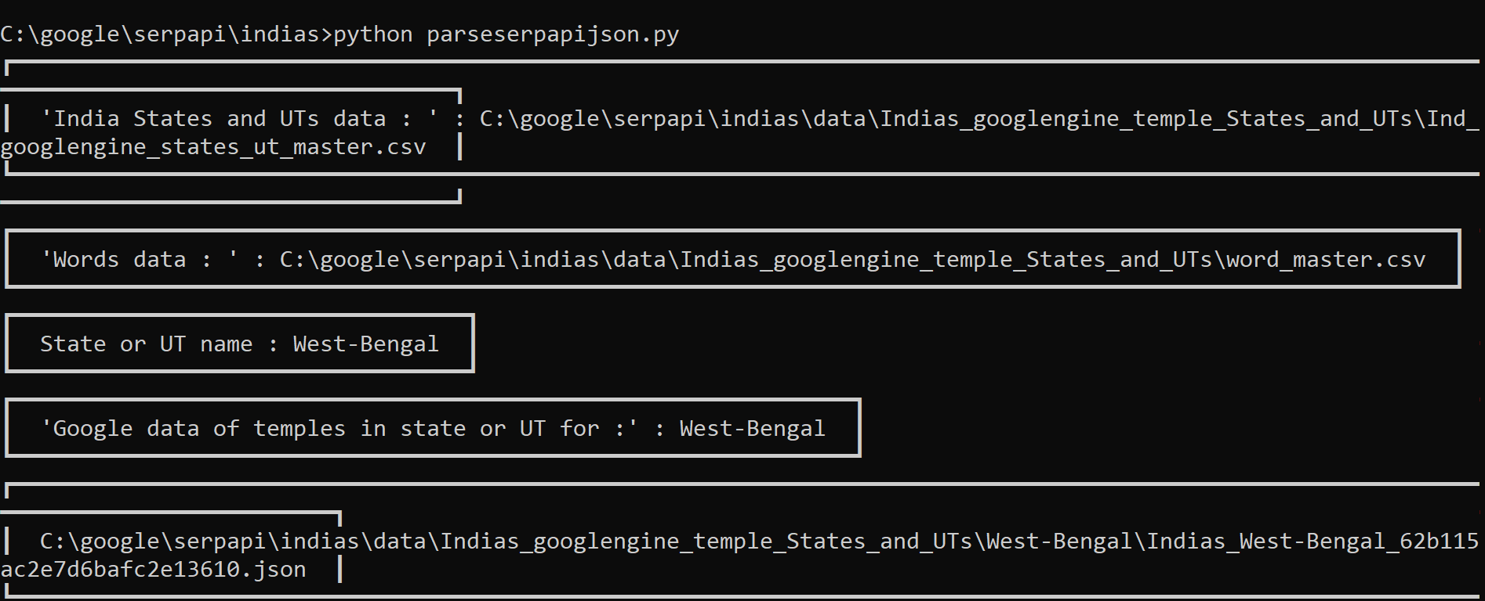

|  |
| --- |
| C:\google\serpapi\indias>python parseserpapijson.py  ┏━━━━━━━━━━━━━━━━━━━━━━━━━━━━━━━━━━━━━━━━  ┃ 'India States and UTs data : ' : C:\google\serpapi\indias\data\Indias_googlengine_temple_States_and_UTs\Ind_googlengine_states_ut_master.csv ┃  ┃ 'Words data : ' : C:\google\serpapi\indias\data\Indias_googlengine_temple_States_and_UTs\word_master.csv ┃  ┃ State or UT name : West-Bengal ┃  ┃ 'Google data of temples in state or UT for :' : West-Bengal ┃  ┃ C:\google\serpapi\indias\data\Indias_googlengine_temple_States_and_UTs\West-Bengal\Indias_West-Bengal_62b115ac2e7d6bafc2e13610.json ┃  ┃ 'SerpApi Google filtered temples data : ' : C:\google\serpapi\indias\data\Indias_googlengine_temple_States_and_UTs\West-Bengal\Indias_West-Bengal_Temples_Google_SerpApi.csv ┃ |

Output

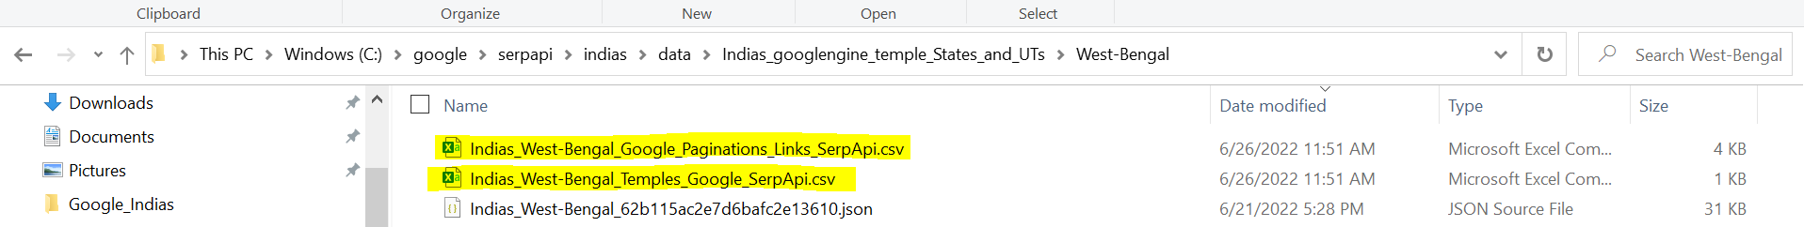

Out of Two CSVs :

C:\google\serpapi\indias\data\Indias_googlengine_temple_States_and_UTs\West-Bengal

|  |  |
| --- | --- |
|  |  |

Appendix:

SerpAPI, Json : Indias_West-Bengal_62b115ac2e7d6bafc2e13610.json

|  |
| --- |
| "search_metadata": {  "id": "62b115ac2e7d6bafc2e13610",  "status": "Success",  "json_endpoint": "https://serpapi.com/searches/86d897a66db73848/62b115ac2e7d6bafc2e13610.json",  "created_at": "2022-06-21 00:49:48 UTC",  "processed_at": "2022-06-21 00:49:48 UTC",  "google_url": "https://www.google.co.in/search?q=temples+West+Bengal&oq=temples+West+Bengal&uule=w+CAIQICIRV2VzdCBCZW5nYWwsSW5kaWE&hl=en&gl=in&num=10&sourceid=chrome&ie=UTF-8",  "raw_html_file": "https://serpapi.com/searches/86d897a66db73848/62b115ac2e7d6bafc2e13610.html",  "total_time_taken": 6.1  },  "search_parameters": {  "engine": "google",  "q": "temples West Bengal",  "location_requested": "\"West Bengal, India\"",  "location_used": "West Bengal,India",  "google_domain": "google.co.in",  "hl": "en",  "gl": "in",  "num": "10",  "device": "desktop"  },  "search_information": {  "organic_results_state": "Results for exact spelling",  "query_displayed": "temples West Bengal",  "total_results": 33900000,  "time_taken_displayed": 0.54  }, |

More details :

Google Engine Search by SerpAPI

Python : Create the Google search JSON.

Project contact: Google Cloud Search API, Kyndryl

Email: Ramamurthy.valavandan@kyndryl.com

Python API for Google Search Engine

Use Case: Creating the Temples List, Description of Temple, Co-ordinates, Distances from major cities in India.

Purpose : After connecting to Google Search Engine API the JSON is generated

This program is used to connect Google Search API (SerpAPI)

Download the searched information which is saved in the JSON file based on the Google Search Engine.

Create the necessary folders in local and download and save JSON for locally parse the search key.

---------------------------------------------------------------------------------------------------

SerpAPI Sponsorship

Google Engine is sponsored by SerpApi. SerApi has sponsored 40,000 credits for Google search

with the API Key for scraping Google and other search engines.

On behalf of Google Engine, researchers, we express our gratitude to SerpAPI LLC, for provisioning

their sponsorship SerpAPI's sponsorship has helped us make our research and social work contribution

for speaking out greater audience.

With the advent of SerpAPI, Google Engine has addressed our research work on Temples in India

with the experience of a blazingly fast, super easy to use, and data-rich API in

Google Cloud Platform Search Engine on Big Query for Research in Google Cloud Engine.

With SerpAPI, Google Engine will be helping the student community on projects.

About SerpApi

SERP API is a real-time API to access Google search results.

It solves the issues of having to rent proxies, solving captchas, and JSON parsing.

Design and developed by :

Kyndryl Solutions Private Limited

Project Team : Google Cloud Platform - Guild.

Nature Labs : Google Engine @ SerApi, LLC.

Download from Git Hub

https://github.com/gcpguild/googlengine/blob/main/parseserpapijson.py

How to use

python parseserpapijson.py

Contact

Kyndryl GCP Guild Moderator: Ramamurthy V

Email: ramamurthy.valavandan@kyndryl.com

GCP Contact: gcpguild@gmail.com

Date: June 21, 2022.

Contributors: 22 key members from Google Cloud Search API.

For SerpAPI Key request, please write an email request with an email subject of 'request for SerpApi Key'

Email: ramamurthy.valavandan@kyndryl.com

"""

#-----------------------------------------------------#-----------------------------------------------------