serpapijsongetlocal.py

This program is written in Python Language

Created for Lab purposes with regulations of Nature Labs

Purpose:

This program downloads the JSON file based on Google Search Engine API – SerpAPI.

Google Search Key: *Temples West Bengal*

JSON file input: Indias_West-Bengal_62b115ac2e7d6bafc2e13610.json

This program is used to download JSON file, which is generated by Google Search API (SerpAPI)

JSON file has the information of the Google Search Engine.

Create the necessary folders locally and download and download JSON locally to further parse the search key.

Download JSON file from SerpAPI - Google Search Engine.

C:\google\serpapi\indias\data\Indias_googlengine_temple_States_and_UTs\West-Bengal

*Execute serapijsongetlocal.py*

*C:\google\serpapi\indias*

python serapijsongetlocal.py

*Indias_West-Bengal_62b115ac2e7d6bafc2e13610.json is downloaded*

*in the data folder*

*C:\google\serpapi\indias\data\Indias_googlengine_temple_States_and_UTs\West-Bengal*

*.*

*Save serpapijsongetlocal.py*

*Directory : C:\google\serpapi\indias*

*Download From Git Hub*

Pre-requirements

Ind_googlengine_states_ut_master.csv

<https://github.com/NATURE-LABS/India/blob/main/Python%20Lab%20India_states_UT.docx>

Ind_googlengine_states_ut_master.csv is required for this program to know which state search Key JSON is required to download the JSON from SerAPI – Google Search Engine.

Here we have demonstrated ‘Temples West Bengal’

Indias_West-Bengal_62b115ac2e7d6bafc2e13610.json.

Usage :

cd C:\google\serpapi\indias

python serpapijsongetlocal.py

Code History :

|  |  |  |
| --- | --- | --- |
| Code | version | date |
| serpapijsongetlocal.py | 0.1 | June 20, 2022 |
| serpapijsongetlocal.py | 0.2 | June 26, 2022 |

Design and Developed :

Kyndryl Solution Private Limited

G1, 6th Floor, Manyata Tech Park

Bangalore, India

Developed by Google Cloud Architect: V Ramamurthy

Email: ramamurthy.valavandan@kyndryl.com

Google Cloud Research: gcpguild@gmail.com

Date: June 20, 2022

Latest version: 2.0

Date of the final version: June 26, 2022.

Download from Git Hub

<https://github.com/gcpguild/googlengine/blob/main/serpapijsongetlocal.py>

After downloading getserp.py from the Git Hub link

<https://github.com/gcpguild/googlengine/blob/main/serpapijsongetlocal.py>

Save the python program in your local system

C:\google\serpapi\indias

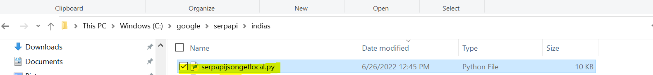

Execute python : Download Serp API JSON

cd C:\google\serpapi\indias

python serpapijsongetlocal.py

Result:

File downloaded :

Indias_West-Bengal_62b115ac2e7d6bafc2e13610.json

Downloaded directory :

C:\google\serpapi\indias\data\Indias_googlengine_temple_States_and_UTs\West-Bengal

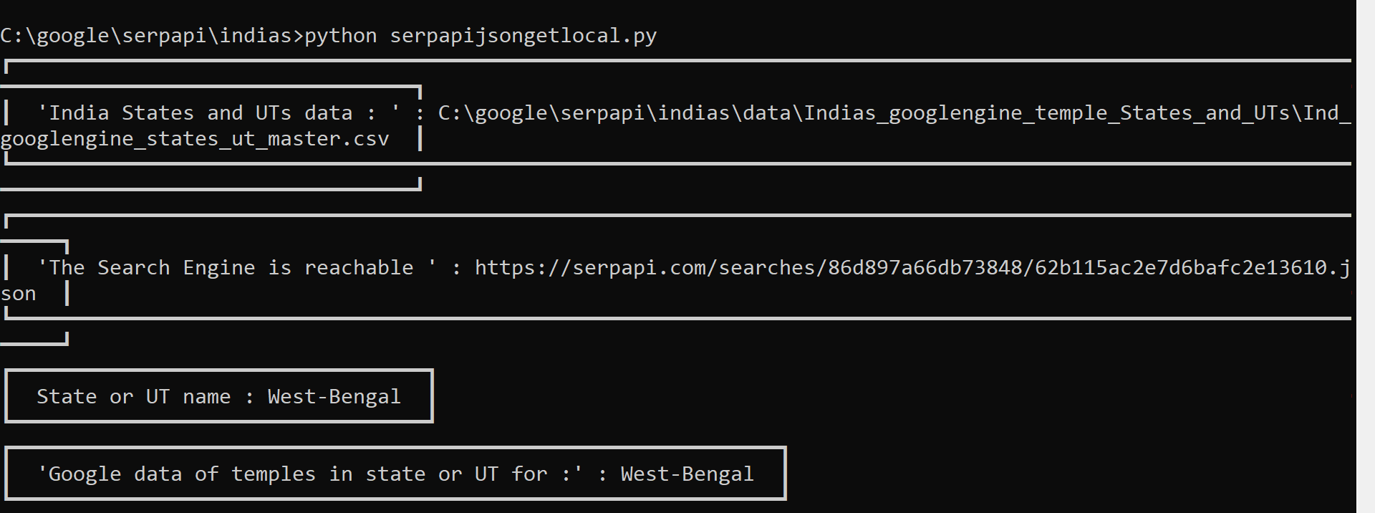

|  |
| --- |
| python serpapijsongetlocal.py  ┏━━━━━━━━━━━━━━━━━━━━━━━━━━━━━━━━━━━━━━━━━━━━━━━━━━━━━━━━━━━━━━━━━━━━━━━━━━━━━━━━━━━━━━━━━━━━━━━━━━━━━━━━━━━━━━━━━━━━━━━━━━━━━━━━━━━━━━━━━━━━━━━━┓  ┃ 'India States and UTs data : ' : C:\google\serpapi\indias\data\Indias_googlengine_temple_States_and_UTs\Ind_googlengine_states_ut_master.csv ┃  ┗━━━━━━━━━━━━━━━━━━━━━━━━━━━━━━━━━━━━━━━━━━━━━━━━━━━━━━━━━━━━━━━━━━━━━━━━━━━━━━━━━━━━━━━━━━━━━━━━━━━━━━━━━━━━━━━━━━━━━━━━━━━━━━━━━━━━━━━━━━━━━━━━┛  ┏━━━━━━━━━━━━━━━━━━━━━━━━━━━━━━━━━━━━━━━━━━━━━━━━━━━━━━━━━━━━━━━━━━━━━━━━━━━━━━━━━━━━━━━━━━━━━━━━━━━━━━━━━━━━━━━━━━━┓  ┃ 'The Search Engine is reachable ' : https://serpapi.com/searches/86d897a66db73848/62b115ac2e7d6bafc2e13610.json ┃  ┗━━━━━━━━━━━━━━━━━━━━━━━━━━━━━━━━━━━━━━━━━━━━━━━━━━━━━━━━━━━━━━━━━━━━━━━━━━━━━━━━━━━━━━━━━━━━━━━━━━━━━━━━━━━━━━━━━━━┛  ┏━━━━━━━━━━━━━━━━━━━━━━━━━━━━━━━━━━┓  ┃ State or UT name : West-Bengal ┃  ┗━━━━━━━━━━━━━━━━━━━━━━━━━━━━━━━━━━┛  ┏━━━━━━━━━━━━━━━━━━━━━━━━━━━━━━━━━━━━━━━━━━━━━━━━━━━━━━━━━━━━━━━┓  ┃ 'Google data of temples in state or UT for :' : West-Bengal ┃  ┗━━━━━━━━━━━━━━━━━━━━━━━━━━━━━━━━━━━━━━━━━━━━━━━━━━━━━━━━━━━━━━━┛  ┏━━━━━━━━━━━━━━━━━━━━━━━━━━━━━━━━━━━━━━━━━━━━━━━━━━━━━━━━━━━━━━━━━━━━━━━━━━━━━━━━━━━━━━━━━━━━━━━━━━━━━━━━━━━━━━━━━━━━━━━━━━━━━━━━━━━━━━━┓  ┃ C:\google\serpapi\indias\data\Indias_googlengine_temple_States_and_UTs\West-Bengal\Indias_West-Bengal_62b115ac2e7d6bafc2e13610.json ┃  ┗━━━━━━━━━━━━━━━━━━━━━━━━━━━━━━━━━━━━━━━━━━━━━━━━━━━━━━━━━━━━━━━━━━━━━━━━━━━━━━━━━━━━━━━━━━━━━━━━━━━━━━━━━━━━━━━━━━━━━━━━━━━━━━━━━━━━━━━┛  C:\google\serpapi\indias\data\Indias_googlengine_temple_States_and_UTs\West-Bengal\Indias_West-Bengal_62b115ac2e7d6bafc2e13610.json |

Output

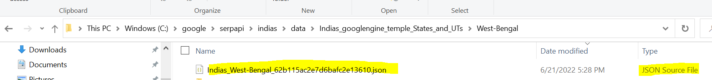

SerpAPI - downloaded JSON file :

Indias_West-Bengal_62b115ac2e7d6bafc2e13610.json

Path of the JSON file downloaded :

C:\google\serpapi\indias\data\Indias_googlengine_temple_States_and_UTs\West-Bengal

Appendix:

SerpAPI, Json : Indias_West-Bengal_62b115ac2e7d6bafc2e13610.json

|  |
| --- |
| "search_metadata": {  "id": "62b115ac2e7d6bafc2e13610",  "status": "Success",  "json_endpoint": "https://serpapi.com/searches/86d897a66db73848/62b115ac2e7d6bafc2e13610.json",  "created_at": "2022-06-21 00:49:48 UTC",  "processed_at": "2022-06-21 00:49:48 UTC",  "google_url": "https://www.google.co.in/search?q=temples+West+Bengal&oq=temples+West+Bengal&uule=w+CAIQICIRV2VzdCBCZW5nYWwsSW5kaWE&hl=en&gl=in&num=10&sourceid=chrome&ie=UTF-8",  "raw_html_file": "https://serpapi.com/searches/86d897a66db73848/62b115ac2e7d6bafc2e13610.html",  "total_time_taken": 6.1  },  "search_parameters": {  "engine": "google",  "q": "temples West Bengal",  "location_requested": "\"West Bengal, India\"",  "location_used": "West Bengal,India",  "google_domain": "google.co.in",  "hl": "en",  "gl": "in",  "num": "10",  "device": "desktop"  },  "search_information": {  "organic_results_state": "Results for exact spelling",  "query_displayed": "temples West Bengal",  "total_results": 33900000,  "time_taken_displayed": 0.54  }, |

More details :

"""

Google Engine Search by SerpAPI

Python : Get the SerpAPI JSON is created by Google search engine.

------------------------------------------------------------------

Project contact: GCP Guild moderator, Kyndryl

Email: Ramamurthy.valavandan@kyndryl.com

Python API for Google Search Engine

Use Case: Creating the Temples List, Description of Temple, Co-ordinates, Distances from major cities in India.

Purpose :

-----------

Get the SerpAPI JSON

The JSON is outcome of the Google Search keywords

Download the JSON from SerPAPI for futher processing of JSON parser and

CSVs generation of Keywords of Temples list in West Bengal and

Another CSV is : Links of Google Search Engine, "pagination", "Organic Search", "Releated Search"

Keywords : 'Temples West Bengal'

After connecting to Google Search Engine API the JSON is generated

This program is used to connect Google Search API (SerpAPI)

Download the searched information which is saved in the JSON file based on the Google Search Engine.

Create the necessary folders in local and download and save JSON for locally parse the search key.

---------------------------------------------------------------------------------------------------

SerpAPI Sponsorship

Google Engine is sponsored by SerpApi. SerApi has sponsored 40,000 credits for Google search

with the API Key for scraping Google and other search engines.

On behalf of Google Engine, researchers, we express our gratitude to SerpAPI LLC, for provisioning

their sponsorship SerpAPI's sponsorship has helped us make our research and social work contribution

for speaking out greater audience.

With the advent of SerpAPI, Google Engine has addressed our research work on Temples in India

with the experience of a blazingly fast, super easy to use, and data-rich API in

Google Cloud Platform Search Engine on Big Query for Research in Google Cloud Engine.

With SerpAPI, Google Engine will be helping the student community on projects.

About SerpApi

-------------

SERP API is a real-time API to access Google search results.

It solves the issues of having to rent proxies, solving captchas, and JSON parsing.

Design and developed by :

-------------------------

Kyndryl Solutions Private Limited

Project Team : Google Cloud Platform - Guild.

Lab : Google Engine @ SerApi, LLC.

Download from Git Hub

https://github.com/NATURE-LABS/temples/blob/main/serpapijsongetlocal.py

How to use

------------

python serpapijsongetlocal.py

Contact

--------

Kyndryl GCP Guild Moderator: Ramamurthy V

Email: ramamurthy.valavandan@kyndryl.com

GCP Contact: gcpguild@gmail.com

Date: June 21, 2022.

Contributors: 42 key members from GCP Guild.

For SerpAPI Key request, please write an email request with an email subject of 'request for SerpApi Key'

Email: ramamurthy.valavandan@kyndryl.com

""" ------------------------------------------