**VPNStatus**

1. Setup the VPN per ITSy’s procedures. Ensure the name of the connection is: **ITSy VPN**. Enter and save the Username and Password.

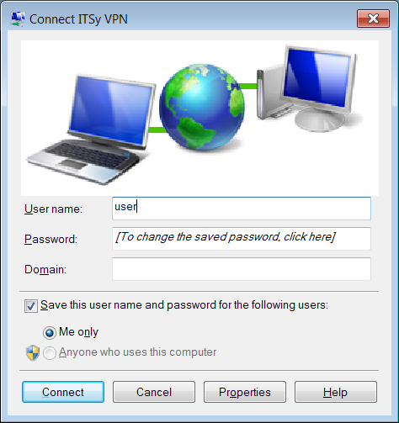

1. Install Python 2.7

<http://www.python.org/ftp/python/2.7.3/python-2.7.3.amd64.msi>

1. Install (Corresponding) Python for Windows Extensions

<http://sourceforge.net/projects/pywin32/files/pywin32/Build%20217/pywin32-217.win-amd64-py2.7.exe/download>

1. Unzip VPNStatus.zip.
2. Double click “VPNStatus.py” to run.   
   Or create a shortcut, add a registry entry to autorun via pythonw to avoid displaying a console window:
   1. pythonw VPNStatus.py

**Screenshots**

Disconnected



To Connect (Right click on tray icon):

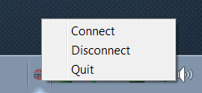

Connected:

